



**What are women’s rights?**

These are fundamental human rights that every woman should have such as the right to vote, the right to earn a fair and equal wage, the right to live free from violence, slavery, and discrimination, the right to be educated, and the right to own property.

Luckily, in some countries women are able to have these rights under the protection of the law. However, unfortunately for women in some countries, they are not granted these fundamental human rights.

This worksheet will test your knowledge on women’s rights successes or failures around the world and might also teach you some facts about women’s rights around the world.

**Directions**: Ask an adult to help answer these questions using the word bank below, if you need to. Once you’ve got the answer, shade in the country with the correct color. Use the map on the wall in the Junior Legislators’ Chamber or use the Internet to help you locate specific countries. Once you are done, check your answers on the back of this sheet! How much did you learn?

New Zealand (Red) Brunei (Orange) Iceland (Yellow)

Cameroon (Green) Brazil (Blue) Yemen (Light Blue)

United States (Purple) Saudi Arabia (Pink) Honduras (Brown)

Egypt (Black) China (Grey)

**Now, see what you know about them!**

1. This country was the first to allow women the right to vote. It happened in 1893.
2. Although this country claims to recognize equal property rights for men and women, in this country only 10% of women own land.
3. In 2015, this country passed a law that finally criminalized femicide, which is the gender motivated killing of women, for the very first time.
4. Since 2008, this country has been ranked the most gender-equal country in the world. For example, this country was the first to make the gender pay gap illegal by applying fines against employers who try to discriminate against women. This country also requires at least 40% of a company’s board to include women.
5. This country has not allowed women *or* men the right to vote yet. This is because this country has an absolute monarchy, which means the head of state is also the head of government and makes all decisions for all of the people who live there.
6. This country gave women the right to vote in 1920 after the ratification of the 19th Amendment to this country’s Constitution.
7. This country has had issues with civil service job postings that only allow males to apply. In 2017, 55% of the jobs advertised by the Ministry of Public Security were advertised for “men only.”
8. This country has been ranked the worst place for gender equality in the world. It has the biggest gap in literacy rates between men (85%) and women (55%). It also has one of the highest rates of child marriage, where it is legal to marry girls as young as 9 years old to men of any age. Even today, 52% of girls are married before the age of 18.
9. In 2011, women in this country were granted the right to vote by King Abdullah.
10. As of 2015, only 26% of women in this country are participating in the labor force and only 65% of women are literate. To combat these issues, human rights groups in this country have begun to provide educational programs for girls as well as teaching them skills to go out into the workforce.
11. This country has the highest femicide rating in the world. A woman is killed every 18 hours. This country’s lack of laws has allowed murderers to get away with many awful crimes against women.

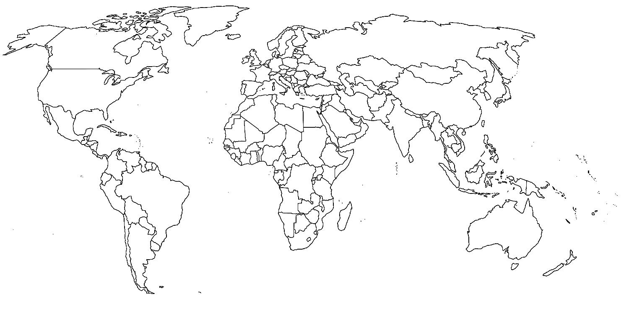

1. New Zealand (Red) 2. Cameroon (Green) 3. Brazil (Blue) 4. Iceland (Yellow) 5. Brunei (Orange) 6. United States (Purple) 7. China (Grey) 8. Yemen (Light Blue) 9. Saudi Arabia (Pink) 10. Egypt (Black) 11. Honduras (Brown)

All correct – **You really know about the civil rights of women around the world! Spread the word !**

8 or more correct – **You are on top of things and realize how lucky you are to be in this country!**

5 – 8 correct **– You are beginning to be aware of how different things are around the world. Hopefully you are inspired to help support civil rights for all human beings!**

Less than 5 – **You have learned a lot by completing this worksheet. Becoming educated is the first step!**