East Exhibit Gallery
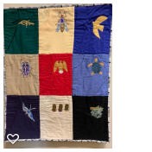
Madeline Albright: Diplomacy Beyond Words
Artist: Wendy L. Starn
Albright, first female Secretary of State under President Clinton, was known for her collection of pins, which were used to send a subtle message beyond what she could say in diplomatic settings.

Materials & Techniques: linen and clothing fabrics, textile paint, acrylic jewels; machine and hand sewn with lapels adapted from garment patterns

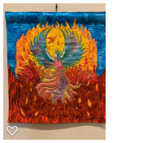
Empowered
Artist: Yvonne Bayham
A tribute to those of us who have found the strength and courage, time after time, not only to rise up and persevere, but also to empower others to rise with us.

Materials & Techniques: fabric collage and raw-edge fusible applique
Price: $375
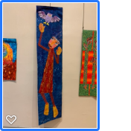
I Dreamed I Could Fly
Artist: Lucy Landry
Inspired by dreams, this work is a vision of power and self-sufficiency, of being set free. Following dreams often means letting go of boundaries and rules and perhaps if we are lucky, gravity.

Materials & Techniques: cotton, silk, recycled sari silk, tyvek, buttons; applique and hand embroidery

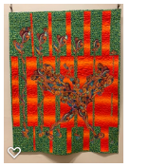
Seeds of Color
Artist: Tracy Stone Gallagher
Seeds of color are planted as they grow; they develop into a beautiful woman of color.

Materials & Techniques: collage fiber art, using cotton fabric with raw edge top stitching to finish

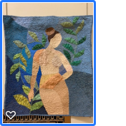
Flourish
Artist: Rebeka Lambert
This art quilt is inspired by women’s bodies, growth, change, and self-discovery.

Materials & Techniques: hand pieced and hand quilted, made with commercial quilting cottons and embellished with yarn and heavyweight thread; it contains cotton batting and is backed with a vintage bed sheet

Volcie’s Buttons
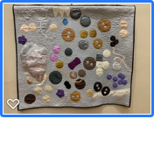
Artist: Mary Bourque Marcotte
I was looking through buttons inherited from my grandmother when they spilled onto the table. I suddenly saw a quilt to honor her life and her quilting. I tested various techniques for her portrait.

Materials & Techniques: upholstery fabric for buttons

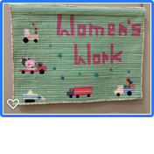
Pink Tractors
Artist: Glen Parks
Made for my new soon-to-be in this world grandchild who turned out to be a boy. I wanted to tell my girl that she can do anything she wants to do.

Materials & Techniques: machine piecing, machine quilting, vintage buttons from the 1950s; adapted from a pattern by Shea Henderson

SHE
Artist: Mary Felder
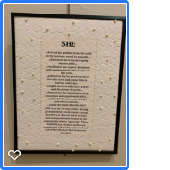
I thought about the women who have influenced my life and those who sacrificed so I could have a better life. My poem is about the women who personally helped me. But there were others who cleared the way for us. Do you know Janet Mary Riley? She was the first woman to hold a full time law school faculty position in New Orleans and is credited with helping to change Louisiana law to make women equal partners in their marriage. She is just one of many pioneers!

Materials & Techniques: old muslin as a substrate and beads as embellishments

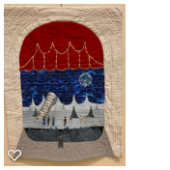
Sarah Caldwell: Music’s Wonder Woman
Artist: Wendy L. Starn
Caldwell was one of the first female conductors and opera producers, and wrote original adaptations of operatic works, including the depicted “Journey to the Moon.”

Materials & Techniques: commercial and hand dyed cottons, velvet, metallic braid, textile paint; fused, machine and hand sewn

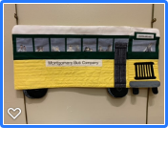
December 1, 1955 - Rosa Road the Bus
Artist: Suzi Stone
Rosa Parks refused to give up her seat on the front of the bus. Her brave actions further helped all people win their equal rights.

Materials & Techniques: commercial fabric with digital printing

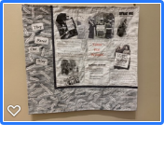
They Paved the Way
Artist: Suzi Stone
Women worked tirelessly to get the 19th Amendment passed so they would have the right to vote. These brave women paved the way for future generations of women to grow and govern our great nation.

Materials & Techniques: hand painted fabric, raw edge applique digital printed images

The Corner of Calvert and Connecticut Avenue
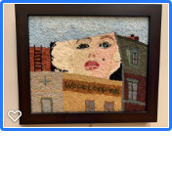
Artist: Corinne Watts
This mural of Marilyn Monroe covers the side of a row house in the Woodley Park neighborhood of Washington D.C. I lived in the neighborhood for 16 years. I saw her every day and have never been able to find out why she is there--a classic untold story.

Materials & Techniques: rug hooking with wool fabric

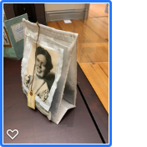
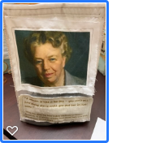
A Woman Is Like a Tea Bag…
Artist: Kathleen Callaghan
A popular quote, often attributed erroneously to Eleanor Roosevelt, is accurate in its assessment of women’s strength and resilience in the face of adversity.

Materials & Techniques: organza, cotton muslin, inkjet-printed photos, burlap threads, wood, paper, machine stitching

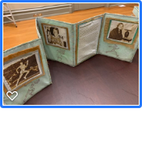
American Women Athletes Who Smashed Barriers
Artist: Kathleen Callaghan
As a distance runner for 40+ years, a veteran of fifteen marathons, including three Boston Marathons, and the overall women’s champion of the 1989 Baton Rouge Marathon, I owe a lot to these women. They ignored past obstacles and rules to prove that women can do many things that men and other women assumed they could not do. When it comes to any challenge, think about those who refused to listen to negative voices and forge your own path. Prove to yourself and others that the accepted norm is not necessarily the truth for you. Just do it.

Materials & Techniques: cotton muslin, lutradur, oil pastels, gelato crayons, alcohol ink, inkjet-printed photos, machine stitching
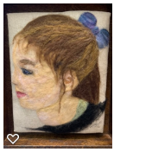
Grace Ann
Artist: Katy Prescott
This is a portrait of a young lady whose first year to vote falls in the 100th year anniversary of women’s right to vote.

Materials & Techniques: wool painting with wool roving on linen

West Exhibit Gallery

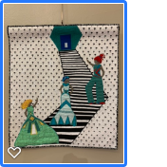
A Woman’s Place
Artist: Yvonne Bayham
A reflection of the ongoing struggle for self-determination for all women--to decide for ourselves the roles and “place” we fill. The stairs represent barriers--those overcome and those that remain. The three figures are those “out front.” And the white silhouettes are the legions of unseen, nameless, faceless women.

Materials & Techniques: fabric applique and improv piecing
Price: $285

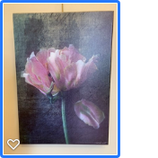
Still Writing Her Story
Artist: Judy Momenzadeh
Aging does not mean our story ends; it is simply a beautiful new chapter in our story.

Materials & Techniques: four original images edited and layered
Price: $180.00
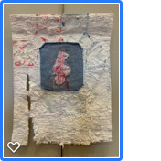
Broken Dreams and Promises
Artist: Lisa A. Ducote
So many times women’s dreams get broken because of family demands and cultural expectations. A hole in the denim and the broken threads to mend it along with the tattered quilt symbolize a rescue attempt.

Materials & Techniques: recycled piece of denim from old jeans, piece of a vintage quilt, and weaving with pearl cotton thread

Why Is Liberty Symbolized As a Woman?
Artist: Kathleen Callaghan
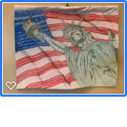
This is inspired by personal experiences of having been held back or under-estimated solely because of preconceived notions about my and other women’s abilities. The blue area of the flag contains the first section of the Equal Rights Amendment, which has never been ratified, despite widespread support nationwide. The red stripes contain quotes made by white males in positions of power.

Materials & Techniques: hand drawn on white muslin with inktense pencils, machine quilted
Nanny
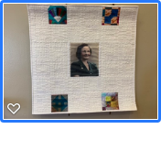
Artist: Vicki Thompson
Lydia Watson Farris (1908-2000), my maternal grandmother, was an amazing woman. Widowed at 28 she raised three children, sometimes working three jobs. She inspired in me the love of quilting. Along with her photo are photos of blocks from four of her many quilts.

Materials & Techniques: Cotton fabric, cotton thread and cotton batting; machine piecing, free motion machine quilting and photo transfer

Momma
Artist: Mary Bourque Marcotte
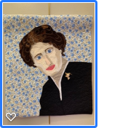
My mother was a prolific quilter and seamstress, and I wanted to honor the woman who raised eight daughters to become successful women. This portrait was taken before her 53-marriage to my dad, but as everyone’s favorite, it is extra special.

Materials & Techniques: commercial cotton fabric

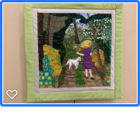
Celebrating Caroline Dormon, 1888-1971
Artist: Donna LaFleur
This piece is in honor of the Louisiana forest conservationist, naturalist, author, teacher and artist, who greatly influenced the establishment of the Kisatchie National Forest and the Louisiana State Arboretum. Her home, Briarwood, is a sanctuary for flora and fauna near Saline, LA.

Materials & Techniques: machine quilted fabric collage

Rule Breaker
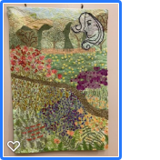
Artist: Joyce Ryder
Inspired by all women who have the courage to break the rules when it matters. I grew up during a time when women were encouraged to accept the status quo without question. Thanks to all of the strong women who have led the way in questioning and breaking the rules.

Materials & Techniques: stamped, dyed and painted fabric, ribbon embroidery, thread painting

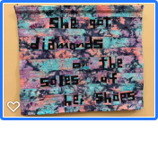
Diamonds II
Artist: Glen Parks
Inspiration from Paul Simon--I want to be that special to have my man put diamonds on the soles of my shoes!

Materials & Techniques: commercial fabric, machine piecing, machine quilting
Price: $325

Leaves 7 - Tones of Mother Nature
Artist: Melanie Borne
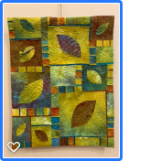
The glorious colors of nature are all around. At this time of year we see them in fall foliage and in the sky at dusk and dawn.

Materials & Techniques: hand dyed cotton; machine pieced, machine and hand quilted
Price: $435

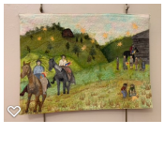
The Giver of Stars
Artist: Joyce Ryder
This piece is based on the book by Jojo Moyes about the female pack horse librarians of the 1930s.

Materials & Techniques: painted and stamped fabric, applique and thread sketching/painting

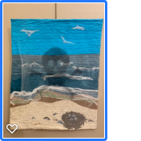
Rachel Carson: Advocate for Nature
Artist: Wendy L. Starn
Oceanographer and naturalist Carson was best known for her book “Silent Spring,” which detailed the effects of the insecticide DDT and led to a ban on usage.

Materials & Techniques: hand dyed and hand painted fabrics, sheer fabrics; machine sewn, fused, sheer layer attached at top

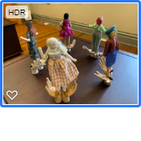
Community of Women
Artist: Lucy Landry
This community of women tells the story of the uplifting power of standing together in community. Those of us here today benefit from the work of previous generations as our daughters will benefit from our work.

Materials & Techniques: cotton, linen, silk, wool, wire, fiberfill; hand embroidery, needle sculpture

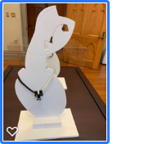
Woman is Yin
Artist: Susie Blyskal
The Yin Yang symbol represents eternity and the continuous cycle of life. Yin is the black swirl, associated with femininity.

Materials & Techniques: spiral bead necklace in black and white with a focal ‘slide’ fringed in black and white and mother of pearl yin yang symbols

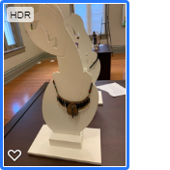
Spirit Woman
Artist: Susie Blyskal
Indigenous native women were the heart and strength of early nations. This beaded fringe necklace of seed beads in five traditional colors is accented with a silver feather medallion Spirit Bag.

Materials & Techniques: ultrasuede Spirit Bag contains rabbit fur, snake skin, cat whisker, and bear amulet

