Sign of the Times: The Great American Political Poster 1844–2012
on display at Louisiana’s Old State Capitol until June 20th, 2020

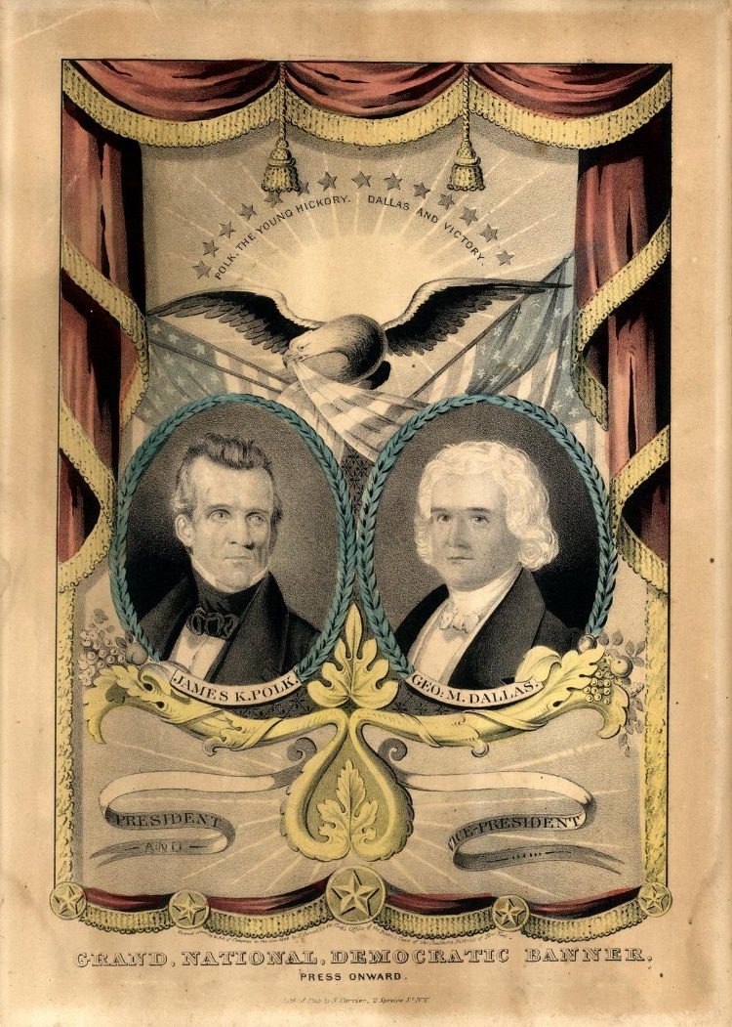
Curated by Dr. Hal Elliot Wert, Kansas City Art Institute

Lithographic printing, pioneered in Germany in the 1840s, made it possible for office seekers to more easily produce posters advertising their candidacy.

Hand-colored portraits of presidential and vice- presidential candidates were first printed for the 1844 race between Whig Party candidate Henry Clay and the eventual winner, James K. Polk of the Democratic Party. The Currier and Ives poster at left uses the oak leaf to symbolize strength, courage and endurance. The sun and rays at the top of the poster connote a glorious future. Polk prevailed and became the 11th president.

Left: Unidentified artist, Democratic Party candidates James K. Polk and George M. Dallas 1844 ink on paper Courtesy of The Granger Collection, New York

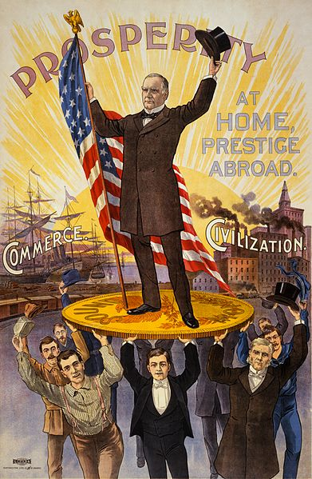

Advances in the process led to the golden age of lithography from 1890-1912. Some of the most intricate and colorful posters in the exhibition come from this time.

Right: Unidentified artist Republican Party candidate William L. McKinley c. 1896-1900 ink on paper Courtesy of Library of Congress

In 1896, William L. McKinley campaigned on returning the country to prosperity. Here he is seen standing atop a gold coin, a reference to the debate over the nation’s currency system. McKinley was elected president in 1896, and was seeking reelection when his vice president died. McKinley added the much revered Rough Rider Theodore Roosevelt to the Republican ticket. The pair won the White House again in 1900.

World War II saw a huge outpouring of posters offered by the Roosevelt administration and included several key Democratic Party campaign posters designed by famous artists like Ben Shahn and James Montgomery Flagg.

Below: Ben Shahn Democratic Party candidate Franklin D. Roosevelt 1944 offset lithograph on paper Courtesy of private collection

“Our Friend,” one of Ben Shahn’s first political posters, was created in 1944 for the Political Action Committee of the Congress of Industrial Organizations (CIO) to elect Franklin Delano Roosevelt to a fourth term. A triumph of visual communication, the poster does not identify FDR or the office for which he is running. Shahn went on to create a number of innovative campaign posters that have become classics of the genre

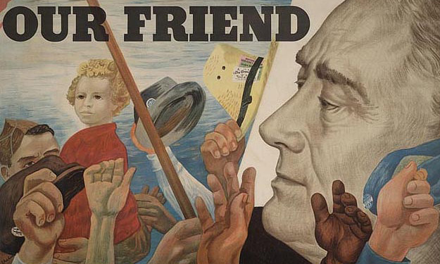

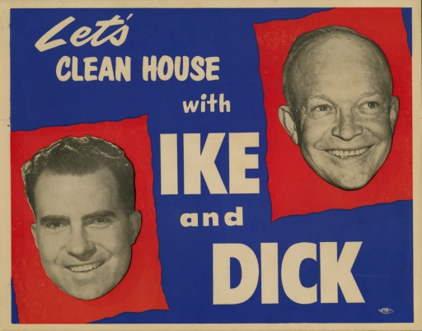
Campaign posters of the 1950s often featured cheap letterpress and offset “boxing style” posters were de rigueur. However, a marvelous new design element that became popular at the time was the “floating head” poster, and several for candidates Eisenhower, Kennedy, and Goldwater are included in the exhibition.

Left: Unidentified artist Republican Party candidates Dwight D. Eisenhower and Richard M. Nixon 1952 offset lithograph on paper Courtesy of private collection

Dwight D. “Ike” Eisenhower, a hugely popular World War II general, ran on a promise to end the stalemated war in Korea. He chose Senator Richard M. Nixon as his running mate and easily swept to a landslide victory over Democratic candidate Adlai Stevenson. “I Like Ike” was a smash success as a campaign slogan; so popular that even a Stevenson button read, “I Like Ike, But I’m Voting for Stevenson.”

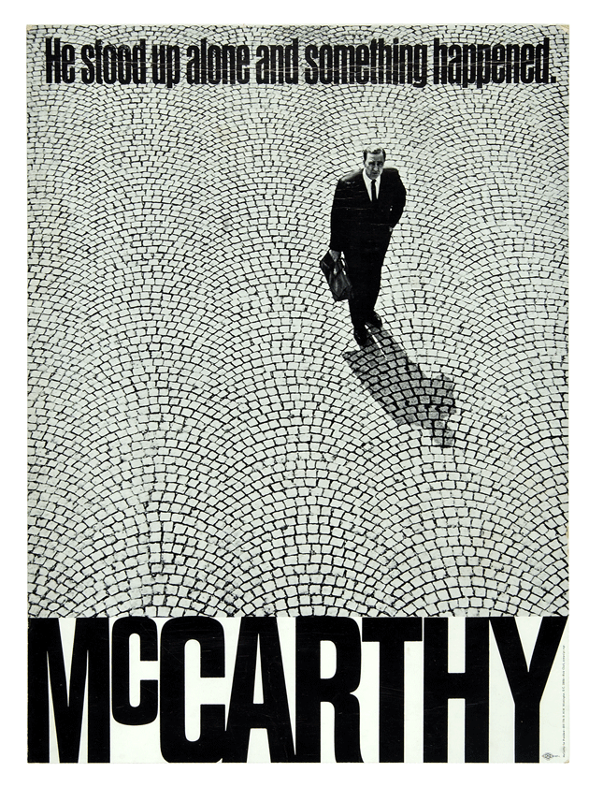
Left: Unidentified artist Democratic Party hopeful candidate Eugene J. McCarthy 1968 offset lithograph on paper Courtesy of private collection

Considered one of the best political posters of the 1960s, its effectiveness lies in the use of both text and visual language. The slogan lacks specificity, allowing the viewer to draw his or her own conclusions as to the “something” that “happened.” Insurgent candidate Eugene McCarthy failed to secure the Democratic nomination; it went instead to insider and Vice-President Hubert Humphrey.

A virtual explosion of exciting political art was fueled by the civil rights, psychedelia and anti-war movements. Offset posters were more frequently used, by some well-known artists such as Alexander Calder, Peter Max, and Andy Warhol screen-printed limited editions to help funds campaign.
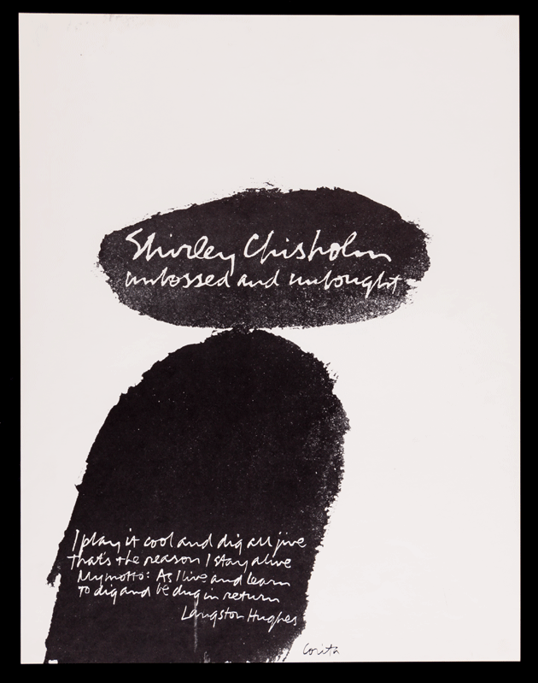

Right: Mary Corita Kent Democratic Party hopeful candidate Shirley Chisholm 1972 offset lithograph on paper Courtesy of private collection

Seven-term Brooklyn Congresswoman Shirley Chisholm was the first African-American woman to run for president as the candidate of a major party. Seeking the Democratic nomination, Chisholm’s campaign issued a number of memorable posters in 1972. None are more memorable than this poster by Mary Corita Kent, an activist artist and former nun. The abstract figure of Chisholm and the use of the Langston Hughes poem written in script - including the phrase “unbossed and unbought” - are hallmark design features of this poster.

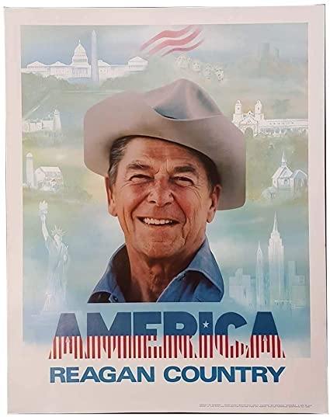
Left: Unidentified artist Republican Party candidate Ronald Reagan 1980 offset lithograph on paper Courtesy of private collection

In 1980, the Iranian hostage crisis, high gas prices, inflation, and domestic economic sluggishness swept the former Hollywood actor and California Gov. Ronald Reagan into the White House. This poster is an example of effective visual communication, coupled with successful branding. There is no date or information on the office Ronald Reagan is seeking. The use of positive images of American life in the poster’s background produced a retro quality engendering feelings of nostalgia in the viewer.

Below: Unidentified artist Republican Party candidate George W. Bush 2004 offset lithograph on paper Courtesy of private collection

George W. Bush, with the war going badly in Iraq, conducted a successful political surge, but his presidency was marked by the Great Recession—a firestorm that briefly threatened financial collapse in the United States. The W 2004 poster is a tribute to successful branding and strong visual communication. Black posters and bumper stickers with the silver letter “W” or phonetic “Dubya” flooded the nation during this time.
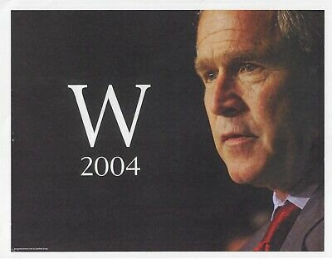
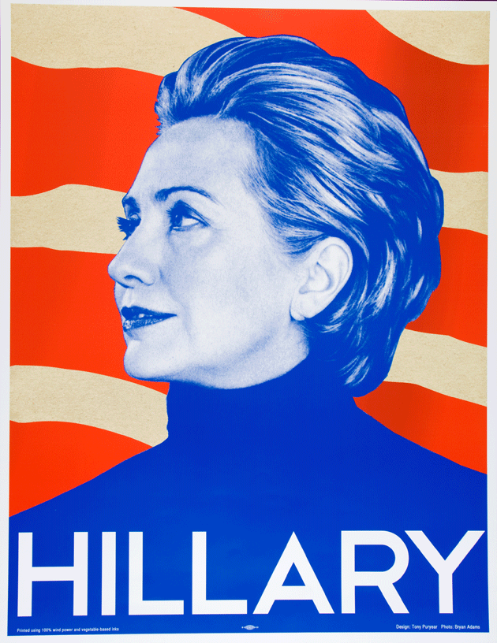
Right: Tony Puryear Democratic Party hopeful candidate Hillary Clinton 2008 offset lithograph on paper Courtesy of private collection

Hillary Clinton, the 2008 Democratic heir apparent, was challenged by little-known Illinois Senator Barack Obama. A hotly contested primary battle ended with a narrow victory for Obama. This attractive, powerful poster was created by Tony Puryear, a Los Angeles writer and artist, and printed on heavy paper stock. This image is on buttons and other campaign items in support of Clinton’s run for presidency in 2016.

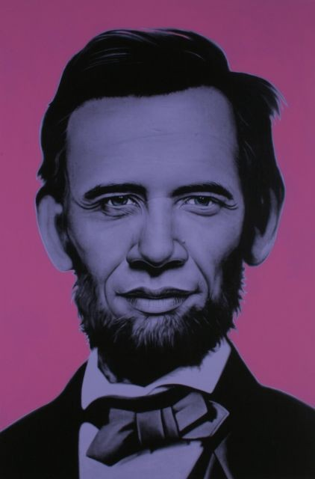
After the graphically exciting 1972 presidential campaign, future contests produced only a few outstanding posters in each election cycle. However, Barack Obama presidential bid in 2008 heralded a renaissance of the form, as many artists—insiders, outsiders, and the famous—jumped on the candidate’s bandwagon. Could the great American political poster at last solidified its place in future campaigns?

Left: Ron English Abraham Obama; Democratic Party candidate Barack Obama poster 2008 screen print on paper Courtesy of private collection

Clearly inspired by the production methods of artist Andy Warhol, Ron English’s Abraham Obama came in a variety of sizes and colors, including two series using diamonds ground to dust. Installations of huge posters printed across the color spectrum appeared at “art happenings” in Boston, Los Angeles, and at the Democratic National Convention in Denver. Some thought the image bizarre, but candidate’s images remade or retouched to look like George Washington or Abraham Lincoln have frequently occurred and were very popular during the poster/postcard boom (1896- 1912) fueled by the new color lithography.

After the flurry of political posters from the 2008 presidential race, the creation of political campaign art declined. Despite its effectiveness in conveying political messages to million through skillful visual communication, the American political poster has been neglected as an art form. Sign of the Times has made every effort to bring eye-popping political graphics to the forefront and to show the great American political poster as art.

