Questions for Discussion
How has time and technology impacted Presidential campaigns? In what ways?
What qualities do you believe are important in a leader of our country? Why?
What else do you need to become President of the United States in your opinion? Why?
What current events or world topics do you feel are the most challenging or difficult to resolve? Why?
What issues would you resolve or address if you were President? Why?
Do you think political debates are an important tool for elections? Why or why not? Cite evidence to support your answer.
Do you think the media is helpful or hurtful to political candidates? Why or why not?

Topics for Debate
Debate Topic A: The Electoral College
Our Constitution outlines that the President of the United States is selected by votes from an Electoral College, not by popular vote. The Electoral College is a slate of 538 electors nominated and selected by each state. Electors are either selected by state party conventions or by a vote of the party’s central committee in each state. The Electoral College casts their votes on election day and the winning candidate is selected based on the most votes awarded from all of the states. Each state has different restrictions (or none) regarding the way their state’s Electors must vote. Some are required to vote according to the results of the popular vote in their state. Others are able to vote according to their pledge to a particular political party. In history, approximately 99% of the Electors have voted as pledged. The Electoral College is what determines which states primarily favor the Republican or Democratic parties to make them “red” or “blue” states.
Why do you think the framers of the Constitution felt electing a leader in this fashion was a good idea or necessary?
Do you think this remains a good system today? Why or why not?
Discuss and debate several statements both for and against the Electoral College system.
(Arguments taken from http://www.usnews.com/debate-club/should-theunited-states-get-rid-of-the-electoral-college)
The Electoral College should be eliminated. American’s votes should “count” no matter where they live. If you are a Democrat living in a “red state” whose Electoral College votes typically go to the Republican Party, your vote in an election doesn’t matter.
Five large states (California, New York, Washington, Texas, and Florida) require extra electoral votes based on their population size. Democrats (based on this current system) today therefore have a plus five electoral vote advantage. The counting of persons puts Republicans at a constant disadvantage.
The Electoral College should remain. The Electoral College defends liberty in ways that direct democracy does not. There is not a single election for president but 51 elections (including Washington D. C.). This according to Alexander Hamilton, “affords a moral certainty, that the office of President will never fall to the lot of any man who is not in an eminent degree endowed with the requisite qualifications.” The Electoral College forces presidential candidates to win people and states which balances national and federal interests.
The Electoral College ensures that power and corruption do not spoil presidential elections. The dual system of both democratic and federal voting is a check and balance system. If instead a direct popular election were in effect candidates who obtain the most individual votes (even if exclusively obtained in a large urban area or region) would win. The Electoral system ensures all voices big and small and from across the country are heard.

Debate Topic B: Campaigning Tactics: Dollars and Sense?
Today, we learn about and follow politicians primarily through the media or advertising efforts. Political candidates must fundraise for dollars to support advertising efforts for their campaigns and these efforts expensive.
The 1971 Federal Election Campaign Laws enacted campaign finance legislation (and amended these laws in 1974, 1976, and 1979), to ensure there is full disclosure of campaign contributions for federal campaigns, to set legal limits for contributions to candidates and political parties, set limits for personal spending, and individual spending by groups not directly associated with a candidate’s campaign.
Since 1976, the Federal Election Commission has also administered a grant program for Presidential candidates that has allowed them to use federal funds in primary and general election campaigns. Eligible candidates must agree to limit spending to a specified amount. For example, if 83 million in federal dollars is available in funding, the candidate must agree to not privately fundraise more for the campaign and set 83 million as a limit in spending for the campaign. Some candidates have elected to forgo the public funding option and have instead raised private monies for their election campaigns.
Discuss and debate the following questions related to election campaign financing.
• If the media (newspapers and television and radio stations) are conglomerates owned by corporations and very wealthy individuals, do you think political campaigns should spend so much money on advertising and airtime in this fashion? Do you think the media might be or could be “bought” by politicians to persuade viewers/listeners/readers in a particular way?
• Corporations and union groups can purchase ads for particular political parties to support their choice for president. Do you think corporations and or union groups should be allowed to do this? Why or why not?
• Private groups (political action committee groups independent of and not organized by a candidate’s campaign) are able to raise and contribute money for an individual’s or particular party’s campaign. There are limits to these type of contributions that are set by the Federal Election Commission. Do you think we need limits? Why or why not
• If you were running for President would you use federal or public funding available for your campaign or try to fundraise it all yourself? What are the advantages and disadvantages to both tactics?

Common Core-Inspired Lessons
Lesson Idea A
The Art of Persuasive Speaking: Change My Mind
Grade Levels 6-9
Summary: This classroom lesson invites students to write a persuasive speech, practice public speaking skills, and persuade others to change an opinion about a particular controversial topic.
Objectives
• Students will research and identify a topic that is controversial.
• Students will choose a particular stance on the topic and outline points to illustrate this opinion.
• Students will understand that speeches need an introduction, a body, and a conclusion.
• Students will understand verbal elements and techniques of engaging speech presentation.
• Students will understand that presidential campaigns require writing persuasive and powerful speeches.
Materials Needed
• Access to the internet to read and view political speeches, conduct research, and make use of online speaking tools
• Paper and writing tools
• Index note cards
• A podium
• Printouts of helpful tips handout for persuasive speaking
Lesson Time
• one class period to experience the exhibition Sign of the Times: The Great American Political Poster, 1844–2012 (or, if this is not available, watch the “virtual tour” at this link: louisianaoldstatecapitol.org)
• one class period for discussion of elements of a successful campaign and elements of persuasive speaking
• one class period for in class work and/or research on a persuasive speech topic
• one class period for class presentations of ten-minute persuasive speeches (or more class time for practice if needed)
Lesson Procedures
Step One: Following time spent viewing this exhibition of political campaign posters either in person or virtually at louisianaoldstatecapitol.org, share information about Presidential campaign speeches as an additional campaigning tool. Use online tools including the Presidential Speech Archive to read or view speeches given.
http://millercenter.org/president/speeches
http://mic.com/articles/79659/12-greatest-political-speeches-in-american-history
Step Two: Discuss the elements of persuasive speaking when writing and giving a speech. Use the tips below as a resource in this lesson and invite students to brainstorm controversial topics as speech ideas as a classroom assignment.
Step Three: Invite students to research a chosen topic and have students draft elements of a persuasive ten-minute speech. Encourage students to rewrite their speeches several times using computers to correct and refine language and grammar. Instruct students to write down key points on notecards to help them organize their thoughts and practice speech delivery. Allow students time to practice in class to gather feedback from each other.
Step Four: Organize class time for each student to present his or her ten-minute persuasive speech to the class as the culminating event of the lesson.
Resources:
http://constitutioncenter.org/headedtothewhitehouse/assets/candidate/speech/speech _2409.html
http://constitutioncenter.org/headedtothewhitehouse/
http://mic.com/articles/79659/12-greatest-political-speeches-in-american-history
http://millercenter.org/president/speeches

HELPFUL TIPS FOR PERSUASIVE SPEAKING
- Identify a controversial topic that will inspire heated debates regardless of one’s position.
- Think about a goal for the audience—perhaps to convince them to change their mind about this controversial topic.
- Research your topic thoroughly. Use evidence to support your points. Understand your audience and their perspective (age, gender, point of view, etc.)
- Read a great speech and note the elements that make it great.
- Write like you talk. Use short words and sentences to make things clear.
- Think about the story you want to tell.
- Think about the sequences or structure of your story and the points you want to make.
- Be yourself and make it personal to make your speech authentic.

STEPS TO WRITE A GREAT SPEECH
(from Alan H. Monroe’s Motivated Sequence)

- Grab the audience’s attention.
• A startling statement
• A rhetorical question
• A quotation
• A funny story
• A dramatic story
• A photography or visual aid

- Establish there is a problem (or need) that demands the audience’s attention.
• Examples to illustrate problem’s impact
• Statistics
• Witness testimony

- Outline a solution to the problem.
• Outline your solution succinctly
• Demonstrate how it meets the problem
• Use examples to show how effective it is
• Support with facts, figures, graphs, diagrams, statistics, testimony
• Acknowledge opposing view and show how your plan overturns this viewpoint

- Show the audience how they will benefit from your solution.
- Provide the impetus and means to act.

Connections to Common Core Standards
(example grade 6)

Reading Standards for Informational Text
Key Ideas and Details
1. Cite textual evidence to support analysis of what the text says explicitly as well as inferences drawn from the text.
2. Determine a central idea of a text and how it is conveyed through particular details; provide a summary of the text distinct from personal opinions or judgments.
3. Analyze in detail how a key individual, event, or idea is introduced, illustrated, and elaborated in a text (e.g., through examples or anecdotes).

Craft and Structure
4. Determine the meaning of words and phrases as they are used in a text, including figurative, connotative, and technical meanings.
5. Analyze how a particular sentence, paragraph, chapter, or section fits into the overall structure of a text and contributes to the development of the ideas.
6. Determine an author’s point of view or purpose in a text and explain how it is conveyed in the text.

Integration of Knowledge and Ideas
7. Integrate information presented in different media or formats (e.g. visually, quantitatively) as well as in words to develop a coherent understanding of a topic or issue.
8. Trace and evaluate the argument and specific claims in a text, distinguishing claims that are supported by reasons and evidence from claims that are not.
9. Compare and contrast one author’s presentation of events with that of another (e.g. a memoir written by and a biography on the same person.

Writing Standards
Text Types and Purposes
1. Write arguments to support claims with clear reasons and relevant evidence.
a. Introduce claim(s) and organize the reasons and evidence clearly.
b. Support claim(s) with clear reasons and relevant evidence, using credible sources and demonstrating an understanding of the topic or text.
c. Use words, phrases, and clauses to clarify the relationships among claim(s) and reasons.
d. Establish and maintain a formal style.
e. Provide a concluding statement or section that follows from the argument presented.

2. Write informative/explanatory texts to examine a topic and convey ideas, concepts, and information through the selection, organization, and analysis of relevant content.
a. Introduce a topic; organize ideas, concepts, and information using strategies such as definition, classification, comparison/contrast, and cause/effect; include formatting (e.g. headings), graphics (e.g. charts, tables) and multimedia when useful to aiding comprehension.
b. Develop the topic with relevant facts, definitions, concrete details, quotations, or other information and examples.
c. Use appropriate transitions to clarify the relationships among ideas and concepts.
d. Use precise language and domain-specific vocabulary to inform about or explain the topic.
e. Establish and maintain a formal style.
f. Provide a concluding statement or section that follows from the information or explanation presented.

3. Write narratives to develop real or imagined experiences or events using effective technique, relevant descriptive details, and well-structured event sequences.
a. Engage and orient the reader by establishing a context and introducing a narrator and/or characters; organize an event sequence that unfolds naturally and logically.
b. Use narrative techniques, such as dialogue, pacing, and description to develop experiences, events, and/or characters.
c. Use a variety of transition words, phrases, and clauses to convey sequence and signal shifts from one time frame or setting to another.
d. Use precise words and phrases, relevant descriptive details, and sensory language to convey experiences and events.
e. Provide a conclusion that follows from the narrated experiences or events.
Production and Distribution of Writing
4. Produce clear and coherent writing in which the development, organization, and style are appropriate to task, purpose, and audience.
5. With some guidance and support from peers and adults, develop and strengthen writing as needed by planning, revising, editing, rewriting, or trying a new approach.
6. Use technology, including the internet, to produce and publish writing as well as to interact and collaborate with others; demonstrate sufficient command of keyboarding skills to type a minimum of three pages in a single sitting.
Research to Build and Present Knowledge
7. Conduct short research projects to answer a question, drawing on several sources and refocusing the inquiry when appropriate.
8. Gather relevant information from multiple print and digital sources; assess the credibility of each source; and quote or paraphrase the data and conclusions of others while avoiding plagiarism and providing basic bibliographic information for sources.
Speaking and Listening
Comprehension and Collaboration
1. Engage effectively in a range of collaborative discussions (one-on-one, in groups, and teacher-led) with diverse partners on grade 6 topics, texts, and issues building on others’ ideas and expressing their own clearly.
a. Come to discussions prepared, having read or studied required material; explicitly draw on that preparation by referring to evidence on the topic, text, or issue to probe and reflect on ideas under discussion.
b. Follow rules for collegial discussions, set specific goals and deadlines, and define individual roles as needed.
c. Pose and respond to specific questions with elaboration and detail by making comments that contribute to the topic, text, or issue under discussion.
d. Review the key ideas expressed and demonstrate understanding of multiple perspectives through reflection and paraphrasing.
2. Interpret information presented in diverse media and formats (e.g. visually, quantitatively, orally) and explain how it contributes to a topic, text, or issue under study.
3. Delineate a speaker’s argument and specific claims, distinguishing claims that are supported by reasons and evidence from claims that are not.
Presentation of Knowledge and Ideas
4. Present claims and findings, sequencing ideas logically and using pertinent descriptions, facts, and details to accentuate main ideas or themes; use appropriate eye contact, adequate volume, and clear pronunciation.
5. Include multimedia components (e.g. graphics, images, music, sound) and visual displays in presentations to clarify information.
6. Adapt speech to a variety of contexts and tasks, demonstrating command of formal English when indicated or appropriate.
Language Standards
Conventions of Standard English
1. Demonstrate command of the conventions of standard English grammar and usage when writing or speaking.
a. Ensure that pronouns are in the proper case (subjective, objective, possessive).
b. Use intensive pronouns (e.g. myself, ourselves)
c. Recognize and correct inappropriate shifts in pronoun number and person.
d. Recognize and correct vague pronouns (i.e. ones with unclear or ambiguous antecedents).
e. Recognize variations from standard English in their own and others’ writing and speaking, and identify and use strategies to improve expression in conventional language.
2. Demonstrate command of the conventions of standard English capitalization, punctuation, and spelling when writing.
a. Use punctuation (commas, parentheses, dashes) to set off nonrestrictive/parenthetical elements.
b. Spell correctly
3. Use knowledge of language and its conventions when writing, speaking, reading, or listening.
a. Vary sentence patterns for meaning, reader/listener interest, and style.
b. Maintain consistency in style and tone.
Vocabulary Acquisition and Use
4. Determine or clarify the meaning of unknown and multiple-meaning words and phrases based on grade 6 reading and content, choosing flexibly from a range of strategies.
a. Use context (e.g. the overall meaning of a sentence or paragraph; a word’s position or function in a sentence) as a clue to the meaning in a sentence) as a clue to the meaning of a word or phrase.
b. Use common, grade-appropriate Greek or Latin affixes and roots as clues to the meaning of a word (e.g. audience, auditory, audible).
c. Consult reference materials (e.g. dictionaries, glossaries, thesauruses). Both print and digital, to find the pronunciation of a word or determine or clarify its precise meaning or its part of speech
d. Verify the preliminary determination of the meaning of a word or phrase (e.g. by checking the inferred meaning in context or in a dictionary).
5. Demonstrate understanding of figurative language, word relationships, and nuances in word meanings.
a. Interpret figures of speech (e.g. personification) in context.
b. Use the relationship between particular words (e.g. cause/effect, part/whole, item/category) to better understand each of the words.
c. Distinguish among the connotations (associations) of words with similar denotations (definitions) (e.g., stingy, scrimping, economical, unwasteful, thrifty)
6. Acquire and use accurately grade-appropriate general academic and domain specific words and phrases; gather vocabulary knowledge when considering a word or phrase important to comprehension or expression.

Common Core-Inspired Lesson
Lesson Idea B
See How You Run: Design a Personal Political Poster
Grade Levels 6-9
Summary: This lesson idea combines image making with creative writing to invite students to create a design for a political poster for a mock presidential race.
Objectives:
• Students will understand the elements of art and principles of design.
• Students will understand what makes a strong visual composition.
• Students will understand how to pair text with imagery to create an eye catching message or slogan.
• Students will compare and contrast strong examples of past Presidential campaign posters.
• Students will understand the history of the Republican and Democratic Party’s use of the symbols of the donkey and elephant.
• Students will consider personal iconography and symbolism for a presidential campaign poster to promote himself or herself as future President.
Materials Needed:
• Pencils
• Newsprint for drafting and sketching possible ideas
• Rulers
• Posterboard or tag board (14 x 22 inches or larger if desired)
• Magic markers in assorted colors
• Colored pencils
• Online poster design tool (if desired to create a version electronically)
• Stencils to use for hand lettering (if desired)
• Examples of past political posters from the Sign of the Times exhibition or texts such as Presidential Campaign Posters published by the Library of Congress
• Information about the history of political party symbols such as the elephant and donkey
Lesson Time:
• One class period to view the exhibition Sign of the Times: The Great American Political Poster, 1844–2012 in person or the on-line virtual exhibition at louisianaoldstatecapitol.org
• One class period to compare and contrast poster designs and slogans.
• One class period to sketch a poster concept and a campaign slogan.
• One class period to discuss students’ posters as a group critique.
Lesson Procedures:
Step One: Follow up a visit (either virtually at louisianaoldstatecapitol.org or in-person at Louisiana’s Old State Capitol) to the exhibition Sign of the Times: The Great American Political Poster, 1844–2012, with a class discussion that compares and contrasts several political campaign posters using digital images online from the Library of Congress or from the text Presidential Campaign Posters. Discuss how the elements of art (line, shape, form, space, color, and texture) work together to create principles of design (balance, emphasis, movement, pattern, repetition, proportion, rhythm, variety, and unity). Introduce the concept of a slogan, a motto associated with a political party or movement that is memorable. Discuss and debate which posters have the strongest imagery and text to create a lasting design and message.
Step Two: Invite students to imagine and conceptualize a poster design for their own imaginary Presidential campaign. Share information about the history of the symbols of elephant and donkey for the Republican and Democratic Parties that dates from the use of political cartoons published in 1837 and the 1870s. Have students sketch their ideas on newsprint, playing with color palette, slogan wording, text design, and imagery. If desired, have students experiment online using various online poster design tools to experiment with layout and photos, color, and text. A digital design can be used as a sketching tool before students begin the hand designing poster creation.
Step Three: Using pencil, instruct students to lightly transfer the sketched design onto a larger sheet of poster board or tagboard. Have students finish the designs using media (markers, colored pencils, etc.) of choice, demonstrating how to use stencils and rulers if desired. Step four Invite students to share and discuss each other’s poster works as a class group and critique them.
Resources:
https://www.canva.com
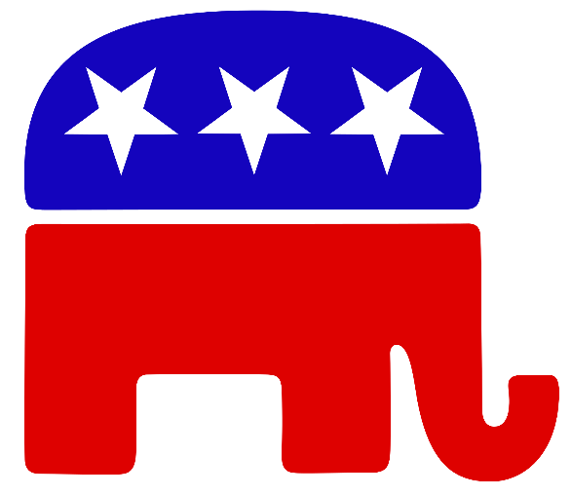
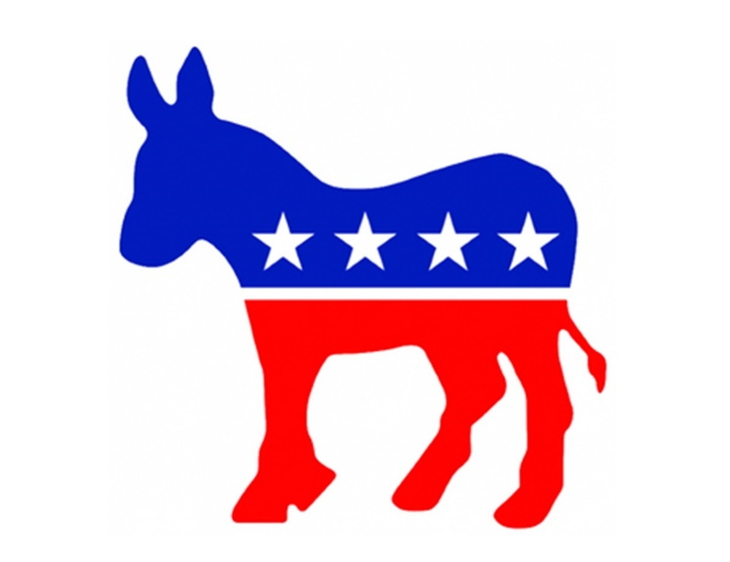

http://www.loc.gov/publish/general/presidential-posters-gallery/index.html
Library of Congress, Presidential Campaign Posters: Two Hundred Years of Election Art. Philadelphia: Quirk Books, 2012
http://www.smithsonianmag.com/arts-culture/political-animals-republican-elephantsand-democratic-donkeys-89241754/?no-ist=
Why Democrats are donkeys and Republicans are elephants: https://www.cnn.com/style/article/why-democrats-are-donkeys-republicans-are-elephants-artsy/index.html
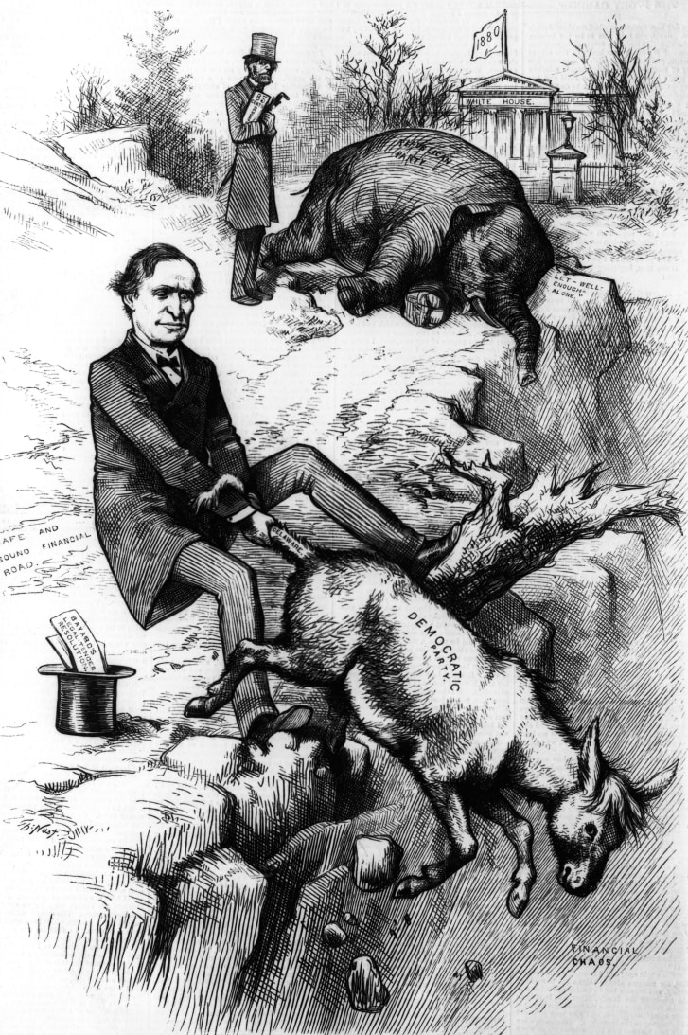
Above: This political cartoon by Thomas Nast, taken from a 1879 edition of Harper's Weekly, was an early use of the elephant and the donkey to symbolize the Republican and Democratic parties.
Credit: Kean Collection/Archive Photos/Getty Images
Connections to National Visual Arts Standards
(example grade six)
Creating: Conceiving and developing new artistic ideas and work
Generate and conceptualize artistic ideas and work
VA:Cr1.1.6a Combine concepts collaboratively to generate innovative ideas for creating art.
VA:Cr1.2.6a Formulate an artistic investigation of personally relevant content for creating art.
Organize and develop artistic ideas and work
VA:Cr2.1.6a Demonstrate openness in trying new ideas, materials, methods, and approaches in creating works of art or design.
VA:Cr2.2.6a Explain environmental implications of conservation, care, and clean up of art materials, tools, and equipment.
VA:Cr2.3.6a Design or redesign objects, places or systems that meet the identified needs of diverse users.
Refine and complete artistic work
VA:Cr3.1.6a Reflect on whether personal artwork conveys the intended meaning and revise accordingly.
Responding: Understanding and evaluating how the arts convey meaning
Perceive and analyze artistic work
VA:Re7.1.6a Identify and interpret works of art or design that reveal how people live around the world and what they value.
VA:Re7.2.6a Analyze ways that visual components and cultural associations suggested by images influence ideas, emotions, and actions.
Interpret intent and meaning in artistic work
Va:Re8.1.6a Interpret art by distinguishing between relevant and non-relevant contextual information and analyzing subject matter, characteristics of form and structure, and use of media to identify ideas and mood conveyed.
Apply criteria to evaluate artistic work
VA: Re9.1.6a Develop and apply relevant criteria to evaluate a work of art.
Connecting: Relating artistic ideas and work with personal meaning and external context
Synthesize and relate knowledge and personal experiences to make art
VA: CN10.1.6a Generate a collection of ideas reflecting current interests and concerns that could be investigated in art-making.
Relate artistic ideas and works with societal, cultural, and historical context to deepen understanding
Va:Cn11.1.6a Analyze how art reflects changing times, traditions, resources, and cultural uses.

Connections to Common Core Standards
(example grade 6)
Reading Standards for Informational Text Key Ideas and Details
1. Cite textual evidence to support analysis of what the text says explicitly as well as inferences drawn from the text.
2. Determine a central idea of a text and how it is conveyed through particular details; provide a summary of the text distinct from personal opinions or judgments.
3. Analyze in detail how a key individual, event, or idea is introduced, illustrated, and elaborated in a text (e.g. through examples or anecdotes).
Craft and Structure
4. Determine the meaning of words and phrases as they are used in a text, including figurative and connotative meanings; analyze the impact of a specific word choice on meaning and tone.
5. Analyze how a particular sentence, paragraph, chapter, or section fits into the overall structure of a text and contributes to the development of ideas.
6. Determine an author’s point of view or purpose in a text and explain how it is conveyed in the text.
Writing Standards
Text Types and Purposes
1. Write arguments to support claims with clear reasons and relevant evidence.
a. Introduce claim(s) and organize the reasons and evidence clearly.
b. Support claim(s) with clear reasons and relevant evidence, using credible sources and demonstrating an understanding of the topic or text.
c. Use words, phrases, and clauses to clarify the relationships among claim(s) and reasons.
d. Establish and maintain a formal style.
e. Provide a concluding statement or section that follows from the argument presented.
2. Write information/explanatory texts to examine a topic and convey ideas, concepts, and information through the selection, organization, and analysis of relevant content.
a. Introduce a topic; organize ideas, concepts, and information, using strategies such as definition, classification, comparison/contrast and cause/effect; include formatting (e.g. headings), graphics (e.g., charts, tables) and multimedia when useful to aiding comprehension.
b. Develop the topic with relevant facts, definitions, concrete details, quotations, or other information and examples.
c. Use appropriate transitions to clarify the relationships among ideas and concepts.
d. Use precise language and domain-specific vocabulary to inform about or explain the topic.
e. Establish and maintain a formal style.
f. Provide a concluding statement or section that follows from the information or explanation presented.
Research to Build and Present Knowledge
7. Conduct short research projects to answer a question, drawing on several sources and refocusing the inquiry when appropriate.
8. Gather relevant information from multiple print and digital sources; assess the credibility of each source; and quote or paraphrase the data and conclusions of others while avoiding plagiarism and providing basic bibliographic information for sources.
9. Draw evidence from literary or informational texts to support analysis, reflection, and research.
Speaking and Listening
Comprehension and Collaboration
1. Engage effectively in a range of collaborative discussions (one-on-one, in groups, and teacher-led) with diverse partners on grade 6 topics, texts, and issues building on others’ ideas and expressing their own clearly.
a. Come to discussions prepared, having read or studied required material; explicitly draw on that preparation by referring to evidence on the topic, text, or issue to probe and reflect on ideas under discussion.
b. Follow rules for collegial discussions, set specific goals and deadlines, and define individual roles as needed.
c. Pose and respond to specific questions with elaboration and detail by making comments that contribute to the topic, text, or issue under discussion.
d. Review the key ideas expressed and demonstrate understanding of multiple perspectives through reflection and paraphrasing.
2. Interpret information presented in diverse media and formats (e.g. visually, quantitatively, orally) and explain how it contributes to a topic, text, or issue under study.
3. Delineate a speaker’s argument and specific claims, distinguishing claims that are supported by reasons and evidence from claims that are not.

Additional Resources
Presidents in History
http://www.4president.org/
This site is about presidential campaigns dating back to 1960 and includes links to the current presidential election. It includes images of posters and bumper stickers, copies of speeches, television advertisements, and more.
http://www.history.com/topics/us-presidents/presidential-elections
The History Channel website has brief information about past presidential elections up until 2008. It includes short videos, pictures, along with audio and video of campaign and concession speeches.
http://www.presidency.ucsb.edu/index.php
The American Presidency Project at the University of California-Santa Barbara includes papers of the presidents Washington to Taft (1789–1913), public papers of the presidents Hoover to Obama (1929–2011), presidential addresses, debates, and more.
http://elections.harpweek.com/
This site from Harper’s Weekly is about presidential elections from 1860–1912 and includes a summary of each election, images of cartoons and prints, and important events happening at the time.
https://www.whitehouse.gov/1600/presidents
The White House site includes a short biography of each U.S. president taken from the book The Presidents of the United States of America.
http://www.presidentialtimeline.org/#/home
The Presidential Timeline website created by the National Archives and Records Administration includes online timelines, exhibits, primary sources, and education activities about presidents dating back to Herbert Hoover.
https://en.wikipedia.org/wiki/List_of_presidents_of_the_United_States
This is a list with photos of every American President. As with all Wikipedia entries and the Internet in general, it is important for students to realize they need to double-check with additional sources to be sure the material is correct.

Political Process, Campaigning, and Parties
https://www.democrats.org
This is the Democratic political party’s official website.
https://www.gop.com
This is the Republican party’s official website.
http://nationalvoterregistrationday.org/about
National Voter Registration Day is an annual celebration of our election process and a drive to get the public to register to vote. This website contains links to voter registration, has information about hosting an event, and more.
http://www.fec.gov/about.shtml
The website of the Federal Election Commission features information about campaign finance law and how Presidential campaigns are funded.
http://www.fec.gov/info/chtwo.htm
This page of the Federal Election Commission website explains how general election funding works for presidential campaigns.
http://www.fec.gov/pages/brochures/pubfund.shtml
This page of the Federal Election Commission website explains the public funding of presidential elections—what the law is, how it works, and the history of this process.
http://www.completecampaigns.com/article.asp?articleid=64
This site contains helpful information about how to run a political campaign.
http://constitutioncenter.org/sieze-the-vote/
The National Constitution Center hosts an online game with facts about the right to vote.
http://millercenter.org/president/speeches
The Miller Center at the University of Virginia, Scripps Library, features an archive of Presidential speeches in American history in transcript form and many are also available as audio or video files.
Electoral College
http://www.usnews.com/debate-club/should-the-united-states-get-rid-of-theelectoral-college
This page from U.S. News and World Report, presents arguments both pro and con from political experts about the Electoral College. Its history, how it works, why we have it, and opinions about why it might be good to revise the election process.
http://www.scholastic.com/teachers/article/should-electoral-college-be-abolished
Scholastic features the Electoral College topic as a debate topic with a pro and con argument for classroom discussion.
http://law2.umkc.edu/faculty/projects/ftrials/conlaw/electoralcoll.htm
This page addresses questions such as “why did the framers of the Constitution choose this method for electing presidents?” and “should the electoral college be abolished or modified?” for a classroom debate.
http://www.270towin.com/
This page features an interactive map to reflect recent presidential election votes by the Electoral College and the 270 votes that comprise an election. The site contains a link to historic maps that reflect which states voted for which party candidate in a particular election year.
http://www.archives.gov/federal-register/electoral-college
This page of the National Archives explains the 2012 presidential election, what the Electoral College is and how state electors vote.
Presidential Libraries
https://www.archives.gov/presidential-libraries/about/
This page of the National Archives features links to the thirteen Presidential Libraries and links to a searchable database of Presidential documents found in the National Archives.
The White House
https://www.whitehouse.gov/about/inside-white-house/west-wing-tour
The White House hosts a website that features an online interactive tour of the nation’s presidential home. Links about the history of The White House, décor and art, and administration, and current presidential issues are featured.
Teaching Young People About the Election Process
http://www.kidsvotingusa.org/index.php/educators/doubleclick-democracy
Kids Voting USA is an online voting service that allows kids across the country vote cast a ballot that replicates the adult ballots. The results are reported in real time.
www.pbs.org/democracy/kids
This site features information about the latest presidential election and introduces kids to the presidential candidates, explains how the voting process works, how government works, etc.
www.ypa.org
Young Politicians of America hosts a website that provides national and international news relevant to current politics.
http://www.pbs.org/parents/special/election/article-theraceison.html
This page hosted by PBS provides talking points for teaching children about presidential elections. Links to varied topics such as civics and presidential trivia are also featured.
http://constitutioncenter.org/headedtothewhitehouse/
The National Constitution Center has online and interactive content for students to examine what it takes to be a presidential candidate, a campaign worker, or an active citizen. It defines what primaries and caucuses are, and the election process from the start of the campaign to inauguration.
http://bensguide.gpo.gov/9-12/election/
This website contains educational content for varied ages of classroom students relating to the branches of government, historic documents, and the election process.
https://kids.usa.gov/president/index.shtml
This website has a downloadable poster that contains information and graphics about how to become president of the United States.
Presidential Campaign Posters
http://www.politico.com/multimedia/video/2012/07/then-and-now-presidentialposters.html
A short video of two editors of the book Presidential Campaign Posters: Two Hundred Years of Election Art speaking about the posters’ history, 2 minutes and 58 seconds long.
http://www.loc.gov/publish/general/presidential-posters-gallery/index.html
The Library of Congress website contains a page that features digital images of presidential campaign posters (many of which are published in their text, Presidential Campaign Posters that travels with this exhibition).
http://www.thedailybeast.com/galleries/2012/05/25/11-best-u-s-presidentialcampaign-posters-of-all-time.html#viewAll
This site features eleven strong presidential poster designs with context and images.

Online Poster Design
http://www.postermywall.com/index.php/posterbuilder
This online design tool helps one create an online poster as an image to upload, download or share on social media.
Lithographic Process and Historic Printmakers
https://www.youtube.com/watch?v=nUXDltQfqSA
This video describes step-by-step the lithographic printing process.
http://www.metmuseum.org/toah/hd/lith/hd_lith.htm
This webpage features a slideshow of historic lithographs from the Metropolitan Museum of Art and a descriptive history of lithography.
http://www.philaprintshop.com/kellogg.html
The Philadelphia Print Shop site includes a short history on the Kellogg Brothers (and the company’s other various names) that are featured as printmakers of poster designs in the exhibition.
https://www.oldprintshop.com/artists/currier-ives-history.htm
This site provides a history of 19th-century printmakers Nathaniel Currier & James Merrit Ives, whose prints are features as political poster in this exhibition.

GLOSSARY
Used with permission from The Programming Guide for Sign of the Times: The Great American Political Poster 1844–2012 © 2015 ExhibitsUSA, a national program of Mid-America Arts Alliance.
Absentee ballot—a ballot that is marked and submitted in advance because a registered voter cannot get to the polls on Election Day.
Amendment—a change in the wording or meaning of an existing bill or law.
Balance—the distribution of the visual weight of objects, colors, texture, and space. One of the principles of design.
Ballot—a sheet of paper used to cast a vote.
Bill of Rights—the first ten amendments to the U. S. Constitution; a statement of the basic rights and privileges of U. S. citizens.
c-print—a c-print, also known as a c-type print or chromogenic print, is a photographic print made from a color negative or slide.
Campaign—the group of activities a candidate does to run for office.
Candidate—a person who runs in an election for office.
Caucus—a meeting that members of the political parties have in some states to help choose presidential candidates for their parties.
Chromolithograph—a colored picture printed by lithography.
Color—one of the elements of art. Color is light reflected off of objects and has characteristics of hue, value, and intensity. Hue is the name of a color. Value is how light and dark it is. Intensity is how bright or dull a color is.
Congress—the national legislature of the United States, consisting of two sections, the Senate and the House of Representatives.
Constitutional Union Party—a political party organized in 1860 to rally support for the Union and Constitution. It formed when the conflict between North and South broke down the older parties. The Constitutional Union group was composed of former Whigs and remnants of the Know-Nothings and other groups in the South who wanted to avoid secessionism over the slavery issue. The party collapsed by the start of the Civil War.
Currier & Ives—a famous American printmaking firm based in New York City from 1834–1907 that was a publisher of cheap and popular lithographic prints.
Delegate—a person who has the authority to act for others.
Democracy—a government in which power is ultimately held by the people and used directly or through representation.
Democratic Party—one of the two major political parties in the United States, organized in 1828, historically the party representing the interests of workers, minorities, and reformers.
Election—the process of voting to choose a person for office.
Elector—a member of the U. S. Electoral College.
Electoral college—a body of electors that elects the President and Vice President of the United States.
Electoral votes—the votes that the presidential electors cast. The electoral vote determines who will be president.
Elements of Art—these are the building blocks of a work of art used by artists to create a work of art. Line, shape, form, space, color, and texture are the basic elements.
Emphasis—this is the part of the design that catches the viewer’s attention. An artist typically makes one part of an area stand out by enhancing various elements.
Executive branch—the section of the government that enforces the country’s laws; it includes the president and all the agencies that report to the president.
Form—forms are three-dimensional shapes that express length, width, and depth.
Free Soil Party—this was a political party active in the United States from 1848–54 that was founded in Buffalo, New York. The Free Soil Party opposed the extension of slavery into the western territories. Their slogan called for “free soil, free speech, free labor, and free men
Grassroots—an effort led by common or ordinary people to get things done.
House of Representatives—one house of the U. S. Congress, with 435 voting members (serving two-year terms); the number of representatives from each state is based on the state’s population.
Iconography—visual images and symbols used in a work of art or the study or interpretation of these.
Judicial branch—the court systems that interpret the country’s laws and sometimes must decide if those laws obey the Constitution.
Lame duck—an official who continues to hold office until the time when an elected successor takes over.
Legislative branch—the section of the government that makes laws; the Congress.
Line—a mark that is greater in length than width. Lines can be wavy, straight, thick, thin, horizontal or vertical.
Lithography—a printing process that uses a flat stone or metal plate on which the image areas are worked using a greasy substance so that the link will adhere to these areas. The non-image areas are made ink-repellant.
Motif—a theme or symbol that is repeated like a pattern. Motif can also refer to the subject of the artwork or design.
Movement—a principle of design that takes a viewer’s eye though a work of art to different focal areas using elements such as shape, color, or line.
National convention—a meeting held every four years so a political party can choose its candidates for president and vice president and create its platform.
Nomination—the act of proposing or choosing a candidate for office.
Offset Lithography—a process used for printing on a flat surface using printing plates that are chemically treated so that only the image areas will accept ink. The plate is rolled onto a rubber cylinder that applies the inked area. The cylinder then is used to transfer the image to paper. The system is “offset” because the plate does not come in direct contact with the paper.
Order of succession—the list of who gets the job if its current candidate resigns, dies, or is removed.
Pattern—is the repeating of an object of symbol all over the work of art.
Platform—a statement of a political party’s beliefs and goals.
Political party—a group of people organized to get and use political power.
Politician—a person who works in party politics or in the government.
Polls—the place where the voting occurs.
Popular vote—the election results of the issues and candidates that ordinary citizens voted for.
Primary election—an election that takes place within a party, before the national election, so that party’s voters can express their choice of which candidates should run.
Principles of Design—the principles of design describe the ways that artists use the elements of art in a work of art. It is how the elements work together.
Progressive Party—Theodore Roosevelt formed this political party in 1912 after deciding to run for President against William Howard Taft and getting rejected by the Republican Party for their support of his candidacy as nominee.
Proportion—is the feeling of unity created when all parts (sizes, amounts, or number) relate well with each other. When drawing the human figure, proportion can refer to the size of the head compared to the rest of the body.
Repetition—a principle of design that works with pattern to make the work of art seem active. Repetition of elements of design creates unity in a work of art.
Republican Party—one of the two major political parties in the United States, organized in 1854, generally favoring business, a limited federal government, and strong national defense.
Rhythm—a principle of design; rhythm is created when one or more elements of design are used repeatedly to create a feeling of organized movement. Rhythm creates a mood.
Screenprint—a variety of stencil printing, using a screen made from fabric (silk or synthetic) stretched tightly over a frame.
Shape—a closed line. Shapes can be geometric or organic.
Slogan—a motto associated with a political part or movement that is memorable.
Space—this is the area between and around objects. The space around objects is often called negative space. The space an object takes up is called positive space. In visual art, when the illusion of depth is created, it is often called space.
Succession—if something happens to the president, the vice president takes the place of, succeeds, the president. If something happens so the vice president cannot do it, Congress has made laws that give the order in which other leaders of the government would take the president’s place. This is called the order of succession.
Term—the amount of time that someone keeps as a job to which he or she is elected. The Constitution says the term for the president is four years. The president can only be elected to two terms.
Texture—an element of art, texture is the surface quality that can be seen or felt. Textures can be rough or smooth, soft of hard. Sometimes textures do not always feel as they look.
Third party—a political party organized around interests different from those of the primary parties in a two-party system. Smaller political parties are called third parties.
Ticket—the presidential and vice presidential candidates for a political party are listed together on the voting ballot. Citizens vote for a party’s presidential candidate and vice presidential candidate together as one ticket. An electoral vote for the presidential candidate also counts as an electoral vote for the vice presidential candidate.
Unity—is a principle of design and the feeling of harmony between all parts of a work of art.
U. S. Constitution—the document (including twenty-seven amendments) that defines the general framework for the U. S. government; the basic and ultimate law of the land.
U. S. Senate—one house of the U. S. Congress, made up of two senators from each state, each serving a six-year terms.
Variety—a principle of design and the use of several elements of design to hold the viewer’s attention and to guide the viewer’s eye through and around the work of art.
Vice President—the person who becomes president if the president dies, quits, is removed, or is unable to do the job of president. The vice president is elected at the same time as the president. The vice president is also the president of the Senate.
Whig Party—a political party formed in the 1830s to oppose President Andrew Jackson and the Democrats. The Whig party stood for protective tariffs, national banking, and federal aid for internal improvements. The party fell into disunity in the 1850s over slavery. Some former Whigs (including Abraham Lincoln, then joined the new Republican party.

