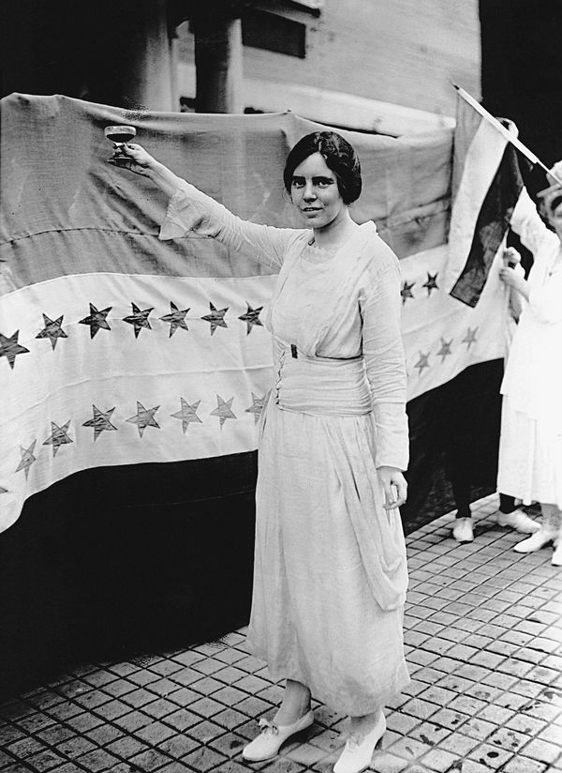
A HISTORY OF THE EQUAL RIGHTS AMENDMENT
A outline of the history of the long battle to pass what would be the 28th Amendment (last updated 1/2020)
(Research compilation from the Smithsonian, National Archives, Equal Means Equal, Alice Paul Institute, etc. websites)
1921 - Origins of the E.R.A. (The Equal Rights Amendment)
- The beginning: In 1921, right after women were given the right to vote, suffragist Alice Paul decided to fight for a law that would guarantee that all people would be treated equally regardless of their sex. Along with Attorney Crystal Eastman, now called the “founding mother of the ACLU,” she drafted the “Lucretia Mott Amendment,” named after the 19th-century women’s rights activist. It said: “Men and women shall have equal rights throughout the United States and every place subject to its jurisdiction.”
Right: Activist Alice Paul, who wrote the original Equal Rights Amendment, wearing suffragist white and raising a toast at a women's rally.
- Resistance: Paul’s insistence on a constitutional amendment proved to be controversial even in suffragist circles. Paul and other like-minded activists believed an amendment would be the fastest path to social and economic parity for women, especially because their efforts to implement similar legislation on a state level hadn’t proved successful, but they faced opposition:

  - Other prominent advocates worried that the E.R.A. went too far and would eliminate hard-won labor protections for female workers.
  - Florence Kelley, a suffragist and labor reformer, accused the N.W.P. (National Women’s Party) of issuing “threats of a sex war.”
  - There were concerns that the N.W.P.’s new direction left behind women of color, who couldn’t exercise their newfound voting rights due to racially biased voter suppression laws.
1923 – The ERA was introduced to Congress for the first time
- Nevertheless, the N.W.P. (National Women’s Party) persuaded Susan B. Anthony’s nephew, Republican Representative Daniel Anthony, Jr. of Kansas, and future vice president to Herbert Hoover Charles Curtis to introduce the earliest version of the E.R.A. to Congress in 1923.

Intervening years (1940 - 1950’s)
- Despite repeated reintroduction, the E.R.A. got nowhere in the face of continued opposition from the labor and Progressive movements. The Republican Party added the E.R.A. to its platform in 1940, followed by the Democratic Party four years later.

- In 1943, as part of an effort to make the amendment more palatable to legislators, Paul rewrote the text to echo the “shall not be denied or abridged” wording of the 15th and 19th Amendments.

- Even re-written, the proposition made no headway until 1950, when it passed the Senate. But, it was saddled with a poison pill provision from Arizona Democrat Carl Hayden that E.R.A. advocates knew would nullify its impact.

Below: The original resolution introducing the ERA. The joint resolution, introduced on December 13, 1923, proposed a 20th amendment to the Constitution that would guarantee equal treatment regardless of sex. (National Archives)
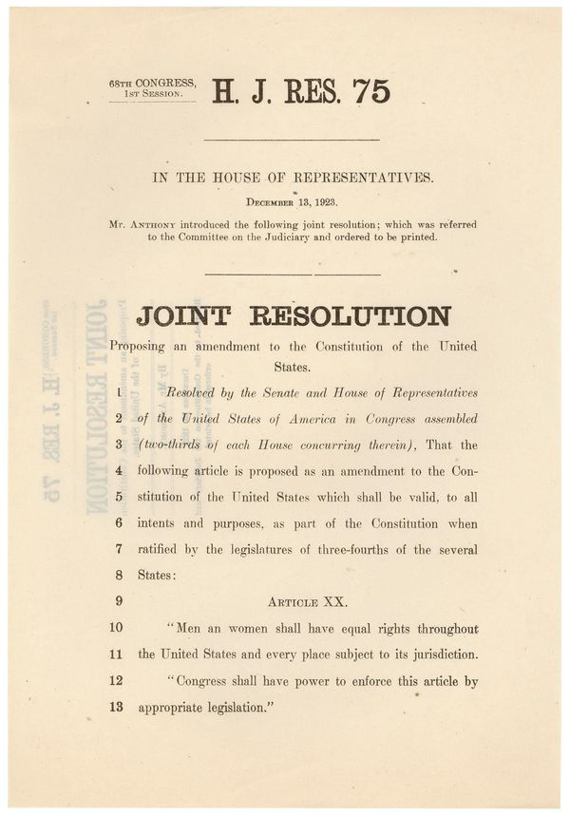
Feminism in the 1960s and 1970s: Amid social upheaval, civil rights legislation and second-wave feminism of the 1960 and ’70s, the E.R.A. gained traction.

- In 1970, Democratic Rep. Martha Griffiths of Michigan brought the E.R.A. to the floor of the house by gathering signatures from her colleagues, bypassing a crucial pro-labor committee chair who’d blocked hearings for 20 years. This moved earned her the nickname the “Mother of the E.R.A.” The amendment won bipartisan support in both chambers; the House approved it in October 1971 and the Senate in March 1972. With Congress signed on, the next stage of the process to change the Constitution began: ratification by the states.
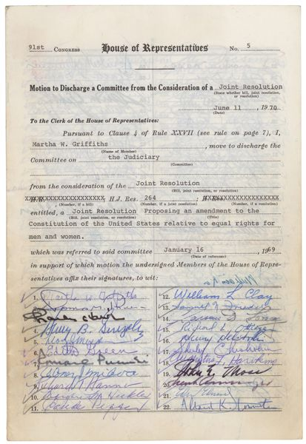
Above: Congresswoman Griffiths used the rarely used tactic of a discharge petition to get the E.R.A. on the House Floor. To do so, she needed to gather 218 signatures from her colleagues. (National Archives)discharge petition
(How amendments to the constitution happen: Article V of the Constitution says Amendments can be offered up for consideration by a two-thirds majority in the House and the Senate (or, although it’s never happened, a convention of two-thirds of the states). After passing that threshold, the would-be change has to be approved by three-fourths of the states to actually become part of the Constitution. States certify an amendment by passing it through their legislatures (or a state convention, although that method has only been deployed once, for the amendment that repealed Prohibition.) Unlike most legislation, amendment ratification does not require the governor’s signature.)
1974 and beyond: The E.R.A. does not get ratified even though Congress passed it

- In the first nine months after the E.R.A. was passed to the states, it racked up 22 ratifications in states from Hawaii to Kansas.
- That number swelled to 33 states by the end of 1974, and Gallup polls showed that almost three-fourths of Americans supported the E.R.A.
- Anti-E.R.A movements gain traction: The E.R.A. had the support of the majority of the public during the years it was up for ratification, but that enthusiasm waned over time, and its political momentum stalled, thanks to the anti-E.R.A. organizing efforts of conservative, religious women like Illinois’ Phyllis Schlafly.

  - Schlafly’s organizations, STOP (an acronym for “Stop Taking Our Privileges”) ERA and the still-active conservative interest group Eagle Forum, warned that the E.R.A. was too broad, that it would eliminate any government distinctions between men and women.

  - Soon, fear spread about mandatory military service for women, unisex bathrooms, unrestricted abortions, women becoming Roman Catholic priests and same-sex marriage.

- Did the E.R.A. supported an “anti-family” movement? Schlafly told the New York Times, that feminists who supported the E.R.A. represented “an antifamily movement that is trying to make perversion acceptable as an alternate life-style.” This message stuck and swayed politicians in states that hadn’t yet ratified the E.R.A. like Florida, Illinois, Georgia and Virginia.
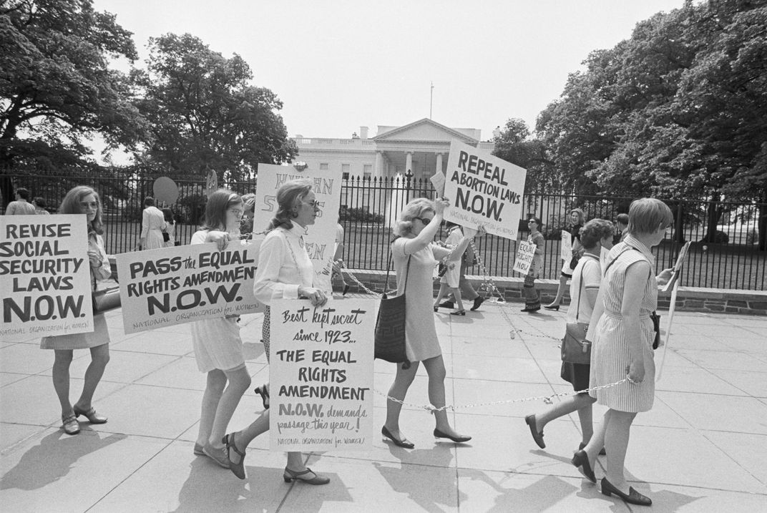
Left: National Organization for Women members demonstrated before the White House in support of the E.R.A. in 1969. (Bettman / Getty Images)
7 year limit should be plenty of time, or was it?

- Lawmakers gave the E.R.A. a seven-year deadline to obtain ratification, which was an arbitrary time limit, (a tradition that began with political maneuvering around the 18th amendment for Prohibition).

- Griffiths, the E.R.A.’s sponsor in the House, felt that it would be ratified as quickly as the recently ratified 26th Amendment, which gave 18-year-olds the right to vote.
Has the window for Ratification passed?

- Deadline extended and still no passage: As 1979 approached (the E.R.A. remained three states short), the Democratically-controlled Congress extended the deadline to 1982. But, not a single additional state signed on to the amendment.

- Deadline gone, but is it reversible? There is legal precedent: The 1982 deadline is long gone, but legal scholars have argued that it’s reversible. (The William & Mary Journal of Women and the Law makes the case that Congress can re-open the ratification window, pointing out that not all amendments (like the 19th) include a time limit and that Congress extended the deadline once before. While the Supreme Court previously ruled that amendments must be ratified within a “sufficiently contemporaneous” time, it also batted the responsibility of defining that window to Congress, as a 2018 Congressional Research Service report outlines. For example, the most recent amendment, the 27th, was adopted in 1992 with the Department of Justice’s seal of approval but that was written by James Madison in 1789 as part of the Bill of Rights and had spent 203 years in limbo.)
- Some states changed their decisions: It’s worth noting that five states—Nebraska, Tennessee, Idaho, Kentucky and South Dakota—rescinded their early ratification of the E.R.A. as socially conservative anti-E.R.A. arguments gained ground. (Legal scholars debate the validity of that rescission, as there is historic precedent implying that ratification is binding. An example: Ohio and New Jersey tried to take back their approval of the 14th Amendment in 1868, but despite this retraction, the official documents still include them on his list of ratifying states. In 1939, the Supreme Court declared that ratification reversal “should be regarded as a political question” and therefore, out of its purview.) As an added side note, Schlafly's home state, did not ratify the amendment before the 1982 deadline, but reversed course in 2018, becoming the 37th state to sign on.

- Zombie Amendment: Until January 2020, the E.R.A. remained in the company of other passed-but-never-fully-ratified “zombie amendments.” (Among them are amendments granting the District of Columbia voting representation in Congress which was passed by Congress in 1978 and ratified by 16 states before it expired, an 1810 amendment prohibiting American citizens from receiving titles of nobility from a foreign government and the Child Labor Amendment, passed by Congress in 1937 and ratified by 28 states. The Corwin Amendment, a compromise measure passed in the lead up to the Civil War and supported by Abraham Lincoln, is a lingering amendment that would have permanently barred the federal government from abolishing slavery.)

What happened in the years since the 1982 deadline passed?

- The E.R.A. didn’t altogether fade from policymakers’ consciousness after its defeat. From the ‘90s until now, congresswomen and men routinely introduced bills to disregard the ratification window or resubmit the amendment (or an updated version that would add the word “woman” to the Constitution) to the states.

- No state had approved the E.R.A. in 40 years when, in 2017, Nevada’s newly Democratic legislature ratified the E.R.A. The next year, Schlafly’s home state of Illinois followed suit. On January 15, 2020, the Virginia General Assembly approved the E.R.A., setting up a heated constitutional debate as this could be seen as the final state needed to pass the Amendment. It is unclear if the Supreme Court can now make a decision or not, but many feel they will be involved.

Since Alice Paul first proposed the E.R.A., women’s civil rights have been addressed in other ways:
States have enacted their own laws broadly prohibiting sex-based discrimination, and thanks to a feminist legal campaign led by Ruth Bader Ginsburg and the ACLU, the Supreme Court recognized sex discrimination as violating the equal protection clauses of the 5th and 14th Amendments (in cases liked Frontiero v. Richardson and United States v. Virginia.)

- Current sex-discrimination law rests on judicial interpretations of equal protection, which can vary by ideology. If ratified, the E.R.A. would give policymakers a two-year buffer period to bring existing laws into compliance, and after that, policies that differentiated by sex would be “permitted only when they are absolutely necessary and there really is no sex-neutral alternative,” explains Martha Davis, a law professor at Northeastern School of Law. It would likely still be permissible, she says, to shape laws differently to address physical characteristics that are linked to sex assigned at birth, like breastfeeding or pregnancy, and privacy qualms like separate-sex bathrooms.

- Other laws, like the mandated draft for only men or immigration policy that differs based on a parent’s gender, might change, and conservative opponents have argued that it could impact welfare programs aimed at women and children.

As for the latest status on the E.R.A.: Virginia has approved the legislation Alice Paul saw as suffrage's successor, and the 97-year-old amendment's future is up to Congress and the courts. Virginia is the 38th state to approve this constitutional change. In the Commonwealth of Virginia, the new Democratic majority voted to make Virginia the 38th state to ratify the Equal Rights Amendment (E.R.A.). Nearly a century after it was first suggested, the E.R.A. now stands a possible chance of making it into the Constitution as the 28th Amendment.

LOUISIANA’s role in the E.R.A.

“Equality of rights under the law shall not be denied or abridged by the United States or by any state on account of sex."
- The people of Louisiana had the opportunity to ratify the Equal Rights Amendment a few times. (The last time the Louisiana Senate passed the ERA was on June 7, 1972, but it was not passed by the Louisiana House of Representatives.)

SUPPORT:
- Following the March 22, 1972 passage of the Equal Rights Amendment by the U.S. Congress, a coalition dedicated to supporting the ratification of the Amendment was formed in May 1972, consisting of the Black Women’s Caucus and chapters of the League of Women Voters based in the parishes of Orleans and Jefferson.

- In 1973, Governor Edwin Edwards supported the Amendment and advised ERA supporters as to how it could be passed. The League of Women Voters of Louisiana and the National Organization for Women sent letters to U.S. Congresswoman Lindy Boggs appealing to her to convince the Louisiana legislature to approve of the ERA. However, Congresswoman Boggs was a supporter of states’ rights and did not openly advocate for the ERA when the legislature rejected the Amendment in 1975.

- One of the most important legislative allies of the Amendment was Dorothy Mae Taylor, the first African-American woman to serve in the Louisiana House of Representatives. Taylor had been involved in the Civil Rights Movement since the 1950s, successfully leading efforts to desegregate New Orleans’s public school system and the city’s recreational facilities.

- Another legislator who supported the ERA was Diana Bajoie, who was elected to the Louisiana House in 1976.

- The ERA had a multitude of supporters outside of the legislature as well. Fran Bussie was the president of ERA United during the 1970s and was the wife of Victor Bussie, leader of the Louisiana AFL-CIO. The statewide AFL-CIO was supportive towards the cause of the ERA, providing space for New Orleans-based ERA Central and advocating for women working alongside men. Bussie also served on President Jimmy Carter’s task force to pass the ERA.

- Clay Latimer was a member of the New Orleans chapter of NOW and co-founded ERA Central, a pro-ERA group based in the city. Latimer, who was also an attorney, directed a grant program entitled “The Legal Status of Women in Louisiana”. This program focused on educating Louisiana women about the state law’s “Head and Master” provision, which indicated that husbands would have control over a couple’s community property. Because of the activism of Latimer and others, the “Head and Master” provision was replaced with a system providing for equal management in 1980.
OPPONENTS:
- ERA opponents included the other woman representing Louisiana in the House of Representatives during the early 1970s, Louise Johnson, who was a fervent ERA opponent. Johnson connected with female ERA opponents through an organization called Females Opposed to Equality. When asked about her opposition to the Amendment, Johnson stated that “There are only three groups that stand to profit by passage of this amendment—the prostitutes, the homosexuals, and the lesbians.” Johnson’s message as well as her organizing of anti-ERA women, including the wives of male legislators, were effective in deterring the progress of the ERA in Louisiana throughout the 1970s.

- Two more organizations opposing the ERA in Louisiana were the Woman’s Auxiliary of the Chamber of Commerce and Louisiana Women Opposed to the ERA.

- Another organization opposing the ERA in Louisiana was the Pelican State’s chapter of the Catholic Daughters of America. The Catholic Daughters of America’s National Board came out in fervent opposition to the Equal Rights Amendment in March 1975. Two months later, in May of that year, the Louisiana chapter of CDA officially opposed the Amendment with a statement from the CDA’s state regent, Barbara Songy, denouncing the ERA. Songy described the Amendment as “a threat, not a support, to women’s rights”. The CDA supported Phyllis Schlafly’s campaign against the Amendment and invited her to speak at their convention in March 1976. The Archdiocesan Council of Catholic Women, another Catholic organization in Louisiana, opposed the Amendment.

*On July 3, 1982, ERA supporters organized a jazz funeral for the Amendment. Between 1997 and 2007, no bills were introduced proposing to ratify the ERA in the Pelican State.
*On April 18, 2007, Representative Monica Walker (D Hessmer) prefiled HCR 4 in the Louisiana House of Representatives, a bill ratifying the ERA. HCR 4 first appeared in the Interim Calendar two days later on April 20, 2007, and on April 30, 2007 it was referred to the Committee on Civil Law and Procedure. The Committee considered the bill on May 15, 2007, but did not progress beyond the Committee.
*On April 28, 2009, Senator Yvonne Dorsey (D-Baton Rouge) introduced SCR 7 in the Louisiana Senate, ratifying the ERA. The bill was read twice and referred to the Senate Committee on Senate and Governmental Affairs. On June 3, 2009, SCR 7 was considered but was voted down by a margin of 3 to 2. Senators Edwin Murray (D-New Orleans) and Lydia Jackson (D Shreveport) voted in favor while Senators Mike Walsworth (R- West Monroe), Jody Amedee (D Gonzales), and Jack Donahue (RCovington) voted against the ratification bill. Two other Senators on the Committee did not participate in the voting: Senator John Smith (D-Leesville) was absent, while the chairman of the Committee, Senator Bob Kostelka (R-Monroe), did not vote on the measure.
*On April 24, 2017, Senator Dorsey, now Senator Colomb, introduced SCR 45 in the Louisiana House of Representatives, a bill memorializing Congress to extend or eliminate the time limit on the ERA. On May 31, 2017, the bill was reported with amendments. A day later on June 1, 2017, the Senate Committee amendments were read and adopted, having been approved by the Committee. That same day, SCR 45 moved to the Senate floor read by title and returned to the Calendar, subject to call, the last action of the session.
- As of today, Louisiana has not ratified the Equal Rights Amendment. In fact, at one point, Louisiana could have been the last state needed to ratify the Amendment (In the session starting April 4, 2019, Louisiana had that chance, but failed. New Orleans Democratic Sen JP Morrell hoped to ratify the Equal Rights Amendment on Wednesday, May 8, 2019. The state Senate rejected Morrell's proposal.,,The resolution, SCR 2, died on a 9-26 vote.

    - Benjamin Clapper, Executive Director of Louisiana Right to Life, said in a statement following the vote, "Leading pro-abortion groups have acknowledged that the ERA would codify abortion rights in America, requiring judges to strike down all pro-life state laws. Because of this pro-abortion impact, we opposed the ratification, and applaud the Senate for showing their commitment to protecting life."
    - “I’m disheartened by my colleagues’ decision to not pass the Equal Rights Amendment through the Senate. Louisiana had the chance to make history, protect women from discrimination, and take an important step toward equality in our state and nation. Unfortunately, we failed,” Karen Carter Peterson, Chair of the Louisiana Democratic Party said in a statement. “Women deserve a future free from discrimination; this isn’t the end of that fight for me and other Louisiana Democrats.”
    - Voting for ratifying the Equal Rights Amendment (9): Sens. Bishop, Boudreaux, Carter, Colomb, Luneau, Morrell, Peterson, Price, and Tarver.
    - Voting against SCR2 (26): President Alario, Sens Allain, Appel, Chabert, Claitor, Cortez, Donahue, Erdey, Fannin, Gatti, Hensgens, Hewitt, Johns, Lambert, Long, Martiny, Milkovich, Mills, Mizell, Peacock, Riser, G. Smith, J. Smith, Thompson, Walsworth and White.
    - Not Voting (4): Sens. , Barrow, LaFleur, Morrish and Ward.

- December 2019: In the wake of Virginia’s passage as the 38th state, Louisiana joins lawsuit seeking to block Equal Rights Amendment ratification. The lawsuit notes that Congress set a 1982 deadline to get the required 38 states to agree. They contend that the amendment isn't needed and would enable the removal of abortion restrictions. The three states behind the lawsuit are Alabama, Louisiana and South Dakota.
  - Advocates for the amendment have argued that the 1982 deadline is not binding and that rescinding a ratification has no legal validity.
  - But the three states in Wednesday's lawsuit that are suing the archivist of the United States, David Ferriero, argue that he is "acting illegally" by continuing "to hold open the ratification process" and refusing to recognize some states' rescissions of the amendment. "The people had seven years to consider the ERA, and they rejected it. To sneak it into the Constitution through this illegal process would undermine the very basis for our constitutional order," notes Alabama Attorney General Steve Marshall. Marshall said state law versions of the ERA have been interpreted to "invalidate reasonable restrictions" on abortion or require that boys be allowed to compete in sports against girls. He argued that the amendment could threaten state-funded institutions that separate sexes, like women's shelters, prisons and colleges.

