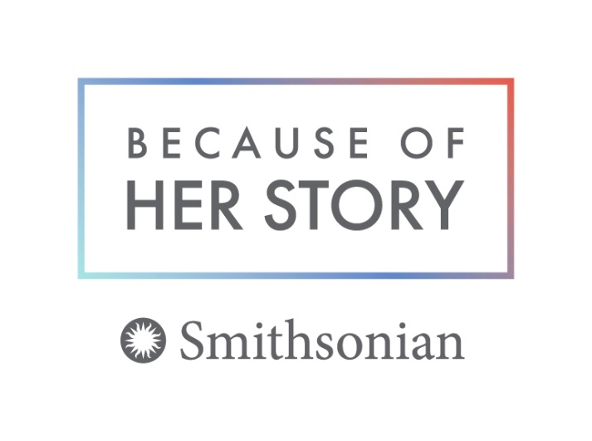
Can you imagine telling the story of your country by using only half of the alphabet?
Could you tell stories about the people who live at your house by only talking about half of those people?

The Smithsonian Institution in Washington, D.C. has created a poster exhibit called “Votes for Women: A Portrait of Persistence!” to help tell the lost stories of women as part of our country’s defining moments. Often, “her story” was not included in history, so some of these remarkable stories may surprise and inspire you!
Your institution can borrow these posters through Louisiana’s Old State Capitol at no charge for a six-week period. There are ten 18 x 24 lightweight framed posters that you can hang using hooks or Velcro.
Reserve this exhibit by calling (225) 342-0500 x425 or e-mailing the Curator at lauren.davis@sos.la.gov.
Educators will find a wealth of relevant resources at https://womenshistory.si.edu/herstory organized via themes like sports, education, science, etc. that include songs, stories, and activities for all ages. For pre-readers, Louisiana’s Old State Capitol has provided coloring pages to be copied. More educational resources can be found at louisianaoldstatecapitol.org.
Visit Louisiana’s Old State Capitol in person or on-line to see “Lionhearted Ladies: Championing the Right to Vote” which tells the story of Louisiana’s struggle to grant women the right to vote. This right became law when the 19th Amendment was passed 100 years ago.

