This lesson examines the different formats and uses of Jacob Riis’s images in the late 19th century. Students will learn about technological innovations, such as the flash powder, the stereograph, the magic lantern, and the halftone print, and how differences in these formats shaped the impact of Riis’s images. They will also consider the ethical ambiguities of Riis’s early photographic techniques.

- Students will learn how technological innovations of Jacob Riis’s era enabled him to strengthen his messages with images.
- Students will engage in close readings of Riis’s images and will compare the different formats in which Riis’s images were originally seen.
- Students will learn new vocabulary that will help them assess the effect of an image on the viewer.
- Students will read accounts to analyze how his photographic process and illustrated lectures were originally perceived.

Flash powder Stereograph Magic lantern Halftone
Engraving Narrative Tone
Visual vocabulary o Composition o Perspective o Subject o Setting

CCSS.ELA-LITERACY.RI.5.6
Analyze multiple accounts of the same event or topic, noting important similarities and differences in the point of view they represent.
CCSS.ELA-LITERACY.RL.8.1
Cite the textual evidence that most strongly supports an analysis of what the text says explicitly as well as inferences drawn from the text.

CCSS.ELA-LITERACY.RL.9-10.1
Cite strong and thorough textual evidence to support analysis of what the text says explicitly as well as inferences drawn from the text.

Although Jacob Riis is best known today for his photographs, he was a journalist and best-selling author, and did not consider himself a photographer at all. He began taking photographs as a way to illustrate his writings, and was at the forefront of photographic journalism because of his early adoption of flash powder. He took advantage of this new technology to capture images that had previously been impossible to photograph--the city by night and dark interior scenes.

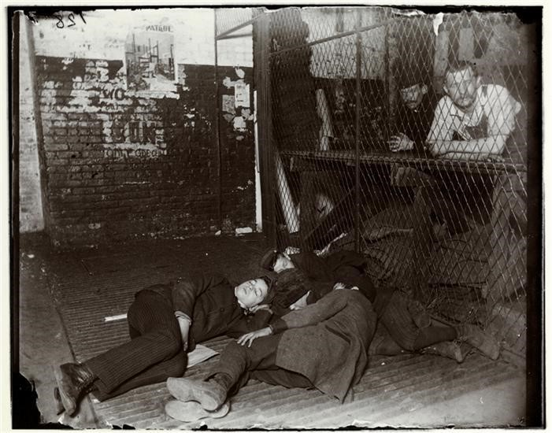
Resource 1

“2 a.m. in the delivery room in the ‘Sun’ office,” Jacob Riis, 1890. From the collection of the Museum of the City of New York, 90.13.1.131.

- How can you tell that Riis used flash powder to take this picture?
- What are the people in this photograph doing? And where were they photographed?
- Why do you think Riis wanted to capture this scene?

“With their way illuminated by spasmodic [bursting] flashes, as bright and sharp and brief as those of the lightning itself, a mysterious party has lately been startling the town o’nights…all the people of the wild and wonderful variety of New York night life have in their turn marveled at and been frightened by the phenomenon. What they saw was three or four figures in the gloom, a ghostly tripod, some weird and uncanny movements, the blinding flash, and then they heard the patter of retreating footsteps, and the mysterious visitors were gone before they could collect their scattered thoughts and try to find out what it was all about.”

Excerpt from Jacob Riis in “Flashes From the Slums,” The Sun, 1888.

“It is not too must to say that our party carried terror wherever it went. The flashlight of those days was contained in cartridges fired from a revolver. The spectacle of half a dozen strange men invading a house in the midnight hour armed with big pistols which they shot off recklessly was hardly reassuring, however sugary our speech, and it was not to be wondered at if the tenants bolted through windows and down fire-escapes wherever we went…Twice I set fire to [my] house with the apparatus [flash mechanism], and once to myself. I blew the light into my own eyes on that occasion, and only my spectacles saved me from being blinded for life.”

Excerpt from Jacob Riis in The Making of an American. New York: The MacMillan Company, 1901.
- How does The Sun describe the people taking the photographs?
- How did both passages describe the subjects’ reactions to being photographed?
- What words does Jacob Riis use to capture the experience of taking flash photographs in his autobiography The Making of an American? Underline the key words.
- How does Riis’s description compare to the account from The Sun? What is different about the narrative (story) and tone (attitude) in both passages?

Starting in 1888, Jacob Riis travelled the country presenting illustrated lectures about life among New York’s poor. Using an early form of projector known as a “magic lantern,” he showed dozens of slides and accompanied them with 2 hours of commentary about the people he photographed, their surrounding environment, and stories about his experience photographing them. Jacob A. Riis delivered his first lecture, “How the Other Half Lives and Dies in New York,” on January 22, 1888, at the Society of Amateur Photographers of New York. He invited the press, and in 1889 a version of his lecture was published in Scribner’s Magazine, which he turned into his book How the Other Half Lives. This book became a national bestseller, making Riis a well-known public figure and social reformer. Throughout the rest of his life, Riis worked steadily as a touring lecturer. He was in high demand, and in 1901, he gave 19 lectures in February alone.

In his lecture last night at the Association Hall, Jacob A. Riis, the well-known police
In his lecture last night at the Association Hall, Jacob A. Riis, the well-known police reporter, gave a graphic account of the “Other Half”…His practiced observations on the state of some of the tenement-house districts of New York were frequently greeted with applause, and the audience, which nearly filled the hall, took a serious and sympathetic interest in the gloomy picture which he presented. The stereopticon [3D] views of the dark alleys, courts, cellars, sheds and other resorts of wretchedness, poverty and crime that lurk in dark corners of the metropolis gave his hearers a realistic assurance of the existence of such dens of infamy [wickedness] as few of them had ever suspected.
Excerpt from “How the ‘Other Half’ Lives,” New York Daily Tribune, May 11, 1888.

- What did the reporter think was effective about the magic lantern show?
- How would the lecture have been different if it had just been Jacob Riis describing what he had seen without visual aids?
- How does the reporter describe the audience’s reactions to the lecture?
- According to this review, what seemed novel (new) about the ways that these images were seen and shared?

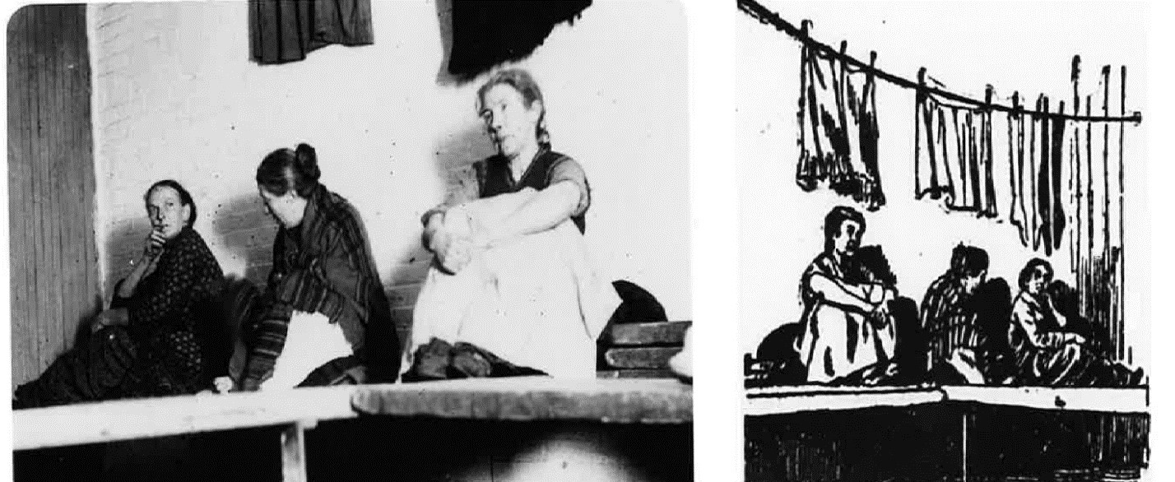
While many people were drawn to Riis’s photographs, in his first book his images were not produced as photographs but rather as line drawings based on the photographs. In the 1880s and 1890s, most people would have encountered his images as single-line wood engravings, unless they were attending his slideshows.
“Women’s Lodging Room in West 30th Street Station,” Jacob Riis, 1887-1888. Side-by-side comparison of photograph and engraving based on photograph, Yochelson, Bonnie. Jacob Riis: Revealing New York's Other Half.

- What differences do you see between these two versions of the same image?
- Which one are you more drawn to? Why?
- Do you think a drawing might be more useful for communicating ideas in some cases, and a photograph in others?
By the mid-1890s, after Jacob Riis first published How the Other Half Lives, halftone images became a more accurate way of reproducing photographs in magazines and books since they could include a great level of detail and a fuller tonal range. The arrival of the halftone meant that more people experienced Jacob Riis’s photographs than before.
Can you think of other ways visual technology has changed since Jacob Riis’s time? How have these new inventions changed the way we see and share images?

In the 1880s, when Jacob Riis was giving his magic lantern presentation on life on the Lower East Side, there were dozens of newspapers in New York City, including newspapers that were geared toward immigrant readers, such as Il Progresso (an Italian-American paper) and the Staats-Zeitung (a German-American paper). Imagine you are a reporter for one of those immigrant newspapers, and have been assigned to cover Jacob Riis’s magic lantern show, “The Other Half: How it Lives and Dies in New York.” Write a review for your newspaper.
Consider:
What did Riis intend to communicate through his photographs and how does he get that message across?
Do you think his images are respectful of immigrants and poor people? Why or why not?
Do they best capture the hardships faced by many in the community? Keep in mind: Who is your article being written for? How might your readers react to Riis’s images?

