Students will analyze visual and textual primary sources and learn about working conditions for immigrants in turn-of-the-century New York. In particular, students will gain an understanding of how labor frequently blurred the line between work and home, at times involving whole families. They will also consider how different reformers envisioned solutions to the labor problems of the day.

- Students will consider particular challenges faced by turn-of-the-century New York City immigrants and weigh those challenges against proposed solutions.
- Students will assess primary sources for information and will analyze strategies used by activists and reformers in visual and text-based sources.
- Students will compare and contrast their analysis of Jacob Riis’s writing to other and other labor documents, and create a banner that garment workers might wear publically to make their issues visible.

- Tenement
- Sweatshop
- Piecework
- Garment industry
- Regulation
- Wages
- Union
- Strike
- Consumer
CCSS.ELA-LITERACY.RI.5.8
Explain how an author uses reasons and evidence to support particular points in a text, identifying which reasons and evidence support which point(s).
CCSS.ELA-LITERACY.RI.6.6
Determine an author's point of view or purpose in a text and explain how it is conveyed in the text.
CCSS.ELA-LITERACY.RI.9-10.6
Determine an author's point of view or purpose in a text and analyze how an author uses rhetoric to advance that point of view or purpose.

In the late 19th century, New York City experienced its second massive wave of immigration. From 1870 to 1900, millions of new immigrants, mostly from eastern and southern Europe, poured into the city, with the majority settling in New York rather than moving on to other parts of the country. Many of these immigrants, especially Russian Jews, found work in the garment industry. Immigrants gravitated toward garment work for several reasons. First, many immigrants had done garment work or tailoring back in their home countries, and those who had not could be trained to do the more unskilled parts of the process. Second, particularly in the 19th century, much garment work was done through a network of contractors who were themselves immigrants. New arrivals to the city who were discriminated against in other jobs or struggled with the language barrier often wound up working for people who shared their background. Lastly, the structure of the labor blurred the line between home and work—many sweatshops were based in the tenement apartment of the contractor, or involved whole families including children, doing piecework out of their own apartments. In families where parents needed to work and watch their children at the same time, or where children needed to contribute to the family income while circumventing any existing labor laws, sweatshop work was common.
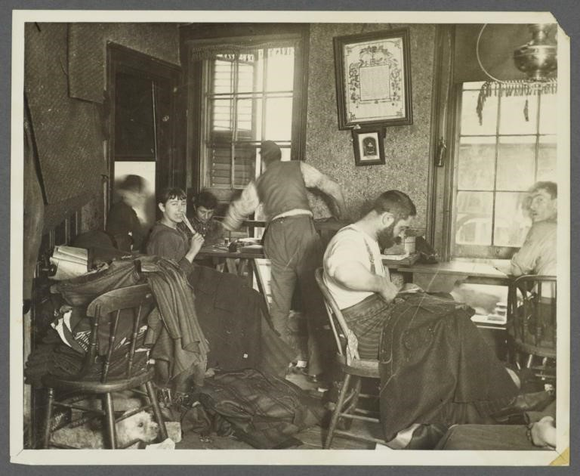

“Knee-pants" at forty five cents a dozen -- A Ludlow Street Sweater's Shop, Jacob Riis, ca 1889. From the collection of Museum of the City of New York, 90.13.1.151.

Document Based Questions
- What are the people in the photograph doing?
- How would you describe this scene?
- Where are the people in the image working? How can you tell?

Resource 2
Jacob Riis, in his work as a police reporter, journalist, author, and photographer “after a fashion,” travelled widely around the Lower East Side. In the 1880s and early 1890s, he frequently opened doors and surprised people he photographed, as in the previous photograph. In this excerpt from his first book, How the Other Half Lives, he compares working conditions in a tenement sweatshop with those in a factory, and particularly considers the sweatshop’s impact on children.
The bulk of the sweater’s work is done in the tenements, which the law that regulates factory labor does not reach… Ten hours is the legal work-day in the factories, and nine o’clock the closing hour at the latest. Forty-five minutes at least must be allowed for dinner, and children under sixteen must not be employed unless they can read and write English; none at all under fourteen... But the tenement has defeated its benevolent [wellmeaning] purpose. In it the child works unchallenged from the day he is old enough to pull a thread. There is no such thing as a dinner hour; men and women eat while they work, and the “day” is lengthened at both ends far into the night. Factory hands take their work with them at the close of the lawful day to eke out their scanty earnings by working overtime at home. Little chance on this ground for the campaign of education that alone can bring the needed relief; small wonder that there are whole settlements on this East Side where English is practically an unknown tongue, though the people be both willing and anxious to learn. “When shall we find time to learn?” asked one of them of me once. I owe him the answer yet.
Excerpt from Jacob Riis in How The Other Half Lives: Studies among the Tenements of New York. New York: Charles Scribner’s Sons. 1890.

- In the first sentence of this passage, what does the word “sweater” mean? What is a
“sweater,” in this situation?
- Why does Jacob Riis think sweatshop work in a tenement is worse than factory work?
- What kinds of regulations [rules] are there for factory work? How is that different for people working in a tenement?
- What does he mean when he says “English is practically an unknown tongue”? What is the relationship to immigrants’ working conditions?
- How does Riis depict the immigrants he speaks with? What is his tone or attitude toward them?
- Why does he refer to himself in the last sentence?

By the early 1900s, tenement sweatshops still existed, but a large scale of garment work had become factory-based. In this document, Clara Lemlich, a young Ukrainian garment worker, describes the conditions in the factories. She became one of the key labor organizers in the Uprising of 20,000 in 1909 and a consumer activist.

First let me tell you something about the way we work and what we are paid. There are two kinds of work—regular, that is salary work, and piecework [being paid by how many pieces of clothing you finish, instead of being paid for how long you work]. The regular work pays about $6 a week and the girls have to be at their machines at 7 o’clock in the morning and they stay at them until 8 o’clock at night, with just one-half hour for lunch in that time.

The shops. Well, there is just one row of machines that the daylight ever gets to — that is the front row, nearest the window. The girls at all the other rows of machines back in the shop have to work by gaslight, by day as well as night. Oh, yes, the shops keep the work going at night, too.

…The shops are unsanitary—that’s the word that is generally used, but there ought to be a worse one used. Whenever we tear or damage any of the goods we sew on, or whenever it is found damaged after we are through with it, whether we have done it or not, we are charged for the piece and sometimes for a whole yard of the material.
At the beginning of every slow season, $2 is deducted [taken away] from our salaries. We have never been able to find out what this is for.
“Life in the Shops,” Clara Lemlich, New York Evening Journal, 1909.
- How is Clara Lemlich’s point of view different from Jacob Riis’s?
- How many hours a day do girls in the factory work? How much time are they given for a lunch break?
- How does her account compare to Jacob Riis’s? What additional information does she give about factory workers and shopworkers?
- What are other challenges she describes that seem unfair about factory work?
- What do you think the workers should do to try to improve their conditions?

In response to their poor working conditions, garment workers like Clara Lemlich started to form unions. They fought for shorter working days, higher pay, and safer workplaces. In the winter of 1909-1910, 20,000 garment workers went on strike, winning some concessions. But their efforts were one step in a long process of regulation and unionization that continues to this day.
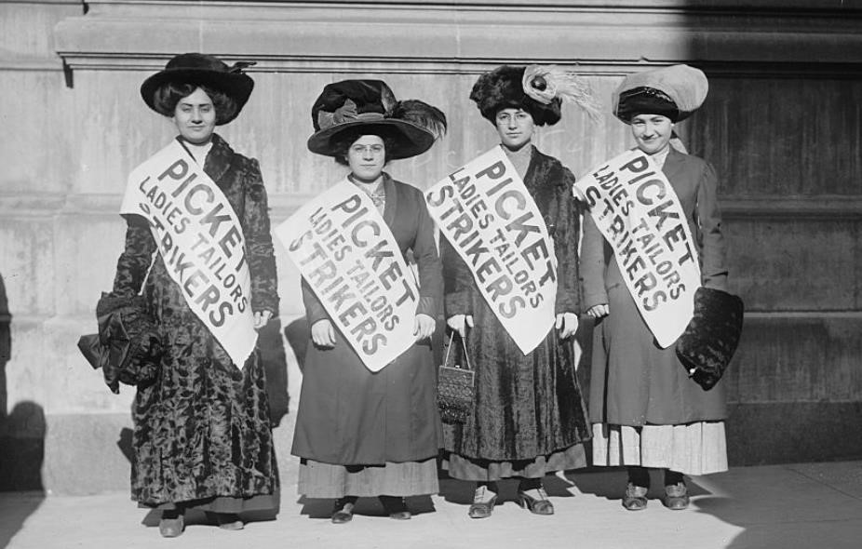Strike pickets, Bain News Service, 1910 Feb. (date created or published later by Bain). From the

Bain Collection, Library of Congress Prints and Photographs Division Washington, D.C. 20540 USA http://hdl.loc.gov/loc.pnp/pp.print. LC-DIG-ggbain-04508 (digital file from original neg.)

- What can we learn about these women from reading their banners?
- What statement are they making?
- Pick a woman in the photograph and write down what you think she would say if a reporter asked her why she is on strike.

Labor activists, then and now, work hard to make people understand what they are fighting for. They march, write letters, make speeches, strike, and they carry signs. The women in the previous picture are wearing sashes to tell people what they are protesting. Imagine you were a garment worker 100 years ago. Design a banner [flag] for you and your fellow protestors to carry. What would you want it to say? How could you use words and pictures to get your message across?

