By examining a selection of photographs and textual excerpts by Jacob Riis, students will consider Riis’s different techniques for capturing the plight of individuals in neighborhoods like the Lower East Side in the late 19th century. They will consider how his portrayals evolved, and debate the ethics of Riis’s approach to depicting working class New Yorkers.

- Students will analyze primary visual and textual sources.
- Students will identify the compositional and rhetorical devices in the texts that Riis used to make an argument.
- Students will debate the “truthfulness” of Riis’s work.
- Students will draw from their observations of Riis’s subjects to construct their own portrayals of the subjects
Portrait Subject Focal Point Composition
Cropping Framing Leading Lines Candid Pose
CCSS.ELA-LITERACY.RI.4.8 : Explain how an author uses reasons and evidence to support particular points in a text; CCSS.ELA-LITERACY.RI.6.1 : Cite textual evidence to support analysis of what the text says explicitly as well as inferences drawn from the text; CCSS.ELA-LITERACY.RH.11-12.2: Determine the central ideas or information of a primary or secondary source; provide an accurate summary that makes clear the relationships among the key details and ideas.

Jacob Riis began using photography as a tool to document conditions he hoped to expose on New York’s Lower East Side. However, he considered himself a writer and not a photographer. A recurrent subject in his work was the overcrowded and poor housing conditions in the Lower East Side. According to his book How the Other Half Lives (1890), there were barely any apartment vacancies in the neighborhood. The housing shortage, coupled with widespread low wages, drove many immigrants into severely crowded overnight lodging. Riis described the lodgings as a source of disease and despair, but also criticized census and health department officials as being ineffective in combating the problem. Riis accompanied a police officer in his late-night investigation of one such tenement and, aided by newly invented flash powder, took the photograph shown on the following page. In many of his early photographs Riis used the flash powder and the element of surprise to capture candid images of his subjects.
Although Jacob Riis was not a trained photographer, he still made decisions about the composition of his photographs. The “visual analysis questions” are suggested for middle and high school students to help them analyze the visual impact of his images.

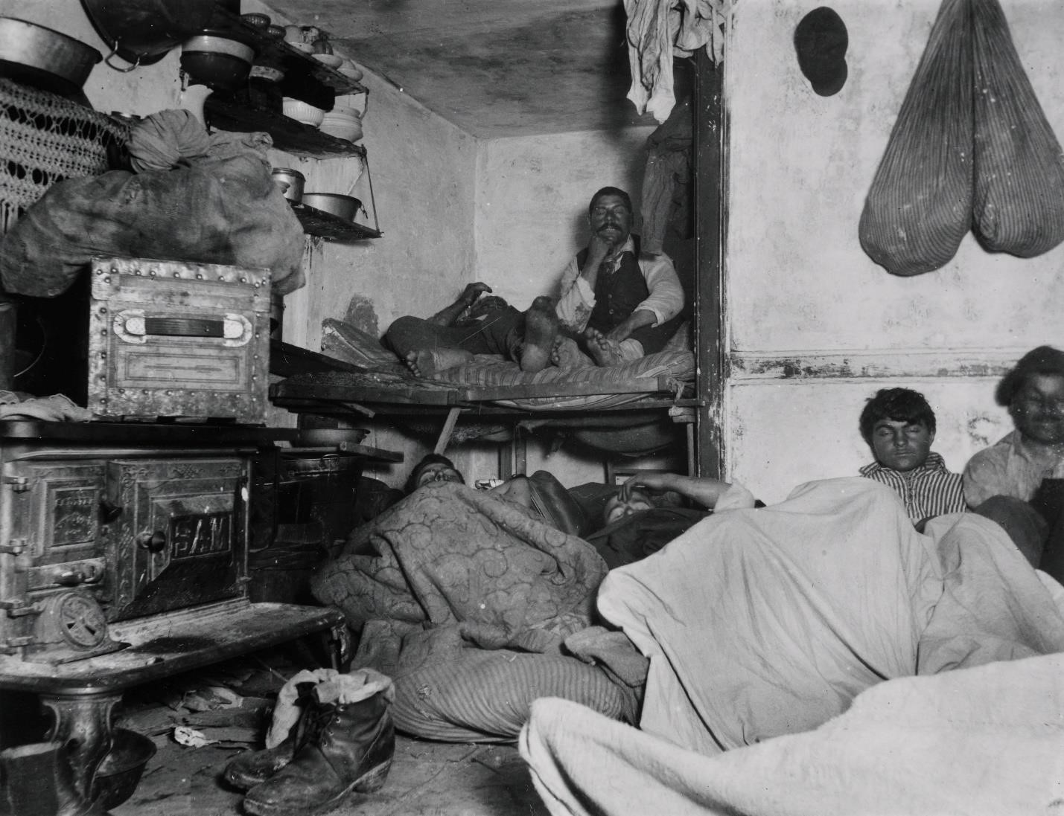
“Lodgers in a Crowded Bayard Street Tenement—‘Five Cents a Spot,’” Jacob Riis, ca 1890. From the collection of Museum of the City of New York, 90.13.1.158.

- What are the people doing in this photograph? What else do you see in their surroundings? How might it have felt to be one of the people in this image?
- Describe the lighting in the photograph. Where is the light coming from in this photograph?
- This is a candid shot, which means that people in the image were not aware that someone was about to take their picture. Does this affect your interpretation of the photograph?
- Why do you think Jacob Riis would have wanted to take this photograph?
- Do you think Jacob Riis had the right to take these photographs?
- Is there a focal point (where your eye is drawn to) in this image?
- Describe the composition (the arrangement of elements within the frame).
- Are there leading lines in the image? (Leading lines are how the photographer uses lines and the surrounding geometric elements to emphasize the subject).
- Photographers can choose to cut out certain elements of the scene or composition through cropping the image. What do you notice about Riis’s use of framing in this image? What does he choose to include in the frame? What do you imagine he cuts out? How does this impact the meaning of the image?

In a room not thirteen feet either way slept twelve men and women, two or three in bunks set in a sort of alcove, the rest on the floor. A kerosene lamp burned dimly in the fearful atmosphere, probably to guide other and later arrivals to their “beds,” for it was only just past midnight. A baby’s fretful wail came from an adjoining hall-room, where, in the semi-darkness, three recumbent [lying down] figures could be made out. The “apartment” was one of three in two adjoining buildings we had found, within half an hour, similarly crowded. Most ot he men were lodgers, who slept there for five cents a spot.
Excerpt from Jacob Riis, How The Other Half Lives: Studies among the Tenements of New York. New York: Charles Scribner’s Sons. 1890.
- What new information can we learn from this excerpt [portion of a longer text] that adds to our knowledge of what is happening in the photograph entitled Lodgers in a Crowded Bayard Street Tenement—Five Cents a Spot?
- What are some of the adjectives Jacob Riis uses to describe the scene? How do they compare to the words you used when you described the photograph?
- What response do you think Jacob Riis wants his audience to have when they read his writing or view his photograph? What led you to this conclusion?

The children of the city were a recurrent subject in Jacob Riis’s writing and photography. Riis believed, as he said in How the Other Half Lives, that “the rescue of the children is the key to the problem of city poverty, as presented for our solution today; that character may be formed where to reform it would be a hopeless task.” In accompanying texts he commonly emphasized his young subjects’ resourcefulness and intelligence, in the hope that he would engender sympathy for them and promote the idea that the city’s children were among the undeserving poor who could succeed if reformers helped improve their circumstances. He took several photographs of children he described as “street Arabs,” an archaic term for homeless or partly homeless children who wander in the streets. In contrast to “Five Cents a Spot,” this image consists of three children who have been posed by Riis.
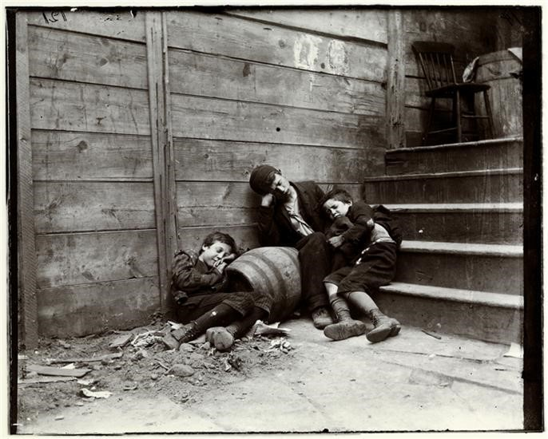
“Street Arabs—night, Boys in Sleeping Quarter,” Jacob Riis, 1890. From the collection of Museum of the City of New York, 90.13.1.124.
- Describe what you see in this photograph.
- Why do you think Jacob Riis chose to photograph this scene? How might you expect viewers to react?
- Unlike in “Five Cents a Spot,” which was a candid photograph, Jacob Riis posed the children in this picture. Although it is meant to show children sleeping at night, the photograph was not taken at night and the children know they are being photographed. Do you think that makes the photograph less effective? Why or why not?

- What is the focal point (where your eye is drawn to) in this image?
- Describe the composition (the arrangement of elements within the frame).
- Are there leading lines in the image? What do they draw your attention to?
- Photographers can choose to cut out certain elements of the scene or composition through cropping the image. What do you notice about Riis’s use of framing in this image? Besides the subjects, what does he choose to include in the frame? What do you imagine he cuts out? How does this impact the meaning of the image?
- Describe the texture (what the materials would feel like) in the photograph. How do these observations affect your reading of the photograph?

Jacob Riis often photographed children he described as “little mothers,” who bore responsibility for cooking and cleaning for their families or taking care of other children in their households. “Little Katie,” portrayed in his 1892 book The Children of the Poor, was one such child.
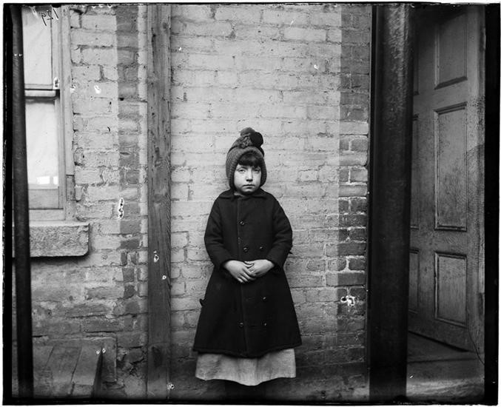

“‘I scrubs.’ Little Katie from the W. 52nd Street Industrial School,” Jacob Riis, ca 1890. From the collection of Museum of the City of New York, 90.13.1.132

The serious responsibilities of life had come early to Katie. On the top floor of a tenement [crowded, low-cost apartment building] in West Forty-ninth Street she was keeping house for her older sister and two brothers, all of whom worked in the hammock factory, earning from $4.50 to $1.50 a week. They had moved together when their mother died and the father brought home another wife…Katie did the cleaning and the cooking…The picture shows what a sober [serious], patient, sturdy little thing she was, with that dull life wearing on her day by day. At the school they
loved her for her gentle ways. She got right up when asked and stood for her picture without a question and without a smile.
“What kind of work do you do?” I asked, thinking to interest her while I made ready.
“I scrubs,” she replied, promptly, and her look guaranteed that what she scrubbed came out clean.
Excerpt from Jacob Riis, The Children of the Poor, New York: Charles Scribner’s Sons. 1892.
- Based on the photograph entitled I scrubs. Little Katie from the W. 52nd Street Industrial
School and the excerpt from Riis’s The Children of the Poor, how would you describe Katie?
- What role does she play in her household?
- How is Katie, the subject of this photograph, interacting with the viewer?
- How does the composition of the photograph affect the way you feel about Katie?
(Composition means the arrangement of the different parts of the photograph).
- How does the composition of this photograph compare to the other photographs presented in these lesson plans?

- What is the focal point (where your eye is drawn to) in this photograph?
- Are there leading lines in the image? How do the lines in this photograph and the surrounding geometric elements emphasize the subject?
- Photographers can choose to cut out certain elements of the scene or composition through cropping. What do you notice about Riis’s use of cropping in this image? What does he choose to include in the frame? And what do you imagine he crops out? How does this impact the meaning of the image?
- Describe the texture (what the materials would feel like) in the photograph.
- How might this photograph be different if she were standing with another child?

This activity can be done as an exercise for the entire class to do together or for students to do in groups.
- On butcher paper, draw an outline of a person, who will represent Little Katie.
- Inside the outline, have students write down what Katie might be thinking or feeling based on Jacob Riis’s account and photograph that they analyzed.
- Outside the outline, have students write down the parts of her environment that affect Katie, and what viewers of Riis’s photographs might think or feel about her.
- Discuss your completed illustration as a group. Are there differences between the responses that you wrote inside Katie and outside of her? How does Jacob Riis’s photograph and written description impact what we understand about Katie?

As an optional follow-up activity, have the students write a diary entry from the perspective of one of the other people in the photographs they looked at today. Students should infer how the subjects of these photographs think of themselves. What might their interaction with Jacob Riis have been like?

