By analyzing historic images, students will learn about the public health issues New Yorkers faced in the late 19th century. They will also understand how Jacob Riis used his photographs to advocate for building playgrounds and parks in especially dense neighborhoods. Students will then consider the role of playgrounds and parks in their own neighborhoods and design a new recreational space.

- Students will analyze visual and textual primary sources.
- Students will consider the public health issues experienced by residents of the Lower East Side, and how Jacob Riis used his writing and photographs to address those issues. • Students will apply their findings by designing a park for the present-day city.

- Immigration
- Tenement
- Density
- Recreation
- Adaptation

CCSS.ELA-LITERACY.RI.4.3
Explain events, procedures, ideas, or concepts in a historical, scientific, or technical text, including what happened and why, based on specific information in the text.

CCSS.ELA-LITERACY.RH.6-8.7
Integrate visual information (e.g., in charts, graphs, photographs, videos, or maps) with other information in print and digital texts.

CCSS.ELA-LITERACY.RH.11-12.7
Integrate and evaluate multiple sources of information presented in diverse formats and media (e.g., visually, quantitatively, as well as in words) in order to address a question or solve a problem.

In the late 19th century, New York experienced a massive wave of immigration. Between 1870 and 1900, nearly 12 million people immigrated to the United States, with the majority entering through New York and settling there. Immigration was a major factor in the city’s notable population growth in this era, and the city’s population more than tripled between 1870 and 1900. This growth put pressure on neighborhoods like the Lower East Side. Large families crowded into small apartments in tenement buildings that were close together and, in many cases, lacked indoor plumbing or running water. By the turn of the century, the Lower East Side was the most densely populated place in the world, and this density took a toll on the health of its residents. Lack of running water or fresh air led to the spread of diseases like typhoid and tuberculosis. Because many people lived in a single apartment, and each apartment was so close to neighboring apartments, these diseases spread rapidly throughout the Lower East Side. The neighborhood had a higher mortality rate than the rest of the city, with children especially at risk.
Many reformers attempted to counteract the high rate of illness and death on the Lower East Side. One important strategy focused on providing the city’s children with more places to exercise and access fresh air. Writers like Jacob Riis used photography to provide powerful visual evidence of the need for open recreational spaces for New Yorkers, especially children.

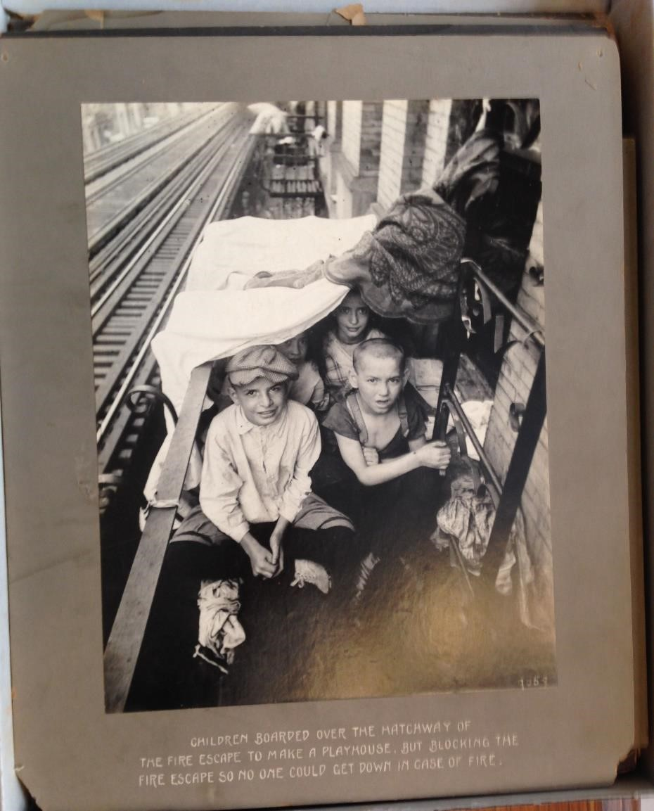

“Children Boarded Over the Hatchway of the Fire Escape to Make a Playhouse,” New York City Tenement House Department, 1903, New York Public Library.
- Describe what the children are doing in this photograph.
- What do you see around them? What could be unpleasant or dangerous about playing this way?
- Why might the children have chosen this location? What can we infer about their daily lives from viewing this image?
- Based on the caption of this image, what do you think Jacob Riis wanted people to feel when they viewed this picture? What kind of change do you think he was advocating for?

Starting in the 1880s reformers saw playgrounds as important places to improve quality of life for children. Early playgrounds ranged from open spaces, to sandboxes, to early experiments with playground equipment like monkey bars and slides. In dense cities where space was scarce, playgrounds on rooftops specially adapted to the environment proliferated.
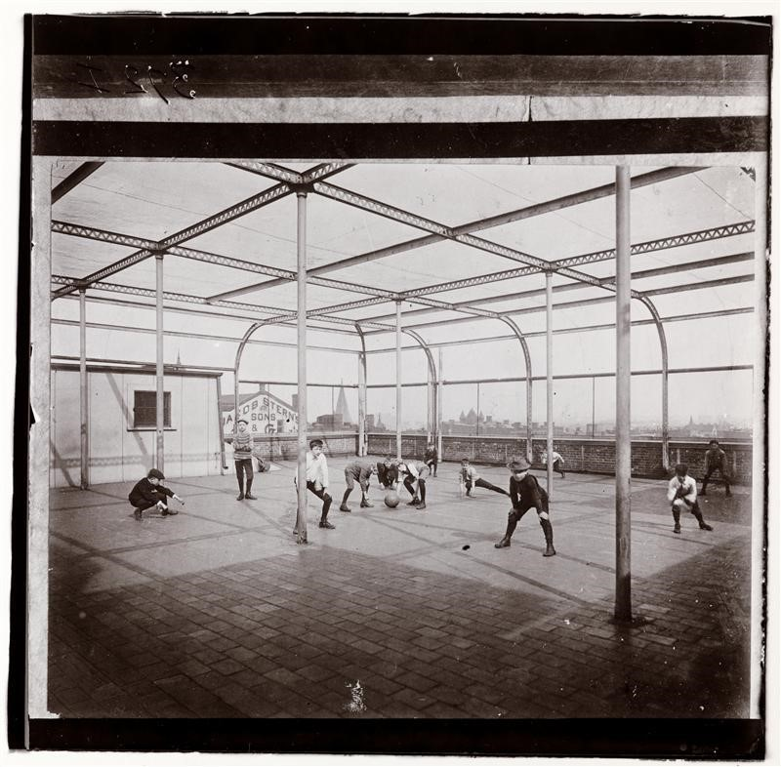
“Roof Playground (boys)—Public School,” Jacob Riis (Chicago Albumen Works), ca. 1897. From the collection of Museum of the City of New York, 90.13.4.366.

- Where are these children playing?
- How does this space compare to the one in the previous picture entitled Children Boarded Over the Hatchway of the Fire Escape to Make a Playhouse? How is this scenario trying to improve on where children play?
- What additions would you make to this space to improve it?

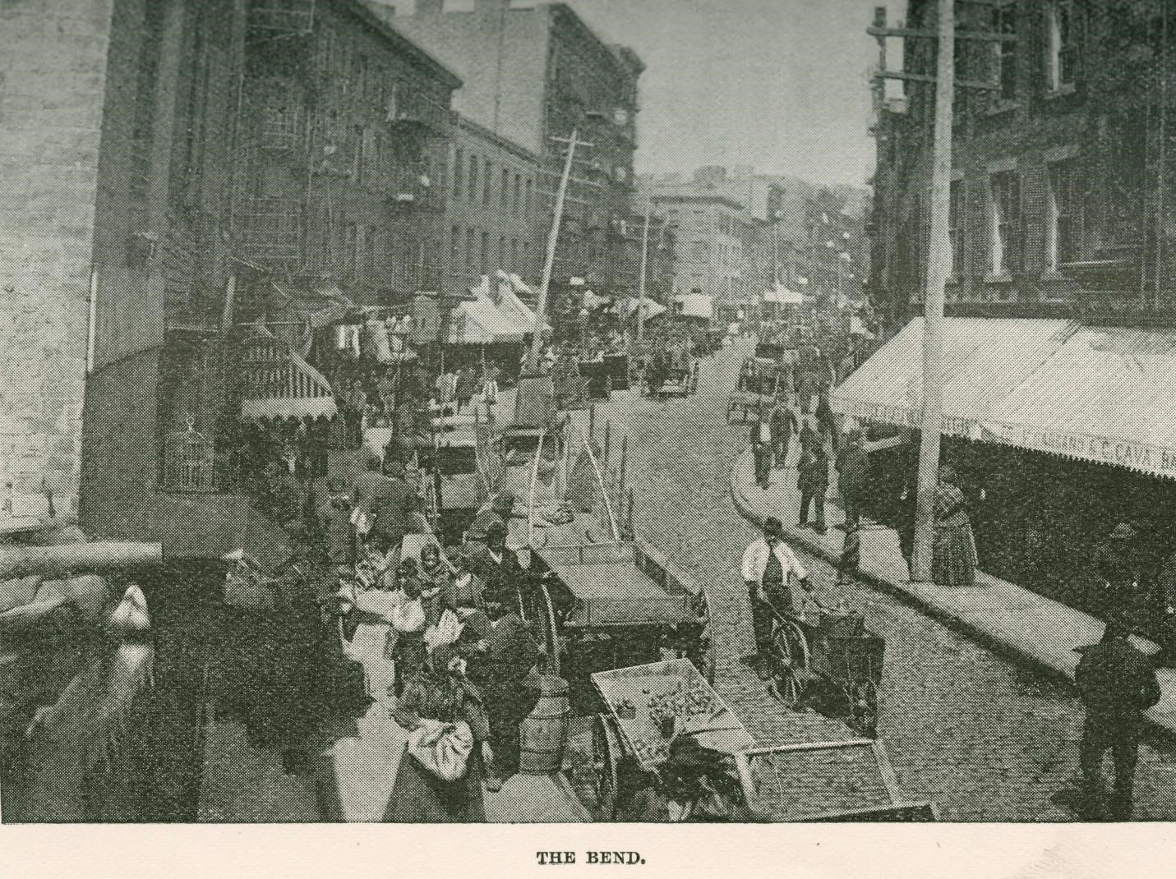
“The Bend,” Jacob Riis, in How The Other Half Lives: Studies among the Tenements of New York. New York: Charles Scribner’s Sons. 1890.
- How would you describe this neighborhood?
- What are people doing in this photograph? What do you notice about the housing?
- What would it have felt like to stand on this street?

WHERE Mulberry Street crooks like an elbow within hail of the old depravity of the Five Points, is “the Bend,” foul core of New York’s slums…There is but one “Bend” in the world, and it is enough. The city authorities, moved by the angry protests of ten years of sanitary reform effort, have decided that it is too much and must come down. Another Paradise Park will take its place and let in sunlight and air to work such transformation as at the Five Points, around the corner of the next block. Never was change more urgently needed. Around “the Bend” cluster the bulk of the tenements that are stamped as altogether bad, even by the optimists of the Health Department. Incessant raids cannot keep down the crowds that make them their home. In the scores of back alleys, of stable lanes and hidden byways, of which the rent collector alone can keep track, they share such shelter as the ramshackle [rundown] structures afford with every kind of abomination [disgrace] rifled from the dumps and ash-barrels of the city. Here, too, shunning the light, skulks the unclean beast of dishonest idleness [laziness].
Jacob Riis writing about Mulberry Bend in How The Other Half Lives: Studies among the Tenements of New York. New York: Charles Scribner’s Sons. 1890.
- What are the problems Jacob Riis identifies in Mulberry Bend? What words does Riis use to describe these problems? Underline them.
- Were these issues noticeable in the accompanying image that was published with this description (The Bend)? If not, what was revealed in the text that you could not see in the photograph?
- How do you think Riis wants his readers to respond to his description of the Mulberry Bend? Describe his tone.
- Who is participating in the angry protests? How have the city authorities and the Health Department previously responded to these issues?
- How would building a park address some of these problems?

This picture shows the same part of town as in the previous picture, but now the buildings on the left have been cleared to build Mulberry Bend Park.

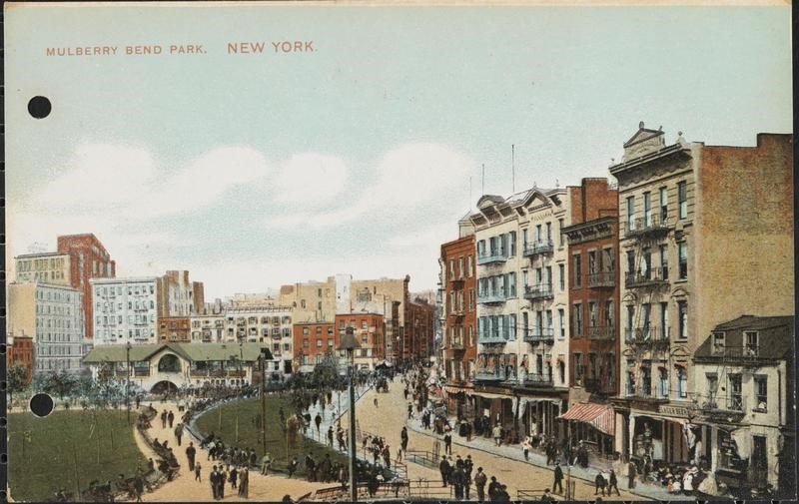
“Mulberry Bend Park,” postcard, ca. 1910. From the collection of the Museum of the City of New York, X2011.34.4465.

- What changes were made to this neighborhood? Do you notice anything different about the street in between the buildings and the park?
- Based on the design of the park, how do you imagine this public space was used?
- What are some positive results after building the park? Are there downsides?
- Are there changes you would make to this park that could benefit the neighborhood?
- This picture was used on the front of a postcard. Why do you think it would have been used in that way?

- Group students in pairs or groups of threes and discuss the following questions: why do neighborhoods need parks and playgrounds? Why do children need them? What kinds of parks and playgrounds are in your neighborhood? What do they look like?

- Hand out the worksheets for this activity. Each worksheet has the same questions, but students will be grouped and asked to answer their questions in terms of the specific landscape they have been provided.

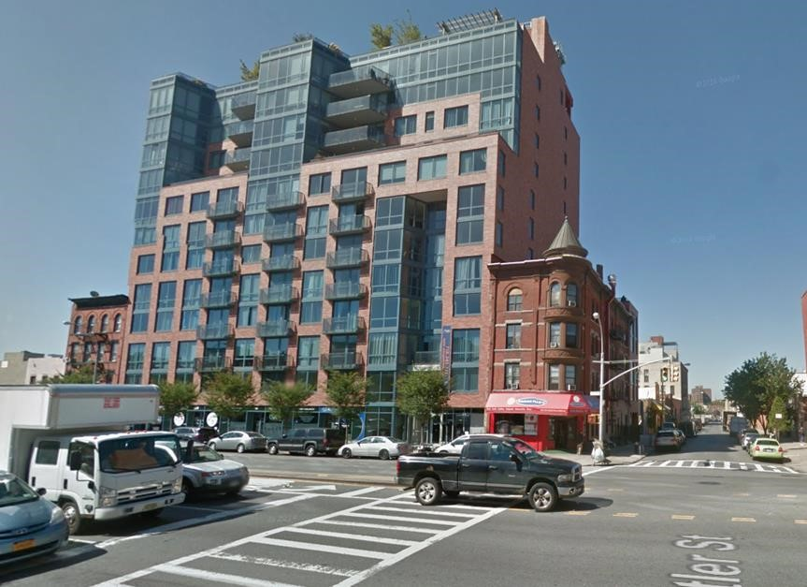

Left:
401 Butler Street, Brooklyn. Image captured from Google Maps, 2015.
See Google Maps for aerial image to estimate size of your park.

What kind of space is available?

Who will use it?

What will they need?

How can we fit what they need in the space we have been given?

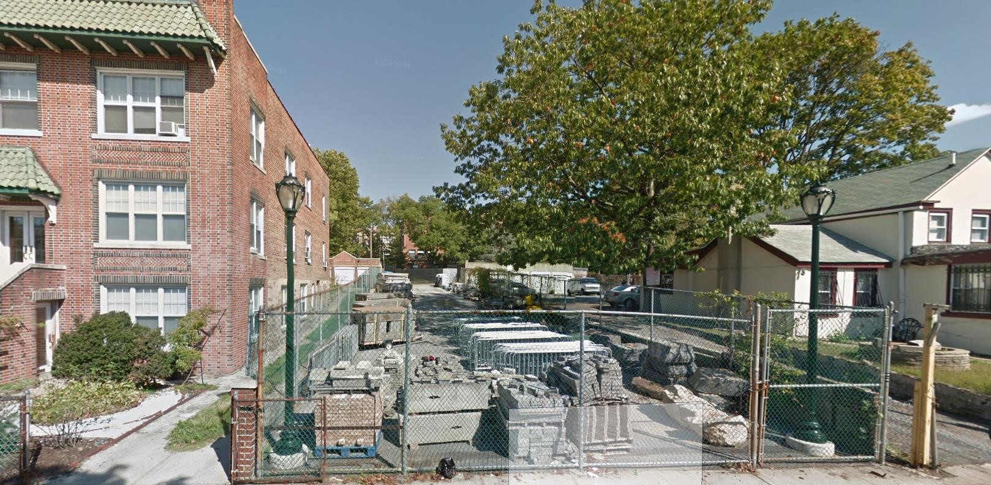
Left: 585 E. 191st Street, Bronx.

What kind of space is available?

Who will use it?

What will they need?

How can we fit what they need in the space we have been given?

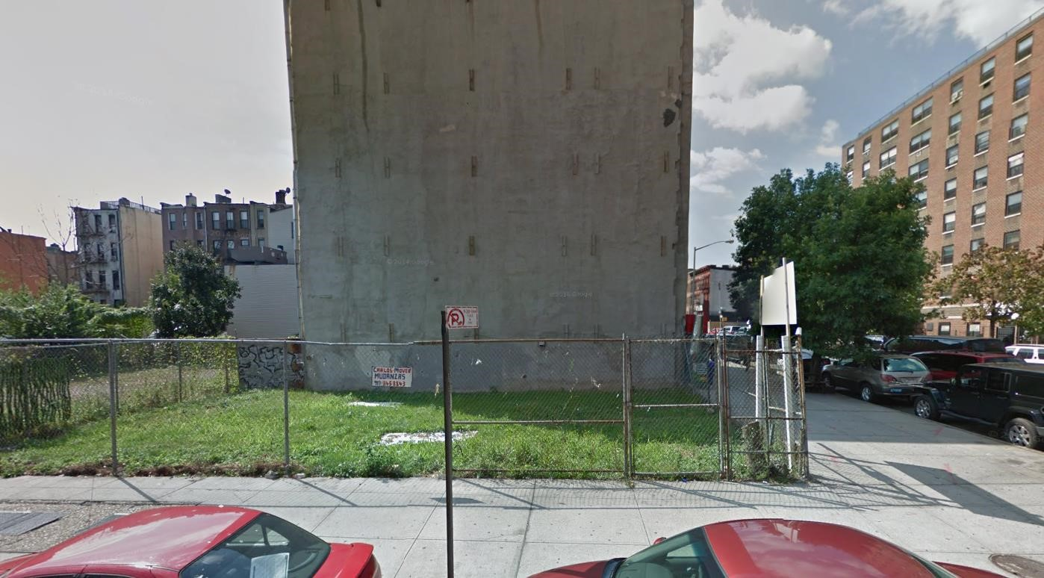
108th Street and Lexington Avenue, Manhattan. Image captured from Google Maps, 2015.

What kind of space is available?

Who will use it?

What will they need?

How can we fit what they need in the space we have been given?

