Educator Resources: Hands-On Content Extension Activity

MEDIA FOR SOCIAL CHANGE: THEN AND NOW

Materials Needed:

• Educator Script/Background provided. You may decide to print each “medium” separately and laminate it to give to each group of students

Jacob Riis used a variety of different media to share the stories of the poor in New York’s tenements with the world. He tried different communication techniques and experimented with new technologies to reach more people, more effectively.

This activity explores six different categories of communications media that have been used by American writers, artists, educators, and others—both in the past and more recently—to raise awareness of social issues and inspire people to act for social change.

DIRECTIONS

After reading through the following material, chose a particular medium. You can explore the information on different media as one large group, led by a facilitator, or divide the group into teams, with each team assigned to explore and report.

The background notes in the information following are designed to provide the educator with some context and help answer additional questions that may come up during the discussion.

PHOTOGRAPHY
Photography became an effective tool to increase awareness of important issues and to promote social justice soon after it was introduced as a commercial product in 1839. A photograph can transport us to places where we could not otherwise go, allowing us to see (and, if the photo is particularly effective, perhaps feel) what it is actually like on the battlefield of a war or in the middle of a citizen protest.
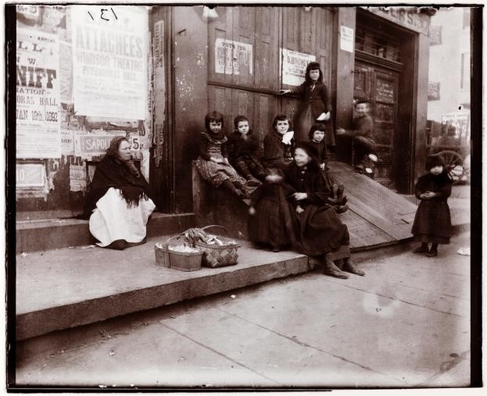
A “Slide” on Hamilton Street, 1891, photograph by Jacob Riis (Museum of the City of New York Jacob A. Riis Collection, 90.13.4.134)

Examine this photo.
What do you see?
How do you feel about the children you see?
Jacob Riis reported on the conditions of the poor to try to bring about change. Why do you think he started adding photos like this one to his stories?
Imagine that you were showing someone this picture, while trying to convince leaders to build playgrounds for children. What would you say?
What surprises you about this street scene or what seems to be missing from the picture? Does the adult seem to be connected to the children? Explain your answer.

Jacob Riis used hundreds of photos like this one to communicate what life was like for the poor in New York’s tenements. When he showed this picture of children playing on a cellar door, he referred to the door as a playground “slide,” to make the case that the children in the tenements needed real playgrounds. As a result of his efforts, real playgrounds—dedicated park spaces with playground equipment—were constructed in neighborhoods and schools in the tenement district.

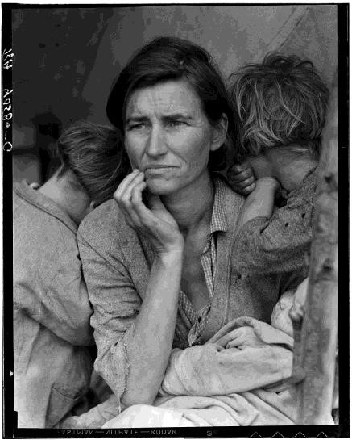
Dorothea Lange (1895-1965) was an American photojournalist who worked for the U. S. government’s Farm Security Administration during the Great Depression (1929-1941). She was a pioneer of documentary photography. This photo from 1936 shows a hungry California mother and two of her seven children, huddled in an encampment. A pea picker whose crop was destroyed by freezing weather, the mother had just sold the tires from her car in order to buy food.

When the federal government saw Lange’s photos, they sent 20,000 pounds of food to the encampment. The photograph became the most recognizable image of the Great Depression, and it remains an iconic image of poverty and human suffering.

Migrant Mother, 1936, photograph by Dorothea Lange

Examine this photo. What do you see?
What words come to mind as you study it?
How does the image make you feel, and what aspects of the photo, specifically, cause those emotions?
Of the many photos that Lange took of suffering people during the Depression, why do you think this particular one has become so well-known and often reproduced?
If Dorothea Lange had submitted a very detailed written description of meeting this woman and her children to the Farm Security Administration instead of this photo, do you think her report would have had the same effect? Explain your answer.
Describe another photograph, from the past or more recently, which you think helped to increase awareness of an issue or bring about some sort of social change.

JOURNALISM—PRINT, BROADCASTING, DIGITAL & SOCIAL MEDIA
Print Media
Journalism—reports of the news of the day—became commonplace after the printing press was invented. At first, written stories were printed as broadsides (posters) tacked up in public spaces or distributed in pamphlet form. The news has been delivered in newspapers for centuries, and in magazines for the last century and a half. With these printed media, literate people could learn about what was happening in the world around them within weeks or even days.

Jacob Riis wrote stories about the tenements of New York for many newspapers and magazines and was considered a pioneer of photojournalism, supplementing his text with powerful images. Before halftone technology was commonly used, artists converted the photographic images to wood engravings that could be printed in the newspaper. Halftone photos replaced the artist’s renderings after 1900.
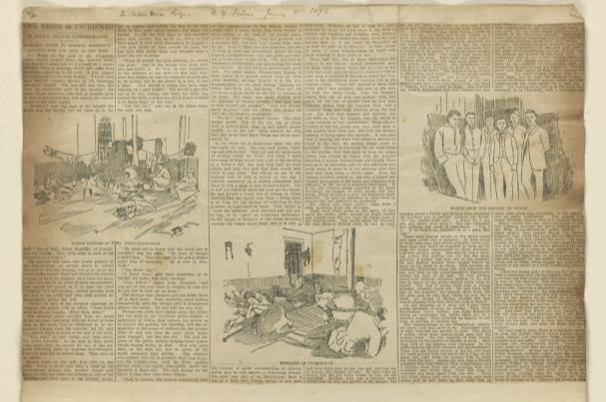

Vice Which Is Unchecked in Police Station Lodging Houses,” New York Tribune, January 31, 1892
(Jacob A. Riis Papers, Manuscript Division, Library of Congress, 025.00.00)

This image shows one page from a lengthy 1892 newspaper article by Jacob Riis. Compare this newspaper page to a newspaper page today. What are the similarities and differences?
The pictures in the article are based on photographs by Riis and others. Why do you think the illustrations look different from the original photos?
Do you think the illustrations encouraged people to read the article?
Do you think the people who lived in the slums that Riis was writing about read these newspaper stories? Why or why not?
What are the advantages and disadvantages of communicating through newspaper stories? Do you read the news in a print newspaper? What other media are journalists using today?

Broadcasting Media

In Jacob Riis’s time, people received news about the world on a daily or weekly basis, mostly through newspapers and magazines. In 1920, a new technology provided a new medium for journalists: radio—a system of wireless communication that transmits sound through electromagnetic waves. For the first time, people all around the world could listen to stories as they were happening. They could hear about communities affected by flooding or follow the daily victories and losses of troops fighting in the Second World War. But with this new broadcasting medium, they could not see pictures.

Possible discussion questions:
From 1920-1950, most Americans got their news from the newspaper and the radio. If you had lived during that time, which communications medium would you have preferred and why? Imagine a family gathering around a radio to listen to news stories. How does that experience differ from reading an article?
What new daily broadcasting technology made both sound and pictures accessible soon after World War II?
Describe a time when you think that a radio or television broadcast helped to increase awareness of an issue or bring about some sort of social change.
Documentary films (e.g., “An Inconvenient Truth,” “Life, Animated,” “13th”) can also be agents for social change. Discuss the level of commitment that documentary filmmakers must have.

Digital & Social Media
Technology continues to change how we get our news. Today, digital and social media—blogs, websites, Facebook, YouTube, Twitter, Instagram, etc.—are important tools for journalists and social activists. These media have become ways that just about anyone can raise awareness of issues.

Possible discussion questions:
List different kinds of digital and social media. Which ones do you use? Which ones do you prefer and why? What are the advantages and disadvantages of these forms of communication?
How easy is it to learn about news or current issues today? How does that compare to Jacob
Riis’s time? What are some strategies for using digital and social technologies to spread the word (hashtags, shares, etc.)? Describe a time when you think that digital or social media helped to increase awareness of an issue or bring about some sort of social change.
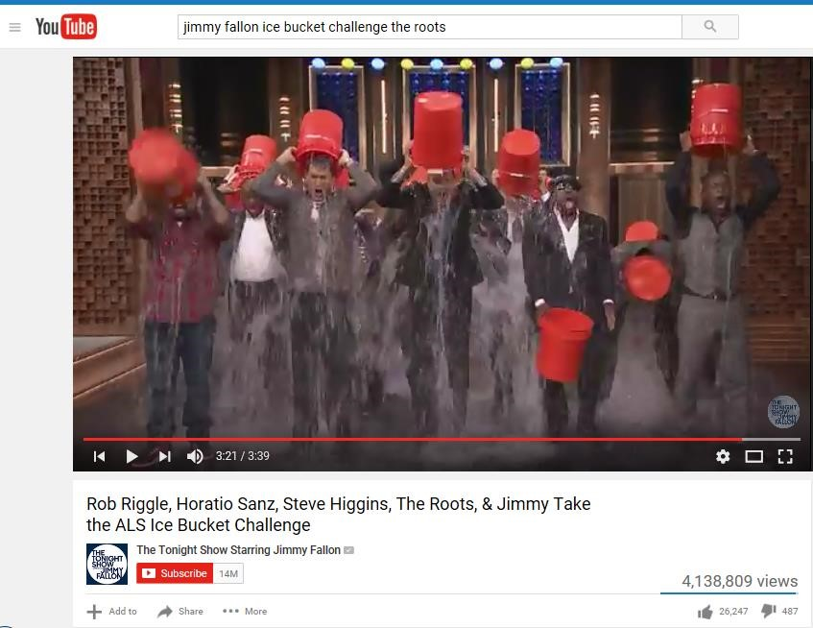
The Tonight Show” with Jimmy Fallon Takes the Ice Bucket Challenge, 2014
In 2014, a social media campaign was launched to raise awareness of the neurological disease, ALS (amyotrophic lateral sclerosis). For weeks, people dumped buckets of ice water over their heads and challenged others to do the same, posting videos and pictures with the hashtag, #icebucketchallenge. This picture shows Tonight Show host Jimmy Fallon, members of the band, The Roots, and comedians Rob Riggle, Horatio Sanz, and Steve Higgins taking the Ice
Bucket Challenge together on TV. The video wasn’t a news broadcast, but it made news. As a result of social media efforts like this, millions of dollars were raised for ALS research, and more people had an understanding of the disease.

Examine this image. Do you know what’s going on in this YouTube video?
Did you learn more about ALS as a result of the Ice Bucket Challenge?
How many different kinds of media were used to promote the Ice Bucket Challenge?
Describe another example of when digital or social media were used to increase awareness of an issue, inspire citizen action, or bring about some sort of social change.
Is it important to have a good understanding of an issue before posting about it? Explain your answer.
Do you think that digital and social media makes it possible for anyone to become a social reformer like Jacob Riis? Explain your answer.

Lectures
Jacob Riis travelled the country, showing his magic lantern slide shows of photographs and telling people about the problems he witnessed in the slums of New York. People heard his lectures and encouraged him to write articles and books, to reach even more people.
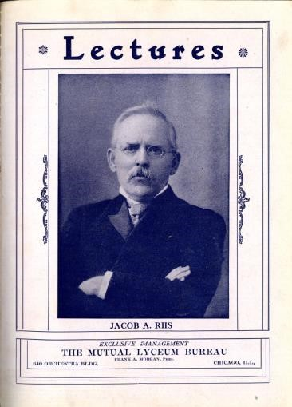
“Lectures: Jacob A. Riis,” Chautauqua brochure, 1908 (University of Iowa Special Collections, MSC0150)

Public speaking can be an effective way to raise awareness of social issues and inspire people to act for social change. The words “lyceum bureau” and “chautauqua” refer to movements of adult education that were popular from the mid-1800s through the early 1900s. Organizations planned assemblies such as lectures and other programs. Social reform speeches were especially popular.

Examine this image. Have you heard the terms “chautauqua” or “lyceum” and do you know what they mean?
Jacob Riis traveled the nation as a lecturer when the chautauqua and lyceum movements were popular. Many significant Americans were also popular public speakers. Do you know these names? Can you guess what they spoke about?
- Frederick Douglass
- Susan B. Anthony
- Mark Twain
- Jane Addams

Brainstorm a list of other people who gave important public speeches in American history. How do we know about these speeches today?

- Frederick Douglass (c. 1818-1895) gave lectures to make people aware of the horrors of slavery;
- Susan B. Anthony (1820-1906) spoke out for voting rights for women;
- Mark Twain (1835-1910) gave lectures that reflected his writing—satirical and humorous observations of American life—his speeches are considered the predecessors of today’s stand-up comedy;
- Jane Addams (1860-1935), like Jacob Riis, lectured about the needs of the poor, the problems of child labor, and the contributions of immigrants in her city of Chicago. For her efforts, Addams received the Nobel Peace Prize in 1931.
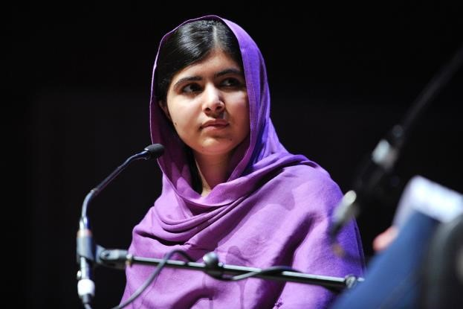
Pakistani activist, Malala Yousafzai (born 1997) giving a lecture
(Southbank Centre/Creative Commons license)

Malala Yousafzai was raised in Pakistan. Her family operated several schools, and when she was
11 years old, she began to speak out against the Taliban, an extremist political movement in the Middle East, because it tried to ban girls from attending school. She became an activist for the education rights for girls, lecturing in public and publishing a blog.

When she was 15, a Taliban gunman tried to silence Malala. After recovering from the murder attempt, she continued to lecture for girls’ education, and her story has been told in a book and a documentary film. In 2014, when she was 17, Malala Yousafzai became the youngest person to receive the Nobel Peace Prize, honored for her struggle against the suppression of children and for the education rights of all children.

Examine this image. Do you recognize this young woman?
What media did Malala use, to speak out for the right of girls to attend school?
Why do you think she was so effective?
Can you give examples of other young people who publically speak out to increase awareness of an issue, inspire citizen action, or bring about some sort of social change? What media do they use and why?
Do you think that digital and social media makes it possible for anyone—even a teenager—to become a social reformer? Explain your answer.
Have you ever used digital or social media to communicate about an issue you cared about? Jacob Riis used technology to add impact to his lectures. How has modern technology changed public lectures today?

Jacob Riis used magic lantern technology to illustrate his lectures with photographs. Today, lectures can be posted as YouTube videos; and more than one billion views have been tallied for all of the TED Talks that have been produced to date.

Exhibitions

Temporary exhibitions—displays of images or objects in public spaces—became very popular during Jacob Riis’s time. Educational exhibitions were common at fairs in the late 1800s and early 1900s. Local organizations would mount exhibits at state or county fairs to raise money when new schools or roads were needed in the community or to raise awareness of health issues, such as milk pasteurization or immunizations. Hundreds of thousands of people attended world’s fairs in major cities—great places to find large audiences for the exhibitions organized there.
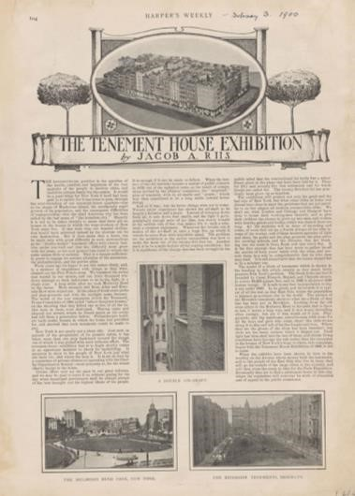
“The Tenement House Exhibition,” Harper’s Weekly, February 3, 1900
(Library of Congress, Jacob A. Riis Papers, 006.00.00)

In 1899, Jacob Riis’s tenement photos—along with architectural models and statistical charts— were organized into an exhibition format. Displayed in the former location of an upscale New York restaurant, 300,000 people visited the exhibition in just two weeks. Afterwards, the exhibit traveled to the Paris world’s fair and toured several American cities. As a result of new audiences seeing the materials, news laws were passed to improve life in the tenements, and the New York City Tenement Housing Department was created to help enforce the new laws.

Examine this image. This is a reproduction of an article in a popular national magazine. What’s the name of the magazine and when was it published?
Why do you think that Jacob Riis exhibited architectural models of the tenements and statistics about the residents, in addition to his photos?
If Riis were alive today, do you think he would have used new technology to create cool infographics for the data he was sharing?
Do you think it helped the cause that the exhibition traveled to other U. S. cities or to Paris?
Explain your answer.
Have you visited exhibitions (other than this one)? Where? Describe your experiences. Have you ever visited an online exhibition? How did it compare to experiencing an exhibition in the real world?
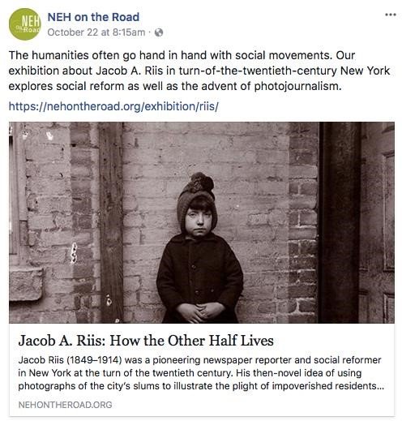
“Jacob Riis: How the Other Half Lives” traveling exhibition
(screenshot captured of NEH on the Road Facebook post)

If students share ideas and feedback about their exhibition experience while doing this activity, please pass them along to us via social media, or contact Caroline Kennedy, the Educator at Louisiana’s Old State Capitol directly at ckennedy@sos.la.gov

What do you think are the goals of this traveling exhibition? Do they differ from the goals of the 1899 Tenement House Exhibition? Explain your answer.

Do you think that Jacob Riis would be surprised that his work is still considered important a century later? What would he think about his work appearing on Facebook?

What kinds of media are used in the Jacob Riis traveling exhibition?

Which components or communication methods do you think are the most effective? Why?

Jacob Riis used many different media to tell the story of the tenements of New York. Why do you think that the curator of this exhibition used a variety of media?

Do you have creative ideas for ways to share stories like this with visitors your age?

Music
Music can also be an agent of social change—a creative way for musicians and songwriters to share their own beliefs and values, as well as explore different perspectives, new ideas, and current issues. Songs can call attention to social injustice and inspire action, by making an emotional connection to the audience. Across American history, songs have been written to unite laborers, support legislation, protest war, and raise empathy for the poor.

Song for Equal Suffrage, a song by Charlotte Perkins Gilman, 1911

Day of hope and day of glory! After slavery and woe,
Comes the dawn of woman's freedom, and the light shall grow and grow Until every man and woman equal liberty shall know, In Freedom marching on!
Woman's right is woman's duty! For our share in life we call!
Our will it is not weakened and our power it is not small. We are half of every nation! We are mothers of them all! In Wisdom marching on!
Not for self but larger service has our cry for freedom grown,
There is crime, disease and warfare in a world of men alone, In the name of love we're rising now to serve and save our own, As Peace comes marching on!
Socially conscious songwriters organize words that have important meaning in an aesthetic way, and in that sense, poets and spoken word performers do the same thing, without music.

In the decades before women were granted the vote by the Nineteenth Amendment (1920), hundreds of songs were written both for and against women’s suffrage. Many pro-suffrage songs were sung at rallies and marches across the country. Charlotte Perkins Gilman (1860-1935) was a feminist writer, poet, and lecturer for social reform. In 1911, she published a collection of her works, Suffrage Songs and Verses. The first three verses of her “Song for Equal Suffrage” are printed on the card. It was meant to be sung to the tune of “Battle Hymn of the Republic,” a song also written by a woman—Julia Ward Howe. (Howe, in turn, had borrowed the tune from an earlier, anonymous abolition song.)

Read aloud the lyrics of this song and see if you can guess the famous patriotic tune the writer used as the music. Anyone bold enough to try to sing a verse?! Why do you think the songwriter chose to set the lyrics to that music?
What other cause for freedom is mentioned in the song, as the writer calls for women’s liberty next?
Find some phrases in this song that make the argument for why women should be able to vote. Where do you think this song was sung?
Why do you think songs to raise social awareness are often sung at gatherings, such as marches, rallies, and protests?
Brainstorm a list of more recent songs that have increased awareness of a social issue or inspired citizens to take action. Do you consider any of these songs to be controversial and why? Where and when have you heard songs like that? Are there particular songwriters or performers that you consider to be musician-activists?
If you choose to discuss more recent musician-activists, here are a few songs that you might want to consider:

- “Freedom” by Beyoncé (2016) is associated with the Black Lives Matter movement;
- “What’s Going On,” written by Marvin Gaye, Obie Benson, & Al Cleveland, protests an incident of excessive force by police in the 1960s;
- “Factory” by Bruce Springsteen (1978) is about the dangers of working in a factory;
- “Allentown” by Billy Joel (1982) describes how residents of a Pennsylvania town are impacted by the closing of the steel factories;
- “Blowin’ in the Wind” (1962) by Bob Dylan asks the listener to consider difficult questions about war, peace, and freedom;
- “God Bless the USA” by Lee Greenwood (1984) was written to encourage American unity and patriotism;
- “Another Day in Paradise” by Phil Collins (1989) describes the plight of the homeless;
- “Big Yellow Taxi” by Joni Mitchell (1970) raises concerns about the environment;
- “Why I Sing the Blues” by B. B. King (1969) laments many injustices in African American history, from slavery to urban poverty;
- “A Change is Gonna Come” by Sam Cooke (1964) looks to the changes that Cooke hoped would take place during the Civil Rights Movement.

Babies in the Mill, a song by Dorsey Dixon, first recorded in 1962

I used to be a factory hand when things was moving slow,
When children worked in cotton mills, each morning had to go. Every morning just at five the whistle blew on time To call them babies out of bed at the age of eight and nine.
Chorus: Come out of bed, little sleepy head and get you a bite to eat. The factory whistle’s calling you, There’s no more time to sleep!
To their jobs those little ones was strictly forced to go. Those babies had to be on time through rain and sleet and snow. Many times when things went wrong their bosses often frowned. Many times those little ones was kicked and shoved around.

Chorus

Those babies all grew up unlearned, they never went to school. They never learned to read or write. They learned to spin and spool. Every time I close my eyes, I see that picture still. When textile work was carried on by babies in the mills.

This song about child labor was written by Dorsey Dixon (1897-1968), a textile worker who was also a musician and songwriter. He and his six siblings worked with their father at a cotton mill in South Carolina. Dixon started work there when he was 12, but his sister began work at just 8 years of age. Child labor laws in South Carolina at the time specified that workers had to be at least 12, but mill operators (and sometimes, parents) encouraged younger children to lie about their age.
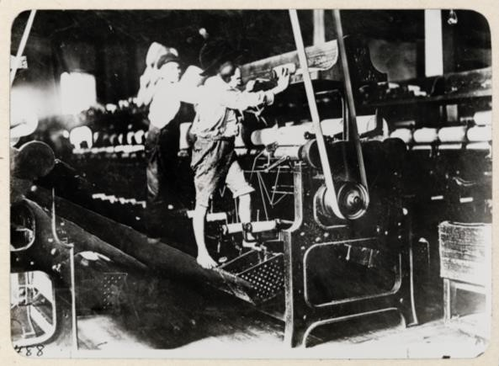
The photo was taken in a Mississippi textile mill, circa 1910, around the time when Dorsey Dixon was having the experiences that he would later write about in this song. Lewis Hine photographed the image on the card, and Jacob Riis used it in an article he wrote for Scribner’s Magazine in 1911.

Read the lyrics of this song aloud.
Describe the daily routine for one of these child laborers. How does that compare to how a typical child at that time should have spent their day? Why do you think they were working? Why do you think the songwriter chose to call them “babies” rather than “children”? How does this song make you feel?
Examine the photo of children in the cotton mill. What are the most significant or surprising details of the picture? Compare the imagery of the song with the imagery of the photo. If you were trying to raise concern about child labor during this time, how might you use the song or the photograph as communications media? Do you find one to be more effective than the other? Explain your opinion.

Art
Art has also been a medium for social change, particularly in the last 150 years. For example, German artist Käthe Kollwitz (1867-1945) spent much of her career creating artworks that express the effects of hunger, poverty, and war. Francisco Goya’s The Third of May 1808, painted in 1814, commemorates the Spanish people’s attempt to resist Napoleon’s invading army. Similarly, Pablo Picasso’s mural, Guernica (1937), shows the suffering of the people in a Spanish city bombed by Germany and Italy during the Spanish Civil War.

Many contemporary artists are known for driving social change, including Favianna Rodriguez, Nick Cave, and Robert Karimi. They use various media, such as posters, fabric sculpture, performance, and much more. These individuals are often considered artist-activists.
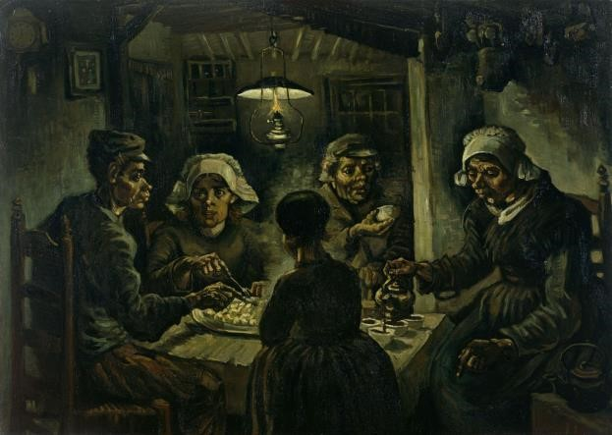
“The Potato Eaters,” 1885, oil on canvas
Vincent van Gogh (Dutch, 1853-1890)
(Van Gogh Museum, Amsterdam, Netherlands/Wikimedia Commons)

Examine this reproduction of a painting of local peasants by artist Vincent van Gogh. Who do you think the subjects are? What are they doing?
How does the painting make you feel?
Imagine you are in the room with the peasants. Describe the temperature, how the fabric and wood objects feel, how your eyes adjust to the light. What do you hear and smell? How does your experience of the steaming cup contrast to the feeling of the air in the room? As you describe how the experience of this scene might feel, point out the specific details that formed your impressions.
This depiction of peasants, sharing a simple meal of potatoes that they had grown, was painted around the same time that Jacob Riis was taking photographs in the tenements of New York.
Compare this image to tenement photographs by Jacob Riis.
If a painter wanted to raise awareness of a social issue with an artwork, where do you think it might be shown? Can a painting have the same impact as a photograph? Explain your answer.
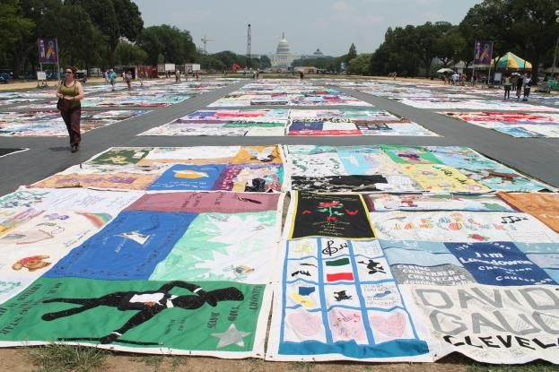
NAMES Project/AIDS Memorial Quilt, launched in 1987
(Photo at the Smithsonian Folklife Festival 2012, by Elvert Barnes/Wikimedia Commons)

NAMES Project/AIDS Memorial Quilt, launched in 1987
In 1987, AIDS activist Cleve Jones launched the NAMES Project—often called the AIDS Memorial Quilt—to honor people who have died of AIDS-related causes. Thirty years later, the project continues to grow, as more people add new quilt panels. Now made up of more than 48,000 individual memorial panels, each 3-feet-by-6-feet in size (to represent the size of an individual grave), it is the largest piece of community folk art in the world. Various numbers of panels are exhibited in different locations, as an ever-changing art event.

The goals of the Quilt: to bring awareness to how massive the AIDS pandemic really is, to bring support and healing to those affected by AIDS, and to raise funds for community-based AIDS service organizations.

Examine this image. Do you recognize this artwork or this exhibition location? Why is the location of this picture significant? Discuss various places where you might encounter artworks for social change. How does location affect their impact?
This is an example of community folk art. What do you think that means?
How is the AIDS Memorial Quilt similar to some of the other media for social change that you have examined in this activity? How is it different?
What does a quilt represent to you, as a cultural object? Do you think that a quilt is an effective medium for this project—even though it is a quilt made of both traditional and untraditional materials? Explain your answer.
Describe an artwork you have experienced that made you think about a social issue. Where did you experience it and what was the medium?
Can you think of other media for social change that have a community art or a crowdsourcing aspect?

