Dress Up Like a Colonial General or Lady!

Did you know that in addition to being a famous General and Founding Father that George Washington was also known for his incredible sense of style? He tried to make sure his appearance reflected dignity and presence.

Using items you probably have around the house and with an adult's help, you can make your own bonnet or hat to transform yourself into a proper Colonial Lady or commanding General of the Continental Army!

How to make a Colonial Bonnet

What you will need:
- A piece of cloth (ex. a fabric scrap, an old t-shirt, a dish towel)
- Measuring tape or ruler
- Scissors
- Yarn or ribbon
Cut 1/2 inch slits in a circle inside the larger one
- A pencil
- Optional decorations like extra ribbon or lace)
Larger circle is
13 to 16 inches long
Instructions:
- Measure out a circle that is 13-16 inches in diameter and then cut it out.
- Take a pencil and trace another circle 1 in from the edge of the fabric.
- Using your scissors, cut small ½ -inch slits along the line you just drew. The slits should be about 3 inches apart from one another.
- Cut a length of ribbon or yarn that is long enough to tie around your head. Thread it through the slits that you cut in the fabric and pull slightly to tighten it. Place the cap on your head and tie the ribbon into a bow to secure it.
- Congratulations, you now have a proper Colonial Bonnet! You can leave it as it or decorate it with extra ribbons, lace, or feathers.

Modern Day Hack:
Put an upside-down coffee filter on your head!

From Maddie Tinsley, LSU Class of 2021 and Louisiana’s Old State Capitol Intern, Summer 2020

How to Dress Like a Colonial General

What you will need:
- Black Construction Paper (although you can use whatever paper you have)
- Scissors
- A pencil
- Glue or a stapler
- Optional: white paper, plastic ribbon, or string

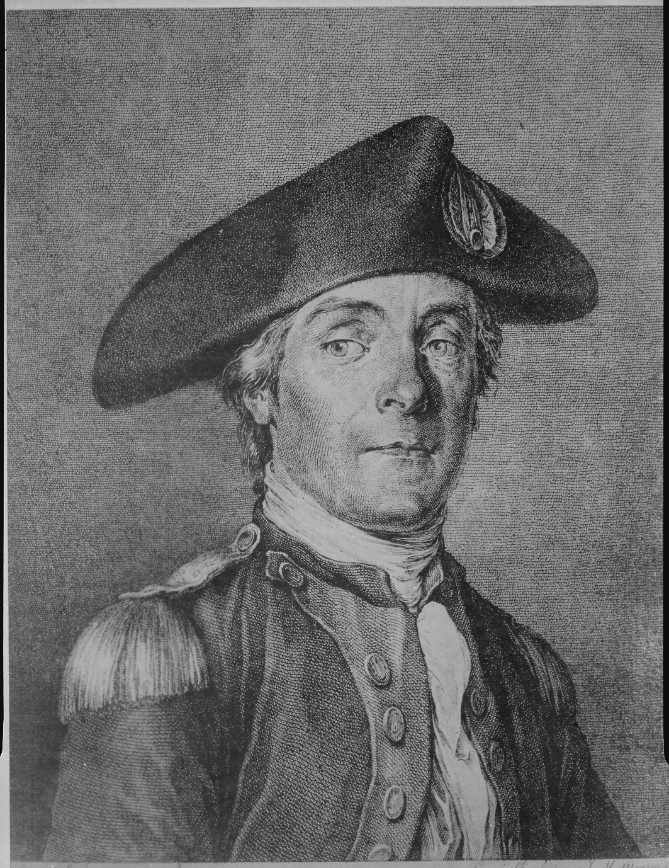
Instructions:
- Print and Cut out the template on the next page.
- Trace the outline of the template onto 3 sheets of construction paper and cut out each one. These will be the three sides of your hat.
- Using your glue or a stapler, attach the three sides of that hat at the spot marked with an “x” on the template.
- Put this on your head, and now you have a tricorn hat just like George Washington!
- Add a fancy “crest” like in the photo, if you wish!

For even more fun: Check out our video, where we add an extra special touch! Even when he was young, George Washington used to powder his hair white to look more “distinguished.” You can add a “powdered wig” to your hat by curling strips of white paper, ribbon, or string and gluing them along the edge of your hat.
From Maddie Tinsley, LSU Class of 2021 and Louisiana’s Old State Capitol Intern, Summer 2020

