Many artists use vibrant color to create distinctive artwork. You can, too! Let’s make a “modern” version of George Washington!

Step One: Print out the next page.

Step Two: Use a black marker to fill in the darkest gray area.

Step Three: Use two other colors to fill in the remaining dark and light gray areas. In our example, we used dark blue and light blue, but you can try whatever inspires you!

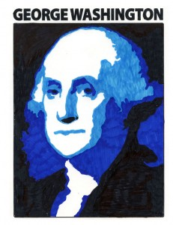
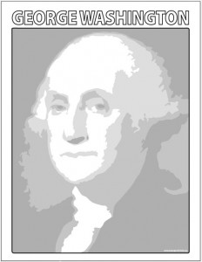

Make

this

become

this …

Color the letters above his face, then sign your name to your Masterpiece! When you visit Louisiana’s Old State Capitol, try and find our statue of the nation’s first President and read the fascinating story behind it!

