George Washington’s Revolutionary Spies!

Learn the methods they used to spy on the enemy and win the war!
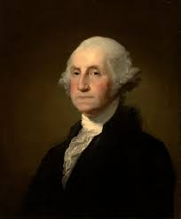
Did you know that George Washington was an expert Spy Master? Follow along and learn how George Washington, with the help of regular citizens and patriots, carried out spy missions that helped the 13 Colonies win the War for Independence!

George Washington knew that if the Colonists were going to beat the much larger British Army as the Revolutionary War broke out in 1775, they would need to outsmart them! So, Washington organized a detailed network of spies to gather information about the British and to deliver it to his Continental Army. They were also used to deliver false information and mislead the British.

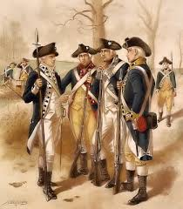
Many methods were used. One was a Cypher, which is a writing system that uses numbers to represent certain words and letters. Another technique was referred to as Mask Letters, where secret messages were written within longer notes. The secret could only be revealed by covering up part of the note with a special mask. Another trick was to use Invisible Ink, where a secret message could be written that would only be visible to a fellow spy.

Washington used regular people like shopkeepers, farmers, and tailors to spy on British officers. We owe our freedom to these brave citizens who acted as spies for Washington just as much as we owe it to the soldiers of the Continental Army or the men who signed the Declaration of Independence!

From Maddie Tinsley, LSU ’21 and OSC Intern 2020
The Cypher Code

The most famous of these spy groups was called the Culpepper Spy Ring. They developed a variety of different methods to spy on the British for George Washington, who was secretly known as Agent 711. The Culpepper Spy Ring was known for their Culpepper Code Book, an unbreakable cypher that had 763 number-to-word combinations!

Your Mission: Pretend that you are one of George Washington’s spies and your job is to decode secret messages for the General. You have just received this letter from a messenger saying that it contains urgent information from the Culpepper Spy Ring. To reveal the message, use the group of codes from the real Culpepper Code Book on the next page to find the word that matches each number in the letter. After you have decoded this secret message, try writing your own secret messages! You can use the codes here or use any of the other 763 cypher codes in the actual Culpepper Code Book! Find them here: https://www.mountvernon.org/george-washington/the-revolutionary-war/spying-and-espionage/the-culper-code-book/

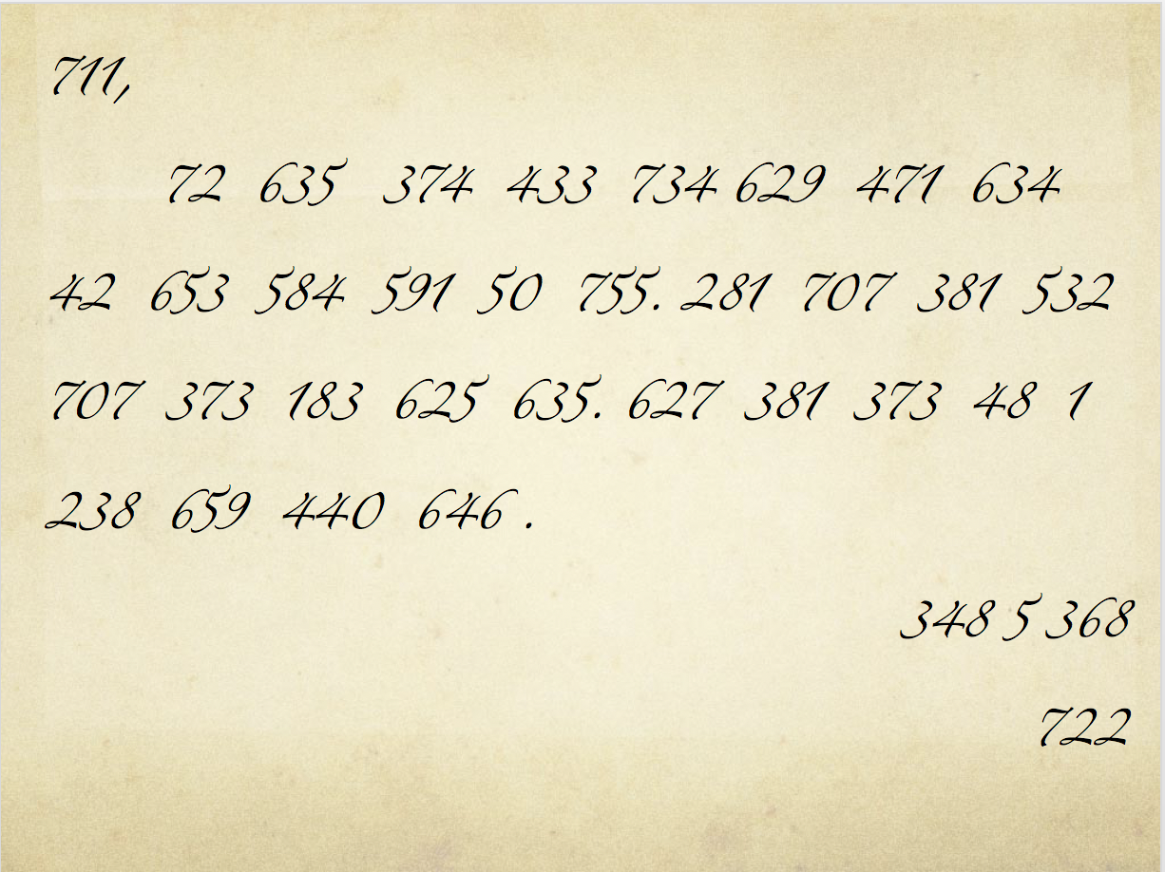
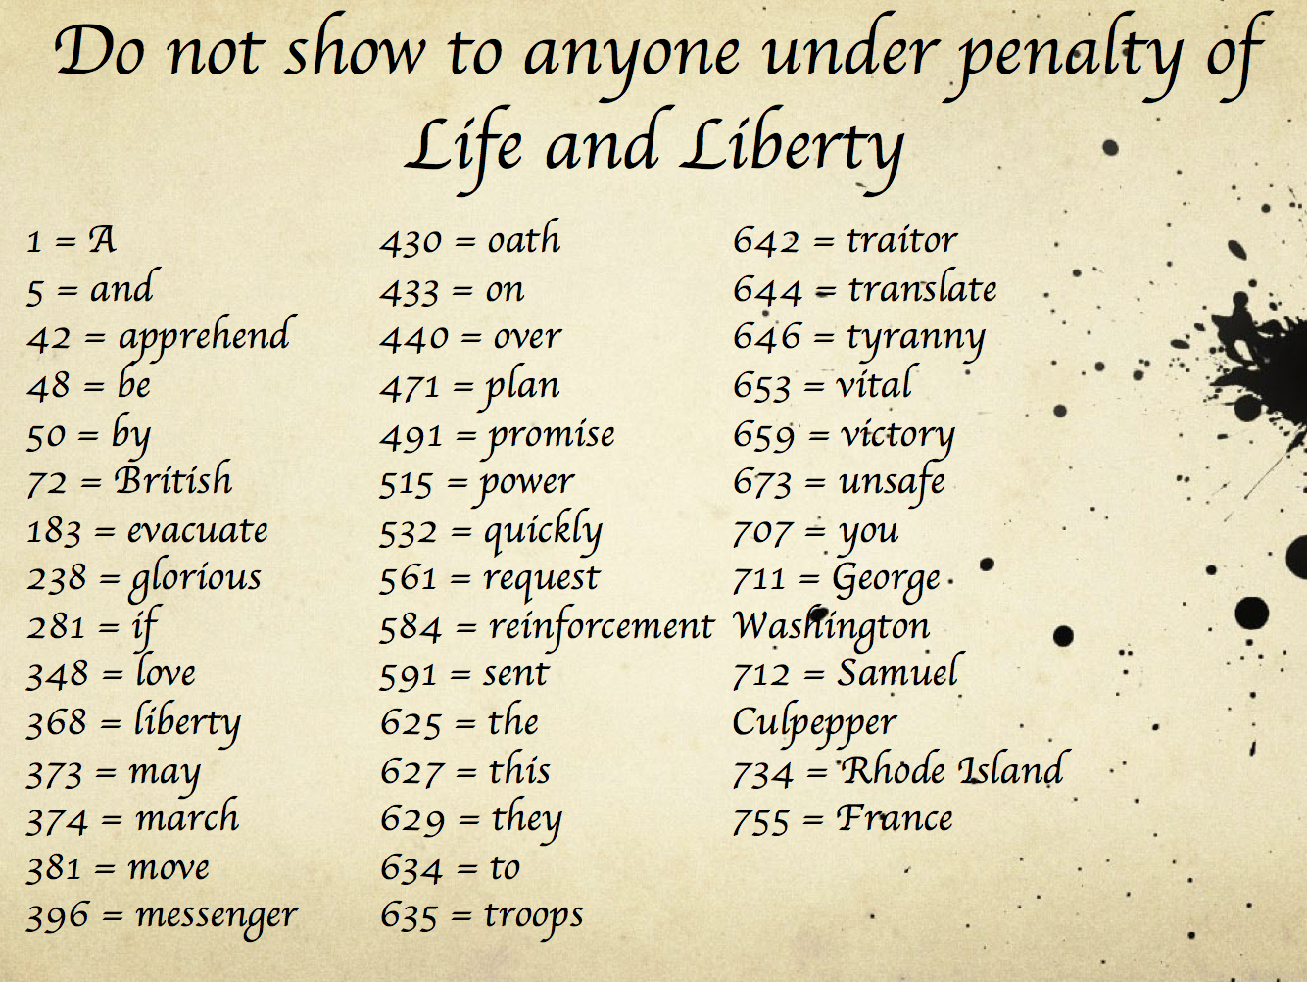

Please note that since "722" does not appear here, it could mean YOU! Your name could be "722" as you pretend to be a spy in the Culpepper Spy Ring! Don't let anyone know but your fellow spies! May you win the war for Independence!

From Maddie Tinsley, LSU ’21 and OSC Intern 2020

Mask Letters

You have just received two separate letters, one containing a seemingly normal message and the other containing a pattern for a paper “mask”. Just to be sure no one else figures out to use them together, you could have received one letter from a "drop off point" like the stump of an old hollow log in the woods, and the other letter you could have gotten in a more conventional way.

Your job is to carefully cut out the shape on the following page and then place that sheet of paper (now with the hole cut out) on top of the letter. The secret message will be in the empty space. After you have uncovered the secret message, you can use this mask to write your own secret messages!

From Maddie Tinsley, LSU ’21 and OSC Intern 2020

Invisible Ink

Invisible ink was used to write secret messages that could only be revealed in a special way. First, the message would be written with invisible ink on the back of a letter or a scrap of paper that would not look important. Then, the paper would be transferred to the hands of another spy without detection. For example, a seemingly unimportant letter could be delivered in an envelope that would normally be tossed away. But, this envelope would have an important message written on the back in invisible ink! Now, to reveal the message, the spy would carefully expose the envelope to heat, like a fireplace. Today, we can hold the invisible message up to a light bulb and almost magically, the secret message will appear!

How to make your own invisible ink!

What you’ll need
- Baking Soda
- Water
- Or, substitute a fresh lemon instead of baking soda
- Paper
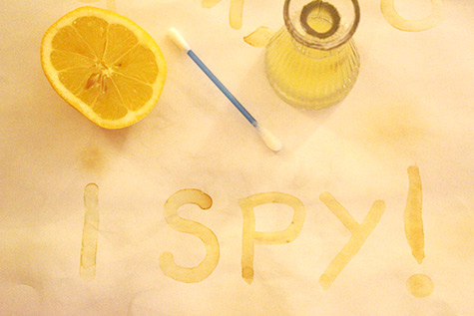
- A Q-tip, paintbrush, or tooth-pick

Instructions

- Mix equal parts water and baking soda or squeeze a lemon and keep the juice in a small bowl.
- Using your Q-tip/paintbrush/tooth pick write your secret message. (Makes sure no one is looking!) Then, let it dry completely.
- With an adult's help, expose your message to a heat source (like a lightbulb). Watch as the message you wrote reappears!

From Maddie Tinsley, LSU ’21 and OSC Intern 2020

