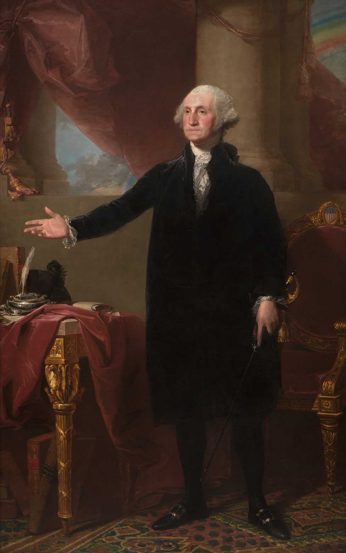
HOW WELL DO YOU KNOW GEORGE WASHINGTON?
- Which colonial-era person from France named his son George after the father of our country?

- What was George Washington’s favorite fruit and why?

- Why was Washington called “Conotocaurius” (meaning the Devourer of Villages) by Iroquois native Americans in 1753?

- Who painted the image of George that is now on the $1 bill?

- Who was the only President NOT to live in the White House? Answers Below! If you got all 5 correct, then you’re smart enough to be a pretty good President yourself! If you had 4, then maybe you could teach American History. 3 or less? Do some reading – the story of George Washington is amazing!
ANSWERS
- The Marquis de Lafayette, the Frenchman who brought French resources in to help Washington defeat the British, was so close to his friend that he named his son after him. Born in 1779, his son’s full name was Georges Washington Louis Gilbert de La Fayette. (The French spelling of “George” includes a final “s.”
- Washington’s favorite fruit was the pineapple! On the only trip of his life out of North America, Washington discovered the “Pine Apple” as it was called back then, in Barbados. It was such a delicacy that some people would rent one to impress guests at lavish parties! Washington often requested them brought back from travelers and traders to the West Indies, whenever possible.
- Washington’s great-grandfather was first given the same name in the late 17th century when he fought against a native American uprising to make way for British colonists. In 1779 during the American Revolutionary War, 40 Iroquois villages were destroyed under George Washington’s orders.
- The portrait shown here is by artist Gilbert Stewart and was used for the image we now see on the $1 bill. Some say he is grimacing in pain due to bad teeth and ill-fitting dentures.
- Although Washington oversaw its construction, the White House was not ready for occupants until our nation’s 2nd President, John Adams, moved in with his family. It was built in the area reserved for federal buildings and the nation’s capital, and named after him: Washington, D.C. (or District of Columbia)

