FUN FACTS ABOUT GEORGE WASHINGTON’S TEETH

One myth about George Washington is that he had wood dentures. Not so. Read on for the toothful truth. Color his teeth as directed, and remember to brush your teeth twice a day!

Washington wrote in his diaries how he suffered from aching teeth, sore gums and ill-fitting dentures. It made it hard to eat and speak. Here are the facts:

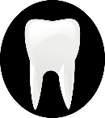
Washington's dentures might have looked like wood, but he had his lost teeth replaced with fake ones made of bone, hippopotamus ivory, gold, lead, and a brass screw. Occasionally, he bought real teeth from other people! (Color two teeth yellow to look like old bones and ivory. Color one tooth orange (for gold) and one tooth gray (for lead). Make another tooth look like a brass screw!)

During the Revolutionary War, Washington used a French dentist who had been providing dental services to high ranking British officers. (Color one tooth with a filling.)

Washington’s dental troubles helped trick the British army. Washington was embarrassed when British forces intercepted a letter requesting dental cleaning tools. But he used this to his advantage, sending another letter about his dental woes along with information that his forces would not be headed South. This was a trick! The British were defeated at Yorktown in 1781. (Color one tooth red, leave one tooth white, and color one tooth blue.)

Washington saved several of his pulled teeth for later use in his dentures. He kept several of his pulled teeth in a locked desk drawer at Mount Vernon hoping that these original teeth could be used in new dentures. (Color cracks on 4 of the teeth.)
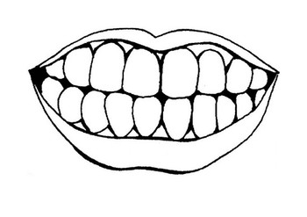

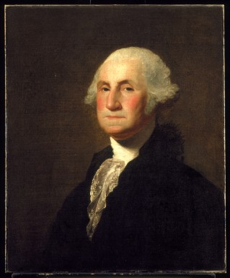
Washington bought human teeth. Deep within one of Washington’s account books is an entry which details Washington’s purchase of 9 teeth for 122 shillings. (Color three teeth your favorite color.)

When he was inaugurated as President, Washington had only one working tooth remaining. Despite all his attempts to save his remaining teeth, Washington was down to just one tooth by 1789. The last tooth was pulled, and Washington gave this tooth to his dentist as a memento. The dentist put it in a small glass container and hung it from his watch chain. (Put a sparkle next to a white tooth.)

Washington’s dental troubles impacted the shape of his face. In a letter written in 1797, Washington complained how his dentures were “already too wide, and too projecting for the parts they rest upon; which causes both upper, and under lip to bulge out, as if swelled.” (Color the gums red to show they hurt and color the lips pink to show their funny shape.)

Martha Washington, George’s wife, understood the importance of keeping teeth clean. Martha regularly urged her children and grandchildren to take care of their teeth. Taking care of teeth is important, even if you are the President of the United States! (Color two more teeth green. YUCK!)

Washington’s dental troubles made him less excited about giving speeches. His troublesome fake teeth made speaking to a crowd a challenge. Can you imagine having to lead a brand new country when your teeth are hurting?

(Put your crayons down and go brush your teeth! Then, ask your grown-ups when you can visit Louisiana’s Old State Capitol to see the mysterious missing George Washington statue on the first floor!)

These toothy facts provided by Mount Vernon’s Mansion, George Washington’s former home.

