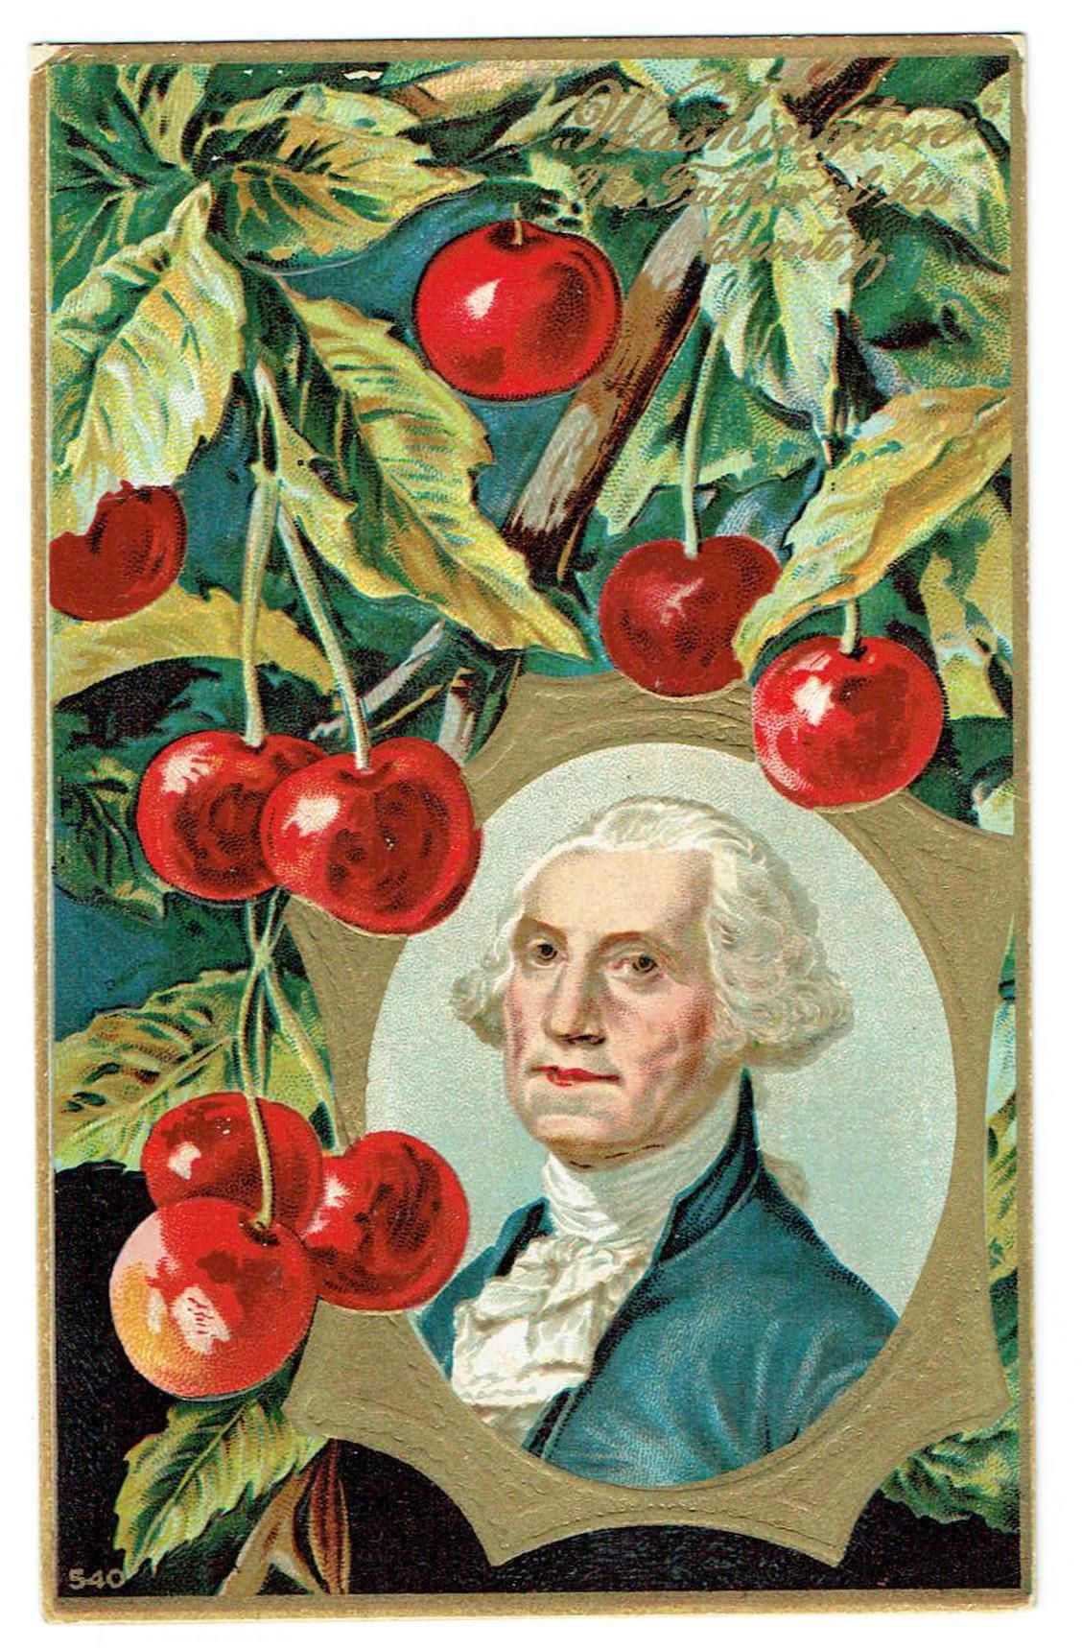
Recipe for Cherry Bounce
President Washington’s Favorite Drink
for adults ONLY
Place 1 cup fresh cherries and 1 cup sugar (or 1 can of cherries, drained) in a glass jar with a lid. Mix in 2 cups brandy (or bourbon). Seal the jar and put in a cool place (refrigerator). Every week, stir the contents. After 3 months, strain the cherries (using them on ice cream). Pour the liquid in cordial glasses and enjoy!
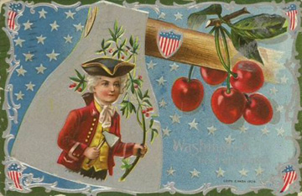
Homemade Cherry Cream Soda for Kids
RECIPE
½ water ½ sugar 1 teaspoon vanilla 1 cup cherry juice (try squeezing your own* or buy it already prepared) 1 cup Club Soda or soda water
With a grown-up’s help, stir together ½ cup water and ½ cup sugar in a large saucepan and bring to a boil, stirring to dissolve the sugar. Remove from heat and allow to cool. Once cooled, add 1 teaspoon of vanilla and 1 cup of cherry juice. Put mixture in the refrigerator until very cold, and just before serving add 1 cup of Club Soda. Serve over ice for 2 delicious drinks – one for you and one for someone you’d like to be your Vice President! CHEERS!
Did you know? It is a myth that Washington cut down a cherry tree and later told his Dad about it saying “I cannot tell a lie. I chopped down that cherry tree!” But the tale was repeated to teach good moral lessons emphasizing honesty and other good traits.
*You can make your own cherry juice by boiling ½ pound dark sweet cherries and 1 cup water in a saucepan over gentle heat, stirring occasionally for an hour. Allow the mixture to cool and strain it. For maximum yield, mash the mixture into the sieve. Cooking was a lot of work in those days!

