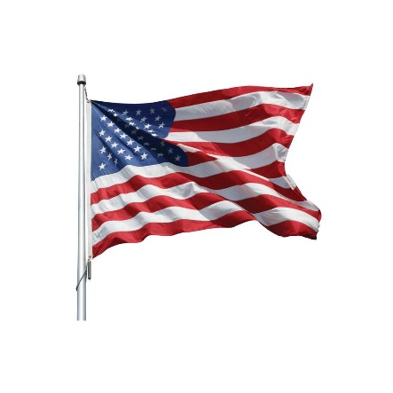
Can you pass the “Citizen Test?”
If you were born in the United States you are considered a citizen. Anyone else who wishes to become a citizen of the United States, must pass a test for naturalization. Can you pass this test? Here’s how it works: A USCIS (United States Citizenship and Immigration Services) officer asks 20 out of 128 possible civics test questions orally. It is not multiple choice! At least 12 (60%) must be answered correctly to pass.
There is special consideration for people 65 years old or more who have been living in the United States at least 20 years as a lawful permanent resident – these candidates for naturalization only have to study 20 questions. They will be asked 10 of these in the language of their choice. They only have to get 6 out of 10 (60%) correct to pass.
We’ve chosen 10 random questions from the “special consideration” test, which is considered easier. See how you do! Go to https://my.uscis.gov/prep/test/civics for more information.
- What is the supreme law of the land?
- How many amendments does the U.S. Constitution have?
- What is the economic system of the United States?
- Name one power of the U.S. Congress?
- Who vetoes bills?
- What do we show loyalty to when we say the Pledge of Allegiance?
- Who wrote the Declaration of Independence?
- Abraham Lincoln is famous for many things. Name one.
- Why does the flag have 13 stripes?
- Name 3 National U.S. holidays.
ANSWERS
- What is the supreme law of the land? The U.S. Constitution
- How many amendments does the U.S. Constitution have? 27
- What is the economic system of the United States? Free market economy or capitalism
- Name one power of the U.S. Congress? You can say one of these: Writes laws, declares war, makes the federal budget
- Who vetoes bills? The President
- What do we show loyalty to when we say the Pledge of Allegiance? You can say one of these: The U.S. The flag
- Who wrote the Declaration of Independence? Thomas Jefferson
- Abraham Lincoln is famous for many things. Name one. You can say any one of these: Freed slaves, saved the Union, Led the US during the Civil War, 16th President, Delivered the Gettysburg Address
- Why does the flag have 13 stripes? The stripes represent the 13 original colonies
- Name 3 national U.S. holidays. Say 3 of these: New Year’s Day, Martin Luther King, Jr. Day, President’s Day (Washington’s Birthday), Memorial Day, Independence Day, Labor Day, Columbus Day, Veterans Day, Thanksgiving Day, Christmas Day

If you got 6 out of 10 correct, you passed! If not, you were lucky to be born here! To see what else you have to do to become a citizens, see https://www.uscis.gov/citizenship/apply-for-citizenship. If that was too easy, see the back for an example of the test that most immigrants have to take. Good luck!
The Citizen Test
- What is the form of government of the United States?
- Name one thing the U.S. Constitution does.
- The U.S. Constitution starts with the words “We the People.” What does that mean?
- What does the Bill of Rights protect?
- The words “Life, Liberty, and the pursuit of Happiness” are in what founding document?
- What is the rule of law?
- Many documents influenced the U.S. Constitution. Name one.
- How many voting members are in the House of Representatives?
- Why do U.S. representatives serve shorter terms than U.S. Senators?
- Why can the President serve only two terms?
- Name one power of the President.
- What are two Cabinet-level positions?
- How many Supreme Court Justices are usually needed to decide a case?
- Name one power that is only for the federal government.
- Name one power that is only for the states.
- What is the purpose of the 10th Amendment?
- When was the Declaration of Independence adopted?
- Why were the Federalist Papers important?
- Alexander Hamilton is famous for many things.
- What amendment gives citizenship to all persons born in the United States?
ANSWERS
- You can say Republic, Constitution-based federal republic, or Representative Democracy
- Defines the powers of the government, Defines the parts of the government, and Protects the rights of the people
- It means Self-government, Popular sovereignty, Consent of the governed, People should govern themselves
- It protects the rights of Americans, or (The basic) rights of people living in the U.S.
- The Declaration of Independence
- Everyone must follow the law. Leaders must obey the law. Government must obey the law. No one is above the law.
- Any one of: Declaration of Independence, Articles of Confederation, Federalist Papers, Anti-Federalist Papers, Virginia Declaration of Rights. Fundamental Orders of Connecticut, Mayflower Compact, Iroquois Great Law of Peace
- 435
- To more closely follow public opinion
- You can say either The 22nd Amendment or to keep him/her from becoming too powerful
- He/she signs bills into law, vetoes bills, enforces laws, Commander in Chief (of the military), or Chief diplomat
- Attorney General, Sec. of Agriculture, Sec. of Commerce, Sec. of Defense, Sec. of Education, Sec. of Energy, Sec. of Health & Human Services, Sec. of Homeland Security, Sec. of Housing & Urban Development, Sec. of the Interior, Sec. of Labor, Sec. of State, Sec. of Transportation, Sec. of the Treasury, Sec. of Veterans Affairs, Vice President
- 5
- The Fed. Gov. can print paper money, mint coins, declare war, create an army, make treaties, or set foreign policy
- The states provide schooling, protection (police), safety (fire departments), give driver’s licenses, or approve land use
- It gives powers not given to the federal government to the states or to the people
- July 4, 1776
- They helped people understand the U.S. Constitution
- Choose one: He was the First Secretary of the Treasury, one of the writers of the Federalist Papers, he helped establish the First Bank of the US, Aide to Gen. George Washington, He was a member of the Continental Congress
- The 14th Amendment

