Myths and surprising facts about the first president

Sources: SARAH PRUITT, Tetra Images/Getty Images, and History.com
When it comes to mythic American figures, George Washington leads the pack. Commander-in-Chief of the Continental Army during the Revolutionary War and the first President of the United States, Washington was revered as the “Father of the Nation.” He revered throughout his life and in death, the legends only grew. Some were based in truth, and others fall squarely into the category of fiction.

Myth #1: He chopped down a cherry tree.
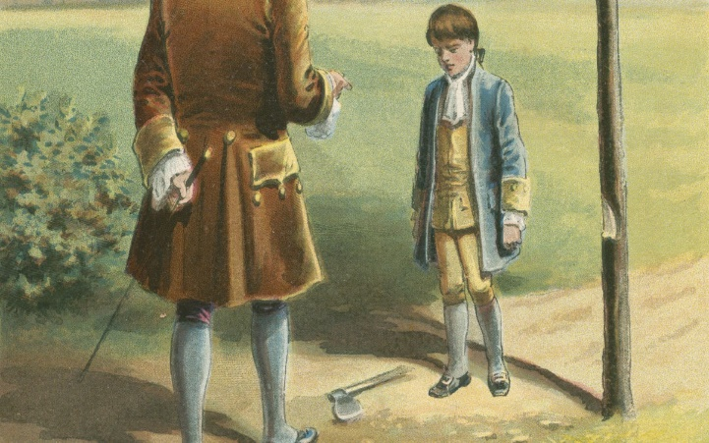

We all have heard the story of how George Washington cut down a cherry tree as a little boy. His father, Augustine, asked who cut the tree down, and George confessed, earning a hug and fatherly praise for his honesty, worth more than 1,000 such trees.

It’s a great story, but there is no evidence to support it. Washington’s father died when he was 11, and the story didn’t appear in print until 1880, the year after Washington died. Mason Locke Weems published a biography of Washington that year, but the cherry tree story did not appear until 1806 in the fifth edition. Weems’s biography focused on his private life rather than his public career. It became a huge bestseller read by generations of American schoolchildren.

Myth #2: He asked Betsy Ross to sew the first American flag in 1776

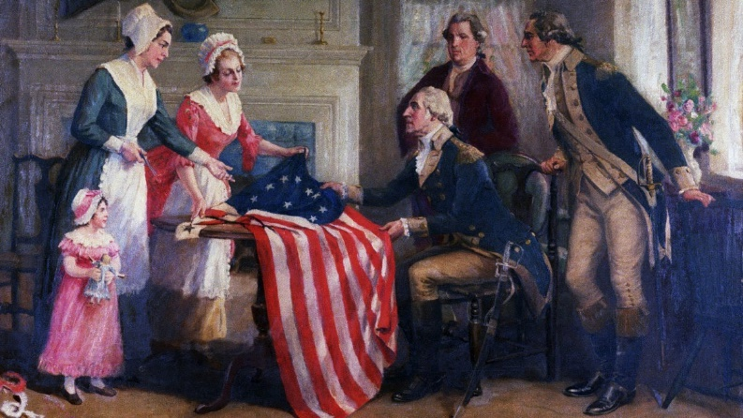
The story of the first flag suggests Washington, then- commander-in-chief of the Continental Army, and three members of the Continental Congress called on Betsy Ross in Philadephia to ask her to craft a flag for the rebellious colonies.
Ross took the proposed design but changed the stars to five points instead of six. She made a sample flag, which was approved as the new banner of the United States.
This story gained wide popularity in the late 19th century, with the help of claims from Ross’ family. She did make flags during the war, but there is historical evidence to confirm that she made the first American flag. Most scholars agree the story is probably more fiction than fact. Edward G. Lengel, former chief editor of Washington’s papers and author of Inventing George Washington (2011), records that Washington visited Philadelphia briefly in 1776. But he didn’t meet with anyone about flags and most likely didn’t know Betsy Ross.

Myth #3: He had wooden teeth.
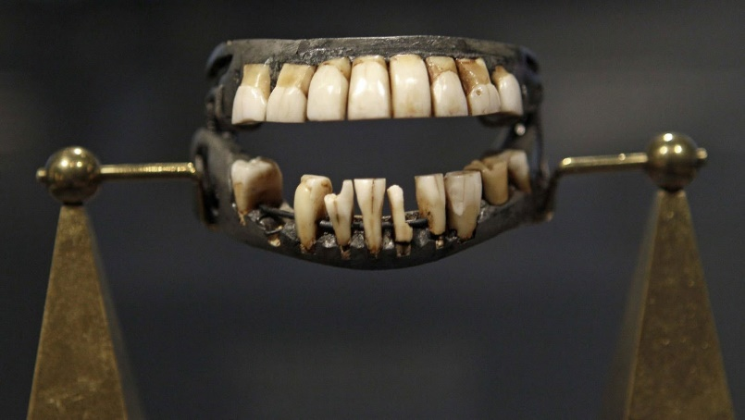
Next to the cherry tree legend, Washington’s supposed wooden teeth are the most repeated myth about the first president. Famous for his enviable strength and healthy constitution, he suffered from dental problems his entire life. By the time he became president in 1789, Washington had only one of his natural teeth remaining; he finally had that one pulled in 1796.
The dental appliance he wore featured filed-down teeth from animals (probably cows or horses), human teeth (possibly, but not definitely, those of slaves) and teeth fashioned from ivory (including elephant, walrus and hippopotamus). Years of stains may have made them look like wood. Because wood is porous and susceptible to expansion and contraction with moisture, was not a material commonly used by dentists at the time.

Myth #4: He knelt in prayer in the snow at Valley Forge
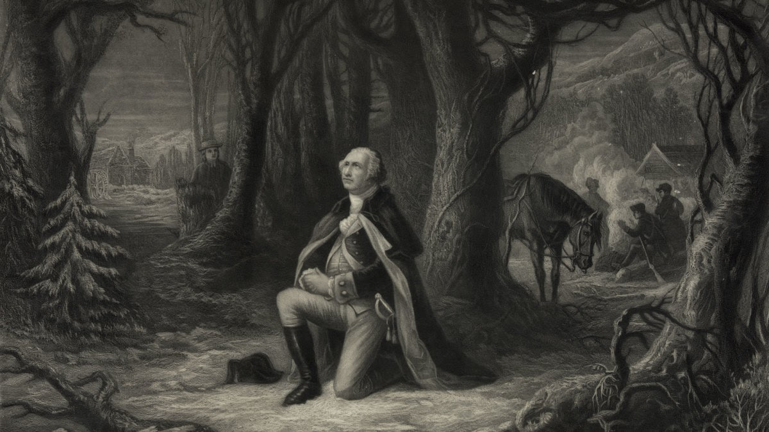
The image of Washington kneeling in prayer at Valley Forge is well known, but the story behind it is less familiar.
A pacifist Quaker named Isaac Potts allegedly stumbled on Washington praying in the snow. Moved by the commander’s faith, Potts converted to the Revolutionary cause.

This scene has been painted, depicted on postage stamps, plaques, marble sculptures and stained glass. President Ronald Reagan called the image of Washington kneeling in prayer at Valley Forge “the most sublime picture in American history.”
Again, there is little evidence to support this story. The first version comes from Washington’s biographer, Weems, in 1804. Modern historian Blake McGready, writing in the 2018 Journal of the American Revolution, says Weems likely intended the story as an allegory illustrating the strength of Revolutionary-era values, and how patriotism could transcend religious differences. Potts could have stumbled upon Washington in prayer, but there is no contemporary evidence suggesting the scene at Valley Forge ever took place.

Myth #5: He could have become king … of the United States.

Further cementing Washington’s status as an icon of American democracy is the idea that he turned down the chance to become king of the new United States.

After the British surrender at Yorktown, the Continental Congress began having trouble getting the former colonies to pay for the still-active army. Frustrated by not being paid adequately or promptly, several officers turned to Washington for help. Colonel Lewis Nicola suggested the new nation could be a “mixed” form of government – with elected officials and a monarch. Washington quickly rejected the idea. “If I am not deceived in the knowledge of myself,” he replied, “you could not have found a person to whom your schemes are more disagreeable.”
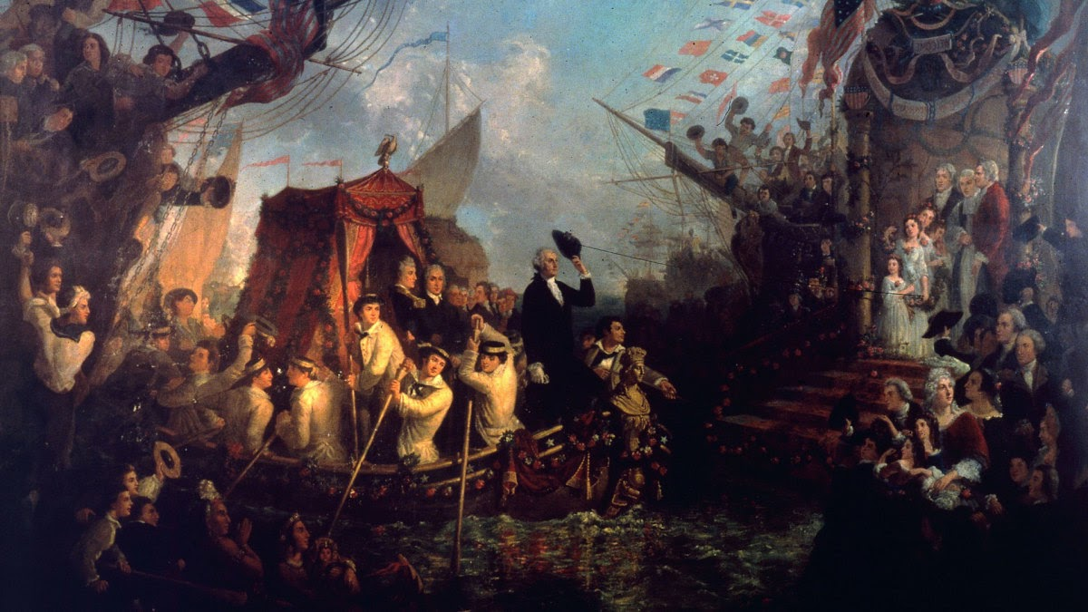
Researchers have concluded that Nicola’s letters to Washington make clear that he was only speaking for himself and not directly offering Washington a crown. (And in reality, a colonel had no crown to offer.)
In 1783, a group of mutiny-minded soldiers were swayed by Washington’s appeal to remain loyal to their country.
Taken together, these two stories have fueled the enduring myth of Washington as the man who wouldn’t be king.

Myth #6: As the first U.S president, he lived in the White House.

Washington never lived at 1600 Pennsylvania Avenue. In fact, Washington, D.C. wasn’t even the nation’s capital when he was president.
President Washington resided first in a New York mansion facing the East River, at 1 Cherry Street; it was owned by Samuel Osgood, first postmaster general of the United States. In early 1790, Washington moved to more convenient location on Broadway, close to Trinity Church. Later that year, when the temporary capital of the United States moved to Philadelphia, the Washingtons moved into a mansion at 6th and Market Streets, formerly owned by William Penn, the English Quaker best known for founding the colony of Pennsylvania.
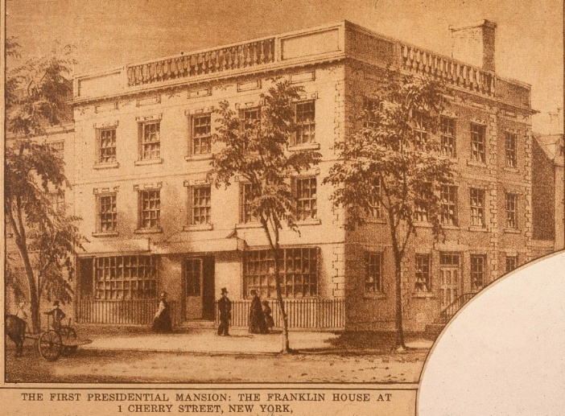
They lived here until 1797, when John Adams moved into the house as the nation’s second president. Though Washington approved plans for the new capital’s construction and specified the location of the executive mansion (or White House), Adams would be the first president to live there, taking up residence in November 1800.
And now, for some FACTS:
Fact #1: Washington had only a grade-school education.
The first president’s formal schooling ended when he was 11 years old, after his father died. That event cut young George off from the opportunity to be educated abroad in England, a privilege afforded to his older half-brothers. Washington’s mother never remarried, forcing him to shoulder weighty burdens at a young age. He was the oldest child of six from his father’s second family. She taught him how to run a tobacco farm, and at the age of 16 he took his first job as a land surveyor. For the rest of his life, Washington would be embarrassed by his stunted schooling.

Fact #2: At age 22, Washington led a disastrous military skirmish that sparked a world war.
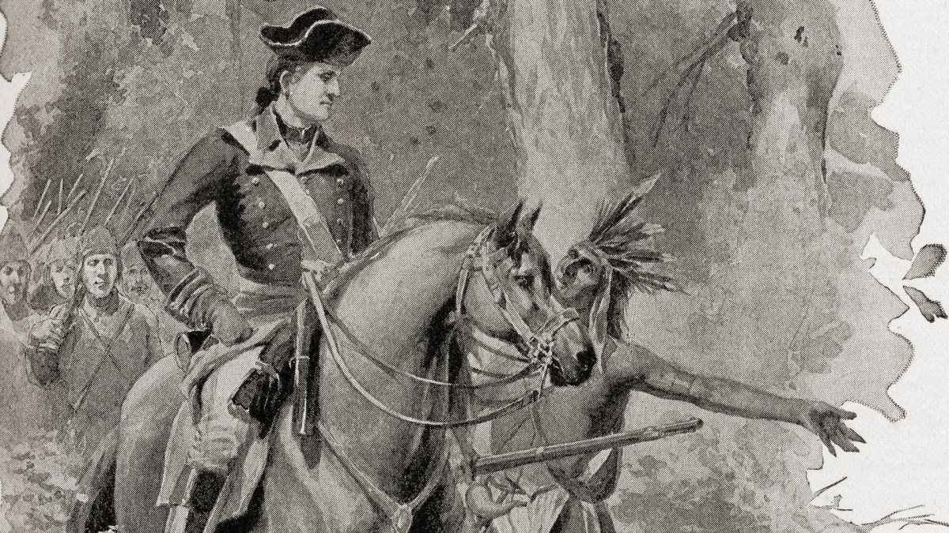

As France and Britain fought for territory at the edges of the North American colonies, Virginia sided with the British. As a Virginia militia officer, Washington was sent to the Ohio Valley (now western Pennsylvania) with some 150 troops, to help repel the French.Warned by local Native American allies that a small French force was camped several miles away, he led an attack with 40 of his soldiers, along with a dozen native warriors.

Who fired the first shot remains in dispute, but in the end at least 10 French soldiers and one Virginian were dead—including a minor French noble, Joseph Coulon de Villiers, Sieur de Jumonville. The French later said he was on a diplomatic mission. Jumonville’s death enraged the French, who called Washington an assassin. The conflict between the French and the British escalated into the French and Indian War, and soon spread worldwide in what became known as the Seven Years’ War.

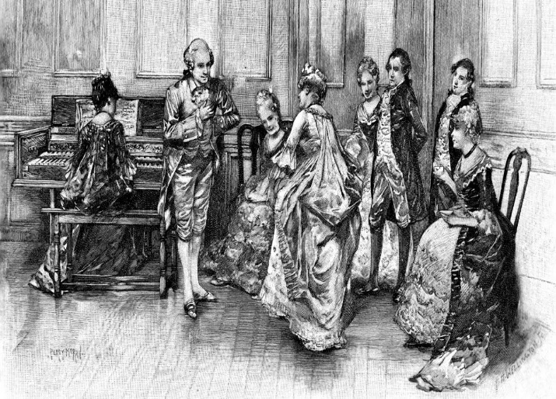

Fact #3: Washington’s first love was the wife of one of his best friends.

“The world has no business to know the object of my love, declared in this manner to you when I want to conceal it,” Washington wrote weeks before his wedding. The letter wasn’t sent to his fiancée Martha Custis—but to Sally Fairfax, who was married to one of his best friends and patrons, George Fairfax, son of one of Virginia’s largest landowners. Described as an intelligent, “dark-eyed beauty,” Sally befriended Washington when he was still an awkward teen. Historians credit her with helping to smooth his rough edges socially, teaching him how to behave and converse among the wealthy and powerful, and even how to dance the minuet. It’s unclear whether romance actually blossomed between the two.

Fact # 5: Washington wasn’t always a great general, but he was an excellent spymaster.
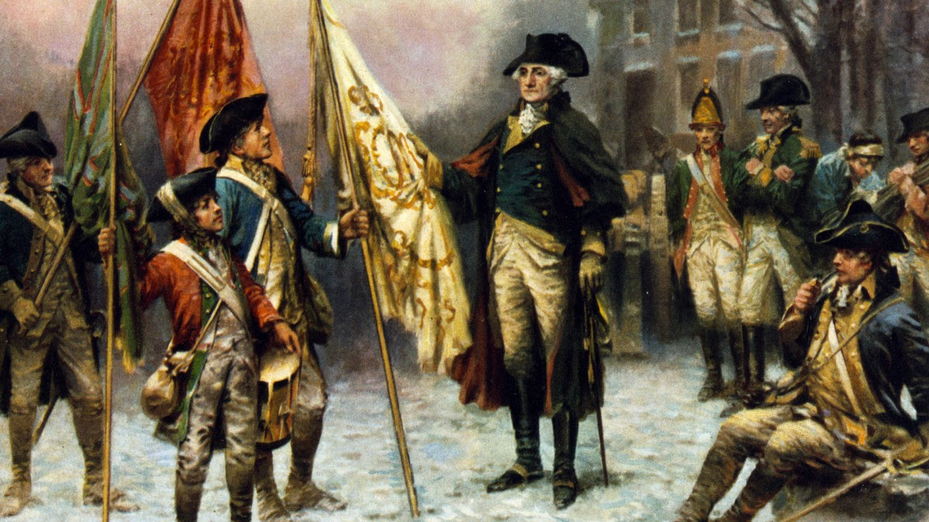

Washington struggled mightily to win the Revolutionary War with an army that was perpetually undermanned, undertrained and undersupplied. To triumph over one of the world’s most powerful military forces, he relied increasingly on his unseen weapon: a secret intelligence network. Throughout the conflict, Washington’s spies helped him make bold, canny decisions that would turn the tide of the conflict—and in some instances, even save his life.

The story of Washington’s underground spy network, and how it helped Americans win their revolution, is replete with intrigue: There were letters written in invisible ink, a rare female agent who went by the mysterious moniker Agent 355, an African-American double agent, a patriot tailor who collected dirt while making clothes for British officers—and the gruesome execution of the spy Nathan Hale. According to the Central Intelligence Agency, “General Washington was more deeply involved in intelligence operations than any American general-in-chief until Dwight Eisenhower during World War II.”
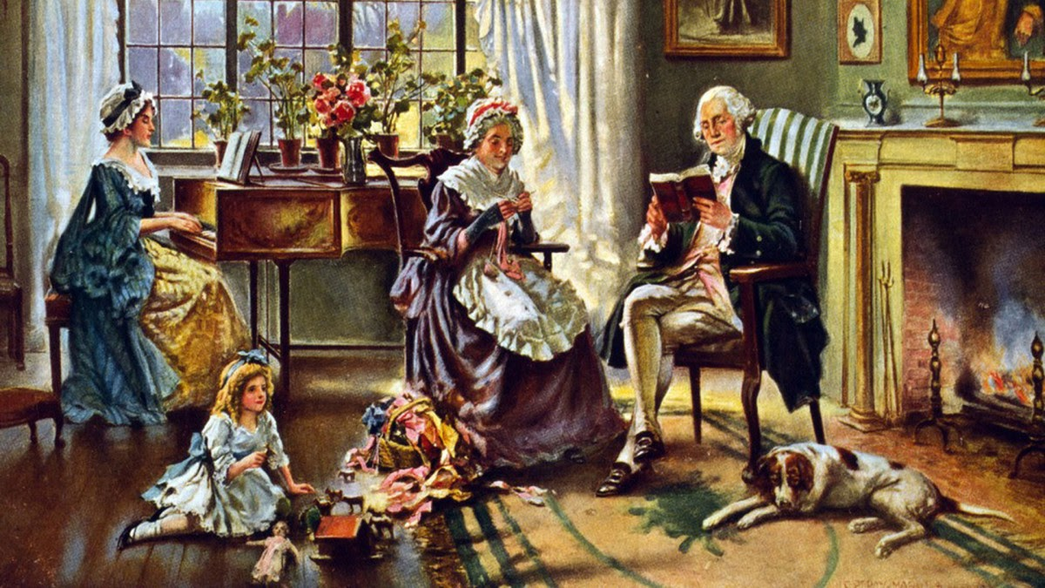

Fact #5: When he stepped down as commander-in-chief, he didn’t want to run the country.

After eight years in the battlefield, Washington was more than ready to return home—to Mount Vernon, his family, his animals and his crops. But he felt compelled to share some hard-earned wisdom with the fledgling nation. In the summer of 1783, he drafted his “Circular Letter to the States,” which detailed what he believed it would take for the American experiment to succeed. In many ways, it was a precursor to his famed Farewell Address 13 years later, a prescient warning to the country of the most likely political pitfalls.

Fact #6: He had no biological children, but was a father figure to many.

It’s never been definitively established why the Washingtons couldn’t conceive. Theories range from George’s early bouts with smallpox or tuberculosis to Martha’s case of the measles. But when Washington married Martha Custis, a wealthy young widow, he became the legal guardian of her two younger children: four-year-old John Parke Custis (known as Jacky) and two-year-old Martha Parke Custis (known as Patsy). He was extremely fond of the, and was bereft when 17-year-old Patsy died of an epileptic seizure.

As a father figure, he was especially fond of dispensing advice via letters—on everything from education to romance. He nagged his stepson to have more discipline with his studies, and warned his granddaughter against marrying for the wrong reasons: "Love is a mighty pretty thing; but like all other delicious things, it is cloying,” he wrote, adding that it is “too dainty a food to live upon alone.”

Fact #7: Washington was really into his animals.

Washington wasn’t just America’s first president, he was also its first mule breeder. (Mules are a mix of horse and donkey.) Recognizing the value of the mule for farmers, Washington is believed responsible for creating the mule stock that powered American agriculture in the South for generations.

And mules weren’t the only animals he bred. In addition to many varieties of birds, Washington kept many canine breeds at Mount Vernon, including Dalmatians, English foxhounds, French hounds, Greyhounds, Italian Greyhounds, mastiffs, Newfoundlands, pointers, spaniels and terriers. A huge dog lover, he selectively bred hunting dogs for speed over the years and gave them endearing names like Sweet Lips, Venus, Trulove, Taster, Tippler, Drunkard and Madame Moose.

Fact #8: Washington was pretty cagey about his religious beliefs.

When it comes to his personal religious beliefs, Washington was tough to read. With so few accounts to draw from, historians are mostly limited to analyzing what Washington did, to try to understand what he may have believed.

The trouble is, even his most straightforward actions can, at times, appear contradictory. The first president encouraged his fellow Americans to show up for worship, for instance, but sometimes struggled to attend church himself for weeks at a time. For many years, he served as a dedicated vestryman and church warden, but left services instead of taking communion. And while he peppered his writings with references to Providence, there’s comparatively little mention of God or of Jesus Christ.

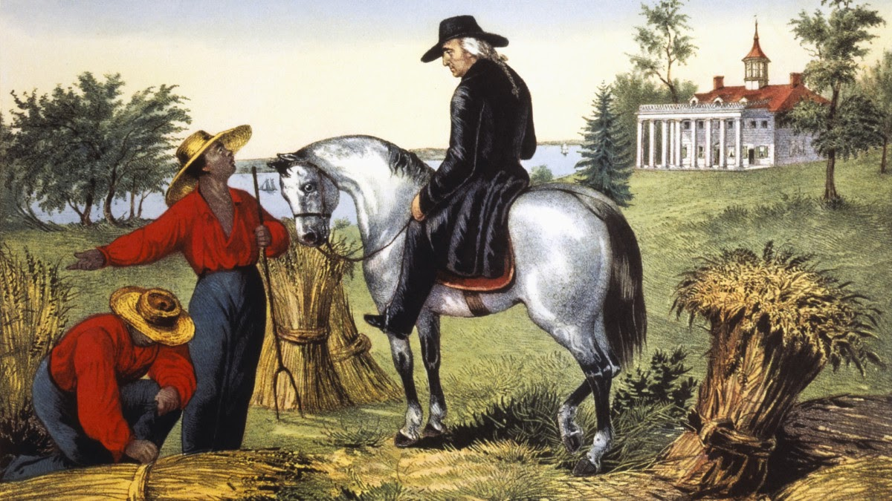
Fact #9: He had a complicated relationship with slavery.

Washington’s contradictory attitudes toward slavery are one of the great mysteries of his life and legacy. Like nearly all wealthy Virginia landowners, he owned enslaved people who worked his land. He received the first enslaved workers of his own when his father died in 1743. Washington, just 11 years old at the time, was willed ten enslaved people. By the time he married Martha Custis in 1759 (who came to the marriage with her own enslaved workers), he had purchased at least eight more.

Over the years, Washington’s thinking on slavery evolved. During the Revolutionary War, he became more uncomfortable with the thought of purchasing and owning other human beings. While he supported abolition in theory, he never tried it in practice. His plantation, his wealth and his position in society depended on enslaved laborers. When one of Martha’s enslaved workers fled to freedom in 1796, Washington spent the last three years of his life trying to force her to return. But when it came time to make his will, it contained an order to free his slaves—with the stipulation that they remain with Martha for the rest of her life.

Fact #10: Washington was a tough man to kill.
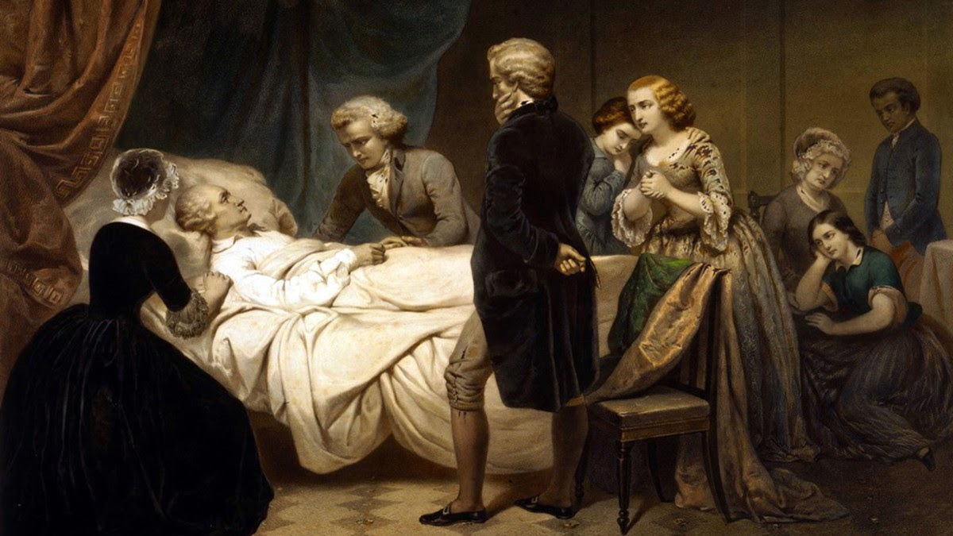

A tall and robust man, Washington survived multiple life-threatening situations. At various points, Washington had diptheria, tuberculosis, smallpox, malaria, dysentery, Quinsy, carbuncle and pneumonia. He survived near drowning in an ice-clogged river. He survived the burning and massacre of Fort Necessity. He survived two horses being shot out from under him and four bullets passing close enough to pierce his clothing—all in one battle.

Ironically, it was a cold that did him in. Technically, it was epiglottitis, an infection of the back of the throat that would be curable with antibiotics today. While he lay dying, his doctors effectively tortured him—burning him to remove the sickness and draining him of a full 40 percent of his blood. Washington was fearful of being buried alive, as he was convinced others in history had been. He directed that his body not be buried for three days after his death, just in case.

