Unit 6: Victory Project
The Victory Project Unit allows students the opportunity to synthesize what they have learned throughout the entire VFW Curriculum experience and complete a final project based on their personal passion and strengths. Students design and create plans for a memorial/monument that honors and communicates the story of the American prisoner of war experience.

Options for the format of the project include, but are not limited to:
- Research paper
- Exhibit
- Documentary
- Digital story
- Web-site
- Dramatic performance
- Slide presentation
- Engaging Students
- Conduct a discussion about memorials to help students have a better understanding about the design process.

Exploration of Memorials
The following U.S. memorials are excellent examples of meaningful memorials created by world class designers. Share them with students and discuss what makes them powerful cultural spaces of remembrance and reflection.
- Flight 93 National Memorial www.nps.gov/flni
- Korean War Veterans Memorial www.nps.gov/kowa
- Liberty Memorial www.theworldwar.org
- National WWII Memorial www.wwiimemorial.com
- U.S. Marine Corps War Memorial www.nps.gov/gwmp/marinecorpswarmemorial
- Vietnam Veterans Memorial www.nps.gov/vive
The documentary, Maya Lin: A Strong Clear Vision, is a good film to have students view prior to starting the project. The 1994 documentary directed by Freida Lee Mock shares the work of the artist most notably the Vietnam Memorial Wall and the Civil Rights Fountain Memorial. The film can provide students with inspiration for their memorials, as well as a behind-the-scenes look into the design process. The film can be found at most public libraries or movie rentals in the documentary section.

Questions and discussion points include, but are not limited to:
- What is the purpose of a memorial?
- What do memorials communicate?
- Does a memorial have to be a physical structure?
- How do memorials serve as a salute to a tragic event, memory, or movement?
- How do memorials help with the healing process for a community or citizenry?
- Some memorials are literal and some are abstract.
- How do the different types of memorials create a poetic communication with visitors?
- How can a memorial go beyond providing a moment of somber remembrance to a personal reflection of optimism and hope.
- What is the difference between a memorial and a monument?

Student Exploration
When discussing the project with students have them ask themselves:
- How would you describe the memorial?
- How is it different than other memorials?
- How does it memorialize POWs?
- What organizations would you approach to erect it?
- What images, dates, times, information, and people are integrated into it?
- Is there a technological component to the memorial?
- Is there an extension piece (museum, web-site, movement, organization) to the memorial?
Review the Victory Project Rubric (see below) with the class and set clear expectations and milestones.

Extension Activity: History Fair
An option to extend the learning and create more meaning for students is to create a History Fair to showcase the completed Victory Project Memorial Designs. This allows students to have more ownership in their projects as they work to create end products which will be publicly displayed. Ideas for the History Fair include:
- Host the History Fair in a community building to reach a more diversified audience.
- Invite family and friends.
- Invite local veterans and POWs.
- Reach out to local media for opportunities to showcase the students’ good work.
- Require students to dress professionally for the Fair.
- Expect students to be present at the Fair and explain and discuss their project with visitors.
- Market the event through a variety of channels.
- Approach local organizations for refreshments, funding, and support of the Fair.
- Document the Fair with photos and video.
- Write a press release for the school and beyond highlighting the Fair and key learnings.
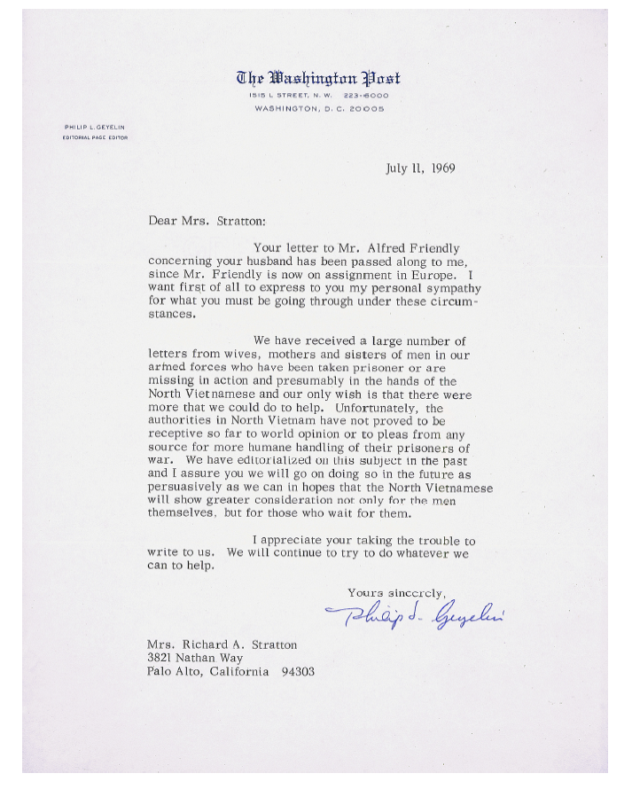

VICTORY PROJECT: RUBRIC

3 | A solid design vision is communicated.  The memorial message is clear and concise.  A high degree of poetic/artistic thought is incorporated throughout the memorial.  High quality, professional, neat, and error-free presentation materials
2 | The design vision is communicated.  A memorial message is provided.  Some poetic/artistic thought is in the memorial.  Good quality, neat, and with few errors in presentation materials
1 | The design vision needs improvement.  The memorial message needs development.  Poetic/artistic thought needs development.  The quality and neatness of presentation materials need  improvement.
0 | Not completed.

NOTES:

