Unit 5: Freedom
Students explain how POWs have sacrificed for our country and use their creativity to create memorial designs to communicate the American POW experience. Students utilize a variety of media and presentation strategies to convey designs and plans. Students will also explore the concept of freedom within the context of the POW experience. Reading interview transcripts and exploring a variety of primary sources will give students an opportunity to learn more about repatriation and how coming home after being a POW can be difficult.

ACTIVITY 1: Central Question Hypothesis

- Hand out the Freedom: At What Cost? (found below) sheet to each student.
- Pose the central question—What is the cost of freedom?
- Have each student write the answer to the central question on the Freedom: At What Cost? sheet. Discuss the students’ answers as a class.
- Hand out and review the Freedom: Rubric. (found below) The rubric outlines and identifies the essential components and content necessary to fully answer the Central Question at the end of the Module. Students should use the rubric in the creation of their final expanded answer of the Central Question.

ACTIVITY 2: Creating Context

- Pose the question, How does life change after repatriation? The question is on the Freedom: At What Cost? sheet.
- Introduce the different interview transcript excerpts to the students. Explain the interviews were conducted with actual American POWs from a variety of wars.
- The transcript excerpts are specific to the themes in this Freedom Unit 5 section. Explain that some excerpts go into more detail than others.
- Hand out the Interview Analysis Guide (found below) to students. Students are to read the excerpts, complete the Guide and be able to discuss both.
- Based on the unique needs of the classroom, have students read transcript excerpts individually, in pairs, or in small groups.
- A variety of transcript excerpts are provided. Select a few or use them all to provide for a wide-range of POW experiences to share/discuss as a class. Disseminate them to students.
- Discuss the interview transcripts and the completed Interview Analysis Guide.
- Based on the unique needs of the classroom, hand out the following primary sources for additional information. Have students read primary sources individually, in pairs, or in small groups. Mix up the groupings of the primary source documents based on class dynamics.
  - Valley of the Shadow
  - The Ballad of Tom Gordy by Jimmy Carter
  - Home from Andersonville painting
  - If I Return Home poem
  - Phases of Repatriation VA—Former Prisoners of War
- Hand out copies of the Written Document Analysis Guide and the Artwork Analysis Guide.(both found below) Have students complete the Guides as they read the primary sources.
- Using the information from the three Guides have students answer the question: How does life change for POWs after repatriation? on the Freedom: At What Cost? sheet. Discuss answers as a class.
ACTIVITY 3: Return with Honor

- Pose the question: How does a POW return with honor? This is the last question on the Freedom: At What Cost? sheet.
- Based on the unique needs of the classroom, organize students in small groups, pairs, or individuals.
- A variety of primary sources are provided. Select a few or use them all to provide for a wide-range of POW experiences to share/discuss as a class. Disseminate primary sources to students.
  - The Toughest Peaks Lie Ahead!
  - The ‘Helping’ Hand
  - American Ex-Prisoners of War
  - The Prisoner of War Medal and Painting
  - The XPW Bulletin
  - POW Medal Decision Matrix
  - Spinelli Photo of Coming Home
- Provide students with copies of the Written Document Analysis Guide, the Political Cartoon Analysis Guide(found below), and the Photograph Analysis Guide (found below) to complete as they read the primary sources.
- Review the guides and the primary sources as a class. Discuss.
- Have the students answer the question How does a POW return with honor? on the Freedom: At What Cost? sheet. Discuss as a class and/or have them turn the sheet in.
- Extension Activity: Have students create a news magazine called “At What Cost Freedom?” Have small groups of students assume responsibility for one section of the news magazine. Each section should cover different experiences, thoughts, and emotions concerning the topics.

ACTIVITY 4: Cost of Freedom

- Pose the central question: What is the cost of freedom?
- Direct students to answer the central question and address all of the items in the Freedom: Rubric in the form of an essay.
- This assignment can either be completed in class and serve as a discussion prompt or given as homework and turned in the next day.
- All students or selected students/volunteers should share their essay.
- Discuss how answers to the Central Question/the essay have evolved and the additional clarity the primary sources provide to the answer.
- Use the Freedom: Rubric to assess each student’s essay response.

FREEDOM: AT WHAT COST?
Central Question:
What is the cost of freedom?
- How does life change for POWs after repatriation?

2) How does a POW return with honor?

FREEDOM: RUBRIC
Central Question:
What is the cost of freedom?

3 | Thorough discussion of freedom which is richly supported with relevant facts, examples, and details. The primary sources and interviews are analyzed, synthesized, and woven into the answer. Specific examples from multiple primary sources are included.
2 | Discussion of freedom supported with relevant facts, examples, and details. An analysis of the primary sources and interviews are included in the answer. Examples from multiple primary sources are included.
1 | Attempts to discuss freedom and support with facts, examples, and details. Discussion reiterates the contents of primary sources and interviews
0 | Not completed.

NOTES:

Unit 5: ORAL HISTORY INTERVIEW - MICHAEL CRAIG BERRYMAN

Michael Craig Berryman, Gulf War

(INT—Interviewer,CB: Michael Craig Berryman)

INT: Did you believe it when they told you that you could go home?

CB: No, I didn’t believe when they told us they were going to send us home. I wanted to believe it. But they had already played so many other mind games with us; I didn’t want to fall for another trick. I was afraid they were setting us up for another psychological defeat. They were wearing us down one more time. They had done a lot of things. They had given us new yellow pajamas; they had let us clean up a little bit; they had let us shave. There were a lot of good indicators that we were heading home. But I wasn’t going to believe it until we were wheels in the well heading south…that we were actually going home.

INT: When did it strike you that you really were?

CB: They took us to the International Airport there in Baghdad and the Red Cross loaded us on the airplane; they flew us out. And as we were taxiing out to the departure end of the runway, you could see the Iraqis had triple-A pieces around the airport guarding it. And I was thinking, “Well they’re going to let us get on the runway, maybe even let us get airborne, then they’re going to shoot us down again as one big bunch.” Paranoia sets in like you can’t imagine. I’m thinking the last laugh they’re going to have on us, they’re going to say yeah you guys are free then they’re going to shoot us down as we’re headed home. And until we punched through the clouds and we were well above their triple-A envelope did I actually believe that we were home free. And as we crossed the Kuwaiti border there with Iraq we had two American F-15 Eagles roll up on either side of the airplane. They did victory rolls, lit their afterburners and went straight up. And everybody was pumped then. We knew that we were safe.

INT: What did you do?

CB: Screamed.

INT: I bet that was a pretty big moment.

CB: Yes it was. I’ll never forget it. I’ll never forget any of it, but that’s beside the point.

INT: What does that make you feel about being over there? Why were you there?

CB: Why was I there as a Marine? I was there because the Commandant said that was my job. People say that we just went to Kuwait to keep the supply of oil flowing, and it makes me madder than a wet hen when they say that because if you’d have seen those people, what the Iraqis were doing to them…They were torturing them. They were raping their country. And we were there to liberate them. We weren’t there to keep the flow of oil going back to the United States. We should have done the same thing in Bosnia in my opinion. We let I don’t know how many hundreds of thousands of innocent people die before we did anything. Again, that’s personal opinion.

INT: Do you think it made you appreciate what we have here more than you thought?

CB: Yes it did. When you don’t have freedom, and then you get it back, you certainly appreciate it a lot more. That’s about the only way I can say it I guess. Put that on a bumper sticker, somebody already has.
INT: What do you think is the most important thing for people to know about prisoners of war?

CB: Man, you’re asking some hard questions now. The most important thing… We already touched on it a little bit. You’re not just there…you’re not out of the war. You’re fighting hand-to-hand combat every day. You’re still a warrior; you’re still doing the best for your country that you can, and you’re not going to give up until the day you come home.

INT: Have you had any damage?

CB: Well, the first month or so that we were back it took for me to get feeling back in my fingers. They said it was partly from the cold, from mild frostbite, and also because they had crushed the nerves with those handcuffs that first day that they had put them on and it just took that long to regenerate the nerves. And the feet were only a couple of weeks to get the feeling back in them.

INT: A couple of weeks…

CB: It’s better than not having fingers and not having toes.

INT: Do you think somebody was sort of looking out for you over the whole thing?

CB: There was so many times that I could have died and didn’t. There was a lot of prayers said in my behalf. And I’m positive that the Lord was taking care of me. There was only a few laser guided bombs that didn’t hit their target in Baghdad. And the one that was supposed to kill all of us went flying right over the top of the building. The one that went down the elevator shaft could have killed us all; it waited until it hit the bottom floor to explode. I could have died in the airplane. I could have been hit when they were shooting at me both coming down in the parachute and running away from them. I could have died a lot of different ways, but the Lord for some reason had something else planned for me. I’m still here. Now my wife may not say that all the time. She’s saying, “Now I could have had that insurance money!” (Laughter)

INT: I’m sure she doesn’t say that too often. Is there anything that you want to add?

CB: No, I don’t think you’ve forgotten anything. No, I don’t think so. I think that’s it.

INT: Thank you.

Unit 5: ORAL HISTORY INTERVIEW - RHONDA CORNUM

Rhonda Cornum, Gulf War

(INT—Interviewer,RC: Rhonda Cornum)

INT: So what are your feelings that you referred to earlier -- all the media attention -- how you felt everything was blown out of proportion? What were your feelings once you gained your freedom and realized that the media was just…

RC: Well, they were all excited about me being female and being captured. So I thought that was- -if they were going to make a big deal about it then that was good as these things go. It was a good thing. I thought I would be a good, a good model for what happens when women get captured. Nothing different than what happens to guys. They come home. They get better. They go back to work. So I mean, you’ve got to find something good about all these bad experiences, and that’s the one. I think we pretty well demonstrated that it’s not different.

INT: Tell me about getting your freedom; whether you were held a day, a month, or more.

RC: Well, yeah, and that’s a wonderful thing, and I have to say I’ve been really happily surprised that, like, the Vietnam guys have just welcomed us into their fold. You know, they spent a lot more time than we did, certainly. I mean, they spent years and we spent at the most 30 days. But the lessons you learn are the same because the fears are the same. The fears are that you don’t know how long it’s going to last and you don’t know if you’re going to get out, and those are the same fears whether you have to have them every day or whether you have them only for a short time. It’s pretty exciting. You just don’t hardly want to believe it. I remember flying back from Baghdad and we’re in a Swiss Air jet, we’re feeling pretty good, but we’re still in Iraqi air space. I know I was thinking there is some poor gunner down there that doesn’t know there’s a truce and he’s going to shoot down this airliner. I mean, you just know. And so you just have -- it takes a while to believe it. You have to really, you know, kiss the ground kind of thing. It has to be your own ground. And I remember we got back to the States, spent a couple days in Washington and then they flew us back to Florida because I was going to get my surgery, actually, in Florida and we have a farm in Florida. And so he dropped us off at Eglin, dropped me off at the hospital, signed me up. I was going to get operated on the next day and I said, I just need to go home. So we borrowed a car and drove out to our farm. I just needed to go actually see it was really still there, because it had been a long time. Then I felt like I was home and I went back to the hospital and got fixed.

INT: Now I’m sure somewhere along the way there’s a debriefing?

RC: We got debriefed on the boat. You know, they took us all to the Mercy for a while first and then they hauled us back to Washington some weeks later and we got another round…

INT: Were you told how to react once you got back or what you could or could not talk about?

RC: No, not at all.

INT: How much did you talk about your experience initially compared to now?

RC: No difference. I talked about it more early on, I suppose, just because more people asked. You know, then when I sort of got reintegrated to what I do, I do surgery and I do…I do research and so there’s much less time being spent being an ex-POW. But it’s a unique experience and so when people ask to hear about it, you know, it’s one of those
things it’s better to learn vicariously than it is to experience, and so I do. I’ve gone to like the Air Force Academy and talked there and I’ve gone to the Marine midlevel, whatever their version of Air Command Staff College is, and I’ve gone to the War College and I’ve gone to a lot of places and talked about this sort of thing.

INT: Do you think about your being a prisoner of war will change anything or help change the mindset?

RC: I think it already did. I think the fact that we now have women flying combat aircraft is a direct result of everybody used the excuse, well, they might get shot down and captured before that. And they said well, yeah, they might, and so what. They might get run over going to work, too, but we let them go to work. So I think it’s a direct and positive impact, yes. And I’ve had several people who voted on that thing say that that had a direct and positive impact on their decision.

INT: Do you feel like the experience that you went through changed your life or changed you as the person you are today?

RC: Well, I think my basic personality is the same. I think it changed me in that it is much -- I get irritated much less easily. You know, when you have a really significant experience happen, then the little minor irritations of life are much less important. You know, you sort of think well, what are they going to do, send me back to Baghdad? No. So you know, it just doesn’t matter. So I think -- I think you focus on things that are important and you learn to just not let yourself get worked up about things that aren’t. That’s how I felt about it, anyway. Well, camaraderie was very interesting. You know, when the Red Cross got us in Baghdad, they very nicely got this whole hotel set aside for them and they had gotten us each a private room. You know, they had gotten the hot water hooked up and everything, and you know, it was very nice of them but the last thing in the world after you’ve been in solitary confinement for the last month is to be by yourself. So we actually used two of these 20 some rooms and it was like a big slumber party and everybody told stories about getting shot down and it was very -- it was very military. It was like, you know, it didn’t really happen to anybody. It was like telling stories about someone even though that was happening to you. I think people always do that. But it was very interesting and then we got to the boat and people did the same thing, only now you’ve got the guys from the unit. Every unit that had a prisoner of war sent one member from their unit over to the Mercy so that they could hear about what happened and sort of get reintegrated and hear about their stuff. And they may have been a little shocked that we weren’t more, I guess, reverent about all the bad things that happened but it just, you know, once you’ve survived it, it’s not bad anymore. So we were, you know, you are very different. You’ve had this very intense shared experience that you can’t really describe unless you have it. And we were really close right then. And once again, here we are five years later. People have, you know, changed jobs, changed units, changed spouses on a few of them, had more kids, gone back to school, gotten out of the service, whatever they have done, so it’s a much less intense thing now. It’s still a big part of your life when you get together, but it’s not the only thing that’s part of your life.

INT: Thinking about what the Vietnam POWs went through, the physical, mental abuse. It almost seems like the Gulf War was such an overwhelming quick victory for the United States that it seems like it missed all the glory and the hoopla. It almost seems like the POW story is not as well known. I mean, hearing all the stories of how bad the abuse and everything was. What’s your feeling about that?

RC: I don’t think about it at all. I don’t, you know, see any reason to dwell on the bad things. I mean, I really don’t. I don’t see any reason to dwell on -- I mean it’s kind of like being in a hospital. We don’t dwell on the two percent of cases that don’t go well, you know? And so there’s nothing really to be gained by that. I don’t think any of the POWs feel bad that people aren’t still weeping about their bad experiences. They’re certainly not.

INT: Someone did comment that it feels like hey, people think that you went through it, now just forget about it. It doesn’t pass. I mean, it’s something in the past but this is something that I’m sure doesn’t go away but--

RC: No, but it’s -- but it doesn’t. You don’t need to dwell on it. It’s kind of like a lot of other things in your life. And you certainly don’t need, you know, I mean, I talk about it because people ask. I don’t talk about it when they don’t. I mean, I know what happened and that’s all that I need to do.

Unit 5: ORAL HISTORY INTERVIEW - PRETSEE DAVIS

Prestee Davis, Korean War

(INT—Interviewer, PD: Prestee Davis)

INT: Do you remember the date that you were liberated or repatriated?

PD: No. I don’t remember, but it was August. But I don’t remember the date.

INT: Give me the circumstances of the liberation.

PD: The conflict ended, so they released the prisoners.

INT: At what point did you know or at least feel confident that you were going to be released.

PD: I never did, because they told me they were going to take me to China and put me in jail. They had shipped about all of the people in that camp. There was 12 of us left back there, and we didn’t get repatriated until about the last minute of the last day.

INT: What went through your mind when the numbers kept getting less and less?

PD: I didn’t worry too much about it, because I eventually thought they would let me go.

INT: Did it help to maintain a sense of humor?

PD: You had to have a sense of humor.

INT: When did you make it to Green Village yourself, and what happened after that?

PD: Nothing. They just turned us over to the American troops. I think we stayed down there two days before they exchanged us.

INT: Where did you go from there?

PD: From Green Village to town where MacArthur invaded Korea then to the ship. Then we came home.

INT: Do you remember any emotions or how you felt when you got back?

PD: No. I don’t, because everybody was happy just to be back. I don’t think there was too much people doing anything different than they already do.

INT: What port did you arrive back into?

PD: I think it was Oakland.

INT: How long before you got back home and saw your family?

PD: Just a matter of days.

INT: Did you have to go through any debriefing when you got back?

PD: They did it on the ship.

INT: What was that like?

PD: I don’t know, because I got smart with two or three of them.

INT: Did you receive medical treatment?

PD: Yeah. We got that on the ship and when we reported back to active duty. I came home, and I didn’t go back to the Army until January.

INT: Had anything changed in your absence or notice anything in America?

PD: No, not really.

INT: Do you think your experience has changed you in anyway?

PD: I sure do. I sure do. It affected me by making me give respect to people who deserve it. It also made it hard for me to trust people, and it has been hard for me trying to change that. It changed my faith in human beings, too.

INT: Can you think of any positive ways it has influenced you?

PD: I think it made me a better person. I think it made me understand people more than I did because I was young and I really didn’t understand people. But I think I understand them now. I am almost sure it made me a better person.

INT: A lot of POWs or Ex-POWs once they are released and come back to the States suffer from disabilities or nightmares contributed to their POW experience. How has it been for you ever since then?

PD: Physically, I am in bad shape. I am 100 percent disabled now. I had nightmares for three or four years, but I haven’t had one in a while. But I had bad nightmares. I was always fighting somebody–the Indians, Chinese, or somebody for the first three years, but that’s all gone now.

INT: Have you found it difficult trying to work with the government? Have you received everything you should have?

PD: I think I got everything I should have, but I didn’t get it easy. There were some problems, but I got them ironed out. So I have no animosity towards the government or anyone else.

Unit 5: ORAL HISTORY INTERVIEW - MELVIN DYSON

Melvin Dyson, World War I

(INT—Interviewer, MD: Melvin Dyson)

INT: What was the date that you were liberated, that you were - that you became free?

MD: I think it was around the, it seem to be like it was around the 10th of December. Because I was out of there by, I think I was out by Christmas, I’m not – after all things that happened I can’t remember them all. But it seems to me like it was later than December somewhere.

INT: Who liberated you? How were you, did someone come into –

MD: Well, I come out through Switzerland. We were pretty close when the war was ended. I was with the Germans as a prisoner of war and somewhere down next to Switzerland. So actually, some of the guys, some of the guys took off, that was the worst thing had ever, when their armistice was signed it exploded and started back to the line. Well, I said, I had walked most of the way in, I was looking for a ride out. I did, I came out through Switzerland, all the way out through Switzerland.

INT: They let you go, they just let you go?

MD: Well, in other words there was an agreement with the governments to do that, to come out, because after all the Swiss were highly liberal you know. They didn’t get involved in anything that would be against them because after all they were in a bad position; after all they were right in the middle of all of this. In other words, I never thought about it until later, until I was smart, got a little smarter, but I wondered why the devil, them French or them different ones how they come in here to a year, two or three years, good gosh they had a chance to get out of there, why the hell didn’t they go.

INT: So did they just say to you okay you’re free to go?

MD: No, it was systemized down, that was something I was proud of that they still had, we still had a system that was disciplined I might call it. We could get with our leaders even the leaders that was prisoners of war and get things to run to get down there after all it’s a two sided deal you know. And I saw guys that tried to get smart with the captors and it didn’t work worth a darn, they got their ears pinned back so fast than, that’s a very good thing in an ordinary life you know. You can’t get by with some cock and bull story or something,

INT: When you got to Switzerland did you go to a U.S. Army camp or did you go to, who did you go to?

MD: Well, we got fed big meal in a depot put on by the American Red Cross. That was really something because we were - we didn’t have that much to eat, the Germans didn’t have it either. But that was the tops, yep.

INT: And were you just also happy just to be out of there?

MD: Oh yeah, well different reactions as far as I’m concerned, different reactions. Some guys, well I played it, I tried to play it smart and do what they want me to do, without reason some guys would fight them practically to keep from doing - after all they had ways of running the camp or something.

INT: When you were back in Switzerland was the war over at that point?

MD: Oh no.

INT: No.

MD: No, no, that was, the arms - just armistice, that’s all it was, I was in Switzerland after the armistice because I was never released out of Germany, I mean out of Germany into Switzerland after the war was over. A lot of fellows, see, were down further close to the Swiss border, a lot not too far into Germany. Fellows when the war broke they took off and went into Switzerland and went back in on by doing different deals and getting back into France. I said, well, after all I walked most of the way in I want a ride out.

INT: Did you go back to fight in the war after you were released from the prison camp?

MD: No, no. You’re not supposed to.

INT: When did you go back to the United States? MD: Well I went back to my outfit and come home with them. INT: Do you remember the date?

MD: Oh, I don’t know, it was six months after I come out of Germany but before we ever came back to the United States.

INT: Was your family there to great you when you when you got back to the United States?

MD: Oh sure, yeah. It was if, as there as they could, if you were at, especially if you were into a big camp, a fairly big camp, there was always people there that knew you and knew and some of your own relatives come there. I don’t know, it’s a give and take deal.

Unit 5: ORAL HISTORY INTERVIEW - FLOYD FRIEND

Floyd Friend, World War II

(INT—Interviewer, FF: Floyd Friend)

INT: Do you think people have treated you differently in your life because you were a prisoner of war? And if so, how?

FF: I don’t think so. I never asked to be treated different. I don’t tell them I’m a prisoner unless they ask me. But I have my license plate, it says I am. And we’ve been real fortune I guess -- fortunate. We have several cars to stop, honk at us and said, “Welcome back” and “Thank you” and such as that, which makes you feel good. But we didn’t ask for it, so we’ve got the title, so do the best we can.

INT: What did you feel when you first saw your wife and your child when you got home.

FF: Just felt good inside and you cried a little. The only thing is, she was running to somebody else -- I was fat when I got home. I was bloated up, you know. Come across in a hospital ship and I worked -- I didn’t want to stay in bed, so they put me into mixing milk shakes for the bed patients. And so every time I mixed one, I drank one. And I think I weighed about 200 pounds when I got home. And her dad recognized me and he came up, was shaking hands and her and my daughter was running down the tracks to meet some tall skinny guy. I don’t know whether that was a come on or what.

INT: She went home with you anyway right?

FF: She did. When she turned around and seen her dad shaking hands with me, she run off and left her daughter and burnt rubber getting up there where I was at.

Unit 5: ORAL HISTORY INTERVIEW - JOHN McCAIN

John McCain, Vietnam War

(INT—Interviewer, JM: John McCain)

INT: When you realized that you were finally going to get home, when did it hit you that it was going to happen? What moment was it real you were going to see your family again? JM: It was -- it had been so long it was almost anti-climactic. We really knew that it was at a crucial point when the B-52s came and bombed the Christmas of ’72. Once the announcement was made as I say for me it was almost anti-climactic. I had been waiting for it for so long. It was like when a kid waits for his birthday party and it finally comes and it’s not quite as much as you thought. Of course I was happy. Of course we were overjoyed to return to our home and our family and our country and be out of there. But it wasn’t that I wanted things to eat and it wasn’t that I wanted…a lot of the other creature comforts. My particular desire was to read because all those years had gone by and I didn’t know what had happened and I hadn’t had anything to read. So when I got to Clark Air Force Base which was our first place I used. I had all these books and I would read and then fall asleep. My eyes would hurt and then I’d wake up and read some more and I’d fall asleep, wake up, because I was so -- I had missed that probably more than anything else, a lack of information. It probably bothered me as much as anything else, as far as deprivation is concerned.

INT: Do you feel like you lost time?

JM: Oh yeah. You feel like you lost time but you know, listen, I don’t recommend the treatment but I know that I’m a far, far better person for having had the experience. Far better and the things that have happened to me in my life I am truly the most fortunate person that I’ve ever heard of. I’ve had the most wonderful life that anybody could ever imagine and my appreciation obviously for it was heightened dramatically by my experience in prison.

INT: Well I guess the “what was it like?” is a very sort of general question but—

JM: The important -- the important thing about doing well in the prison experience is obvious and that’s communication. Staying in communication with your other prisoners gives you the sense of organization and team work and ability to resist. That’s why they kept us separate for so long. They know that it breaks down wills when you keep people apart. But the other thing is to keep a sense of humor. You know when the -- when the Vietnamese have all power over you, you have a tendency to be intimidated. So the thing you’ve got to do is laugh at them and laugh at their stupidity and their idiocy and their dumb ideas and their -- and their worship of Uncle Ho and the classless society where the officers walk around with boots on and smoke cigarettes and have better food and the guards are in sandals. I mean, it was very important to keep a sense of humor, and to keep a tight reign on your emotions so that you didn’t get too optimistic nor too pessimistic, but to keep a very level and steady kind of attitude.

Unit 5: ORAL HISTORY INTERVIEW - JAMES STOCKDALE

James Stockdale, Vietnam War

(INT—Interviewer, JS: James Stockdale)

INT: Was there a significant change do you think when you came home and came back into your regular life, living with Sybil and your family? Do you think she was surprised by who you had become? How different were you?

JS: Well, I don’t, she -- we’d been married 18 years before I was shot down so I don’t think she was any -- somebody else and, although she had had a lot of different experiences. And I don’t think -- and I’d had a lot of different experiences but I think to a couple that’s been married that long it seems like a natural growth has taken place, it doesn’t surprise you. We were very lucky to have had that because it was another story to those who were just newlyweds, and I don’t think the statistics are much different than the national averages in or out of prison, but I know that there were some very -- kind of preoccupied young officers that would hear rumors from home or something like that. I can’t cite any specific examples but that was a long time -- Sybil often talks about how -- she didn’t use herself as an example, but mostly newlywed girls, it was a different thing than it was for a woman with four children and 18 years in marriage.

INT: When you found out you were going to be released, what did you feel?

JS: Well it came as no surprise to us, we knew when those B-52s started bombing on the 18th of December to -- the word were yelling in the cell blocks, “Pat [?], this is it, we are going home, we’ve been waiting all this time for this.” And so that was the mood, we just knew in our blood -- and the people -- the Vietnamese, our officers were -- the streets were silent. They weren’t bombing downtown, everybody in America was told so, but I know for a fact Sybil -- when we went over there a couple of years ago, we were in downtown Hanoi, they are kind of mildewed old French buildings that had been there since the 19th century, and I said, “What are you doing?” She was [inaudible words] she is like, “I can’t see any signs of bomb damage down here in this part of town,” and there wasn’t any, and it was all out in the rail yards, but still you could feel the earth shake and you knew that this was like doomsday, it was altogether different than the tactical bombings which only -- a tactical raid takes about 10 minutes and you get used to the noises and maybe there would be an ambulance you can hear later, maybe a fire truck. But they claimed no great number of casualties -- I mean they could have lived through that forever, but when you bring in the big stuff, why, we just knew it that it was a different story and -- so that that’s about the way it was, I mean everything fell in place, we were -- the commissar, Major Bui, and I’m not supposed to know that name but people were in places where -- with him that word got out. He sort of had a nervous breakdown. The last time I saw him was the summer of 1970. He had come there after I came, I was shot down in September, he -- they didn’t set up the camp system, as I’ve described isolation and all the others stuff until the fall of ’65. It wasn’t until then that they were sure that this was going to be a continuing war. That’s documented in various history books. They said this is going to be -- we are going to have to win this war on the streets on New York, let’s prepare to take these people and -- I don’t think -- brainwashing is not something that I think exists, really, I mean it’s just matter -- I mean -- but they -- you can be forced to do things, there is no question about that.

INT: If there is one thing what did you miss the most?

JS: Well, I missed the affection of my family. I mean it would have been a -- you see a trip back to -- it would have been to sit in our presence and have a look at them, they changed you know, over time. And there was a lot of the long hair had come in. That was a lot of shock to a lot of people, with the boys. And my boys were relatively conventional but I know a lot of fathers who really had the -- when times were easy and here’d come the family pictures so they’d like to say then, I’d like to get back and make sure those kids are normal, like you were not what they looked like to you now, and all that sort of thing. But I guess those are the anxieties that you would like to quell with some kind of a visit. It wasn’t anything, I didn’t personally wish for some particular thing to eat or want to see a -- there is a quotation of me and I was at (inaudible word) going home and a guy said, can you believe that we’ve had a man on the moon. And I said, I guess I could, but I don’t think that’s the greatest thing I’ve ever heard of. He thought, that’d ring a bell, oh my God, we got a man on the moon. I mean that didn’t give me any kind of a thrill.

INT: Did you know your littlest boy? When you were captured he was real little.

JS: Yeah, three.

INT: He was like three, and was that hard to get to know him again? JS: Well, that was a very interesting question you’ve raised there because in my case we had four boys and the older two had gone on excursions with me. We’d gone camping, I’d participated with them. They came over one time when I was in EUMA Arizona and we were flying gunnery flights and they stayed there with me in the BOQ room for a couple of days. So they knew me as dad, the other two didn’t have those kind of memories, they didn’t have much of any memory. They each in the period I wasn’t concerned about it, I wasn’t even aware what difference I was dealing with. But both of those boys in its own independent way, I think, one of them wrote me a note and one of them came and spoke to me. But they said I just want you to know I know who you are now and I’m very happy you’re my dad and we are going to be okay together. Now this was after a couple of years of thinking about. So that’s part of the separation problem, and those guys had to take their time. They didn’t know, they lost a lot of autonomy, they, you know here I was a new guy and I seemed to have the last word on everything and that’s not the way they grew up. They had their area that they were in charge of, so that’s part of the downside of this.

Unit 5: ORAL HISTORY INTERVIEW - ROBERT WINDHAM

Robert Windham, World War II

(INT—Interviewer, RW: Robert Windham)

INT: Tell me about the actual liberation?

RW: When the force came in the doctors were out there to talk to the commanders so they just moved right on through the town. They went on through, safely. The only person I got to see was the Lieutenant. He set up in the hallway a field range. He asked what I was hungering for. I said, steak, eggs and bread. He made just that for me and I was sick right off the bat. I didn’t keep it down long. I started all over again drinking milk.

INT: Once you were liberated, tell me where you went all the way back to the United States.

RW: I often think about this. The American army can not be beat by anybody in the world. I’m proud of them. I’m talking about every part of the military. I think it was another four or five days before the medics all came in. They looked at me and decided where I should go first. All that is wrong with you is you need some food. They put me in an ambulance with three other fellows that I think were British and shipped us back to an evacuation hospital. I stayed there five days. A Red Cross lady came in and asked if I wanted to write my wife a letter. I said I couldn’t move my arms or legs or anything. So she wrote my wife a v-mail letter and my wife received it two days after it was postmarked. That was her first news that I was okay and was on my way home. The War Department sent the information too but it came after the letter.

INT: Did you eventually go to Lucky Strike?

RW: Yes but I can’t tell my Lucky Strike thing until I finish up here. Five days at the evac hospital, I was shipped by plane to Nice to the 97th General Hospital. People kid me about being on the Riviera but I spent the next 8 weeks there trying to get on my feet. The legs and muscles were a real problem. Treatment was tremendous.

INT: Eight weeks on the Riviera and then on from there.

RW: That’s right. I managed to maneuver myself on to a bus to the airport and on to a C47. We landed there at Lucky Strike. The first thing some Lt. Colonel came out, he said I wasn’t ready to go home right now. He said he had a job for me.

Interview Analysis Guide

- Name of POW: _____________________________________________________________

- In which war did the POW serve?

- List three things in the interview you view as historically important.
1)

2)

3)

- Write two questions you would ask the POW that were not asked by the interviewer.
1)

2)

5. What did you find most interesting about the interview?

6. What new insight did the interview give you into the POW experience?

Valley of the Shadow
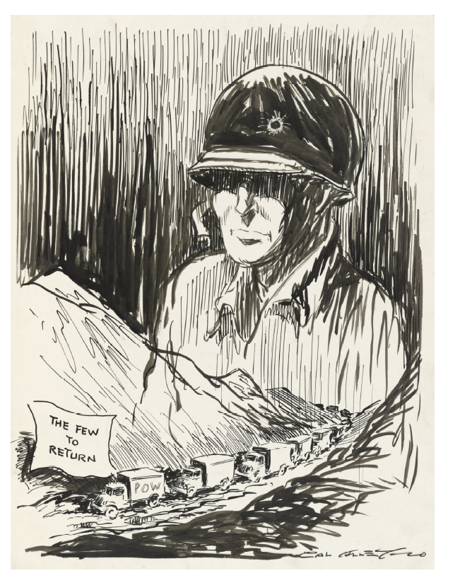
Alley, Cal. “Valley of the shadow.” Library of Congress, Washington, DC. April 16, 1953.

Cartoon shows a convoy of prisoner of war trucks labeled "The Few to Return" traveling through a valley over which looms a huge ghostly figure of a soldier with a bullet hole in his helmet. The caption refers to the Biblical "valley of the shadow of death" from the 23rd Psalm. Reflects American anger, as the first Korean War prisoner exchange began in April 1953, at the large number of soldiers believed to have died in North Korean POW camps.
Artwork Analysis Guide
Observe
1. Study the work of art for 60 seconds. What is your overall impression of the piece?

2. In the table below, list the people, objects, and activities you see depicted in the piece.

People | Objects | Activites
Make Meaning
3. Based on what you observed, list three things you might infer about this work of art?

Ask Questions
4. What questions would you like answered about this work of art?

Photo Analysis Guide
Observe
1. Study the photograph for 60 seconds. What is your overall impression of the photograph?

2. In the table below, list the people, objects, and activities you see depicted in the photograph.

People | Objects | Activites
Make Meaning
3. Based on what you observed, list three things you might infer about this photograph?

Ask Questions
4. What questions would you like answered about this photograph?

5. Where could you find the answers to these questions?

Written Document Analysis Guide
1. Identify the type of document:

2. Identify any unique characteristics of the document.

3. Date(s) of the document:

4. Author (or creator) of the document:

5. For what audience was the document written?

6. List three things the author said that you think are important:

7. Why do you think this document was written?

8. What evidence in the document helps you know why it was written? Quote from the document.

9. Write a question to the author that is left unanswered by the document.

Political Cartoon Analysis Guide

VISUAL ELEMENTS TEXT ELEMENTS
1. List the visual elements you see in the cartoon. 4. Identify the cartoon caption and/or title

2. Which visuals on your list are symbols? 5. Locate words and phrases used by the cartoonist to

3. What do you think each symbol means? 6. Which words or phrases in the cartoon appear to be the most
significant? Why do you think so?

7. Describe the emotions portrayed in the cartoon.

MEANINGS

8. Describe what is happening in the cartoon.

9. Explain how the text in the cartoon clarify the visuals.

10. Explain the message of the cartoon.

11. What groups would agree/disagree with the cartoon’s message? Why?

The Ballad of Tom Gordy
by President Jimmy Carter
In ‘42 the Japanese
took our troops on Guam,
Alive or dead—we didn’t know.
One was my Uncle Tom.

He was the Navy boxing champ,
my hero with his crown.
Now with him gone, his family moved
down to our Georgia town.

My grandma and my aunts felt Tom
was not his wife’s but theirs.
She could feel the coolness but
stayed on to join their prayers.

What bound them all together was
the hope and faith and dread.
When two years passed, the dispatch came:
my Uncle Tom was dead.

His wife and kids moved back out West
to start their lives again,
And after Tom was gone three years
she wed a family friend.
The end of war brought startling news:
Tom Gordy was alive.
Four years he had been digging coal
deep in a mountainside.

The women took the feeble Tom
and smothered him with care.
He never would tell anyone
what happened over there.

Tom Gordy soon regained some strength
and craved a normal life,
But mother and sisters told him lies
about his absent wife.

Betraying him. Tom wanted her,
but couldn’t figure how
To bring her back or overcome
her second marriage vow.

He got four years’ back pay and made Commander, U.S.N.
It didn’t take him long to find
a woman’s love again.

Tom closed the past except when his
three children came to stay;
When I would mention his first wife
he’d always turn away.

Once my submarine tied up
where she lived with her kin.
I went to visit them, afraid
they wouldn’t let me in.

But all the folks they knew were called
when I first gave my name;
All night we danced and sang because
at least Tom’s nephew came.

Tom Gordy was President Jimmy Carter's uncle and a person he looked up to. Tom was missing in action at Guam and was missing so long he was presumed dead. Eventually, his wife remarried. At the end of the war, he showed up at the door one day of his sister’s house. As it turns out, he had been held in a Japanese slave labor camp building railroads.
Home from Andersonville, “Blessed are they that suffer for righteousness’ sake”
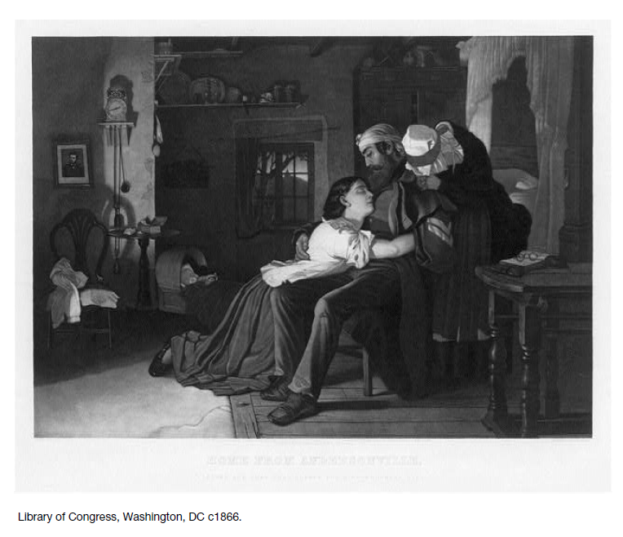

Poem by Silas Crase

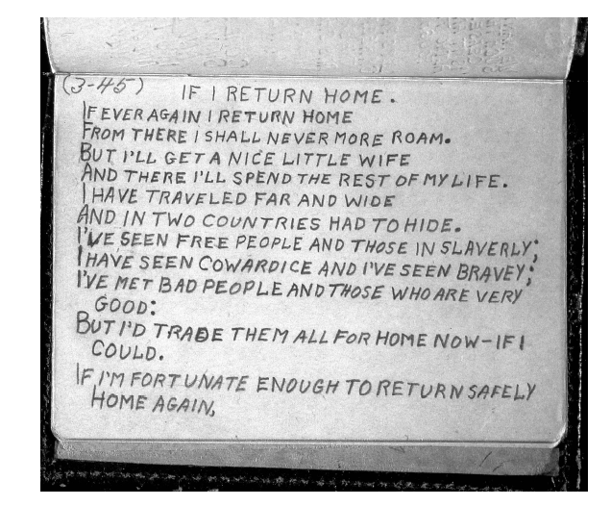

Photograph of Silas Crase’s diary. Poem entitled, “If I Return Home.”

Crase was a ball turret gunner in a B-17 and was shot down over Germany in October 1944. Crase was never captured, evading Germans for several months. He composed this poem while considered MIA.

PHASES OF REPATRIATION

E1. ENCLOSURE: YELLOW RIBBON REPATRIATION PROCEDURES

E1.1. THE THREE PHASES OF REPATRIATION
A successful repatriation process hinges on proper preparation. Logistic, medical, and debriefing support planning should begin when a person is captured or taken hostage. Repatriate personnel in accordance with this Instruction and supplementary instructions approved by DPMO and published by JPRA. JPRA shall determine if a SERE psychologist or other trained mental health professional is required to remain with the returnee through all phases of handling and debriefing.

E1.1.1. PHASE I begins when the returnee first comes under U.S. military control.

E1.1.1.1. Transport released personnel to the Combatant Command's designated theater treatment and processing facility. This facility will normally be located in the theater where the personnel were held. Personnel who were imprisoned together should not be separated during the repatriation process.

E1.1.1.2. While en route to the theater treatment and processing facility, medical personnel, to include a SERE Psychologist (or other appropriate mental health professional if a SERE psychologist is not available) shall be on hand. The SERE Psychologist or other mental health professional will begin a psychological assessment of the returnee that will continue through the entire repatriation process. Medical personnel shall conduct a cursory medical review of the returnee and administer medical treatment that cannot wait until the returnee is admitted to a full-service hospital.

E1.1.1.3. Advise returned DoD contractor employees upon initial repatriation that they may choose to be processed through all phases of YELLOW RIBBON, including PHASE III hospitalization in CONUS. Inform them that if they elect to leave the military processing sequence, they will not be allowed to reenter. When a returned DoD contractor employee elects to be processed through the DoD system, the Department of Defense will coordinate with the Department of State (American Citizens Services and Crisis Management Branch) to ensure that all available personal, medical, dental, and family data is provided to YELLOW RIBBON Processing Centers.

E1.1.2. PHASE II begins upon arrival at the theater treatment and processing facility. Initiate more in-depth medical treatment, initial debriefings, and personnel actions at this point in the repatriation process. Immediate medical care and mental health treatment will be addressed first.

E1.1.2.1. Prior to starting the debriefing process, the returnee shall be given an opportunity to sign a DD Form 2810, "Promise of Confidentiality," found in attachment E1.A1. of this Instruction. This statement promises confidentiality, to the extent authorized by law, in return for total disclosure regarding the returnee's captivity experience.

E1.1.2.2. Medical treatment shall include the services of a SERE psychologist or other SERE- trained mental health professional (if a SERE psychologist is not available) who will be available to address any returnee concerns or problems. Immediate medical care or mental health treatment shall be addressed first.
E1.1.2.3. Intelligence personnel shall be on hand to conduct a tactical debriefing. This debriefing will be limited strictly to perishable tactical information the returnee may possess and time-sensitive information on U.S. personnel last seen alive in a POW camp system, but who are still unaccounted for. If the returnee possesses such information, intelligence personnel shall conduct a basic, narrowly focused debriefing once

PHASES OF REPATRIATION (continued - page 2 of 3)
cleared by the returnee's physician. In the event this type of debriefing is required, the debriefing will last only as long as the returnee is able to hold up physically and mentally. If the returnee is a Military Service member and reveals information implicating himself or herself in a potential violation of the Uniform Code of Military Justice or other U.S. criminal law and the debriefer is a military member or a DoD employee, the debriefer shall stop debriefing and inform the returnee of his or her rights under Article 31(b), UCMJ. If the returnee requests counsel or does not desire to continue the debriefing, the debriefing will cease until counsel is obtained. If the returnee does not request counsel and agrees to continue with the debriefing, the debriefing may continue. If the returnee is a DoD civilian or DoD contractor employee and the reveals information implicating himself or herself in a potential criminal offense under U.S. criminal law, the debriefer will cease questioning and consult with a judge advocate or an attorney assigned to the U.S. Attorney's Office before continuing.

E1.1.2.4. Returned personnel shall meet with their designated Military Service representative, normally a Military Service Casualty Officer, following the intelligence debriefings. At this point during PHASE II processing returnees shall be allowed to telephone home. Prior to any phone call, the Military Service representative, in coordination with applicable professionals such as doctors, chaplains, family support personnel, etc., shall brief the returnee on any family issues that may have occurred during the returnee's absence (e.g., divorce, death in the family, etc.). The Military Services shall also begin working with the returnee to ensure a smooth transition back to personal, professional, and family life.

E1.1.2.5. Working in coordination with the Military Service Casualty Officers or their representatives, PA shall ensure any public statements the returnee makes are coordinated through the PA office and JPRA. PA shall also provide security guidance on what aspects of the returnee's captivity may and may not be discussed publicly.

E1.1.3. PHASE III begins when the returnee is transported to a CONUS facility.

E1.1.3.1. When more than one person is returned, all returnees should remain at the same location, if feasible, until the debriefing process is complete.

E1.1.3.2. An escort officer shall accompany each returnee to the PHASE III processing center. The SERE Psychologist or other trained mental health professional shall remain with the returnee, as determined necessary in consultation with JPRA, throughout all phases of handling and debriefing.

E1.1.3.2.1. Personal escorts may include representatives from any Military Service; however, when all returnees are from the same Military Service, escorts should be from that Military Service. The primary consideration is for returnees to have someone from their Military Service immediately available to respond to questions or provide assistance.

E1.1.3.2.2. If a flight originates OCONUS, the personal escort will accompany the returnee to the final processing location. Escorts will support returnee needs and security as required, but will not interfere with Military Service medical personnel and their duties.

E1.1.3.2.3. Military Services and Combatant Commands will assign personal escorts based on returnee needs, aircraft resources, and escort availability.

E1.1.3.2.3.1. A one-to-one returnee-to-escort ratio is ideal, however, do not delay returnee evacuation due to lack of escorts or the need for additional aircraft space solely to accommodate escorts.
PHASES OF REPATRIATION (continued - page 3 of 3)

E1.1.3.2.3.2. From OCONUS to CONUS, provide at least one Military Service escort for every five returnees of that Military Service. In CONUS provide at least one Military Service escort for each point where the DoD aircraft discharges returnees.

E1.1.3.2.4. Due to expected high interest by the press, a DoD PA officer should accompany a returnee on CONUS flights. PA officers should consult with the returnee before coordinating media events and activities. PA officers should ensure that events coincide with the desires of the returnee, who is attempting to regain control over his or her life.

E1.1.3.2.5. In addition to personal escorts, a physician, chaplain, SERE Psychologist, and DoD PA Officer will normally accompany each flight transporting returnees to CONUS.

E1.1.3.2.6. The OCONUS command shall package and label non-medical records the personal escorts carry (these records may contain classified information). Military Service medical personnel shall handle medical records.

E1.1.3.3. Address long-term issues involving medical, intelligence, and personnel issues during this phase.

E1.1.3.4. During PHASE III, returnees shall receive all required medical and psychological treatment. Returned military personnel shall remain under the care of a physician until the member is pronounced fit for duty, discharged, or retired.

E1.1.3.5. Qualified and trained Military Service SERE and intelligence specialists and debriefers shall debrief each returnee in-depth under JPRA supervision. This debriefing will include questions regarding their knowledge of wartime incidents involving personnel declared Killed In Action/Body Not Recovered in an effort to account more fully for those individuals. If the returnee was not given an opportunity to sign a DD Form 2810 during PHASE I, provide the returnee an opportunity to do so now. These debriefings will last as long as necessary, but will not be conducted in a manner that is physically or mentally stressful to a returnee.

E1.1.3.6. Military Service representatives, normally the Military Service Personnel and Casualty Officers, shall work together to explain career options fully to the returnee. They shall address all family issues that have the potential to affect a returnee's well being or career, and resolve them to the extent possible to the satisfaction of the returnee.

E1.1.3.7. For military personnel, PHASE III will conclude only when required SERE and intelligence debriefings are concluded, and the returnee is declared fit for duty, discharged, or retired. There is no set time limit for PHASE III processing. Military Service personnel will not return to duty until all medical (including psychological care), intelligence, personnel, and casualty issues are addressed.

“Repatriation of Prisoners of War, Hostages, Peacetime Government Detainees and Other Missing or Isolated Personnel.” Outlined in an Instruction document by the Department of Defense, Number 2310.4, Washington, DC. November 21, 2000.

VA—Former Prisoners of War
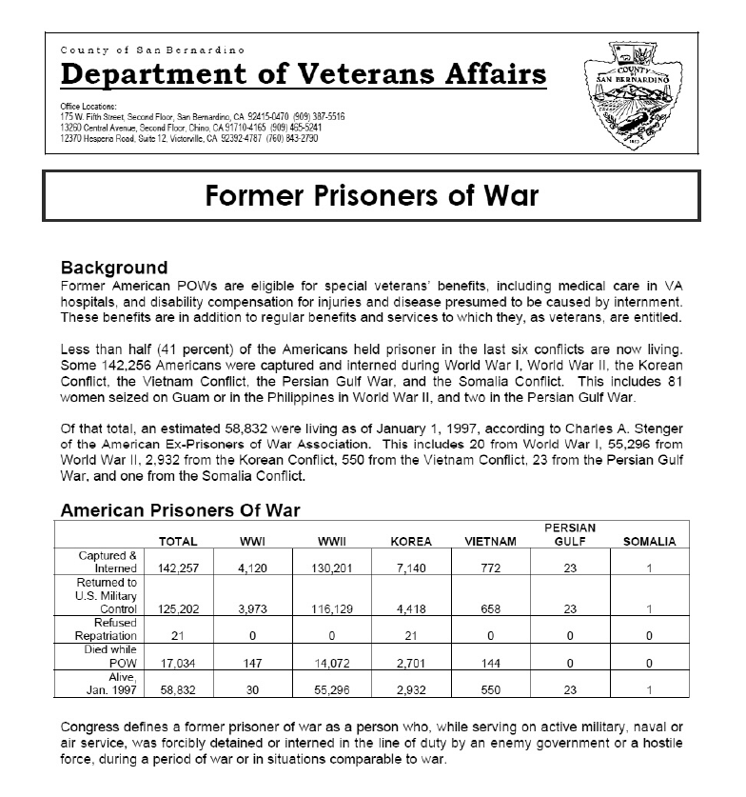

VA—Former Prisoners of War (page 2 of 2)
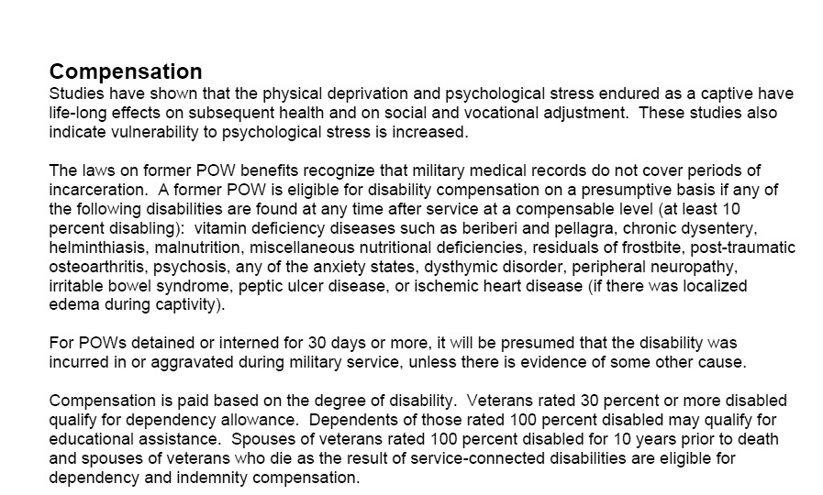
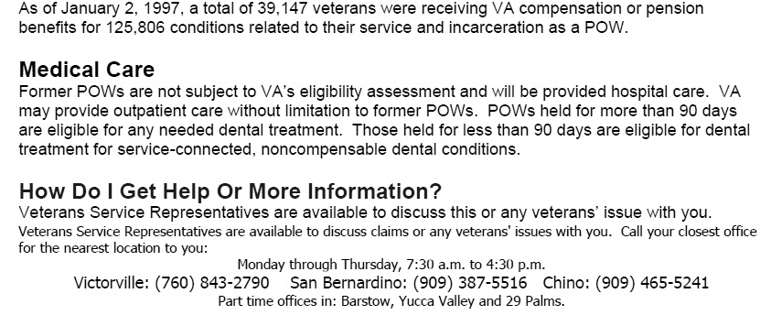

The toughest peaks lie ahead!

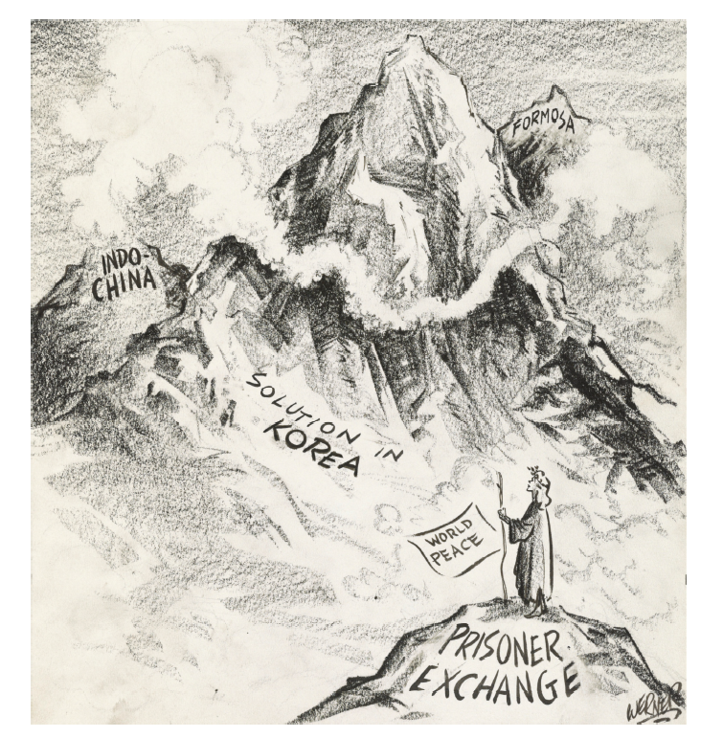
Werner, Charles George. “The toughest peaks lie ahead!” Library of Congress, Washington, DC. April 2, 1953.

Cartoon shows a female figure representing “World Peace” standing on top of a mountain labeled “Prisoner Exchange.” Other mountains labeled “Solution in Korea,” “Indo-China,” and “Formosa” lie in the distance. Drawn as the Allies and the Communists began their first prisoner exchange of the Korean War on April 20, 1953, suggests that many problems in Asia remain to be solved.
The Helping Hand
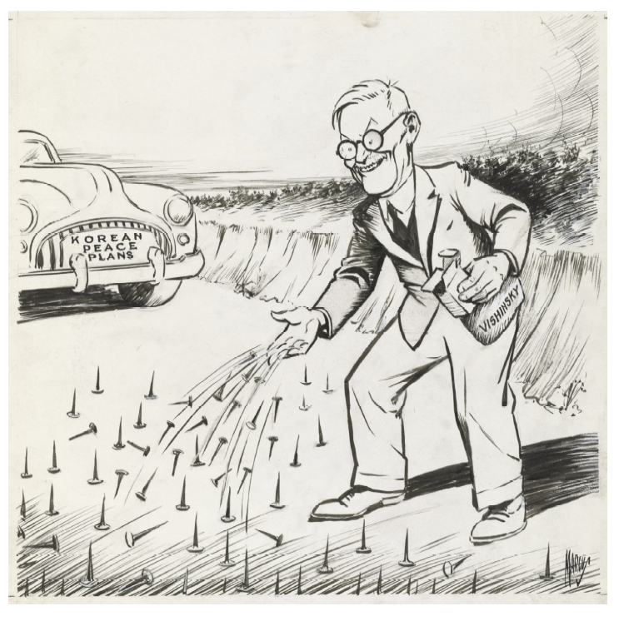
Marcus, Edwin. “The Helping Hand.” Library of Congress, Washington, DC. 1952. Cartoon shows Soviet foreign minister Andrei

Vishinsky spilling nails on the road in front of an approaching car labeled “Korean Peace Plans.” May refer to Vishinsky’s announcement in October 1952 that the Communists would not compromise on their insistence that as part of a Korean peace settlement, all prisoners be repatriated. The United States and its allies insisted that all prisoners of war be given a choice on whether they would be returned to their homeland.

American Ex-Prisoners of War

The American Ex-Prisoners of War (AXPOW) is a not-for-profit organization established to encourage fraternity for the common good among former captives; assist ex-POWs, civilian internees, and their widows and orphans; maintain allegiance to the United States of America; and preserve and defend the United States from all enemies. The group, which was founded on 14 April 1942, also maintains historical records of the prisoner-of-war experience. The AXPOW is a Congressionally-chartered organization and has its national headquarters in Arlington, Texas, and its legislative quarters in Washington, D.C.

The American Ex-Prisoners of War emblem was designed as a lapel pin by Bryan I. Doughty of Denver, Colorado, an ex-prisoner of war and national director. The heraldic symbols, representing justice are balanced on swords. The curves at the top of the shield portray the two massive military defeats suffered by the United States Armed Forces in World War II: Bataan and the Battle of the Bulge. Non Solum Armis is Latin for “Not by Arms Alone.”

Edwards, John S., “American Ex-Prisoners of War,”
The National POW Museum Dedication Program. April 9, 1998.
John S. Edwards was the Past National Commander of American Ex-Prisoners of War.

The Prisoner of War Medal and Painting
The Prisoner of War Medal is the latest issue of an American service campaign medal. It is presented only to men and women who, as a direct result of combat in World Wars I and II, Korea, Vietnam, and the Persian Gulf War, became POWs and served their country honorably. This medal symbolizes the American fighting spirit - an eagle caged behind a ring of barbed wire. Although the eagle is prevented from flying, his spirit and pride are undaunted and unwavering, giving the enemy no solace or comfort in his capture.

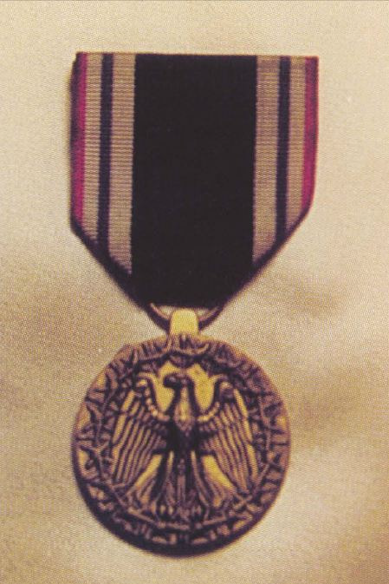
The motto of the American Ex-Prisoners of War is that the fight against the enemy is “not by arms alone.” Escape attempts, subversions, espionage, intelligence gathering and the passing of information to underground forces were part of the POW resistance while in captivity. Physical inhumanities were despicable, but so, too, was psychological torture. During the latter wars, the majority of deprivation was deliberate and designed to test human endurance. Celebrating the recipients of the Prisoner of War Medal is a beautiful painting by George Skypeck, which hangs in the Prisoner of War Museum. The painting depicts the four eras for which the medal is awarded to POWs, their survivors or next of kin.

World War I shows ground combat infantrymen, aerial dogfights and survivors of a German U-boat attack on the high seas. Scenes from World War II include prisoners of war caring for each other, burying their dead comrades and life in the Stalag Lufts. During this war, nurses were taken prisoner after the fall of Corregidor and the Philippines.

Caption for Photo, upper right: The obverse of the POW Medal shows the eagle, symbol of the American spirit, though surrounded by barbed wire and bayonet points, continually on the alert for the opportunity to seize hold of beloved freedom, thus symbolizing the hope that upholds the spirit of the prisoner of war. On the reverse, below
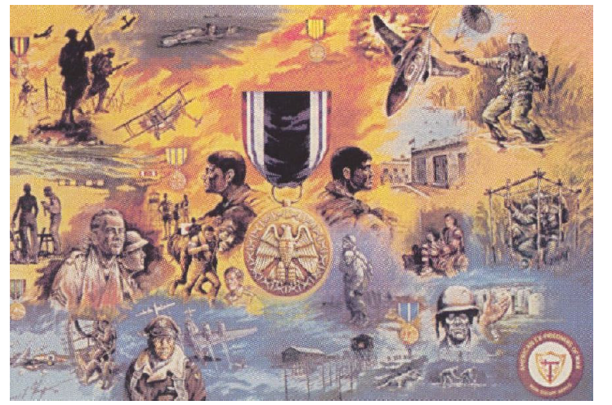
the words “AWARDED TO”, is space for engraving the recipient’s name; and below it, “FOR HONORABLE SERVICE WHILE A PRISONER OF WAR”, with the shield from the coat of arms of the United States of America.

Information for painting, left: American Ex-Prisoners of War Commemorative by George L. Skypeck. Copyright Coors Brewing Co.

Article information: Edwards, John S., “The Prisoner of War Medal and Painting,” The National POW Museum Dedication Program. April 9, 1998. John S. Edwards was the Past National Commander of American Ex-Prisoners of War.
The Prisoner of War Medal and Painting (continued)

The scene changes dramatically during the Korean War when Americans were captured on a cold night after an attack by North Korean and Chinese infantrymen. Prisoners of War during the Vietnam conflict are depicted by a pilot struggling with his chute in a rice paddy, determined to fight it out with only his .38 caliber pistol. In another scene, a team of soldiers are held in a bamboo cage, uncertain whether they will even be transported to camp. During the Vietnam War, the vast majority of POWs were Air Force and Naval air crew who were blasted out of the skies in a high-tech war thousands of feet above ground. Some would never be seen or heard from again. Those captured in the “South” never made it “North” because of immediate torture and murder, despite stipulations in the Geneva Convention. To those who survived an escape from the combat zone, they would face long years of torture and isolation.

The final scene is of a hand holding a set of dog tags against the backdrop of long rows of white gravestones. The silent questions remain: Who is still held? Who is still missing? Who died and why and how? As yet, there is not a complete accounting of all POWs and the reasons why many have died, despite international codes and agreements.

The special logo of the American Ex-Prisoners of War is shown as recognition of all POWs who now serve this nation as veterans and honored citizens. A tribute to their steadfast patriotic spirit and belief in America.

The XPW Bulletin
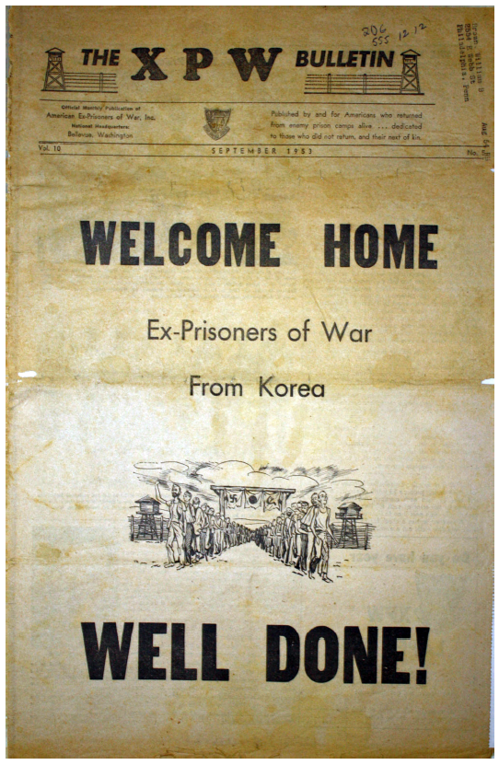

The cover of the American Ex-Prisoners of War Association Newsletter from September 1953. Cover story is essentially the men of WWI and WWII welcoming the Korean War POWs into their ranks —connecting POWs across time.
POW Medal Decision Matrix

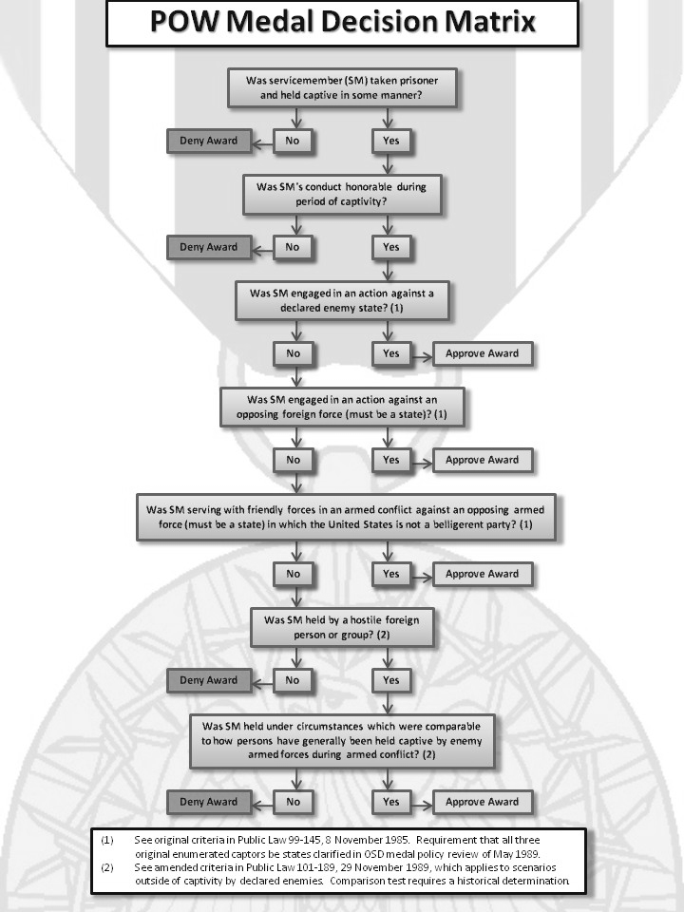

Spinelli Photo of Coming Home
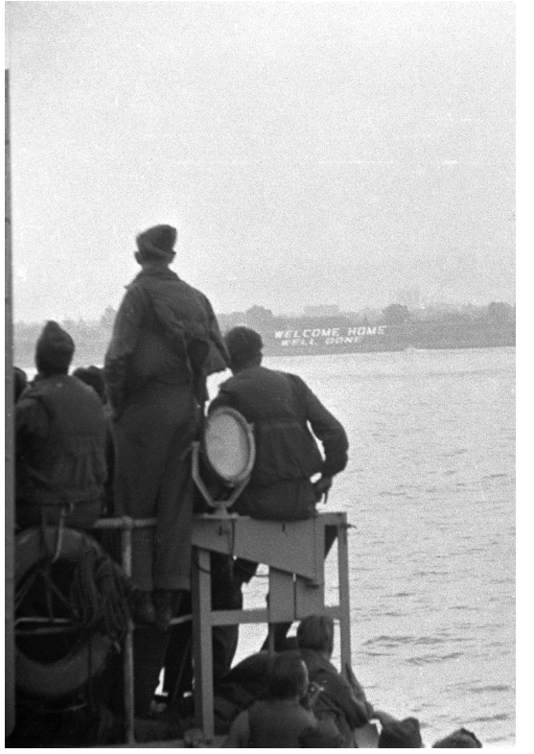
Spinelli, Angelo. Spinelli: Behind the Wire; entering the United States through New York Harbor on June 13, 1945

Angelo Spinelli was a POW during WWII. He was captured by the Germans in 1943. During his imprisonment unknowingly to the Germans, he used his camera to photograph his surroundings. In April of 1945, his camp was liberated. He used his camera to document the liberation, including his trip home to the New York harbor. His collection of photographs and negatives is the largest single collection of POWs in existence.

