Unit 4: Those Who Wait
Students synthesize primary source documents to develop an understanding of repatriation and how repatriation impacts POWs. Students construct and defend their position on the cost of freedom. Students learn about the families and friends of POWs at home - how they coped, the sacrifices they made, and the challenges they endured while their loved one was imprisoned. The module emphasizes the proactive actions of families and friends to ensure the safe and timely return of their loved ones.

ACTIVITY 1: Central Question Hypothesis
- Pose the central question—How do families of Prisoners of War cope with the capture of their loved ones?
- Hand out the Those Who Wait: Life Is Different (found below) sheet to each student.
- Have each student write their answer on the Those Who Wait: Life Is Different sheet. Discuss the students’ answers as a class.
- Hand out the Those Who Wait: Rubric (found below). Review the rubric with the class. The rubric outlines and identifies the essential components and content necessary to fully answer the central question at the end of the Module.

ACTIVITY 2: Creating Context
- Hand out the primary source Statement of Mrs. Sybil Stockdale from the Congressional testimony on Prisoners of War in Vietnam 1970 (found below) and the Written Document Analysis Guide (found below) to students. Based on the unique needs of the classroom, students can read the statement individually or in small groups.
- Have students complete the Written Document Analysis Guide after they read the statement.
- Review the statement and the Guide with students. Discuss how the families of POWs during the Vietnam War banded together to create The National League of POW/MIA Families. Additional information about the organization can be found on their web-site:https://www.pow-miafamilies.org/.
- Have students conduct additional research as needed.

ACTIVITY 3: Life is Different

- Pose the question—How and why do lives change once families are informed their loved ones are POWs? This is question #1 on the Those Who Wait: Life is Different sheet.
- Provide students with the following primary sources. Depending on the unique needs of the classroom, have students read the primary sources individually, in pairs, or in small groups. Mix the primary sources amongst all students or have student groups read one set of primary sources.
  - Red Cross Bulletin
  - Postcard from Curtis David
  - Postcards to POW’s Mother
  - “Boy Soldiers Mom Joyful at Tydings”
  - ‘Thank the Lord,’ PW’s Mother Says
  - Letter to Clara Barton
3. Another primary source to consider using in this activity is the letter Kurt Vonnegut wrote to his parents while a POW in Germany. Vonnegut, Kurt. “Letter from PFC Kurt Vonnegut, Jr., to his family, May 29, 1945” Armageddon in Retrospect. New York: G.P. Putnam’s Sons, 2008.
4. Provide students with the Written Document Analysis Guide to complete as they read the primary sources.
5. Have students answer the question “How and why do lives change once families are informed their loved ones are POWs?” on the bottom section of the Those Who Wait: Life is Different sheet.
6. Discuss students’ answers, the Guide and the primary sources.

ACTIVITY 4: Agents of Change

- Pose this question to students—How have families of POWs challenged the status quo to make change?
- Provide students with the following primary sources. Have the students read the following primary sources individually, in pairs, or in small groups. Mix the primary sources amongst all students or have student groups read one set of primary sources.
  - National League of Families meet with President Nixon
  - Letter-Writing Campaign
  - History of the POW/MIA Flag
- In addition, the following TIME Magazine articles can be accessed to provide additional insight into how POW families have driven change and dealt with their loved ones being captured.
  - Rawlings, Nate. “Captive of the Taliban: In the Hometown of an American Prisoner of War.” TIME Magazine May 15, 2012. See: http://content.time.com/time/nation/article/0,8599,2114824,00.html
  - “P.O.W.S: Some of the Bravest People.” TIME Magazine February 5, 1973. See: http://content.time.com/time/magazine/article/0,9171,906803,00.html
- Provide students with a Written Document Analysis Guide and a Photo Analysis Guide to complete while they review the primary sources.
- Have students answer the question: How have families of POWs challenged the status quo to make change? on the Those Who Wait: Life is Different sheet.
- As a class discuss the students’ responses.
- Extension Activity: Have students write a diary/journal entry as if their loved one was a POW. They should discuss their fears and frustrations, as well as their action plan to ensure the government is ensuring open communication and the humane treatment of the POWs.

ACTIVITY 5: Central Question: Defend with Evidence

- Pose the Central Question again—How do families of POWs cope with the capture of their loved one?
- Inform the students they need to answer the Central Question and address all of the items in the Those Who Wait: Rubric in an essay format.
- Share existing classroom writing expectations with students for the essay.
- Establish a due date and have students turn in the essay.
- All students or select students/volunteers should share their essay.
- Discuss how answers to the Central Question have evolved.
- Use the Those Who Wait: Rubric to assess each student’s essay response.
- Extension Activity: Have students create a poster in support of POWs and MIAs for an awareness rally or campaign.

THOSE WHO WAIT: LIFE IS DIFFERENT
Central Question: How do families of POWs cope with the capture of their loved ones?
1. How and why do lives change once families are informed their loved ones are POWs? Cite at least three examples.

2. How have families of POWs challenged the status quo to make change? Cite three examples.

THOSE WHO WAIT: RUBRIC
Central Question: How do families of POWs cope with the capture of their loved ones?

3 | Thorough discussion of those who wait which is richly supported with relevant facts, examples, and details. The primary sources are analyzed, synthesized, and woven into the answer. Specific examples and mention of Sybil Stockdale’s statement and the National League of Families are included.
2 | Discussion of those who wait supported with relevant facts, examples, and details. An analysis of the primary sources are included in the answer. Sybil Stockdale’s statement and the National League of Families are included.
1 | Attempts to discuss those who wait and support with facts, examples, and details. Discussion reiterates the contents of primary sources.
0 | Not completed.

NOTES:

Statement of Mrs. Sybil Stockdale (p.1 of 4)

Mrs. STOCKDALE
Thank you, Mr. Fascell. Mr. Chairman, and ladies and gentlemen, first of all, I want to express my gratitude to Senator Dole for taking the initiative which brings us all, so many of us, to Washington today and to all the Members of Congress who have helped us thus far.

My husband is Capt. James Bond Stockdale, U.S. Navy, and may I interject at this point that his mother’s maiden name was Bond and he was James Bond Stockdale before Ian Flemming created his character.

Jim is a 1946 graduate of the U.S. Naval Academy, holds a master’s degree from Stanford University in international relations, has four sons between the ages of 19 and 8, and is presently 46 years old, having spent one-ninth of his lifetime in solitary confinement in Communist prisons. While serving aboard the aircraft carrier U.S.S. Oriskaw, he was shot down while on a mission over North Vietnam, on September 9, 1965. He was listed as missing in action.

On April 15,1966, I received two long, four-page letters postmarked Hanoi, confirming the fact that he was alive. The first was written on December 26,1965. He said that he had been given only one letter from me, dated October 3. I had written a letter every week since he was listed as missing. He also said, “As for my welfare and surroundings, I wish I could report on acquaintances in my straits, but I have not seen an American since I was shot down.” He said he had a bum knee and shoulder, had been treated at the hospital and that he was told that he would soon be able to return to the hospital where the doctors would finish the job.

He reported he was able to hold his weight at what he believed to be about 140 pounds. His normal weight was 170 to 175 pounds. He said, “In the mental category I have my ups and downs. Perhaps solitude builds character. I sometimes think of how such experiences gave depth of insight to Dostoevsky and other writers. Be assured that, above all, I have securely found God.”

He had been told that he could expect to be given one letter a month and perhaps could write as often. In his second letter written on February 3, 1966, he said, “Keeping warm takes energy and I lost some weight.” He also said, “I am still not used to being alone, but I have worked out methods to keep my mind occupied.” He told me his knee and shoulder still needed medical attention.

I received two more letters from him in 1966 in which he reported things were very much the same with him and in a letter written on January 2, 1967, he said, “Let all know that all is the same with me.”

Since 1967, I have received six very short notes from him, the most recent one having just arrived. It was written on March 25, 1970, and he was either only physically able to complete four lines on a seven-line form or was only allowed to write four lines. The complete letter contains 38 words.

This from a 46-year-old man with a master’s degree in international relations, who dearly loves his family and when he was first captured wrote long four-page letters.

He has never indicated that his original circumstances have changed in any way and I can only conclude he has been in solitary confinement throughout his captivity. I understand from returned prisoners that this is customary treatment for high ranking officers.

Statement of Mrs. Sybil Stockdale (p. 2 of 4)
COMMUNIST TECHNIQUE OF DEHUMANIZATION
A study of Communist techniques clearly indicates that this is customary treatment of prisoners held by them as part of their dehumanization of their captives. To the best of my knowledge, no American has ever seen my husband since he was captured.

The press reported in 1967 that a Polish journalist saw him, but that my husband refused to be interviewed and reportedly claimed to be the movie hero, James Bond. An article in the Soviet newspaper Pravda in late 1965 said, “One night when we were in Than Hwa, we saw a car parked by the city hospital. There were several Vietnamese standing by the car. Sitting on a bench and leaning against the car was a towheaded, husky fellow * * * a prisoner of war, an American pilot,, Capt. James B. Stackdel. The pilot had been captured by peasants of a fishing village situated about 30 kilometers from Than Hwa.”

My husband is not towheaded, but he was very gray when he left and I assumed the translation could mean light haired.

Those few Americans who have been granted visas to enter Hanoi have never reported having seen him, although they have, on occasion, brought back mail to this country from him, and have related to me on the telephone the fine treatment which the prisoners are being accorded.

I could only conclude from my own evidence that these people were either propagandists for the Hanoi Government or dupes. It has since been documented by returned prisoners that statements about good health and good treatment in the very few letters so very few of our loved ones are allowed to write, are the result of coercion by the North Vietnamese.

HOW THE POW FAMILIES’ GROUP WAS STARTED
After I learned that my husband was being held a prisoner in North Vietnam, I tried to determine what his rights were as the captive of a foreign government. I was counseled by the U.S. Government that it was in my husband’s best interests for me to remain quiet about the fact that he was a prisoner.

I have never been able to determine the rationale for this policy, but assume there were reasons why the Government felt this policy was sound. I visited with Governor Harriman in 1966 and 1967. and in the summer of 1967, visited several congressional offices searching for someone in Congress who would bring the plight of our American, prisoners of war to the attention of Congress.

When the military savings deposit program, which allowed men serving in Vietnam to invest the savings from their military pay, was passed by Congress, I indicated that I wanted to participate and was told that my husband’s pay did not qualify as the bill was so written that those being held in North Vietnam were excluded.

I asked several Government officials why this was so and was assured that it was just an oversight which I found both depressing and appalling. An amendment to that bill was eventually introduced in Congress at the request of the wives and families of those captured and missing and a year later we were allowed to invest the savings from our husbands’ military pay in this program.

By 1967 I knew 33 wives in circumstances similar to mine in the San Diego area. Many of us had been meeting informally for some time and in 1967, we formed a local organization dedicated to the aim of trying to
Statement of Mrs. Sybil Stockdale (p. 3 of 4)
help our men. In order to better understand Government policy concerning our men and to assure ourselves that our Government was acting in the best interests of our loved ones, we invited Government representatives to come to San Diego to answer our many questions and to make them aware of our problems as dependents of those being held prisoner and listed as missing.

When my husband had been a prisoner for 3 years, my best judgment led me to believe that the best interests of the men could be served by letting the world know the truth about the rights of our husbands and sons as captives of a foreign government signatory to the Geneva Convention and North Vietnam’s total violation of its most basic tenets.

I took a survey of the total mail received by the 33 wives I knew and reported those facts along with my personal situation to the press. That article appeared in the San Diego Union on October 28, 1968. I hoped that by telling the truth publicly myself, I might be able to encourage others to do the same.

At the time of President Nixon’s inauguration, our League of Wives in San Diego asked as many as they could reach to send telegrams to the new President, Secretary of State, and Ambassador Lodge, requesting that the prisoner-of-war problem be given a high priority consideration during their administration.

In February 1969, I realized that the miniscule flow of mail was decreasing and, as I became increasingly concerned for my husband’s welfare as well as that of all the men. I decided to telegraph the North Vietnamese in Paris inquiring about his welfare and felt others might want to do likewise.

I sent out a form letter asking others to notify me if they wanted to participate in a group effort to get information about our men. I set up a schedule so that 10-20 telegrams a week would be arriving in Paris, thus allowing North Vietnam time to check their records and answer our inquiries at a reasonable rate. I sent 61 original letters to others I knew throughout the country and asked them to pass it on to others they knew in our circumstance.

I received hundreds of letters back in return and for months we sent telegrams to the North Vietnamese on a scheduled basis. In many of the letters I received, wives and parents expressed the desire to continue working as a group toward the end of trying to get information about our men and the protection of the Geneva Convention accorded to them. In other local areas wives had been meeting together and in June 1969 we gave our national group effort the name of the National League of Families of American Prisoners in Southeast Asia.

THE AIMS OF THE GROUP
Our aims are to inform fellow Americans and world citizens of the codes for treatment of combatant prisoners, as established by the Geneva Convention for the dignity and protection of mankind. We want to make known the true and desperate plight of the American prisoners of war and the men listed as missing in action and to make known that their desperate plight is due to the refusal of the North Vietnamese Government to abide by any of the simple humane requirements for the treatment of combatant prisoners.

Ours as a group is an effort to supplement that which our Government is doing to insure humane treatment for our men and in no ways reflects any discredit on the efforts made by our own Government.
We believe that the cumulative voices of the indignation from people all over the world will have a profound influence on the North Vietnamese Government if they want to be recognized as a respectable government in the world community.

Statement of Mrs. Sybil Stockdale (p. 4 of 4)
We have been appealing to those spheres of influence which we felt might best be able to influence the Communists to accord our loved ones the protection of the Geneva Convention.

Last fall some of the wives and families began to go to Paris to seek information from the North Vietnamese directly. We publicized our trips so that the world would become aware of the desperate plight of our men and their families. Some of those making such trips paid for them out of their personal funds and some were sponsored by TV stations. Others were sponsored by civic organizations and concerned citizens who wanted to help in this way.

We have appealed to Congress as well as many other spheres of influence to take whatever action is necessary to insure the basic standards of human decency for our loved ones and me will continue to do so. I have found that when Americans are informed about the desperate plight of our men and their families, that they are deeply and genuinely concerned.

CONGRESSMEN SHOULD ENLIGHTEN THEIR CONSTITUENTS
I, therefore, respectfully request that each Senator and Representative of the people of America enlighten their constituents about the incredibly cruel mental and physical torture which captured and missing American servicemen held by the Communists have been enduring for years and continue to endure every long and lonely hour of every day and night, and then to poll their constituents about their concern for their fellow Americans in these circumstances and personally deliver the results of such a poll to the North Vietnamese.

The North Vietnamese have clearly demonstrated that they do care about world opinion and American public opinion. We have made some progress thus far in bringing about modification and change of the North Vietnamese attitude. Letters from some 400 men in North Vietnam have been promised and about half have been delivered. However, no mail has ever been promised from our men held in Laos and South Vietnam.

I ask you to try to imagine the daily torment which the wife of a missing man endures as she hears and reads of names released, a few at a time and she learns about a few more of her friends and acquaintances receiving mail and yet the fate of her loved one appears on none of these lists and she continues to hang in an agonizing limbo, not knowing whether she is wife or widow and how to answer her children’s searching questions about their daddies. I am so profoundly proud of all of these wives and families who have faced disaster bravely and acted with the quality of dignity which they seek for their men.

The support we are asking of you is not related to any particular view on the war in Vietnam. We are only asking your help in obtaining humane treatment for your fellow Americans. I feel certain the American people will not find their elected representatives lacking in expressing to the North Vietnamese, again and again, their genuine concern for their fellow Americans.

Thank you.

“American Prisoners of War in Southeast Asia, 1970.” Hearings before the Subcommittee on National Security Policy and Scientific Developments of the Committee on Foreign Affairs, House of Representatives, 91st Congress, Second Session. Washington, DC 1970

Written Document Analysis Guide
1. Identify the type of document:

2. Identify any unique characteristics of the document.

3. Date(s) of the document:

4. Author (or creator) of the document:

5. For what audience was the document written?

6. List three things the author said that you think are important:

7. Why do you think this document was written?

8. What evidence in the document helps you know why it was written? Quote from the document.

9. Write a question to the author that is left unanswered by the document.

RED CROSS BULLETIN - page 1 of 2

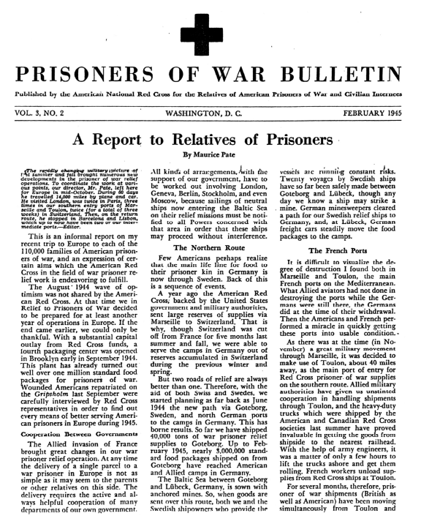

RED CROSS BULLETIN - page 2 of 2

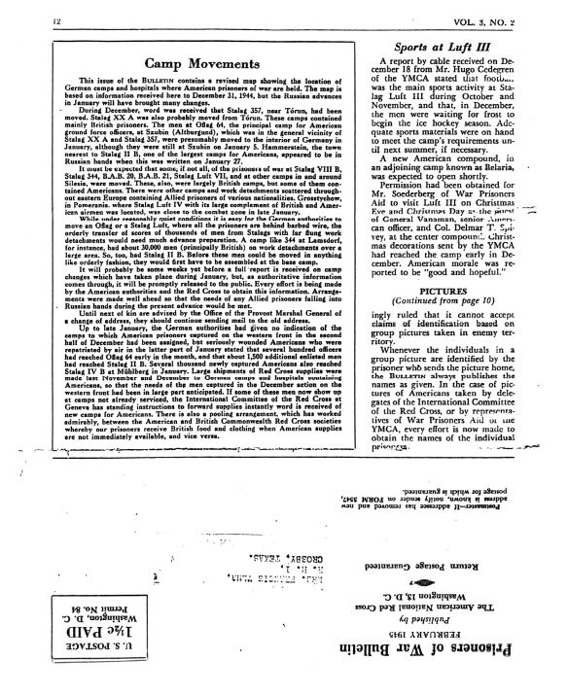

Postcard from Curtis Davis

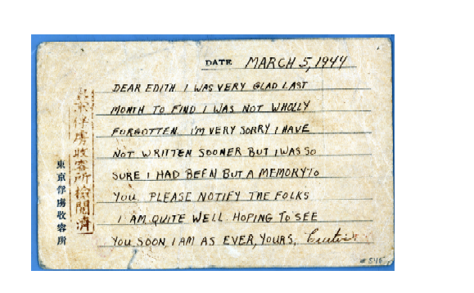

Postcard sent from Japanese POW camp March 5,1944 by POW Curtis Davis to his girlfriend, Edith.

Communication between POWs and those at home were challenging throughout the different wars. During the Civil War, communication was primarily through mail. One of the challenges was mail had to have both Confederate and Union postage. During WWI and WWII in Europe, communication was through the Red Cross serving as an intermediary. The Red Cross collected the mail and sent it home. They also sent care packages to POWs. The POWs in the Pacific Theater, Korea, and Vietnam were typically cut off from all communication. The only form of communicating for many of the Vietnam POWs was through propaganda films. This was not direct communication with home, but simply appearing in the films communicated they were alive. This was also the case during the Gulf War.

Postcards to POW’s Mother
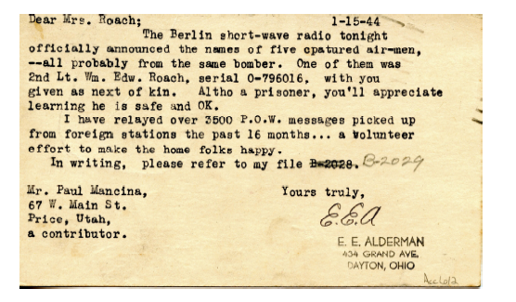

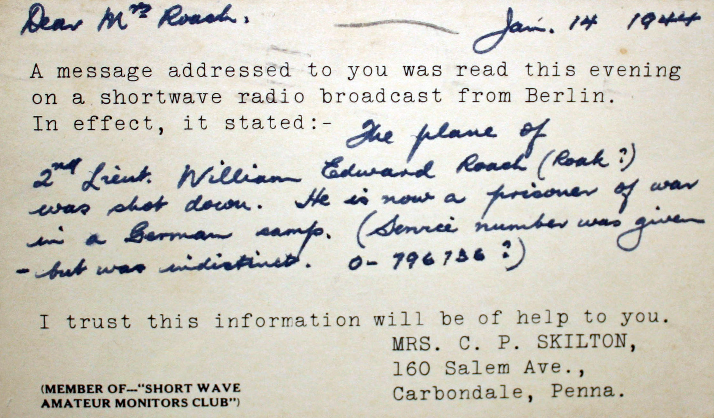
Postcards addressed to WWII POW William Roach’s mother.

German radio would sometimes broadcast information on POWs, and Americans listening on shortwave would send telegraphs/postcards to family members of those men mentioned in the broadcasts. In many cases, this was the only way POW’s family members found out about their loved ones’ captivity or condition.
Boy Soldiers Mom Joyful At Tydings

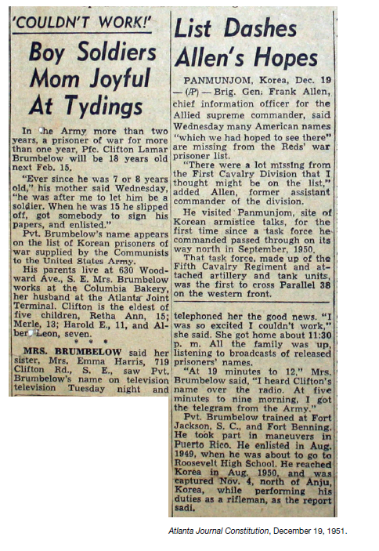

“Thank the Lord,” POW (PW) Mother says …

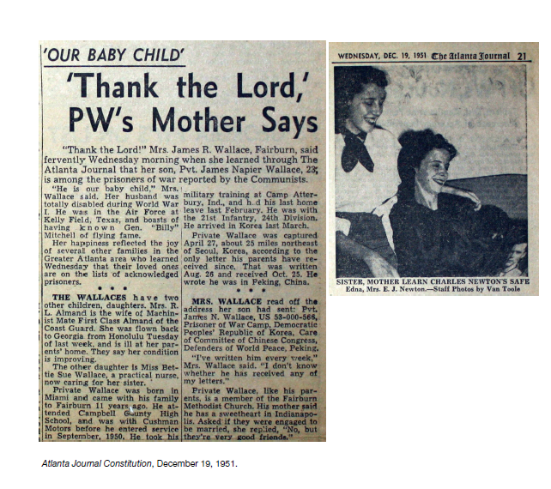

Letter to Clara Barton

Quincy, Aug 27th, 1865

Miss Barton

My dear Madam,

I feel very grateful to the information received from you of Bryant Newcomb Co. E 32nd Reg – you say he died in Rebel Prison at Andersonville, Georgia, Oct 21, 1864 – And is that all that we can ever know of our lost darling?

Is there no one that can give us any information with regard to his death and sufferings? O what would I give to know what his disease was, and if he had anyone with him to comfort him in his last moments, and if he had any message for his loved ones – for he was so dear to us all- and so thoughtful. O he was too good for this world – This dear mother is heartbroken since the news received – she has raised a great deal of blood, and I fear it will arouse her death. But she feels that it would be a great relief if she could hear the particulars.

He was a dear Brother to me. I would give millions if I had them if I could know the particulars of his prison life and death. Do you think there is any possible chance of his remains being identified? If so, please let us know – I hear that I am trespassing on your patience. But if there is anyone that knows anything of my darling brother please do all you can for us. And you will ever be remembered with the deepest love and gratitude.

Accept the thanks of all and the love of a poor heartbroken mother.

Yours very respectfully,

Mrs. Hannah N. Nash

Quincy, Mass

Clara Barton worked closely with Dorence Atwater of the Missing Soldiers Office in the late 1860s. They worked to notify family members of their loved one’s fate at Andersonville. This was a monumental and vitally important task in an era where the government did not provide this information. Over half of all Civil War dead were unknown or in unmarked graves. The soldiers simply didn't come home at the end.

National League of Families meet with President Nixon

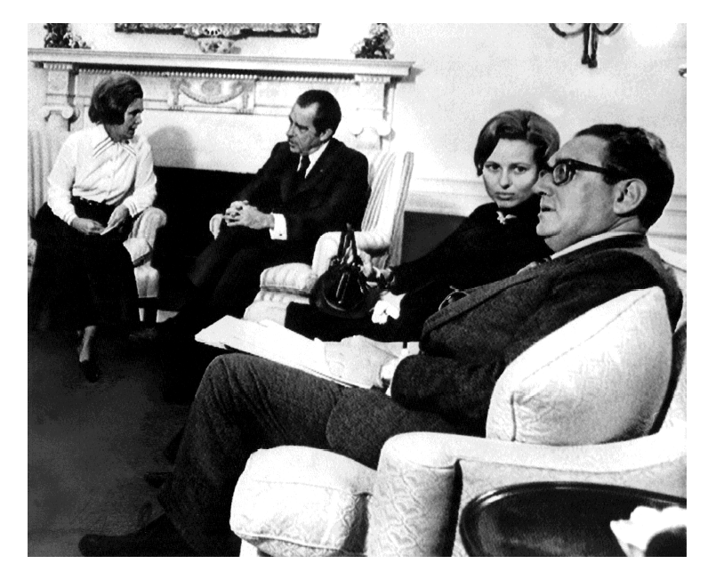
National League of Families leaders Sybil Stockdale and Phyllis Galanti meet with President Nixon and National Security Adviser Henry Kissinger. Courtesy of Paul Galanti.

Letter-Writing Campaign
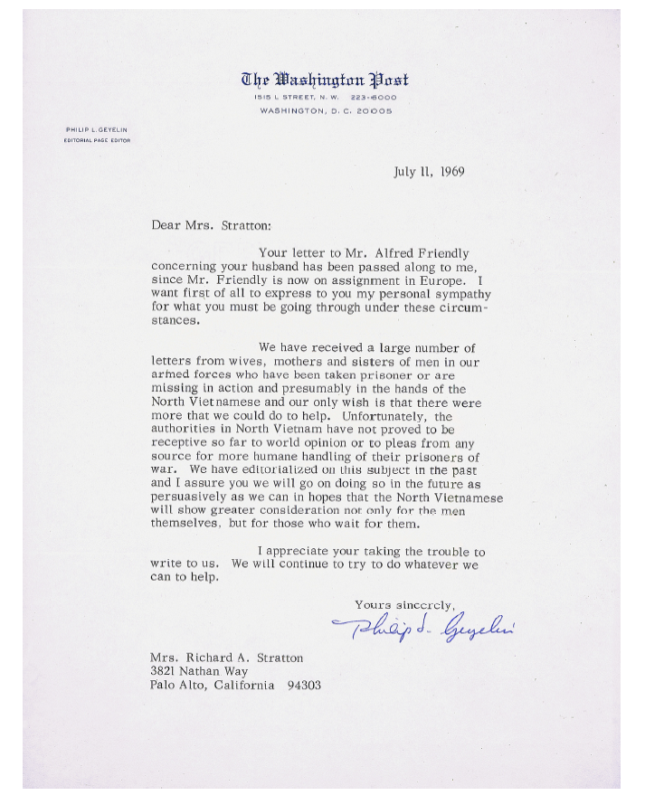

Alice Stratton and other POW wives conducted a letter-writing campaign to call worldwide attention to the plight of American POWs. Courtesy of the Hoover Institution Archives.
History of the POW/MIA Flag
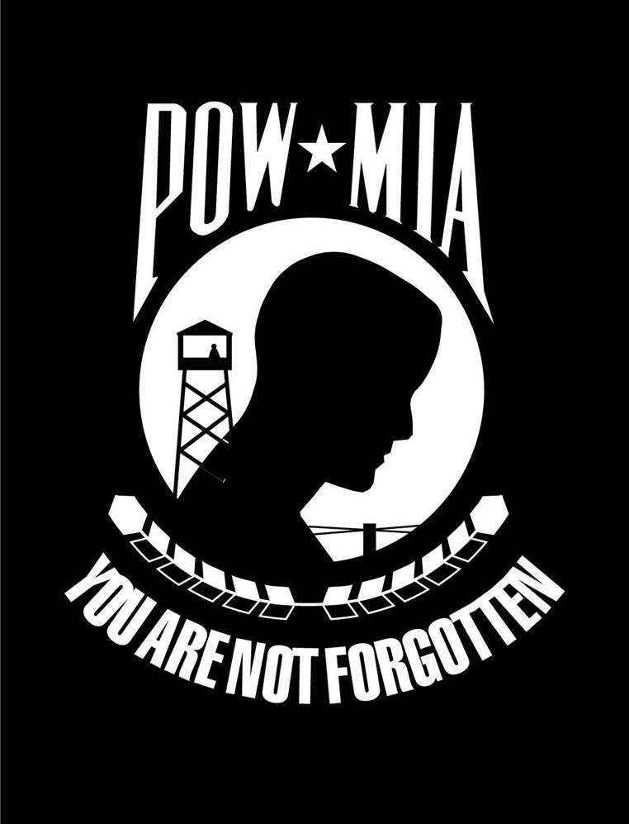
In 1971, Mrs. Michael Hoff, an MIA wife and member of the National League of Families, recognized the need for a symbol of our POW/ MIAs. Prompted by an article in the Jacksonville, Florida, Times Union, Mrs. Hoff contacted Norman Rivkees, vice president of Annin & Company which had made a banner for the newest member of the United Nations, the People’s Republic of China, as a part of their policy to provide flags to all UN member nations. Mrs. Hoff found Mr. Rivkees very sympathetic to the POW/MIA issue, and he, along with Annin’s advertising agency, designed a flag to represent our missing men and women. Following League approval, the flags were manufactured for distribution.

Concerned groups and individuals have altered the original POW/MIA flag many times; the colors have been switched from black with white to red, white, and blue, to white with black. The name POW /MIA also has been revised at times to MIAIPOW. Such changes, however, are insignificant. The importance lies in the continued visibility of this symbol, a constant reminder of the plight of Americas POW/MIAs.

On March 9, 1989, an official League flag, which flew over the White House on 1988 National POW/ MIA Recognition Day, was installed in the U.S. Capitol Rotunda as a result of legislation passed overwhelmingly during the 1OOth Congress. The leadership of both Houses hosted the installation ceremony in a demonstration of bipartisan Congressional support. This POW/MIA flag, the only flag displayed in the U.S. Capitol Rotunda, stands as a powerful symbol of our national commitment to our POW/MIAs until the fullest possible accounting for Americans still missing in Southeast Asia has been achieved.

According to Section 1082 of the 1998 Defense Authorization Act, the POW/MIA flag must be flown on specific days at certain federal buildings. Those days are:
- Armed Forces Day, the third Saturday in May;
- Memorial Day, the last Monday in May;
- Flag Day, June 14;
- Independence Day, July 4;
- POW/MIA Recognition Day, the third Friday in September; and
- Veterans Day, November 11.

The locations include:
- the Capitol;
- the White House;
- the Korean War Veterans Memorial and the Vietnam Veterans Memorial;
- each national cemetery;
- buildings containing the official offices of the secretaries of State, Defense, Veterans Affairs, and the director of the Selective Service System;
- each military installation, as designated by the Secretary of Defense;
- each U.S. Postal Service office; and
- each VA medical center (flag required to be flown any day that the U.S. flag is displayed).

Edwards, John S., “History of the POW/MIA Flag,” The National POW Museum Dedication Program. April 9, 1998. John S. Edwards was the Past National Commander of the American Ex-Prisoners of War
Photo Analysis Guide
Observe
1. Study the photograph for 60 seconds. What is your overall impression of the photograph?

2. In the table below, list the people, objects, and activities you see in the photograph.

People | Objects | Activities

Make Meaning
3. Based on what you observed, list three things you might infer about this photograph?

Ask Questions
4. What questions would you like answered about this photograph?

5. Where could you find answers to the questions?

