Unit 3: Prison Life
Students analyze primary sources to explore the different ways people learned about POWs and construct an understanding of the realities of the families of POWs. Students will also analyze how families of POWs challenged and changed government protocols.

ACTIVITY 1: Central Question Hypothesis

- Pose the central question—What factors impact the POW experience?
- Hand out the Prison Life: The Realities sheet (found below) to each student.
- Have each student write the answer to the Central Question on Prison Life: The Realities sheet. Discuss the students’ answers as a class.
- Hand out and review the Prison Life Rubric (found below) with the students. The rubric outlines and identifies the essential components and content necessary to fully answer the Central Question at the end of the Module. Students will be charged with answering the final Central Question in the form of an essay/ informative magazine article.

ACTIVITY 2: Creating the Context

1. Discuss with students how being taken captive is as old as war itself, but that POWs having rights is a recent innovation. In ancient times, prisoners of war were often sold into slavery, put to death, or ransomed for large sums. Over time, barter systems developed to exchange soldiers of equal rank. (See tab under http://louisianaoldstatecapitol.org/education/lessson-plans-for-current-exhibits/ called “Leiber Code, Code of Conduct, and the Geneva Convention” for primary source material. It is with the material for Unit 2, so this may be review if you have completed that Unit.)

The first written rules of war, the Lieber Code, were signed by President Abraham Lincoln in 1863 as instructions to the Union Army. For the first time, there were rules forbidding the torture and killing of POWs. The Hague Convention of 1907 was influenced by these rules. The U.S. and most European countries agreed that “prisoners must be treated with humanity.”

The rules were a vast improvement over the practices of previous centuries, but they were proven inadequate during WWI. The Geneva Conventions are a series of treaties developed over time which established the standards of international law for the humane treatment of POWs and other victims of war. In reaction to WWI, 43 countries expanded the standards at a diplomatic conference in 1929. They agreed on more stringent measures for adequate food and shelter, the exchange of the sick and wounded, and payment of work required by the enemy.

Confronted with the mistreatment of prisoners and civilians during WWII, the world convened at a diplomatic conference resulting in the four Geneva Conventions of 1949. The Conventions’ earlier treaties were revised in an on-going effort to protect the rights of POWs and other non-combatants. Today, the Geneva Conventions have been adopted by every nation in the world.

2. Extension Activity: Have students construct a timeline to illustrate the evolution of treaties and international laws concerning the treatment of POWS.

ACTIVITY 3: Prison Life Perseverance

- Have students read question #1 on the Prison Life: The Realities sheet. Discuss the question: In what ways have POWs persevered through imprisonment?
- Introduce the different transcript excerpts to the students. Explain the interviews were conducted with actual U.S. military personnel from a variety of wars.
- Hand out the Interview Analysis Guide (found below) sheet. Go over the sheet and discuss expectations.
- Have students read the interview transcripts individually, in pairs, or in small groups.
- A variety of transcript excerpts are provided. Select a few or use them all to provide a wide-range of POW experiences to share/discuss as a class.
- Allow students to read the transcript excerpts, complete the Interview Analysis Guide sheet, and complete question #1 on the Prison Life: The Realities sheet.
- Have students turn in the Interview Analysis Guide in and/or discuss the students’ responses as a class.

ACTIVITY 4: The POW Experience

- Pose question #2 on Prison Life: The Realities: How has the POW experience been different for U.S. military personnel during the wars in the 20th century?
- Have the students read the following primary sources individually, in pairs, or in small groups. Mix the documents amongst all students or have student groups read one set of the documents.
  - Clark Lee articles “Let the Punishment Fit the Crime” political cartoon
  - Tap Code
  - “My Mother” poem
  - Image of POW and captor
  - Communist Treatment of POWs
- Another primary source to consider using in this activity is this short story: Vonnegut, Kurt. “Guns Before Butter.” Armageddon in Retrospect. New York: G.P. Putnam’s Sons, 2008.
- Hand out the Political Cartoon Analysis Guide and the Written Document Analysis Guide for the students to use while they review and analyze the primary sources.
- Have students answer question #2 on the Prison Life: The Realities sheet. Discuss student answers and/or have them turn the sheets in.
- Extension Activity: Have students draw a mural illustrating the different experiences American POWs have experienced in wars throughout time.

ACTIVITY 5: Central Question Defend with Evidence
- Have students re-answer the Central Question using the Prison Life: Rubric (What factors impact the POW experience?) on their own paper.
- Inform students they need to answer the Central Question and address all of the items in the Prison Life: Rubric in the style of a magazine article or editorial.
- Have students share their articles/editorials and/or turn them in. Use the Prison Life: Rubric to assess student responses.
- This assignment can either be completed in class or given as homework and turned in later.
- All students or select students/volunteers should share their answer to the Central Question.
- Use the Prison Life: Rubric to assess each student’s response.
- Extension activity: Have students use the Tap Code sheet to attempt communication with each other. This could be organized as a whole class activity or a small group activity. The goal is to get the students communicating using the Tap Code and experiencing what it would be like to only communicate with others using the Code.

PRISON LIFE: THE REALITIES
Central Question: What factors impact the POW experience?
- After reading and discussing the Interview Transcript Excerpts, in what ways have POWs persevered through their imprisonment? Cite at least three specific examples.

2) What After reviewing the primary sources, how has the POW experience been different for U.S. military personnel during the wars in the 20th century?

PRISON LIFE: ESSAY RUBRIC
Central Question: Complete the answer to the Central Question in the style of a magazine article or editorial.

3 | Thorough discussion of prison life which is richly supported with relevant facts, examples, and details. The primary source documents and interviews are analyzed, synthesized, and woven into the answer.
2 | Discussion of prison life supported with relevant facts, examples, and details. An analysis of the primary sources and interviews are included in the answer.
1 | Attempts to discuss prison life and support with facts, examples, and details. Discussion reiterates the contents of primary sources and interviews.
0 | Not completed.

NOTES:

Unit 3 - ORAL HISTORY INTERVIEW - FRANCIS W. AGNES

Francis W. Agnes, World War II

(INT—Interviewer, FA—Francis W. Agnes)

INT: Did conditions improve once you got to Japan?

FA: Once we got to Japan, we felt that conditions would improve, because while we were onboard the ship, they allowed us pork to make pork soup out of. Of course, that’s an interesting thing in itself, drinking soup made out of pork, a nice greasy soup while you’re in rough sea weather. And you can imagine what that did to the hold of the ship, as far as odors are concerned, but when we got to Japan, no, they did not improve, and immediately we were put to work in a steel mill, doing slave labor in the steel mill. Let’s kind of roll back to when I was on Bataan – not Bataan, but when I was in Cabanatuan prison camp. In Cabanatuan prison camp, there were a large number of us, as you know, that were moved to Cabanatuan, and of course everybody wants to know why you didn’t escape, or why didn’t you escape and go into the guerilla faction in the Philippines. Well, this was easier said than done. First off, the Filipinos in and around the area, as you recall, were occupied by the - the Japanese occupied their country, and therefore, they were – not that they were loyal, but they were supportive of the Japanese troops, because how else would they stay alive, unless they played the game with the Japanese troops. So, when, and if you did try to escape, and you didn’t make it to the guerillas immediately, which were up in the mountains, and you were captured, you might be befriended by a Filipino and say, come on in and rest, and so you would go on in and rest, and then the next morning, you wake up, and here’s a squad of Japanese, there with bayonets and bringing you back to camp. When we first got into Cabanatuan, we were put into ten-man squads. The ten-man squads, and they did this for a purpose. If one person out of that squad escaped, the other nine were assassinated. And I know of several squads that this had happened to, and actually moved us down to the wire to watch us observe these men being assassinated. They had to dig their own grave and then they had them kneel in front of that grave, and then the firing squad took care of them from there. One squad that was in the particular barracks that I was in, there was nine of them scheduled to be assassinated on the following morning when the new General, [inaudible] come in and he said there would be no more assassinations, but they were already marched out when the order came, and so their life was saved. Otherwise, they would have been assassinated. So this is another deterrent that kept us from attempting to escape or get in with the guerillas. At the same time, while we were in Cabanatuan, the Philippines would attempt to black market and bring food in through the fence lines and so forth, but there again, it was a matter of their life and, of course, if you got caught doing it, why you could just say good-bye, because you too were a life. Now, once you escaped, or if you escaped and then got caught, they were brought back to the camp, and it was a matter of time before they met their demise. They’d tie you to a pole out in the hot sun, and just put water and food far enough to where they couldn’t reach it, and then, of course, they would go into the - and pass out and then they’d come to again and try to regain it. No matter how strong you are, you just can’t stand it forever, and eventually they met their demise, and then they would move them out and bury them.

INT: Did you ever see the people who had to dig their own graves? What were –

FA: I tell you, as far as Americans are concerned, we are one of the best group and the proudest group of people and the bravest group of people there are. If they’re told they have to dig their own grave, what do they do, they go out and they do just that. They dig it, and then when they finish, if the guard said to them, now how do you want to die, do you want to be blindfolded, no, I don’t want to be blindfolded, I’ll stand here, you just do it. Americans are brave.
Unit 3 - ORAL HISTORY INTERVIEW - MICHAEL CRAIG BERRYMAN

Michael Craig Berryman, Gulf War

(INT—Interviewer, CB: Michael Craig Berryman)

INT: Were you in solitary confinement?

CB: I was in solitary confinement for 30 of the 37 days. INT: What does it do to you? CB: It gives you a lot of time to think. You think about everything. I thought about what it was going to be like when I finally got home to my family and I could see them again. I thought about old friends, schoolmates. I did a lot of thinking about food. Everybody says when you’re starving that’s the last thing you want to do is think about food. But I spent 6, 8, 10 hours a day thinking about what meal I was going to cook myself when I got home. I had this obsession with eating chocolate. And I was thinking of all the different chocolate desserts that I could make. Anything you could do to keep your mind occupied and active. One thing you didn’t want to do was let your mind kind of just go idle. Because then if you ever did get the chance to escape you wouldn’t be ready and you wouldn’t be sharp. So you wanted to keep yourself mentally sharp as best you could and that was one of the things -- that you were constantly thinking about something. INT: If you had escaped, where would you have gone?

CB: Well, we thought about that too -- if we’d have had a chance to escape. Looking back at it now, we had these yellow POW uniforms and they could have probably given us a bus full of gas, and we could have never made it out of Baghdad or even out of Iraq. There was nowhere we could have gone, but you always got to have a plan. Again, that’s just part of that positive framework that’s in that Code of Conduct. If you get a chance to escape, you got to try. You always think things are going to get better.

INT: Do you think that’s responsible for helping everybody make it through something like that?

CB: Oh I think so, ‘cause it was miserable. But you’re thinking, “If I get a chance to escape things are going to be better. This is going to be over with.” And that just helps you get through that day to day process and that’s what it is. You’re living day to day, thinking each day is going to be a little better than the last.

INT: What was the worst day?

CB: My worst day was the day that we got bombed out of the compound by the Air Force. And it was the interrogation right prior to that. When the interrogations were the same, it’s kind of like you know what’s coming next so it feels like you’ve almost got a little bit of control of what’s going on, because you know what’s going to happen; you have a good idea. It’s when things start getting out of the norm and you start losing that perceived control that you get worried. And they took me in to an interrogation and the first half of it went just like it should have. They’d ask me the questions; I’d answer some, I wouldn’t answer some. They’d beat me and we’d just keep going through the process. And about halfway through it we stopped. The guys took off my handcuffs and two guards each held a hand up on this table in front of me. The interrogator took out a knife and he stuck this knife right in between my fingers. He said,
“Ok Michael, I’m going to ask you five questions. For every question you don’t answer you’re going to lose a finger.” And I tell you what: at that point, I panicked. I knew that no matter what I told him, whether it was true or not, he was going to start chopping off my fingers to prove that he had ultimate and complete control over me. So he started asking me these questions. And I had gotten myself so worked up, if he had asked me my name again, I couldn’t have told him. And he was asking these questions and my mind was totally blank. I couldn’t answer them. And I just kept waiting for him to start cutting off one of my fingers. And they beat me around a little bit. I guess thinking that we were still playing this game. And finally I think it dawned on him that I was so scared that I was of no use to him anymore. And he took the knife back, had them take my hands back off the table, put the handcuffs back on. He said, “Michael, I’m going to bring you back in a few days and we’re going to see how you do then.” And from that point on I was always terrified of that next interrogation. Well that night they bombed us out of that compound. The Iraqis moved us to another compound and it was also the night they kicked off the ground war. I think that the Iraqis at that point realized that they were going to be responsible for how we looked in a very short period of time. So there were only a few other guys who were ever interrogated again. Fortunately I was not. They started fattening us back up. We started getting three meals a day again. In the 23 days that we had been in this compound we called the Biltmore, I had lost about 25 pounds. I started getting three meals a day again. The bruises and the cuts and everything started healing back up and things got much better.

INT: Did you ever do any videos?

CB: I ended up doing two videos. On the 7th of February they took Bob Wetzel and myself down to the TV station where they did all the videos that they released to the American public. And all of us were forced to do those videos. When I say forced, you’re forced. They had a guy off camera with a gun, much like now, saying, “If you don’t answer these questions they’re going to kill you.” And they gave you a script and said, “These are going to be the questions. These are going to be your answers. And we’re going to convert it to Arabic.” So it didn’t matter what you said, they weren’t going to tell their people what you said anyway so they were gonna get their point across. So I made that video and just a few days prior to us being bombed out of the Biltmore they came down and made us do another video very much like the same thing.

INT: Did you try and get a message across?

CB: The first one I tried to get…I was fortunate enough I had seen the first batch of videos that had been released before I got shot down. So I could see these guys looked like they had been coerced into making these statements and I was pretty confident that the American people would know, no matter what you said, that we were coerced into saying it. And I tried to use some of the same techniques that they had used to show that this was a coerced statement. And I tried to get a statement over to my family. But unfortunately none of my tapes had ever been released so they didn’t ever know that I had been captured and had been taken POW. My wife, for 37 days had been told that I was killed. I hadn’t got a chance to get out of my airplane. So it was probably tougher on her that entire 37 days than it was on me because I knew that if I didn’t do anything stupid I’d be coming home. I might not have as many fingers as when I left but I’d be alive and I’d be going home. She never knew that. She was always told, “He’s dead. What are you going to do with the rest of your life?”

INT: Were you ever offered any medical treatment?

CB: The only medical treatment that I got was for my neck and face injuries when I first went into that company-sized headquarters. They bandaged my cuts up and tried to stop the bleeding. When I got turned over to the Secret Police or the Republican Guard there in Basra… during my interrogation, the second interrogation after they had broken my leg, I finally convinced them that I needed to go to the bathroom. The interrogator said, “Ok take him to the bathroom.” These two guys picked me up and they started carrying me to bathroom. And just outside the bathroom we stopped, and they swung me around, they were on either side of me. They had another four guys form a semi-circle in front of me and the guy on my left, the first thing he did was kick my broken leg. And again I hit the ground, just excruciating pain. These guys completely encircled me and just started beating on me and kicking on me and I was still handcuffed, still blindfolded. And I was rolling around back and forth again trying to protect my broken leg as best I could but not let them concentrate on the other good leg and break it too. As I was rolling around back and forth they were having just a blast beating on me. And finally I said hey, I’m not doing any good here; I’m just taking a lot of punishment. They’re not asking any questions they’re just having fun beating on me. They’re taking out their frustration. Finally I just said I’m just going to lay here. I’m going to lay here on my left side, protect my leg as best I can. I’m going to clench up my fingers behind my back to keep them from being broken. And just let them have at me and they’ll wear out one of these days. Well it went on for a few more minutes and finally they just stopped. It wasn’t fun anymore that I wasn’t resisting. So they picked me up and threw me back up against the wall and they were all just sitting around looking at me. And I smell this guy light up a cigarette. And I’m thinking, “You know, that’s a cold son of a bitch that can smoke a cigarette while his buddies are beating on this helpless individual.” Then I got to thinking well there’s one other thing this guy could do with that cigarette. And about that time I felt him touch me on the forehead. And he burned me three times across the forehead, burned me once on the nose, once on either ear. And each time he did it, they’d all laugh because I was blindfolded; I couldn’t see it coming. So I’d feel that heat as he’d touch me and I’d jerk and they’d all laugh. And after he got done burning on me, all of the sudden these guys just split. I looked up underneath the blindfold and I could see an Iraqi officer running over towards me and I guess they were doing something that they weren’t authorized to do. So they were all running not to get caught. Well the last thing that guy did was he took that cigarette, and that cut that had been bandaged before, they had knocked the bandage loose and it had started bleeding again. And I guess he’s thinking he’s going to get his last little shot at me. And he put that cigarette and he crushed it out in that cut in my neck, thinking he’s gonna be bad. What he had probably done was the best thing he could have done for me; he cauterized that wound with that cigarette and it didn’t bleed anymore. So he did me a favor in the long run. Painful, but it worked out in my benefit. And we never saw any doctors or anything like that after that until we were right ready to be released.

INT: Let’s see. Am I missing anything? What did you eat?

CB: The most interesting part was when we were in the Biltmore. We were in there for 23 days from the 1st of February until the 23rd of February when the Air Force bombed us. We got one meal a day. The guards mid-afternoon or so would cook their dinner food. And typically they would cook some sort of a lamb stew or something like that. And you could smell the meat cooking; you could smell the vegetables in there, and it would drive you crazy because you were starving. And they would eat as much as they wanted. When they were done they would refill this pot with water, and they would come by and they would give you two scoops out of this pot. And if you were lucky they would dig down in the bottom and maybe pull you a carrot or a potato, couple of pieces of meat or something. So you got two scoops of that watered stew and then you got two pieces of bread. And that’s all you ate. And I remember the first day I thought well they’ve just forgotten to give us breakfast and lunch. And they’re just now getting around ‘cause they’ve been busy. So I ate it real quick and I ate it all up. And I was kind of hungry and I thought they’d come back with dinner. Well they didn’t. Then in the morning when they didn’t come back I said well something’s wrong here. And they finally brought the meal again the next day, and I ate it all again. And the third day it finally dawned on me that we were just going to get one meal a day. I’m a Marine. It took a while to sink in. What I did was I ate the soup and I ate one piece of bread. And I kept one piece of bread for me so in the morning when I was gnawing hungry I had something to nibble on. It was interesting…midway or so through our February stay there, one day they gave us this whole stack of bread, like seven pieces of bread. And I ate quite a few of them, and I had a couple of them leftover ‘cause I wasn’t going to eat them all this time. I was going to save some for later. And I’m sleeping there at night and I hear this rumbling around in my plastic bag. And I’m thinking what’s going on? So I get up and I look, and there’s this huge cockroach eating my bread. And of course I killed him real quick, and I’m thinking am I going to keep this cockroach so I can eat him too, or am I going to throw him away? Well of course I just threw him away. He ate probably that much [holds thumb and forefinger about two inches apart] of my precious bread.

INT: Makes you think doesn’t it?

CB: Yes it does. You know old Scott O’Grady saying that he was eating ants and grass and stuff like that. Well yeah, you can get that hungry to eat bugs.

INT: Were you cold?

CB: Constantly cold. It was February and January. And everybody says, “Well it’s a desert. It had to be hot.” Well it was miserably cold. You laid on a concrete floor the entire time. The cells were probably 6’ by 10’ and it was all concrete with ceramic tile on the surfaces. And you laid on that floor. They gave you two blankets, and you wrapped yourself up with those two blankets as best you could and you laid on that concrete floor. And after the first couple of weeks, you couldn’t feel your hands anymore; you couldn’t feel your toes, and it was shivering all the time.

Unit 3 - ORAL HISTORY INTERVIEW - RHONDA CORNUM

Rhonda Cornum, Gulf War

(INT—Interviewer, RC: Rhonda Cornum)

INT: I found it rather interesting in reading particularly your book, your relationship with Sergeant Troy Dunlap. Because there are differences -- male and female, officer and enlisted, and the awkwardness of the situation when you’re first together. And then it seems like, I mean I could be totally wrong, but it seems like by the end, it’s just a really neat relationship.

RC: Yeah. That end didn’t take very long to happen either. When Troy and I got together, actually they had captured him and then they--and they had me, I think, next. I think they thought I was dead at first. I probably started moving around and they came and got me. They threw me down next to him and there’s this big, you know, 13 or 15 guys with guns pointed at you and you’re looking at each other trying to think of something positive. And I was so happy to see another American. And I didn’t know this guy from Adam. I mean, he’d been in our unit but he was an infantry guy and I was a doc. And just like you said, I was an officer, he was enlisted. He said good morning, ma’am. I said good morning, Sergeant Dunlap. And I only said that because I could read his name on his shirt. But it’s amazing how quickly all the differences go away, and the very important things like you’re on the same side and you’re the only two friends you have in the world right then. I mean, the rest of the world just disappears, and there’s just you and whoever you’re with. And it was a very comforting thing, I would have to say, for both of us. Yeah, it was awkward. I mean, having to have some 20-year-old guy help you go to the bathroom and get your clothes on and off is not a comfortable thing for anybody, but I would rather him than one of them. So he took good care of me, and I’d say he thinks the same thing.

INT: I found that interesting in that you didn’t violate the Code of Conduct. There’s nothing wrong with what you did, you felt.

RC: Well, I just wasn’t--didn’t sound quite as professional. You know, and I think maybe that’s being a physician as opposed to being somebody who has had training in that sort of thing. I mean, I know what the Geneva Convention says. You know, you won’t do anything to hurt, or what the Code of Conduct says. You don’t do anything to hurt your fellow prisoners. You won’t do anything to help the enemy, but I couldn’t see any reason to just tick this guy off. And I mean, the Army doesn’t cleanse their uniforms, for example, when you go to war. And so I’m wearing a flight suit that says Major Rhonda Cornum, Second of 229th Attack Helicopter Battalion. I could see no reason to not tell him what my name was. You know, my helicopter, my wrecked helicopter was sitting on this guy’s bunker. So for me to tell him I didn’t know how I got there was just stupid. And I have to say that I don’t think -- it just didn’t sound as professional when I said well, it was a Blackhawk. You know, if you don’t know what it is by looking at it, then me telling you won’t help you. And if you do know, then there’s no reason for me to lie to you. So the only things I told them were things that were obvious. But it just didn’t sound quite as professional as if I had somehow stood at attention, which I couldn’t stand up anyway so that was hopeless, but and said, you know, my name is Rhonda Cornum and my social security number is [deleted for confidentiality]. I mean, that might have sounded better but it just didn’t seem very practical. I think you have to temper professionalism with common sense and good judgment.

INT: What was going through your mind in the vehicle when the Iraqi guard was--

RC: Well, there were two things that were most important in my mind. The first one was surely this guy could do better than a--than this bloody, broken-armed woman. And the second thing was that I hope Sergeant Dunlap doesn’t do anything stupid. And luckily for him he thought the same thing. He said I would like to defend this lady but it would be stupid and they’d shoot me and she’d still get molested. So, I mean, you know, good judgment won there, too. You know, getting molested, getting physically or sexually molested is a bad thing but in the ultimate scheme of things it’s not nearly as bad as getting wired to the “Talkman” like Tico [Jeffrey “Tico” Tice] or getting your bones broken or your eardrums pounded out or all the things that are pretty much unrecoverable. So in the hierarchy of bad things, it’s less important. Now that’s not to diminish its importance in our society, but as a POW experience, it’s unpleasant and it’s unprofessional for them to do it and I’m sure that we don’t when we capture people, but it’s you know, it’s not the worst thing that’s ever happened to anybody either.

INT: What about medical treatment during your time as a prisoner of war?

RC: I think the medical treatment I got while I was at Baghdad was as good as they could provide to anyone. I feel very competent about that. The orthopedic surgeon who took care of me there in fact had already been to -- he was trained in the West. He had already given talks, for example, at Mayo Clinic. I mean, the guy is well respected and very professional and certainly took care of us as well as he would have taken care of any of his people. Now, we’re in a hospital that doesn’t have much medicine, only has electricity about three hours a day, didn’t have the normal suture materials like you would normally use, didn’t have a lot of things. So we got as good as there was. I didn’t get any until I got there, hardly, so I can’t speak much about that. But once again, I did about the third day I was there, I guess. I got taken to a field hospital, and I got my arms at least they weren’t set like where they were supposed to be, but at least they put them in slings so they stopped moving which was a vast improvement.

INT: Because you sustained…

RC: I had, yeah, displaced fractures on both sides, and it was pretty painful. The arm kind of went up to here and went down on both sides. It hurts a lot. But you know, pain is one of those things that if you can’t do anything about it, you might as well just disassociate yourself from it and forget about it.

INT: What about rations, food, while you were a prisoner of war? How would you describe that?

RC: Well, it was not very frequently forthcoming. And part of that may have been my fault. You know, I couldn’t eat very fast because somebody had to feed me. The food that while we were in Basra was quite good, actually. You know, rice and lentils and tea and stuff. In fact, the food in Baghdad was pretty good. There just wasn’t very much of it and it was only if you happened to be there at a time when they happened to have food available that you got any. So there were a couple days where we just -- we were either traveling or getting holed somewhere and we just didn’t get any. But it was pretty good, actually. And that’s pretty good after six months of MREs, so pretty good is a very relative term.

INT: Did you ever have any contact with the civilian population?

RC: The only contact I had with civilians was while we were in Basra for one afternoon. We were in this room that had bars on the windows but glass on the other side and there were people who would come and look in at us, and I think they were very angry. And we sort of were happy when the guards came in and closed the curtains. And what they told us in fact the next day, and we heard a lot of noise in the hallway and noise outside, was that basically a lynch party had come to take us out of there. I guess they were tired of getting bombed and were blaming us. And they had defended us, and whether or not that was true, I don’t know, but it’s certainly possible. So the only, the only experience I had with civilians was that. Other than that, we were just in jail the whole time.

INT: While you were a prisoner of war did you receive any information about what was happening in the war?

RC: The only thing that happened, on the bus ride to Baghdad, Captain Andrews stood up and said the war is over. Well, they hit him and told him to sit down. And I thought how does he know that? He’s been captured the same amount of time as I have. So whether he said that because he really somehow knew it or because he was just saying it to sort of psychologically do something to them, I don’t know. And the only other thing I mean, I got no information. There was radio on all the time but all in Arabic, so that was not real helpful. But when I was in, when I was in Baghdad, the surgeon did say to me, he said I can do your definitive repairs here but I think you’ll get back to the States in time to have it done there. And that was his only hint that, you know, negotiations are ongoing and you’re going to leave. So I thought that was, I thought that was pretty subtle but pretty helpful.

INT: Did you get a chance to see other prisoners of war from other nationalities making kind of comparisons of any difference of treatment?

RC: The only person…I saw some Brits. We got captured with some Brits and one Italian and one Kuwaiti. They were all in the same boat we were. I don’t think there were any differences that I, certainly none that were obvious to me.

INT: Had you taken a given day, what do you do to have to get through each day?

RC: Well, I sang. I mean, we’re allowed if you try to talk to somebody else they would yell at you, but they didn’t seem to mind me singing. And when I was in Baghdad, I decided, I mean, I read the same books from ex-POWs that everyone else has so I thought well, it’s time to get in shape and get some kind of program. Well, by this time I could at least get in and out of bed by myself, so I started walking, you know, triangles in my room from one sort of two corners and across. Not much. I mean, you sing every song you know. You go through every musical you remember. We didn’t do -- we didn’t try to communicate with each other particularly while we were there. I guess because by the time we were there, we were almost going to get out. INT: Was there any communication at all?

RC: I mean, I knew about how like Sergeant Stamaris was the only other person I knew that was there where I was and they would tell me about him. There was professional courtesy. And as a surgeon, they had me go talk to him and tell him what they were planning and that it was a good idea, and so it really wasn’t a big issue for us. I think it was much different for the people who were at the other prison. But for the people, for the, as it turned out, there was some other guy and I think he must have been a Brit, who was in this prison ward and he never said a word. I mean, never sang, never made a noise. And I couldn’t hear anything. I mean, the only reason I know he was there is that they loaded three of us on to leave. So I had no way of knowing he was there. I knew Stamaris was there and I knew I was there, and I didn’t know there was three of us there until we left. I would have probably tried to communicate with him if I knew who he was, had I known he was there. It was clear to him I was there. He told me about hearing my singing.

INT: I’ve heard a little bit of humor from different people, and actually someone referred to the British when it comes to humor. For you, how much of a part did humor play?

RC: Oh, sense of humor is absolutely vital to getting through these kind of experiences successfully, I guess. And I guess it really came out afterwards when people were talking about what happened to them. For example, when we were in, we were in prison and they asked me, you know, what are you doing here? And I said well, I’m a doctor and I do search and rescue. And they said well, are you going to rescue anybody? I said no, we were just, you know, training. And they asked Sergeant Dunlap what he was doing there and he said, “I came to kill Saddam Hussein.” Judgment did not win out that day and they pounded on him. But it was a funny story nevertheless. I think he must have felt guilty that he didn’t break any bones in the wreck so he was going to try to make up for that when he got captured.

INT: How much did the Vietnam War, knowing what the POWs endured there, or the fact of, you know, a lot of folks in Vietnam were and are still unaccounted for, how much bearing did that have for you and your experience?

RC: Well, it had -- I certainly was aware of it and I think the bearing it had was on how the whole war was conducted and I think that the Gulf War was conducted in every way to be different from Vietnam in terms of mobilizing support for it at home, and certainly terms of letting the military pick targets, in terms of massively instead of incrementally attacking. And so I felt very confident that they would handle the POW situation just as differently as they had handled everything else. And I felt very confident that we would all get back if we were still alive. And if we didn’t, that they would turn the whole place into green glass. I just felt very confident that Cheney, Powell, and Bush were going to get us out.

INT: Which in fact that was one of the conditions.

RC: Which in fact it was so. So I think, I think the POW -- the Vietnam POW experience unfortunately for them but fortunately for us had at least as much of an impact on the leadership as it did on us. You know, the “peons.” And so they said well, we may make mistakes, but we’ll make new mistakes. And they certainly didn’t make any that we could see.

Unit 3 - ORAL HISTORY INTERVIEW - PRESTEE DAVIS

Prestee Davis, Korean War

(INT—Interviewer, PD: Prestee Davis)

INT: What were the surroundings like and where were you taken for the interrogations?

PD: Usually they were in the camp commander’s quarters.

INT: I guess you were able to give name rank and serial number.

PD: That’s all and Social Security.

INT: How were the people doing the interrogation if you had questions you couldn’t answer or didn’t answer?

PD: I told a lie in some of the interrogation. I can’t even remember the question. The first thing they wanted you to write. I got into trouble because I refused to write a letter home. Because in order to write letters home, you had to say you were being treated nice. We had good food and all, so I got into trouble with the camp commander because I refused to write. He called me into his office one night about two in the morning, him and a guard, and he asked me why I refused to write. I told him because I wasn’t going to say all this stuff. He got angry with me and spit in my face. I wanted to kill him but the guard was standing there with the gun, but I wanted to hurt him.

INT: Was there any medical treatment provided at the camp?

PD: Very little. We had some doctors that were captured but the Chinese didn’t have any medicine so there was very little medicine. We had I think around 1,800 people that died in that camp from lack of medicine because American doctors could do anything without medicine.

INT: Was there a cemetery there or nearby?

PD: Somewhere in the mountains. I don’t know where it was because I never went on a detail. Like I said, I was sick so I didn’t have to go on them. A lot of the guys that went into the mountains two days later they were dead because of the weather conditions and no medicine you would get pneumonia.

INT: Was there anything at all that was done for you or that you managed to do for yourself as far as to help your medical condition?

PD: Not really. I just think it was mind over matter. You had to make up your mind if you wanted to live, and I know a lot of people who died because they said I can’t eat this or can’t do that and if you can’t do it you’re not going to make it.

INT: What were some of the main medical conditions at Camp Five?

PD: Probably pneumonia and malnutrition..

INT: How often did you receive your rations?

PD: Twice a day.

INT: In what amounts?

PD: Poor poor.

INT: You already mentioned cracked corn --

PD: That was early in our capture in 1952. They started giving us half-way decent food. We started getting rice and chicken and dumplings. Things got a little better. People started getting into better shape and started building up. I contribute it to the peace talks were going good, and the Chinese didn’t want to send back in the condition we were in so they started feeding us.

INT: How did you go about receiving your rations?

PD: They had a building where the cooking was done, and you just walked in there and got it.

INT: Was the food always cooked when you got it?

PD: Yeah, it was always cooked.

INT: Before we leave food what about water?

PD: We had water out of the Yellow River, but we had to boil it. We had a hot water house.

INT: What about sanitary facilities?

PD: The woods.

INT: It sounds like you did some work. You built a couple of buildings, digging trines.

PD: We also had to go into the mountains. Most of the buildings were heated through the floor so we had to go in the mountains to cut down trees for the fire so we could heat the buildings.

INT: Were you on any type of work details?

PD: Just the wood detail.

INT: What about clothing?

PD: We had those combat suits we were wearing when we first got captured. We wore what we were captured in.

INT: What about any recreational activities?

PD: We had softball, baseball, basketball, football, and we had track and field competitions between the companies.

INT: Did you participate in any of these and if so did you have a favorite?

PD: Basically I coached the football team and the track and field team. I didn’t have anything to do with basketball, but I coached the other teams.

INT: Do you know who supplied the equipment?

PD: The Chinese did. We gave them a design for a football and they had it made in China.

INT: What about any social or religious activities in the camp?

PD: Whatever we decided to do ourselves. We had religious meetings.

INT: How did you occupy a typical day at Camp Five?

PD: Like I said, when we first got there, they were doing all these documentation and stuff. Later on there wasn’t. After ’52, there were a lot of sports going on. We could play basketball and softball. We play within ourselves, so we had something to do.

INT: Did each day start at a particular time? Did they have roll call?

PD: Yeah. They had roll call three times a day - in the morning at noontime, and at night.

INT: Was there ever an occasion or occasions where they didn’t come out with the total number of people?

PD: Yeah. Because we would say I’m not going, so we would stay in the building and they knew where we were at. They would open the doors and tell us to get out there so we would. The guard, we called him Itchabod, thought we were calling him Number One. But we were calling him Itchabod because he was scratching all the time.

INT: Tell me about the guards and any interaction between the guards.

PD: We didn’t have any problems with the guards because they were outside and we were inside in the fence. They were outside the fence, so we had very little contact with the guards. They didn’t bother us, so we didn’t bother them.

INT: Was there any trading done with the guards or with anyone else?

PD: I can say when we first got captured there was trading done because some guys that smoked didn’t have cigarettes. So they would trade their watch to the guards for cigarettes. But that was about it. But when we got up to the camp, they started issuing cigarettes for people that smoked.

INT: Were there any Red Cross packets?

PD: No. The Chinese made it known that they didn’t recognize the Geneva Convention or the Red Cross.

INT: Did you ever witness any bad treatment by the guards or subject to any yourself?

PD: Not at that point. They had a jail within a jail with cement blocks that they would put us in when we got out of line. I did something once that they marched me down to the Yellow River and made me take my shoes off and stand there on ice.

INT: Were there any rules or regulations set up among the prisoners themselves in order to maintain order or discipline?

PD: Not really. Everybody knew what the place was and what you were doing there.

INT: Did you or others ever plan or attempt to escape?

PD: No. We were on the Yellow River, and there was nowhere for us to go unless there was a boat out there to pick us up.

INT: Even though your contact was limited, were there any of the guards that you came friendly with or knew that you were safe to deal with?

PD: No, no. INT: What other forms of punishment did the guards use?

PD: When you got out of line, they would put you in the cement block. That’s basically it.

INT: Did you still receive rations while you were in there?

PD: No.

Unit 3 - ORAL HISTORY INTERVIEW - MICHAEL DYSON

Michael Dyson, World War I

(INT—Interviewer, MD: Melvin Dyson)

INT: Were you just put at this camp and then you remained there the whole time you were?

MD: No, this was temporarily set up, and the first move that they made was that end of first town which you’ve heard of, Sedan. You’ve heard of Sedan, well I was in Sedan for quite a time before I was moved back into Germany. So no, the treatment wasn’t bad, the treatment was of course you know that you were a prisoner of war and you were - if you had any sense at all, you didn’t get smart, you didn’t get smart. I saw of guys who get a little bit smarter after they got their ear pinned back. So I know after all, after - and you didn’t have a chance.

INT: So if you behaved well you were treated well?

MD: I was treated - we were all treated well, it was not a matter of, treatment was never bad. Never - the treatment was never bad all the way through. Even back into Germany and back all around the treatment was never too bad. Only when, like I said, some of these guys got too, bit too smart and if we did the same thing whether with our prisoners of - in other words they had to toe the line. As far as I was concerned they’ve got you, better cooperate. You cannot - in other words I said why ask me questions you know more about the war than I know, and stuff like that, and they laugh about it because they knew it, they were just double checking. I didn’t know anything about what was the main ingredients and so forth and so on, I didn’t know it because after all I was just a kid 18 years old turning 19.

INT: Where did you sleep? What were the conditions like that you slept in, and where you ate, and what kind of food did you eat?

MD: We ate the same food as they did eat. They weren’t bad because what actually coming right down to it, they didn’t have the food either. They didn’t have the food or they thought - in fact for one thing that I can say is when they didn’t have the food and the equipment - they had the equipment maybe not the food, or, the Germans - I’m talking about the Germans. That [inaudible word] on the war, after all we froze them out and had them blockaded. And so actually they didn’t have a chance because they couldn’t supply the army and you’ve got to have an army that supplied, you can’t just turn a bunch of your men loose and expect to get results, you can’t do it. I can analyze about as time goes over - as time, as well as I’ve analyzed a lot of what happened and why it happened and so forth going.

INT: Where did you sleep? Where did you sleep when you were held prisoner?

MD: Held prisoner? I don’t know, just regular barracks probably with guards over you. Their treatment wasn’t too - my treatment wasn’t bad at all. I never did say that my treatment was bad. So if you behave yourself, in other words that’s, I think that’s been the trouble a lot of times a fellow was taken prisoner and got smart and was going to show them how he can outwit them and all of this and that. You can’t do it, you can’t do it. In other words they know all the answers. They’re asking you questions that they already know the answers too. So I analyzed it after, I was fairly smart; I knew what was taking place.

INT: Did any of the prisoners of war that you were with get sick while they were in the prison camps? Did anyone have any - did any?

MD: Well, this was, as [Tucker] said, prison camp. Now until I was moved way back into Germany into the larger area, I was at just a small attachment, guards and stuff, but no, we were, we were in France quite a lot, this all happened in France, the capture and everything. I was in Sedan, you’ve heard of Southern Sedan perhaps? Well I was in there for about - after I was taken prisoner. Eventually what, up to, because we were out further into France than Sedan was but, oh, I don’t know. It’s just kind of moved around.

INT: So some of these people did get sick then while they were prisoner?

MD: Well, that was a big question. They didn’t have themselves food, they didn’t have food themselves. In other words that’s what changed the war. What won the war was the supplies. The supplies that the Germans had was all used up and they were spread out all too thin, they were spread out towards Russia and all around and they didn’t have the stuff to do on.

INT: Do you remember the meals that you ate while you were prisoner? Do you remember what kind of food you were given?

MD: Oh no, I can’t remember that. When we got something to eat we would take it without what – we didn’t know what the hell kind it was. We didn’t, that didn’t, as long there was food – as I remember now, it’s food, that was what we was anxious about.

INT: So now you are saying you were treated pretty well. Did you receive any - where you able to have any correspondence with the outside world? With any of the other, any of the other –

MD: Well, there was letters; there was letters that I wrote in Germany that was delivered in the United States for my father. Oh yeah, and the same thing could probably, the other way too. If a German was captured, if the Americans captured some Germans they give them a leeway of a letter or something, a card or I think different outfits had different ways of doing it.

INT: Yeah did you receive any mail while you were in the –

MD: Not in the main, not until it was in, the war was partly over in the main camp then I think I did receive a card or something. INT: So your daily activities changed all the time. MD: Sure it does, from even when you are in camp it changes, in German camp. In Rastatt and other places that I was in the camps, oh yeah they, they more or less, they knew what was going on don’t worry about that. Like I told them, I told a guy - I remember telling this guy the question would be, you, hey, what the hell is matter with you guys? I said you know more about the war than I know about it - why are you giving me all of this stuff, and I said you’re giving me information that I didn’t know a thing about. Sometimes it gets comical, it really does. I’ve analyzed it after, I cannot remember all of this stuff that happened at that time but later on in life I analyzed it up and that is where it come out. Oh God. I

NT: Were you ever? Were you forced to work at the camp? I mean did you have to perform any labor at the camp?

MD: Oh yeah, sure. They had labor camps so they had different things to do to more or less to maintain your own way - your way. So actually, oh no, it was not all one side, you were playing smart or cooperating or if you played too smart you got caught at it.

INT: What type of work where you required to do in the labor camps? What type of stuff?

MD: I don’t really remember, mostly maintenance work or something like that.

INT: Were there any?

MD: I was never – in only one big camp and that was at Rastatt. Rastatt, that was a big camp, that was really a big one. They had about 25 to 30,000 people there, prisoners at that camp. But things were pretty good, the deal is - what happens to a person again to play it smart, don’t try to run things for them because they got the upper hand, you know, and they know more about what to do than you, do something on the sideline, I’ll tell you that. I learnt that quick.

INT: How long where you in the camps for?

MD: About four months. You can serve a lot of information in four months.

INT: Did you ever talk with the other prisoners of war about escaping or trying to -

MD: Oh sure, things were always moving, when we were going to be close enough when we go into Switzerland or something like that, yeah, it was kind of, but their treatment wasn’t too – treatment wasn’t bad. Nothing to eat, they didn’t have it themselves. That was what kind of winning the war, lack of food for the Germans, the Germans didn’t have it.

INT: What were the guards like? Where they –

MD: All different types, mostly older men. Naturally, older men.

INT: And they, did they speak English? Did the guards – MD: Once in a while you ran into somebody, well the same way with some of the prisoners spoke German you know. So it’s vice versa as far as that is concerned. Sometimes one way, sometimes the other way. I didn’t speak German, I couldn’t speak German but I was with guys that did speak German.

INT: Did you become friendly with any of the guards?

MD: In a way you’re bound to, you can’t get away from it, it just – if they treat you good you’re good with them. In other words, it’s vice versa, you can’t treat people mean and expect good on - you got to have discipline but as far as discipline and being mean is two different things, all together they’re different.

INT: Do you, did you ever trade or barter anything with the guards? Did you ever say you know maybe –

MD: Oh no, it was nothing ever, well, I never went into that, we had facts you know, we told some little lies about this and that.

Unit 3 - ORAL HISTORY INTERVIEW - SAMUEL J. FARROW

Samuel J. Farrow, Korean War

(INT—Interviewer, SF: Samuel J. Farrow)

INT: What helped you make it through? A lot of people just died…

SF: I don’t know. I had two kids then, and I was just determined to live. And as I said, they didn’t have no medical care, and hot food that we was used to, and so we was eating millet and soy beans. Soy beans I knew what it was, but millet I didn’t. Lots of the guys about 2,000 in this camp and only about 14 came out. And most of them, quite a few of them died due to the fact that no food, and the medical care, ‘cause we had quite a few wounded with us. Those people don’t - they are, they are way behind civilization.

INT: When you thought about your kids, your two kids, and you were determined to live, did you just know you were going to see them again, or was it more of a hope? What did you feel when you thought about home?

SF: Well, during that time, I was real – well, I wouldn’t say real religious, but I was brought up in church, and I just prayed a lot. For some reason I just, I don’t know, I guess I’m the type I just figured I was gonna make it. It was gonna be done. I mean, helping the other guys, and trying to get the guys to eat. This was the biggest thing. It’s to get them to eat. And we would make ourself eat. Because the stuff didn’t have no - it just didn’t have no taste to it, and we figured that we weren’t gonna be there long. Because everyday when those, the bombers would, I mean planes would go North, come back. One would come over the camp, shake his wing. So we figured it wouldn’t be long, but it turned out to be quite a, I mean quite a while.

INT: Was there anything, did you ever smile at anything in Korea, did you ever smile the whole time that you were there? SF: Some of the jokes that we was telling among ourselves.

INT: Did it help?

SF: Yeah, yeah, I would say yes.

INT: Tell me about it. Is it true that humor helps?

SF: It actually did. I mean, man, you got to do something here. And I’m not gonna use the exact words. But if you don’t eat the stuff, I’m gonna eat it or if not, I’m gonna take it and sell it to somebody. You know, and I’m definitely gonna take your shoes, because if we take it to the hill, or we used to call it 5 and 1 - five peoples go up. The one to stay up there is, you know, trying to make jokes out of it. And we made quite a bit of jokes. I would say that - really one guy in particular that I know of, we call him, his name was [P?] Webster[?] we call him PW. He would always be making, trying to crack a joke or something, and making a guy get up that was just determined not to move. And that happened in the camp and also on the march.

Unit 3 - ORAL HISTORY INTERVIEW - FLOYD FRIEND

Floyd Friend, World War II

(INT—Interviewer, FF: Floyd Friend)

INT: How long were you a prisoner of war?

FF: Approximately five months. I was captured in December and liberated on Easter Sunday in ’45. INT: And you were where?

FF: I was in Germany at Stalag 9B, up on top of a mountain.

INT: What was the worst thing about being a prisoner of war?

FF: The worst thing is not having anything to eat. And the first five or six weeks, you was wondering what’s going to happen to you and such as that. But, after five or six weeks you got over that. And from then on, you just thought about something to eat. Thought about your family – and that was it.

INT: You were married at the time?

FF: We were married in August of ’41. I went in the Army in February of ’43.

INT: So you left behind a wife and a baby?

FF: A wife and a six-month-old daughter.

INT: If you could tell me what you thought about them while you were a POW.

FF: If you was ever going to see them again. And then after awhile, you got over that. And you wondered how they were and what they were doing and when you would be back home. We knew we was going to be liberated, because we could hear ‘em fighting a month before we was liberated.

INT: What sort of things did you do to keep your spirits up?

FF: Well there wasn’t much you could do. We were sitting on top of the mountain, and if my recollection is right, there was about two to four foot of snow on the ground up until March. March it started thawing out and then we got to sit outside and pick lice off of us. We was all like a bunch of monkeys. We were crawling with lice. As I remember, when I got back to the base -- back to the hospital, they deloused us and you could just sit there -- we were naked. And they sprayed us and you could feel them dropping off of you. And you’d look down there and they was piled up down around your feet.

INT: Did you realize how unhealthy conditions were while you were a POW?

FF: Oh yeah, but you thought you was at the Hotel Ritz and you just got by with what you could ‘cause you knew you was going to get home pretty soon.

INT: What was the most creative thing you ever did to get by?
FF: Pick lice off of myself. That was about it. And then we sat there and watched them bomb - - once our Air Force bombed Frankfurt. There wasn’t anything you could do. You’re sitting up there -- there were so many of us in a small group and as I said we sat there. We hadn’t got to where we could sit outside, we’d sit there and pick lice of ourselves, so we wouldn’t itch so much. But it seemed like if you got one off, why five would come back.

INT: You said there was a lot of snow. Did you have enough clothes to keep warm? Did you have shoes?

FF: We had what we got captured with.

INT: What was that?

FF: We had long handles [?] on, fatigues, a jacket -- field jacket and that was it. We didn’t have enough clothes because we were cold all the time. When they put us in the barracks, we were able to build a fire, till we run out of bunks. And when we run out of bunks, we didn’t have no more fire. But, there’s so many in one barracks, that body heat was enough to keep the temperature down pretty good.

INT: How many feet per man? If you could tell me how big the barracks was?

FF: I can’t recall. I know when we went in the gate, they tore a blanket half in two and give me half and the guy behind me half. Well actually when you got in there you buddied up with somebody, so two of you could get in one bunk and use two halves of the blanket to cover up with, and that was it.

Unit 3 - ORAL HISTORY INTERVIEW - JOHN McCAIN

Francis W. Agnes, Vietnam War

(INT—Interviewer, JM: John McCain)

INT: What did you do when you were alone?

JM: Communicate. Try to communicate with your fellow prisoners. That’s what we spent a lot of our time doing, trying to tap onto the walls, getting messages, organize, resist.

INT: How did you resist?

JM: I think there’s three keys to successful resistance. One is to have faith in God, and I believe that with everything in me. I think faith in your country, in that you have to believe that your country is working to bring you home and have not forgotten about you. Remember a lot of people are forgotten. Lyndon Johnson stopped the bombing in the fall of 1968, and it didn’t resume again until over two years later. When the bombing had stopped, we thought we were going to go home, and obviously we didn’t, so depression certainly set in. So you have to believe that your country wants to bring you home. And finally, faith in one’s fellow prisoners. One of the tactics of the Vietnamese used to use is to take you in the interrogation room and play a tape of one of your fellow prisoners confessing to war crimes, saying bad things about the country, etc. Remember that the Vietnamese wanted to use the prisoners for two reasons: negotiations at the bargaining table, as negotiating chip, bargaining chips at the negotiating table, and also for propaganda to make their people believe that we were, that we believed that we were indeed air pirates and war criminals, etc. So they would play a tape of a fellow prisoner and then say, you can do the same, you should do the same. Well you had to believe that your fellow prisoner only made that tape under the most extreme mental and physical duress and that was important. So those three I think are keys to successful resistance. And I didn’t always win; I failed on numerous occasions but I always did the best that I could and the overwhelming majority of the men who were in Hanoi with me did the very best they could.

INT: We’ve talked to a lot of these guys, and I’m sort of curious, you’re all still pretty close.

JM: My dearest friends.

INT: Some people say closer than family. Could you tell me when you are reunited with them now, what do you feel?

JM: Whenever I see some of my old friends, and many of them come through frequently, come through Washington, I feel the sense of warmth. I feel a sense of shared service and sacrifice, and I am very comfortable with them, very comfortable. We seem to lapse into the same old kind of relationship that's now many, many years ago. So I feel also frankly a little bit that we are sort of passing from the scene, that we’ve had our defining moments in many ways and that we can look back, I think with some pride at how we tried to serve our country.

INT: I read a little article today about you and at one point you actually got far enough to almost attempt suicide. What failed you then or what brought you to the -

JM: Well the Vietnamese had mistreated me very badly for a long time and I wrote a confession which is -- I felt at least in spirit of violation of the Code of Conduct. There’s many who do not believe that is the case. The Code of Conduct says I will resist to the best of my ability, and I did resist to the best of my ability. But I was very despondent, I was --thought that frankly I had failed my country and my family. And so I made a somewhat feeble attempt, which the guards detected me and then they watched me for a while and then I got over that.

INT: Do you think you were a little hard on yourself then?

JM: I think you’ve go to set the highest standards for your own self and even though you don’t meet those standards, I think you have to set them and strive towards them. And the one thing I learned from that experience was that you just have to keep trying. You just have to, even when you fail you have to keep trying. The ones that I think suffered the most especially mentally were those that gave up.

INT: If you could tell me one thing that made the biggest impression on you in your time there. What moved you the most, what instance or person, word?

JM: The Vietnamese offered to release me early. It was clearly because of my father’s position. I refused that offer of early release. I’m glad I did not know that the war was going to be going on for several more years. But I did so again because of the Code of Conduct and the close kinship I felt to people like [Everett] Alvarez, who I had never met, who had been there three years before I ever arrived. So, following that refusal I was very badly mistreated for a long time by the Vietnamese. It was in July of 1968 -- I was supposed to be released for the occasion of Fourth of July. The following Christmas I was in a small cell in what we know of as the Hanoi Hilton. It was very cold. The camp commander who was really the camp commander of all the camps, came into my cell. He was wearing a suit. He was not wearing his uniform. He had a cigarette case and a lighter and he had a little diamond stick pin in his neck tie. And he came in and they had just finished playing some music on the radio. Everybody had a loudspeaker in their room. I remember the last song was “I’ll be Home for Christmas.” Dinah Shore sang. And so he came in and he sat and talked with me for about two hours, and he talked about his family and his upbringing and how he had been in the revolution and fought against the French and all that and gave me cigarettes and the guards brought in tea and we drank tea and it was a very unusual kind of experience. And at the end of the conversation which was about two hours he said to me, he said, “You know this war is going to last for a very long time.” This was in the Christmas of 1968. He said, “Maybe you should have accepted our offer of release,” and I said, “I don’t think you’ll ever understand why I could not accept the offer of release.” And he paused and then he said, “I think I understand better than you know” and walked out. And I think he and the other Vietnamese respected the decision that I had made.

Unit 3: ORAL HISTORY INTERVIEW - JAMES STOCKDALE

James Stockdale, Vietnam War

(INT—Interviewer, JS: James Stockdale)

JS: Still early in the war, before I left there were over 500 in that prison. Americans mostly all pilots and air crew. It was a different experience then -- lots of POWs’ lives because the only way you could get captured in North Vietnam was to probably be shot down, there were a few people that were on intelligence missions I guess, but I never run into any of those. There was one man with us who was also shot down but he was a civilian who flew for CIA airline up in Laos. We’ll talk about how we were isolated and kept from communicating but we got around that with a tap code that we resurrected, not Morse code but another code that’s more ancient than that Morse code and easier to work on a wall. We really built a society within the prison, I mean we had laws and the code of conduct that was put out by Eisenhower, President Eisenhower after the Korean war has a very important article in it, in Article 4, if I’m captured if I’m senior I will take command and if I’m not senior I will obey the senior -- officer who is senior. And so when I was shot down I knew I was the only wing commander to ever survive a parachute ejection. And I thought -- and when I saw that leg I said, my side to myself because I knew that I would probably be the senior guy in there. And there I was arriving flat on my [?] with damn crippled leg. It was a real challenge to want to establish an organization and to -- I didn’t really -- we grew into this but you really have to -- you have to have rules and laws and you have to be -- nobody wants to be the boss really because you’re the first one down the chute when they have the purges because when you’re -- but in working with those guys it was -- I wouldn’t have made it if it weren’t for the -- weren’t for the organization and the others. I don’t think -- but the population of this country, we’ll call it, everybody had a Bachelors degree, at least half of them had Masters degrees, mostly in aeronautics or associated fields. Their ages -- I was probably one of the oldest, I was nearly 50 when I got out. See I spent my forties in jail, I was just short of 42 and I was just about 50 when I got out. So it was a different experience but one that I wouldn’t trade for anything.

INT: Did any of those folks die while you were in Vietnam?

JS: Yes, Stores [?] died, Stores [?] died, he was one of them, he died there – he kind of gave up, quit eating, I don’t know, so you know Viktor Frankl says in his book about his imprisonment in a Nazi prison, is just kind of a terrible thing to say, but he says you know, if you are going to be close to a person, you are better off if he is a pessimist than if he’s an optimist because the optimists are always floating these fairy balloons of good times up the road and a lot of people can take that and just with a grain of salt. But there are people that take it to heart, and there were some many target dates paraded that everybody was in a kind of a good nature, that we all will be out next summer, well – but that time about six summers past. I don’t know, I can’t analyze it but Ron [?] was a very nice guy. I was taken out of there before the rest of them because one night this fellow that died, Harry Jenkins was sick and he called ‘bau cau’ [?] for a guard. He was, really had worms, and he had a fever, and the guard said ‘No bau cau [?], no bác sĩ,’ that was doctor, so we get what we called the riot – the Alcatraz riot, we all went to the – we waddled up to where – where we could shout out and we had to – we woke up that part of the town that night. Yow, yow, banging on the doors, and finally they – the crowd came in and they calmed us down and took Harry and took him to a doctor and that was all we wanted. But the next morning they had interrogations about who was the instigator, they pretty well knew, I was. I put out the word, I got up early, got under the door and said nobody eats anything for 24 – for 48 hours, eat nothing for 48 hours, that showed our indignation. And that got a reaction too and then they said – I knew I was interrogated. The word was – I would never forget Bob Schumacher [?], who I said goodbye to this morning who would had a lot of engineering education and now has a Ph.D. and – but he said don’t forget, you are probably going to be alone, he sent me this message that E to the X is equal to the sum for N equals 1 to N equals infinity, and it was an expression, a mathematical expression. He said you can use that with natural law, that you can make natural logarithms out of that. And I memorized it, I could memorize things like that, and that expression is called a Taylor Expansion. But sure enough that next morning at dawn they were at the door and they were loading me out and they put my hands behind me and they didn’t have handcuffs, they just did it with a wire. And I knew when they got back to the old prison where I was because I had been in Hoa Lo prison and they put me in room 18 I knew the steps, how many. And that was the big torture room there. So I had a pretty bad summer there, that summer. But the first thing I looked – I had a peek hole in that room, and I was put – every room I’ve ever lived I know where you can peek out and there I saw coming around the corner was Rabbit, he was one of these English-speaking guys and right behind him was Pig Eye [?] the torture guard, and Rabbit bangs the door open, he said “I only want to know one thing,” he said, “I have been brought off a job that I like and here – come back here to work on you,” he said, “are you going to be my slave or not.” I said, “No,” Twenty minutes later I was screaming like a baby, and old Pig Eye [?] had me down on those ropes going, but – that went – that was the summer of agony, but also of observation, I could – with that peek hole I could – and all that stuff. I was alone then for another year and I didn’t – they wouldn’t even let me ever be in the cell block where other Americans were. So I would be – I could shout to the top of my lungs and nobody could hear me, and there were places in that prison where they could do that, it’s a big – it’s over a square block and – but finally I got back in the fold, so that’s kind of a – we had – they stopped torture in the fall of 1969 and I was one of the – I was the last one to be tortured and I tried to kill myself and that – I did – broke a glass window – the night before I was to go through this, they had been – they didn’t have the first team – torture guards on me, it was at the time when Ho Chi Minh had died and the city was in a kind of mourning and there everything was different and I had gotten through the day and they hadn’t gotten anything out of me. I was kind of relieved but then this little fellow bug [?] came by and he said don’t make your too plans – too many plans, tomorrow is the day we will going to get you where you are going – we are going to give – we are going to find out. They caught me with a note in the meantime so they had evidence and it was worrying me because it triggered this – this note that I had composed had triggered stuff that they knew I knew. So anyway, how serious I was I don’t know but I knew that I had to do something to dramatic and I was in raveling irons and I went to that window, I knew – they had a man come and check me every so often and I thought that I had it in the right cycle. And I broke this little pane, and that was the only room in the prison where we had access to pane glass, I mean I could really break it, I even had an inside light switch that I knew was there, I could turn that up and I used those shards and cut myself up and passed out. But then I was – the next thing I know the room is full of people, the lights are on and all these officers were in there and they had – they burned my clothes, took them out them out, they were blood-soaked, and they bandaged my arms and had a medic in there and then they put the leg irons back on and I lay back down to spend the rest of the night but there was something funny, they scrubbed the room with a – it was some kind of – it penetrated my – it didn’t smell like Lysol but it was something like that they used to clean up the room. And the next morning the Commissar himself came in and he said, “Take off – he said to the guard, “Take off his shackles,” and he was – he had two cups of tea and he sat down at this table and he said, “Sit down and have a cup of tea, Stardale,” he called me. And he said what – why did you – what possessed you to do that last night? He said, “As you know I sit with the general staff and they’ve already ordered an investigation and I have to have answers for them today. And that’s going to – it’s going to be bad for me.” Well, I don’t remember he said, “We’ll put you – they put me in a place where my arms could heal. But that was the end of the torture and the reason I never understood why exactly except that years later I found out that that very week Sybil was in Paris, seeing the North Vietnamese representatives about humane treatment for all of us. And she was in national news and they were very conscious about that. The last thing they wanted was me dead. And my picture had been on the papers and mug shots. So anyway that’s a wrinkle. But the years after that, there was four more years – let’s see six, nine, seven hundred, four more years before we got out. But that was all downhill really. I mean more – it was more like – it didn’t change instantly. It took about a year of transition before we were moved into big cell blocks and you could even get in trouble in there but it was not the same.

INT: You were in prison 7 1/2 years. On an average day, what did you think about?

JS: Well, you had a lot of work to do. Here is real story. When we were in – when we were in Alcatraz they would take off our leg shackles in the morning so we could dump our buckets. And they wouldn’t put them back on ‘til mid afternoon unless you were on punishment, you wore them all the time like Harry did one time for 86 days. But I would get up, I had – man needs ritual, you have to have a ritualistic, I mean you have to – you’re happiest as to when you do things – your day is framed, it’s not just floating around out there. And there is a lot once you understand that. You ask yourself a lot of questions about how religion started and how the rituals get written and man feels more comfortable if he is repetitive and he is doing what other people are doing. We didn’t know quite what each other were doing but we all knew that – we all had a lot stuff to remember. We had to remember every prisoner’s name. If you went – I’ve only got 9 K’s [?], I had 10 K’s [?] yesterday. And you tapped and asked guys give me your K’s [?]. So you got – and then I memorized the number of days I was in each cell so I could reproduce my – if they wanted me to write the history of my seven and a half years I would do it day by day by cell number. I wanted to be able to do that. So they might want to figure out what was near me and stuff. It turned out that our interrogations were nearly that rigorous. But then you had to memorize, you had your memory drills, that might consume 45 minutes. I think there was not a man in Alcatraz that didn’t have a kind of a prayerful religious interlude. I remember there I would try to construct – I constructed a prayer that I build upon over months and months. But it was – the more you are in there alone the more high-minded you got until you were so sanctimonious you couldn’t stand yourself. That’s what isolation will do. And at one time we had Catholic friends up, we live in Los Andres Hills [?] and when I could write letters I told Sybil to tell Kathy that I now knew what those Christ or nuns did over there in the monastery across the street, and why they didn’t mind it. So there was that side of life. Well there’s prayer – it wasn’t a month – and after I was put in the cell blocks that I couldn’t – I lost it all – all of that time mindedness just went – here I am just another yoyo sitting around shooting the breeze with these guys. And then there was communication and we had – that all depended upon the guard and what time – but we would communicate for about a couple of – hour anyway. But anyway all of this stuff – and one day I was experiencing this and here the guy was outside, I had something else to do that I didn’t want the irons on yet, maybe it was some more communication. I said here is the guy with the irons, I haven’t had a minute to myself all day. But that’s what you do, I mean you don’t have a minute. I remember Howard Ratley [?] – we were living and he would say we’ve got to get up early, we’ve got to get on the wall because there was no slouching off in here, you are here to work, you are not here to daydream and stuff like that. Because – so that’s kind of an exaggeration, there were times when I was very lonesome and tormented with myself but again, your life – we energized each other, this Alcatraz gang. I don’t know – I remember one day – this is kind of a vain thing to say but I will say it anyway because it really happened. There was – you’d honor a guy – everybody knew the other guy’s shoot down date, and it was kind of like a birthday, you’d remember his birthday too. But HBD, that would be happy birthday. HSD, happy shoot down. And somebody got under the wall – I had been in a separate building, I had to work under the door, not by tap but by flash code, using the same code with Nels Tanner, and he could just go [inaudible word] or something like that and I would know to go under the door because I could see him over there. But this is pretty subtle. But he said there is going to be a chain message today at bucket dump and is for you on shoot down day. And it was my third shoot down day, ’68. And I read the letters and the guy would come up and he would give him about 5 letters, and then – then the next guy would come up. So you had and – but here’s what it was, he said, here is to (Cag), that’s what they would called me air group commander, here is to (Cag) for three great years, we love you, we are with you to the end. I never got a medal that would top that. That – you see what I mean by energizing you and it was a high-minded group. It was – oh there was rough humor once in a while but not pressy [?] but nobody was there to tear somebody down. I never heard – one of the things that we – this sounds – because of the way we came into the system and we realized our own fragility because you learn that you could be made – become a, as I say, a self-loathing, weeping wreck in 20 minutes you were just that far off – you were right there looking at the bottom of the barrel. And they had kind of an interesting – I tried to analyze it later because I never heard anybody lash out at another one and call him a coward or try to goad him into – you would think if you were going to make a movie about this crowd they would surely have been some leader that was John Wayne and he would say, “Now let me let me tell you kid you better get off your butt and get up there and act like a man or I’m going to blah, blah, blah.” I never heard that come out and I think it was because none of us could afford to talk that way because we had been there ourselves and that was good because there was a certain civility that helped.

Unit 3: ORAL HISTORY INTERVIEW - ROBERT WINDHAM

Robert Windham, World War II

(INT—Interviewer,RW: Robert Windham)

RW: The first interrogation was on the morning of the fourth day I was there and I went back the following morning and then I skipped a day and that would put me into day seven. Early in the morning I was taken out by the guard and I was alone and I felt alone. Maybe if they had put the captain with me it would have been okay. They put me in a car with the top down and drove up stream near the Rhine. I had to chase this down later to pinpoint where I was. The guard took me out of the car and took me over to the bank of the river. Here was a barge. They had apparently been ferrying people across the Rhine. When I got there the boat was on the other side. When he came back on this side of the river, I was the only one there. I saw some other American soldiers a couple hundred yards away. They put me on that boat, myself and the guard. We were the only two on there. They took me across alone and when I stepped across in to the snow. I saw a German soldier over there with his bayonet, only one. When my guard put me off that boat, there that other guard was to meet me. He just motioned me this way. Off to the right I could see some German officers in totally different dress. I thought he was going to take me over there but he didn’t. The first thing he did was order me to give him my paratrooper boots. I had ordered them just before I left. I shook my head no. He stuck his bayonet in my chest and I said, no. I realized I had placed myself in jeopardy afterwards. He backed off. He said you go this way. We went up a little trail and I was still by myself. I didn’t know what to do except what the guard told me to do. We went in a depot later in the day. Later that day a train came along and I got placed in a boxcar all by myself.

INT: Did you have any contact with civilians up to this point?

RW: Not a single one. The only contacted I had was back at division headquarters. When I was in the basement I got hungry and I slipped away from the communications sergeant and went upstairs with my steel helmet and got in the chow line with some German soldiers. I got right up to where they were serving and I was going to let them serve mine in my steel helmet and the mess sergeant and took me by the arm and put me back in the basement.

INT: What had food been like up to this time?

RW: Zero, from the time we were captured, that was about the fifth or sixth day. I had been able to get some water. On the sixth day they moved a German sergeant in there. That was the day after I had got in the chow line. The German sergeant had been wounded and was now on his way back to the front line since his wound had healed pretty well. He had been shot with a .30 caliber bullet through the calf of his leg. He didn’t speak any English, but he was able to talk English through the telephone operator. During the course of the conversation the sergeant would talk back to the sergeant. He picked up the word, food. He unrolled his bag and let me know that he had food and that he was going to the front lines and would be able to get food and he let the sergeant know he would like to give me the food he had. He had bread, some chocolate and he had picked up some fruit. He had some meat, very thin and hard and he gave it all to me. He had a couple of eggs, I couldn’t cook them but could bargain with them.

INT: Where were you after that?

RW: I was back at the depot and placed in the boxcar and was shipped to Stuttgart. Just a short distance before we arrived at Stuttgart we picked a few Americans. Then I began to see some of my own people. As we pulled in to the railroad yard at Stuttgart and that’s where we sat until daylight. We were locked both from the inside and outside. There were guard inside the boxcar that unlocked the inside doors. When daylight came, they opened the doors and we stepped outside. One of the things that happened during that night was that one of the British pattern bombing crew came in and lowered the boom on Stuttgart including the rail yards. We couldn’t believe what we saw when we got out of the boxcar. It’s a wonder we weren’t blown away boxcar and all because it was all around us. We managed to get out without any damage. Ten kilometers away was our destination. It was a little north and west of Stuttgart. I can’t pronounce the name of that town. We moved into a camp with big walls around it.

INT: There were guards inside the boxcar?

RW: That’s right, I don’t know if they always did this or night. I know this because during the night I got a cramp in my leg and I got up. Everybody else was lying down. The guard turned around and saw me standing and drew his gun and punched me in the belly like that and knocked me down. There I was lying on top of other people. When the train is moving you won’t have anyone outside, just the inside guard. When the train stopped at the depots outside guards came they just marched them up in front of each car was unloaded.

INT: About how crowded was it in the car you were in?

RW: We were in tough shape if you wanted to lie down. Most of the time you had to set. Your legs might be across somebody else leg. Very little room with 30 or 40 men.

INT: What camp were you in Stuttgart?

RW: I was never could get anybody to tell me. The only thing I did was to go back and march in the direction that we did and look on a map. I think this was the place, based on what I could remember. It was a POW camp for some other folks, including some Jewish people, whose grave inside of the camp that I personally saw with my own two eyes.

INT: Did you see enough to know the difference in treatment between Americans and the others that were there?

RW: No. You see the separation thing is prevalent among military people. All enlisted men were separated from the officers. There was good reason for that if you think about that. You don’t want them with the leadership because they might plan some way to sabotage the camp or do something that would cause a lot of confusion. For instance, right across the fence was Serbian officer personnel. The Serbs had been captured way back in time. The Germans took them in and put them in prison camp at Hammelburg. They were separated from us. You did not want to try and cross these fences. They were allowed to work while American officers were not allowed to work. They would go out in the morning and work in the fields and would come back loaded with things. At night we would have a better chance of communicating with them. We could barter with them for potatoes, yams, etc. since we had the correct barter material which was cigarettes.

INT: What other camps were you in?

RW: We left there the third day we were there and they marched us back to the rail yards and they put us on another train. We didn’t know where we were going as we were locked in the box cars. Hammelburg is about due East of Frankfort on the Main. This camp was originally used to train German youngsters to get ready for war. This had been turned into a prison camp with many nationalities represented. Going back for just a moment to where we were. All of our officers were there including the Battalion commander, company commander and another platoon leader and I joined them there. From there we were shipped to Hammelburg. I was there until the 27th of March. Hammelburg was liberated some time later I can’t remember the date as I was not there. Everyone lost weight very fast with some losing weight quicker than others and I was one of the lot quicker than others people. On March 25th they had to put me into a little dispensary that they had there. I was unable to get my legs to function. I couldn’t stand up. Two days later is when General Patton’s task force came in to try to liberate the camp. They were not successful although they got one or two tanks close to the camp. Most were killed trying to liberate the camp. A couple of days later they put me on a stretcher and put me in an ambulance and shipped me to a little town about 12 miles away called Kissingen and I was placed in a German hospital there.

INT: Was this a civilian hospital or a military hospital?

RW: It was a civilian hospital but you can assume everything was under the command of the military.

INT: Was there a difference between the treatment of the guards and the civilian medical people?

RW: Pretty much so. With all the German people at this time, they were aware the war was coming to and end and treated people a little better. Soldiers didn’t have that privilege. They wanted to declare that city and open city. I was the only American there and I was used as a pawn to get that accomplished.

INT: What was care like at the hospital?

RW: I could have been in a German Walter Reed. I was amazed at the supplies and help they had. The care I had and the treatment I received. You have to take into consideration that they were trying to buy their city out of being bombed and torn up. It lasted longer than that. They put their doctors out on the road to hope for contact so the artillery wouldn’t drop in on them. That didn’t happen for awhile. Meanwhile they did drop some artillery in. They hit the hospital and some plaster and rafters fell on my bed. I was moved. The next morning a nurse came by and removed the stuff from my bed and they moved me down to a lower floor. Back to my treatment it was good but you must remember they wanted payback that was to declare the city an open city.

INT: Where were you at when you were liberated?

RW: Right there in the hospital. When the Lieutenant from the advanced Calgary unit found one of the doctors out front, came in and the doctor met him, told him what he wanted to do with the city. At that point he had to go into the city itself and inspect the city and everything around there. He had to make sure it was not some kind of hoax to pull our troops and then lower the boom on them. He spent several days in there. When he first was there the doctor led him in to the hospital to show him there was an American in there. That was the first trip he made. He spent maybe a week but before he left he came back to talk to me. He said I don’t when I’ll be back. It was just about another week before the American troops showed up.

Interview Analysis Guide

- Name of POW: _____________________________________________________________

- In which war did the POW serve?

- List three things in the interview you view as historically important.
1)

2)

3)

- Write two questions you would ask the POW that were not asked by the interviewer.
1)

2)

5. What did you find most interesting about the interview?

6. What new insight did the interview give you into the POW experience?

CLARK LEE, Article 1

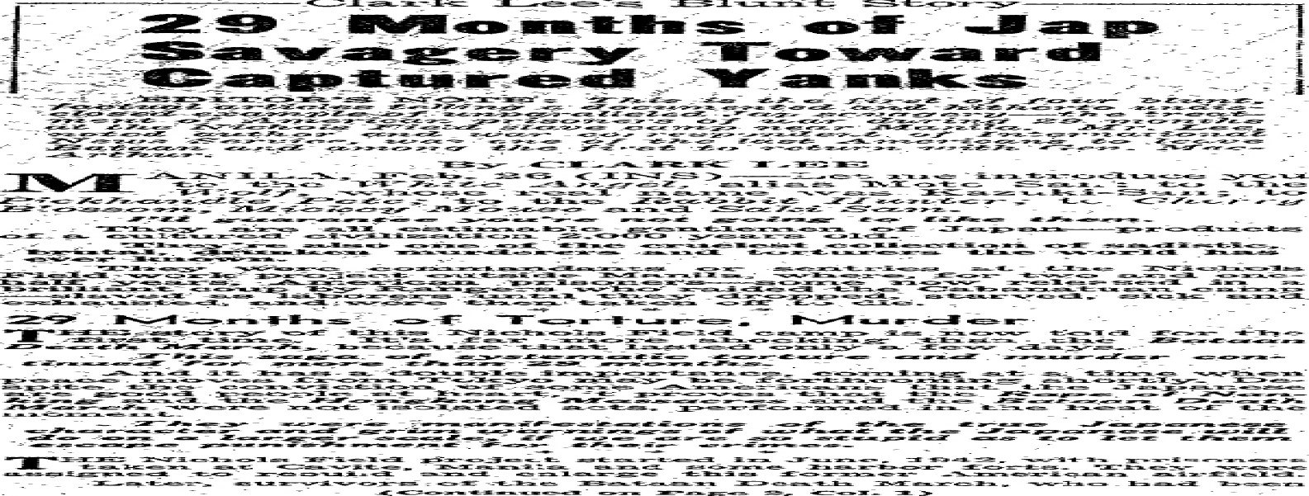

CLARK LEE, Article 2

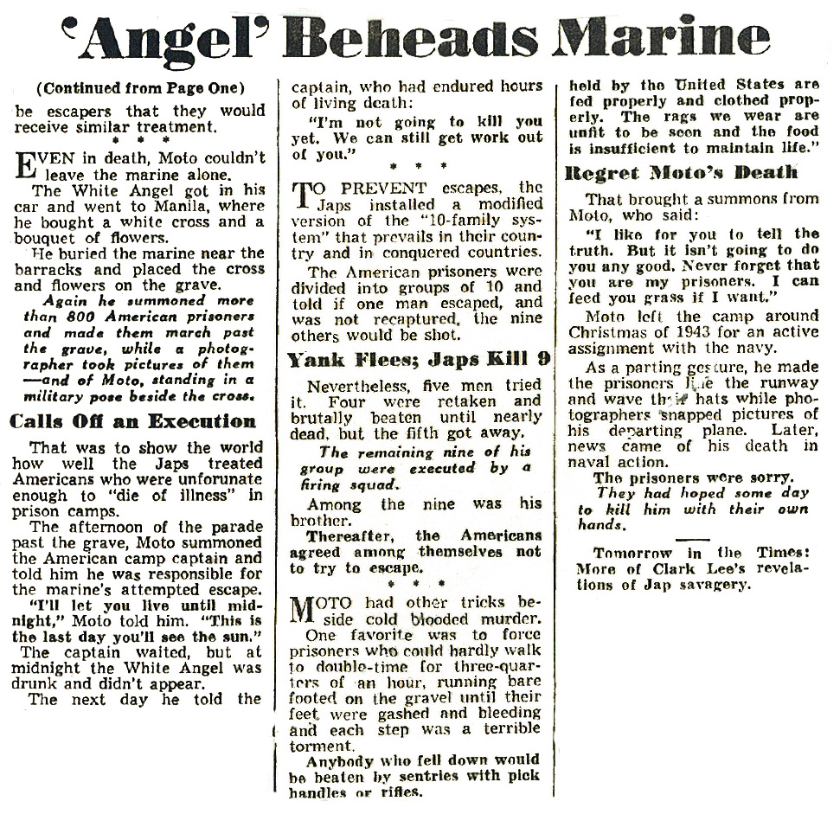

CLARK LEE, Article 2 continued
CLARK LEE, Article 3

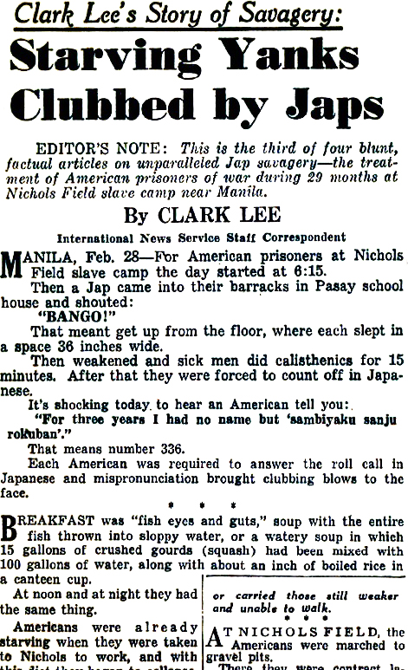

CLARK LEE, Article 3 continued

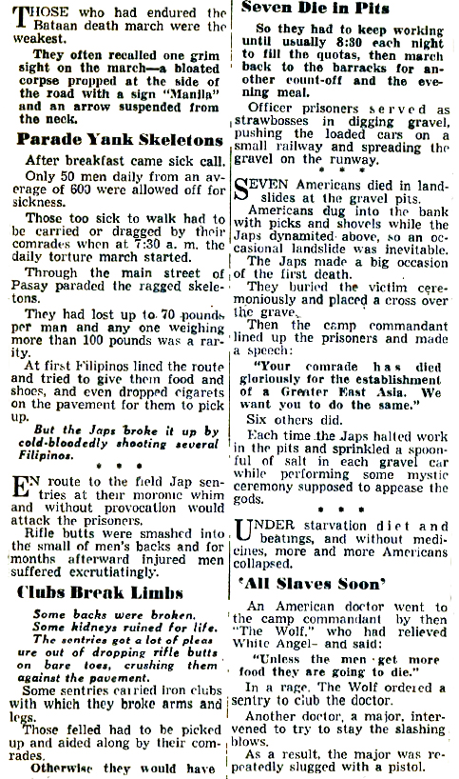

Marcus, Edwin (1885-1961). “Let the Punishment Fit the Crime.” The New York Times April 25, 1943.
The cartoon shows a hand (labeled "Civilization") pointing a revolver at the head of a menacing ape (labeled
"Murderers of American Flyers"). The caption is taken from The Mikado – the Gilbert and Sullivan operetta about Japan. The cartoon reacts to reports during World War II that the Japanese were killing captured American airmen, in violation of the Geneva conventions governing the humane treatment of prisoners. The Japanese had not ratified the convention of 1929.

Written Document Analysis Guide

1. Identify the type of document:

2. Identify any unique characteristics of the document.

3. Date(s) of the document:

4. Author (or creator) of the document:

5. For what audience was the document written?

6. List three things the author said that you think are important.
1)

2)

3)

7. Why do you think this document was written?

8. What evidence in the document helps you know why it was written? Quote from the document.

9. Write a question to the author that is left unanswered by the document.

Political Cartoon Analysis Guide

VISUAL ELEMENTS TEXT ELEMENTS
1. List the visual elements you see in the cartoon. 4. Identify the cartoon caption and/or title

2. Which visuals on your list are symbols? 5. Locate words and phrases used by the cartoonist to

3. What do you think each symbol means? 6. Which words or phrases in the cartoon appear to be the most
significant? Why do you think so?

7. Describe the emotions portrayed in the cartoon.

MEANINGS

8. Describe what is happening in the cartoon.

9. Explain how the text in the cartoon clarify the visuals.

10. Explain the message of the cartoon.

11. What groups would agree/disagree with the cartoon’s message? Why?

The Vietnam Prisoner of War TAP CODE is shown below:
 | COLUMN 1 | COLUMN 2 | COLUMN 3 | COLUMN 4 | COLUMN 5
ROW 1 | A | B | C/K | D | E
ROW 2 | F | G | H | I | J
ROW 3 | L | M | N | O | P
ROW 4 | Q | R | S | T | U
ROW 5 | V | W | X | Y | Z
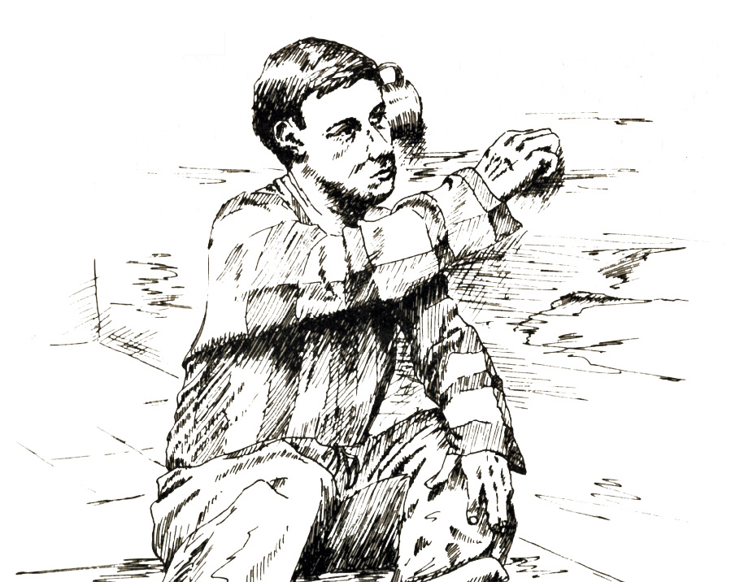
Each letter has two taps - the vertical column is the first tap and the horizontal row is the second tap. So, the letter “S” would be 3 quick taps, then 4 quick taps. A longer pause comes after each word. Common message tapped out was GNGB, which stood for “Good night, God Bless.” A key tool for using the tap code was the standard-issue tin cup which POWs used to amplify sound.
MY MOTHER
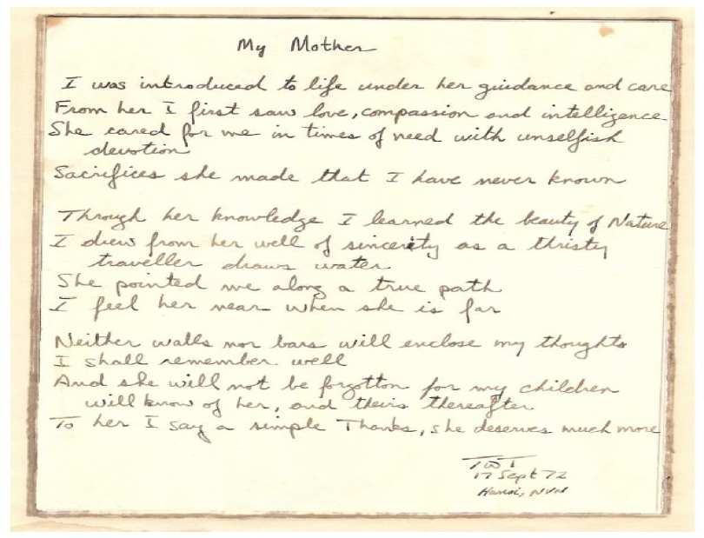

Poem composed by Lt. Commander Ted Triebel in 1972 at the Hanoi Hilton.

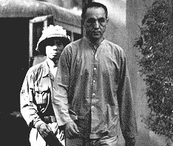
Image of POW Robbie Risner and his captor, known as “Pig Eye the Torturer”

Risner was imprisoned in Hỏa Lò Prison, (known as the Hanoi Hilton to American POWs) and also Cu Loc Prison, known as "The Zoo." Risner spent more than three years in solitary confinement. As the officer of rank with the responsibility of maintaining order, from 1965 to 1973 he helped lead American resistance in the North Vietnamese prison complex through the use of improvised messaging techniques ("tap code"), endearing himself to fellow prisoners with his faith and optimism. He was a POW for seven years, four months, and 27 days. His five sons had been ages 3 to 16 when he was shot down and imprisoned.

The Korean War: Allied POW’s in Korea and China

More is known of the Asian Communists’ treatment of POW’s during the Korean War. Investigations, hearings, and reports have documented these activities to a degree that far surpasses the information on Soviet treatment of World War I1 POW’s. Two of the most pertinent documents relating to Korean war POW’S are the reports of the Senate Committee on Government Operations made by its Permanent Subcommittee on Investigations entitled “Korean War Atrocities” (January 1954, Report No. 848), and “Communist Interrogation, Indoctrination and Exploitation of American Military and Civilian Prisoners” (December 1956, Report No. 2832).

During the Korean war, of the 75,000 U.N. and South Korean soldiers captured by Communist forces, more than 60,000 were unaccounted for while 12,000 were allowed to go home. Investigations established that several thousand American prisoners died or were executed in prisoner-of-war camps. According to the report of the Congressional Committee on Government Operations titled Korean War Atrocities, during the 3-year period covered by the Korean war, the North Korean and Chinese Communist armies were guilty of the following war crimes: murder; assaults; torture-perforation of the flesh of prisoners with heated bamboo spears, burning with lighted cigarettes, et cetera; starvation; coerced indoctrination; and other illegal practices.

Virtually every provision of the Geneva Convention governing the treatment of war prisoners was violated or ignored by the North Koreans and Chinese Communists. More than 5,000 American prisoners of war died because of Communist war atrocities and more than a thousand who survived were victims of war crimes. Furthermore, several thousand American soldiers who had not been repatriated were believed to have been victims of war crimes, had died in action, or were still confined in Communist territory. According to the committee, Communist forces violated the agreement providing for the repatriation of sick and wounded prisoners in accordance with the Panmunjom truce. Finally, the committee charged, the Korean Communists, by false propaganda, attempted to portray the treatment accorded by them to American POW’s in an inaccurate and misleading fashion.

In the field of interrogation and indoctrination, the Senate Government Operations Committee’s investigation of “brainwashing” concluded that the popular conception of this practice was not correct. While it was true that the Communists had considerable skill in the extraction of information from prisoners, the investigation rendered the opinion that the Communists did not possess new and remarkable techniques of psychological manipulation. In connection with these practices, the Chinese Communists and North Koreans, according to the committee, violated
articles 13, 14, 16, 17, and 38 of the Geneva Convention with their use of isolation techniques, their shackling of prisoners, their exposure of prisoners to the curiosity of local populations, their inadequate medical attention, poor clothing, gross inadequacy of foods, improper hospital facilities, and physical mistreatment of prisoners. Coercive interrogation and extraction of false confessions were other practices employed.

“Communist Treatment of Prisoners of War: A Historical Survey.” Prepared for the Subcommittee to
Investigate the Administration of the Internal Security Act and Other Internal Security Laws of the Committee
on the Judiciary, United States Senate. Washington, DC. 1972.

