Victory From Within:
The American Prisoner of War Experience

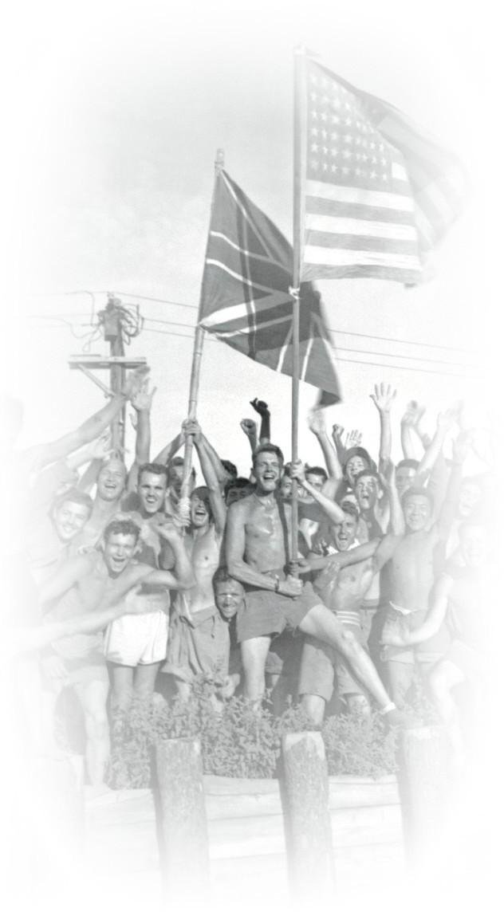
On-site Exhibition Experience at Louisiana’s Old State Capitol
Oct. 1 - Dec. 20, 2019

The Victory From Within traveling exhibit allows students an opportunity to more closely interact with the stories and content of the American POW experience. Graphic panels and video kiosks provide additional content for students to explore and integrate into their curriculum work. While a field trip to the traveling exhibit is not mandatory for the Victory From Within Curriculum, it is highly encouraged. To book your field trip go to: http://louisianaoldstatecapitol.org/education/tour-request-form/ or call the Old State Capitol at (225) 342-0500.

LEARNING OBJECTIVES FOR STUDENTS
- Analyze the content of the VFW traveling exhibit.
- Summarize the POW experience.
- Gather and synthesize information to create well-developed written responses.

COMMON CORE ALIGNMENT
The on-site experience materials align with the Common Core State Standards in English Language Arts and Literacy in History/Social Studies for Grades 9- 10. For a complete list of these standards, go to the Common Core State Standards Alignment section of the Curriculum on our website under the EDUCATION/Lesson Plans for Current Exhibits Tab.

For the full curriculum (lesson plans, activities, worksheets, etc. go to http://louisianaoldstatecapitol.org/education/lessson-plans-for-current-exhibits/

EXHIBIT EXPLORATION TIPS

1. Field trips to the exhibit can be booked at anytime during the curriculum experience, but note that specific dates and times may not be available. Booking early is highly recommended!.

2. Once the field trip is planned, provide a copy of the Exhibit On -Site Journal (provided below) to each student prior to arriving at the exhibit venue.

3. Review the general field trip/exhibit expectations with the class.

4. Explain to students they should explore the entire exhibit by carefully reading the panels, examining the photos, watching the videos, and having conversations with others.

5. If the field trip occurs prior to the start of the Victory From Within Curriculum, tell students they will further explore the topic of prisoners of war through additional lessons, activities, and projects after the field trip.

6. Review the Exhibit On-Site Journal and the Exhibit On-Site Journal Rubric with students. Establish and confirm expectations concerning taking notes and providing responses based on the unique needs of the classroom.

7. Have students explore the exhibit, take notes, and provide responses to the five writing prompts in the Exhibit On-Site Journal individually, in pairs, or in small groups.

8. Depending on time, students can either complete their journals at the exhibit, at home, or in class.

9. Discuss the students’ responses as an entire class.

10. Use the Exhibit On-Site Journal Rubric to assess the work of students.

Victory From Within:
The American Prisoner of War Experience

Exhibit On-site JOURNAL
at Louisiana’s Old State Capitol

Name: _______________________________________________

Date: ________________________________________________

Use this Journal to assist in your exploration of the Victory From Within exhibit.

There are five writing prompts that require your response. There is a page devoted to each one for taking notes and for capturing written responses to the prompts.

At first glance, some of the topics may be specific to a particular panel or section. However, more thoughtful and complete responses draw from different sources within the exhibit.

Your teacher will determine how your exploration is to be structured: individually, in pairs, or in small groups.

- Explain how the camp conditions and treatment of POWs have been similar/different from the Civil War to the War in Afghanistan.
Take notes below preparing for a more formal response below:

Civil War (1861-1865)
Spanish-American War (1898)
World War I (1914-1918)
World War II (1939-1945)
Korean War (1950-1953)
Vietnam War (1955-1975)
Gulf War (1990-1991)
War in Afghanistan (2001— )
Iraq War (2003-2011)

In the space below, write your formal response to the prompt.

2) Explain how and why POWs begin fighting a new type of battle once captured.
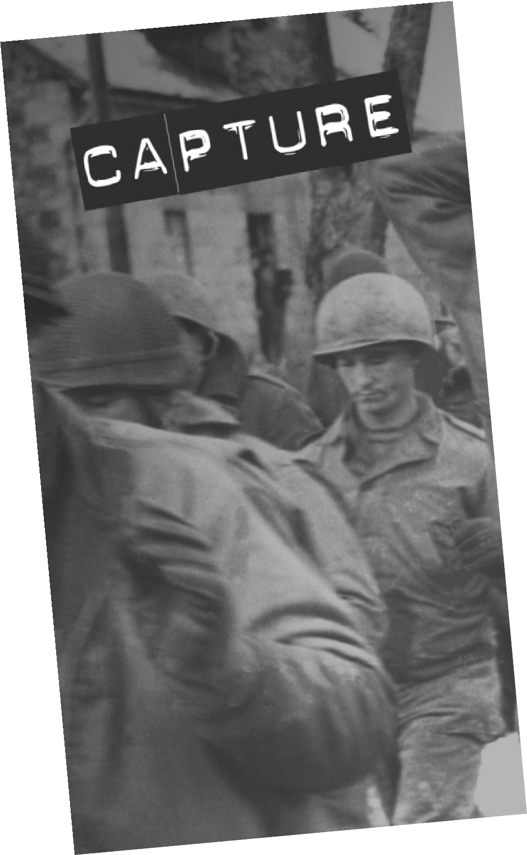
Take notes below.

In the space below, write your formal response to the prompt.

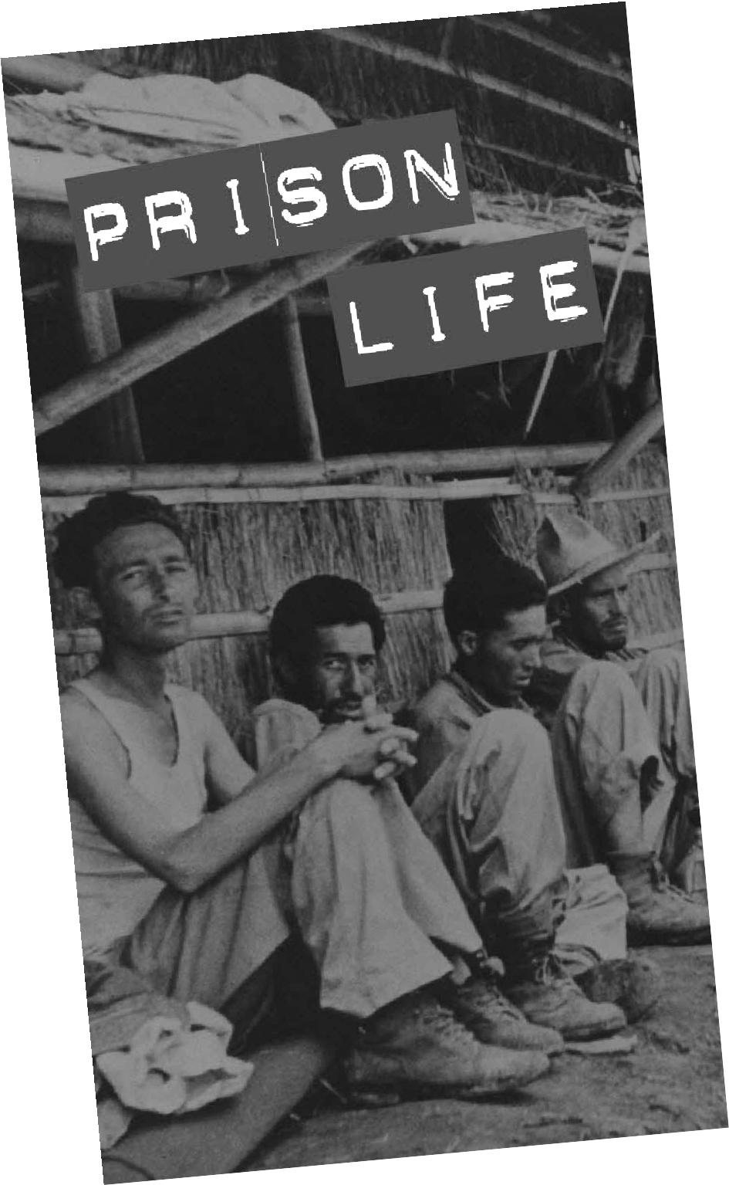
3) Explain why the “Sack of Cement Cross” was so important to the POWs.
Take notes below.

In the space below, write your formal response to the prompt.

4) Explain how throughout history POWs were supported by those “back at home.”

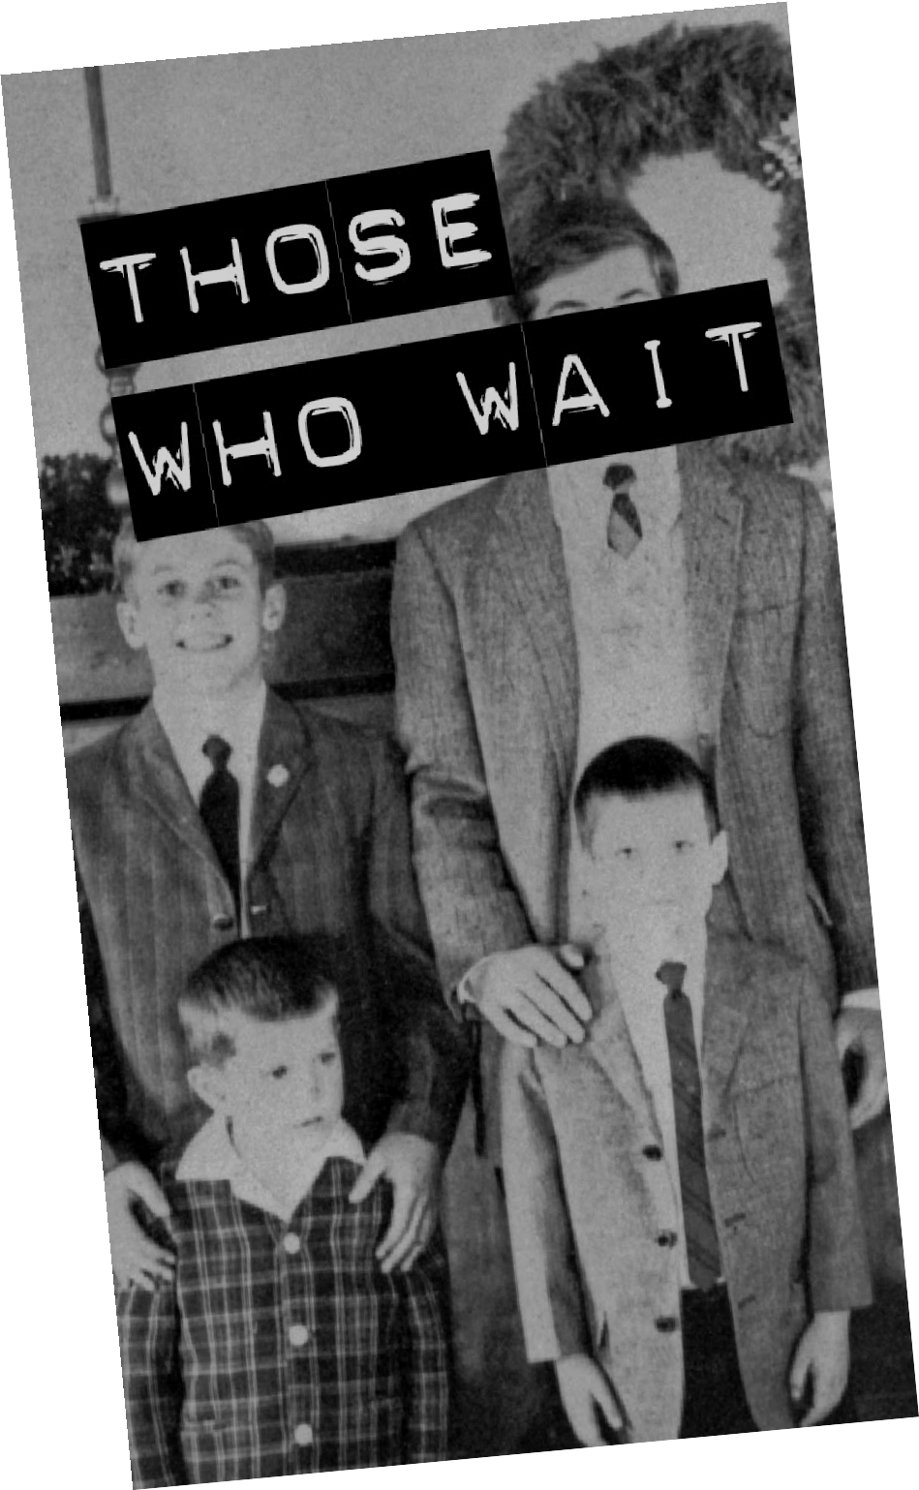
Take notes below.

In the space below, write your formal response to the prompt.

5) Explain why repatriation can be both a positive and a negative thing for POWs returning home.
Take notes below.

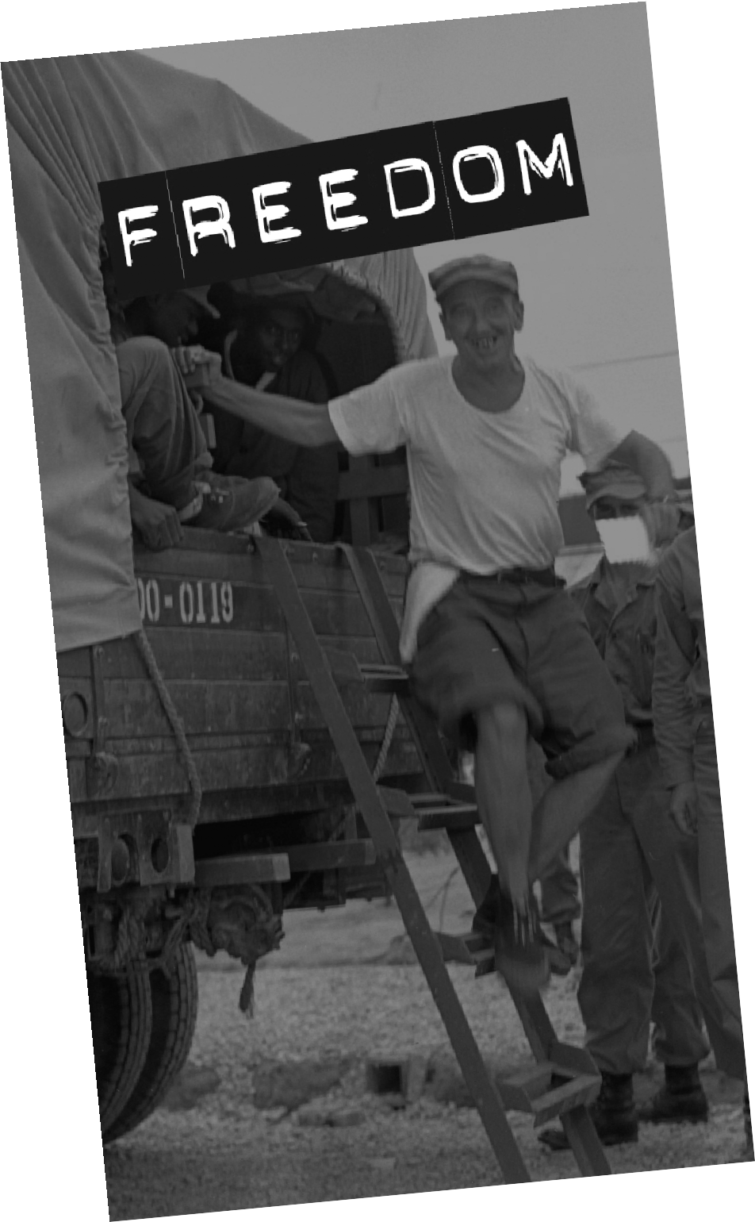

In the space below, write your formal response to the prompt.

Victory From Within:
The American Prisoner of War Experience

Exhibit On-site JOURNAL Rubric
at Louisiana’s Old State Capitol

3 | Thorough discussion of the questions which is richly supported with relevant facts, examples, and details.  The exhibit content is analyzed, synthesized, and woven into the answer.  Specific examples from multiple exhibit components are included.
2 | Discussion of the questions supported with relevant facts, examples, and details.  An analysis of the exhibit content is included in the answer. Examples from multiple exhibit components are included.
1 | Attempts to discuss the questions is supported with facts, examples, and details.  Discussion reiterates the contents of exhibit components.
0 | Not completed.

